

|  |  |
| --- | --- |
| **The Regeneration of Bushmills** | **14th November 2017** |
| **To: The Leisure and Development Committee**  **For Decision** | |

|  |  |
| --- | --- |
| **Linkage to Council Strategy (2015-19)** | |
| **Strategic Theme** | Accelerating our Economy and Contributing to Prosperity |
| **Outcome** | Promoting the Borough as an attractive place to live, work, invest and visit |
| **Lead Officer** | Director of Leisure and Development  Head of Tourism and Recreation |
| **Cost:** (If applicable) | £20k within 2017/18 budget |

**The purpose of this report is to provide Members with an update on the development of a Bushmills Regeneration Plan, beyond the 2020 Village Plan, including:**

* **The development of a brand proposition for the village of Bushmills.**
* **The progression of Bushmills’ ‘Arrival Hub’ Capital Project to Stage 1 of the Capital Investment Programme.**

1. BACKGROUND

During the era of Moyle District Council, a village plan was initiated to create a vision and priorities that would generate social and economic improvement in Bushmills.

Whilst the Village Plan was commissioned by the former Moyle District Council, a Steering Group was established involving representatives from local organisations to oversee development through a series of community engagement consultations.

The document was completed in March 2016, a summary of which is at **Annex A**.

The Bushmills 2020 Village Plan developed a vision for the village, themes, projects and programmes (all detailed in the attached document).

The Bushmills 2020 Village Plan created aspiration and provided direction to the process of regeneration. In essence a ‘community-plan’ had been created.

The Context for Regeneration

Bushmills is unique in that it is at the centre of some of Northern Ireland’s most important tourism attractions including:

* Giant’s Causeway a UNESCO World Heritage Site.
* Carrick-a-Rede Rope Bridge.
* Dunluce Castle.
* Bushmills Distillery.
* Game of Thrones sites.

Beyond the existing offering, the Dundarave ‘country’ Estate is now owned by RANDOX, there is an improving reputation for hospitality and entertainment, and the Salmon and Whiskey Festival is becoming a show case event for the village.

The news in October that the Causeway Coast and Belfast have been rated best region in the world to visit in the coming year by Lonely Planet, will no doubt further raise the profile and popularity of the village.

However, without strategic and joined-up government support, the process of generation is likely to stall or develop in an adhoc fashion, not addressing the key needs of Bushmills:

* Infrastructure is lacking and dated.
* No tangible identity.
* Not functioning as a tourism hub.
* Underperforming economy.
* The village is blighted by dereliction.

2. THE PROCESS FOR REGENERATION

Therefore the aim through regeneration is to ‘*attempt to reverse unemployment, property decay and social exclusion by both improving the physical structure, and, more importantly and elusively, the economy of those areas. In all regeneration programmes, public money is used as an attempt to pump prime private investment into an area’ (Royal Town Planning Institute 2014).*

Having completed an early stage of the process i.e. the Bushmills 2020 Village Plan, it is now necessary to develop and confirm a unique identity for the village, which allows the regeneration process to have an agreed and common context, which is aligned to the potential funding opportunities.

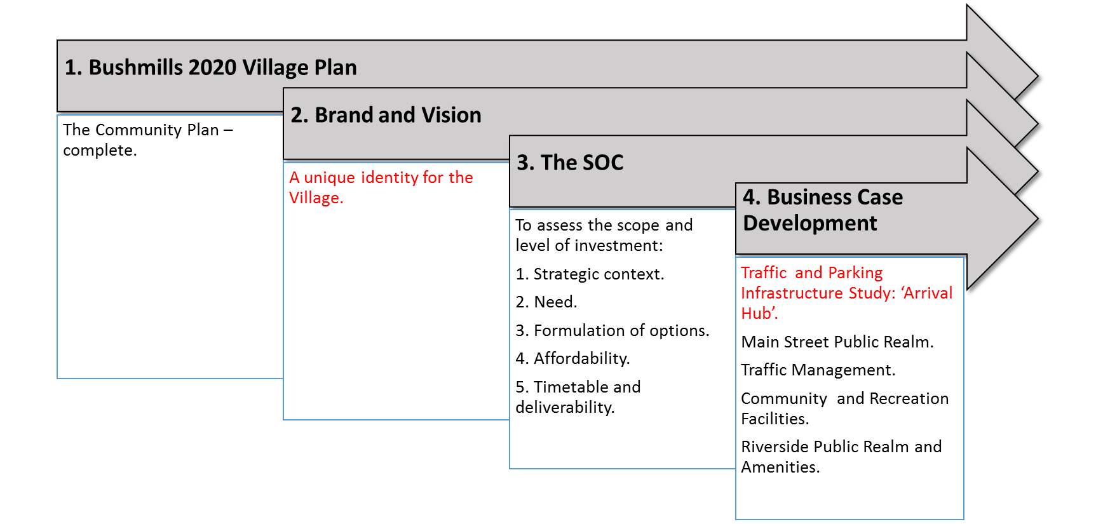The diagram below illustrates the envisaged process.

Note - Red text represents ongoing work.

3. THE BRAND AND VISION FOR BUSHMILLS

Anderson Spratt Group (ASG) was commissioned to deliver a new tourism destination brand for Bushmills in order to develop a strategic approach to ensure the brand proposition for the village of Bushmills is fit-for-purpose as it seeks to attract and grow visitor numbers over the coming years.

ASG were responsible for delivering a robust process of brand research, data gathering and data interrogation which will later inform the development of the final brand identity and its brand communications strategy.

As part of the work, consideration was given to:

* Exploring associations between the current Bushmills village brand, the Causeway Coast & Glens Council tourism brand, the Giants Causeway brand and the Bushmills Distillery brand.
* Engagement with community and stakeholder groups.
* Providing a synopsis of best practice and research on successful branding for similar destination villages and towns.
* Looking to the future identity and brand positioning of Bushmills within the Causeway Coastal Route brand.
* Looking to strengths of the area, including retail, economic and tourism base. Consideration of the image and how the branding can affiliate with this.
* Best practice in the roll-out of the new brand.
* The development of a cohesive brand strategy which considers community, tourism, political audiences and required communications.

Community Engagement and Consultation Outcomes

All stakeholder engagement events (initial stakeholder clinic at Bushmills Distillery, steering group clinic at Mill Youth Hostel and open, drop-in clinic at Bushmills Community Centre) have been conducted.

All questionnaires and feedback from these events has been collated and reviewed as part of the brand concept development work.

Creative concepts for the brand have been presented to a wide group of invited stakeholders including Elected Members, Community Group representatives, the National Trust, Bushmills Distillery, local business people and schools. Feedback responses from this group have been analysed with the following responses:

|  |  |
| --- | --- |
|  | **Preference** |
| Concept A | 65% |
| Concept B | 25% |
| Concept A & B | 10% |

That work is now complete, resulting the completion of the following documents:

1. Bushmills Brand Scoping Report – **Annex B**.
2. Bushmills Brand Presentation (Final) – **Annex C**.

**Recommendation**

**On the basis of the clear majority support for Concept A, the recommendation is to create a brand guidelines document which can be used by all stakeholders who will be using the brand and supply a toolkit of assets.**

4. TOURISM TRAFFIC AND INFRASTRUCTURE STUDY

In 2016 AECOM undertook a study, which focused on the need for parking solutions for the 2019 Open Golf Championship. Based upon growing visitor numbers, the study was increased to include the area East of the River Bann, with the aim of identifying ‘Park and Stride / Park and Ride’ within towns or Hubs.

These are to be strategically sited to facilitate a viable interconnected transport service to the tourist sites (Nodes) and serve to drive economic benefit to the key resorts hubs of Portstewart, Portrush, Bushmills and Ballycastle.

The work included the following data / information collation:

* The study brief highlights that there is an under provision of parking capacity at tourist facilities (nodes) throughout the Council areas.
* A parking inventory at all the hubs and nodes in the study area but limited to within 1 km of the hub centres.
* In addition, all public transport routes connecting hubs and nodes would be mapped to show existing services, including routes and frequencies.
* The process would then include an inventory on public transport facilities at bus stops at hubs (main bus stop only) and nodes.
* Traffic volumes on key approach routes to the study area would be identified via TNI data, identifying the busiest roads to help with decision making on which routes would be best served by Park & Ride.
* Following the review of parking and public transport, it would overlay all relevant bus routes over a map containing car park locations in the four hubs.
* In addition, nodes would be plotted in relation to public transport routes and any associated car parks.
* At the conclusion of this exercise, a clear understanding would emerge of what gaps there are, and from this potential options available for the study in terms of site locations.

Site preference would be developed for each of the towns (hubs) in terms of potential P&S/P&R routes including existing car parks (albeit upgraded) to new sites, based upon the following criteria:

* Accessibility.
* Infrastructure deliverability.
* Infrastructure costs.
* Planning.
* Traffic and transportation.
* Economic Benefit.

The draft document for members approval is at **Annex D**.

Bushmills P&S/P&R Sites

Based upon the acute congestion at the Giants Causeway, the subsequent congestion in Bushmills and the key function as an economic driver, AECOM has been tasked to prioritise the identification of a potential Park and Stride/ Park and Ride facility in Bushmills to create an ‘Arrival Hub’. Eight sites have been identified, details of which are presented in Appendix E of **Annex D** and are summarised in the following table:

|  |  |  |
| --- | --- | --- |
| **Site Name** | **Score** | **Rank** |
| Dundarave Car Park Extension | 28 | 1 |
| Dunluce School Gravel Sports Field | 22 | 2 |
| Dundarave Estate Polo Lands | 22 | 2 |
| Dundarave Estate Potato Fields | 21 | 4 |
| Main Street Car Park Extension | 21 | 5 |
| Bushmills Distillery Car Park Extension | 19 | 6 |
| Giants Causeway and Bushmills Car Park Extension | 19 | 7 |
| Former Dunluce Presbyterian Church Hall | 17 | 8 |

Summary

The entirety of the work detailed in **Annex D** presents potential Park and Stride/ Park and Ride sites in each of the hubs that will satisfy the objectives of this commission.

Whilst this study has focused to a greater degree on Bushmills, it has identified potential locations in Portstewart, Ballycastle and Portrush, which will be considered to a greater degree in the context of Council’s Parking Strategy.

**Recommendation**

**On the basis that a Bushmills ‘Arrival Hub’ has an identified need, it is recommended that:**

**AECOM refine the work relevant to Bushmills detailed in Annex D through:**

* **Consultation with landowners / community groups / relevant stakeholders.**
* **Establish the objectivity of need through proxy analysis.**
* **Detailed cost analysis for each site.**
* **Economic benefit derived through each site.**
* **Capital funding opportunities.**

**Facilitating the completion of the Outline Business Case and Economic Appraisal.**