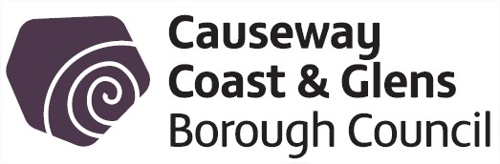
14 February 2017 Leisure and Development - Consultation Schedule

1 | TITLE | RECEIVED FROM | SUBMISSION BY
 | North-West Multimodal Transport Hub Public Consultation | Translink | 20 January 2017
Translink is working together with partners in the Department for Infrastructure, Department of Transport, Tourism and Sport, Derry City and Strabane District Council, Donegal County Council and Sustrans to deliver the North-West Multimodal Transport Hub; a major new active and sustainable transport facility which will transport travel and heritage regeneration in the region.

Situated on the former iconic Waterside Station site, the new Hub will be an important gateway to the North-West; it will encourage a modal shift from car to public transport and other sustainable modes by providing integrated and convenient services to encourage more active travel for a healthier region – supporting a key outcome of the draft Programme for Government.

Proposals include restoration and refurbishment of the former listed Waterside Railway Station, new platforms, and enhanced Park & Ride, an Active and Sustainable Travel Centre, demolition of the current train station, a new bus turning circle, Greenway link to the City Centre via the Peace Bridge as well as Track, Signalling and Telecoms work.

Translink are now launching a public consultation to share views to help develop Hub proposals. The consultation can be found on the following website:

- www.translink.co.uk/northwesthub/
2 | TITLE | RECEIVED FROM | SUBMISSION BY
 | DAERA Knowledge Framework Consultation | Department of Agriculture, Environment and Rural Affairs | 27 February 2017
The draft DAERA Knowledge Framework is a succinct, high level framework that sets out the rationale for the Department’s involvement in education, knowledge and skills, what the Department seeks to achieve and the nature of its interventions.

The Framework is broader than solely education and also encompasses training and technology exchange provision. All of these elements should be central to the Department’s policy objectives and strategic goals, and wherever possible, knowledge and skills acquisition should be integral components of all policy interventions and programmes aimed at delivering the Department’s strategic objectives. It is intended that the Framework will act as the point of reference against which all of the Department’s future knowledge interventions can be tested and anchored. It is this latter aspect that will both drive change and guide the nature of future knowledge interventions.

The consultation can be found on the following website:

- https://www.daera-ni.gov.uk/consultations/daera-knowledge-framework-education-strategy

3 | TITLE | RECEIVED FROM | SUBMISSION BY
 | Economy 2030 – A Consultation on an Industrial Strategy for Northern Ireland | Department for the Economy | 25 April 2017
This consultation document sets out proposals to refocus the economic priorities up to 2030 and invites views on those proposals.

The responses to this consultation, alongside the responses to consultation on the wider draft Programme for Government, will inform the development of a final Industrial Strategy.

The consultation can be found on the following website:

- https://www.economy-ni.gov.uk/consultations/industrial-strategy

Note: Copies of consultations can be obtained from Democratic Services.

