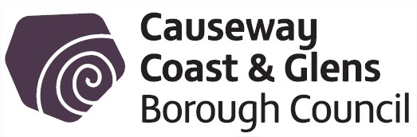
18 October 2016 Corporate Policy & Resources Consultations

1 | TITLE | RECEIVED FROM | SUBMISSION BY
 | Draft Local Government (Payment to Councillors) Regulations (Northern Ireland) 2016 Consultation Document | Department for Communities | 30 November 2016
The Department for Communities is seeking views from consultees on revocation and remaking of the draft regulations. The Local Government (Payments to Councillors) Regulations (Northern Ireland) 2016 (Annex A) which the Department proposed to make under the powers conferred by section 31(1), (3) and (4) and 43(2) of the Local Government Finance Act (Northern Ireland) 2011, “2011 Act”.

The draft regulations are required to give effect to:
(a) the revision of councillors’ allowances, and
(b) other legislative changes resulting from local government reform.

- https://www.communities-ni.gov.uk/consultations/

2 | TITLE | RECEIVED FROM | SUBMISION BY
 | Fresh Start Agreement and changes to the government consultation system | NILGA | 1 December 2016
The Fresh Start Agreement changes, in particular, the reduction of the maximum time period allowed by departments for responding to consultations to eight weeks:

The NILGA Executive has requested that their Head of Policy write to each council for views on how the new system is working and whether members and officers would value continued lobbying for a more effective approach to the issuing of consultations which would allow for more constructive engagement from councils.

3 | TITLE | RECEIVED FROM | SUBMISION BY
 | Future delivery of electoral services in Northern Ireland | The Electoral Office for Northern Ireland | 9 January 2017
Online registration will be rolled out for voters in Northern Ireland within months as part of a comprehensive review of how electoral services are delivered in Northern Ireland. The consultation paper entitled ‘Future delivery of electoral services in Northern Ireland’ gives everyone with an interest a chance to shape how electoral services are delivered in the most effective way after the introduction of digital registration and before the next cycle of elections commences in 2019.
The overarching aim is to ensure the people of Northern Ireland can access modern, efficient electoral services while being confident in the safety and security of the electoral process.
The consultation invites respondents to consider three main areas:
• Making the most of digital registration to ensure Northern Ireland follows success in Great Britain where 90 per cent of registrations are now made online;
• A greater role for local councils in Northern Ireland in managing elections and providing local electoral services such as advice and support to residents; and
• Ensuring that the Electoral Office for Northern Ireland (EONI) can provide the best possible service on a sustainable financial footing for years to come.

