Lifestyle

Historic, breathtaking landscapes made famous by film and folklore, the site of earliest civilisation in Ireland

World class golf facilities for all levels across the borough

Superb sports facilities as well as wide open spaces for adventure and play

The island’s only UNESCO World Heritage Site

A mix of independent and chain-based retail throughout the four main towns in the borough

The most visited region in Northern Ireland, outside Belfast

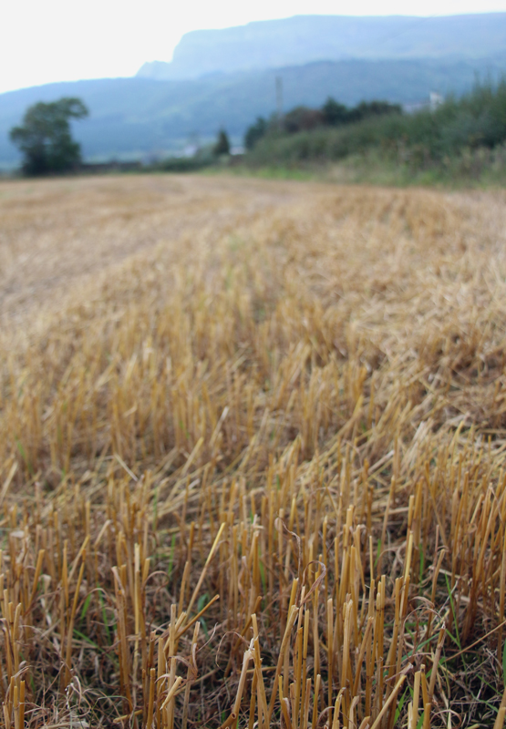

Place

Coleraine and Limavady are recognised as **main hubs**, with Ballymoney a local hub, with excellent **transport and infrastructure links** across the wider region

Belfast International Airport is **50 minutes** outside the Borough, while City of Derry Airport is **20 minutes** outside the Borough; both serve national and international routes with outstanding linkages to the Borough

Business

The area is home to over 6000 VAT-registered businesses – a **ready-made supply chain** for any inward investor

The Council works directly with Invest Northern Ireland to **maximise opportunities and provide support** for all sizes of business

Agrifoods, tourism, retail, and contracting/engineering all play a major part in the area’s business profile

Council is also responsible for **planning** in the local area – meaning a partnership that is solution-led when it comes to business needs

The area has a good **network** of chambers, representative bodies and links to the local University, accessing contacts, research and assistance when required

People

A ready pool of candidates, with **22%** of currently unemployed claimants at **Skill Level 3 or 4** (managers, professionals, skilled trades

**80%** of school leavers have 5 or more GCSEs, Grade C and above

**82%** school leavers went on to further & higher education

Over **1600 students graduate** from Ulster University, Coleraine per annum

Almost **850** students gained qualifications in the STEM (Science, Technology, Engineering, Maths) subjects

**Competitive gross median weekly and hourly wages** mean employees are more cost-effective than equivalents elsewhere in the region

***“Our Vision is of a high value-added, skilled, innovative and enterprising economy.”***

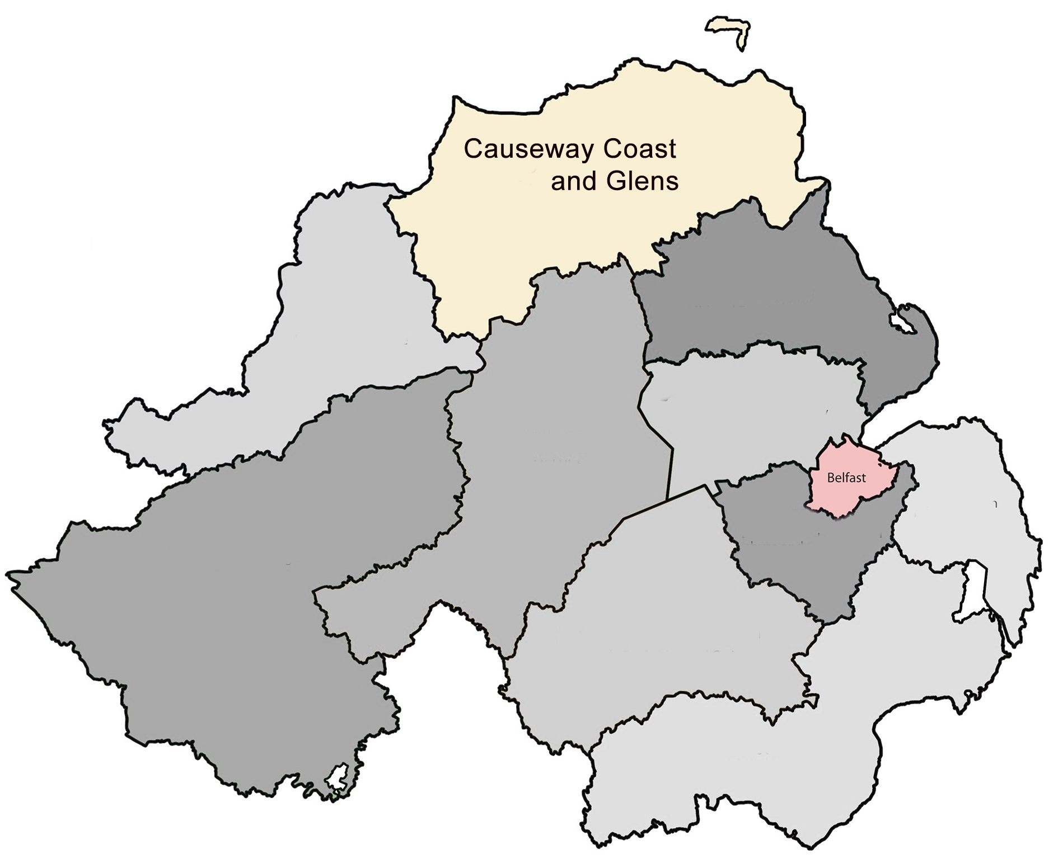

**Key facts**

**about Causeway Coast and Glens Borough Council area**

And...

**200,000sq** ft of planned and existing industrial and office space

**Over 100,000 potential workers** within a forty minute travel time

High availability of **superfast broadband,** public wifi, 3G and 4G connectivity

Competitive Grade A office costs and large scale development opportunities across the borough

House prices around **fifty percent** less expensive than the UK average - £140,000 in comparison to £273,000

Lower than average levels of crime

Around thirty schools, two further and higher education colleges with outreach facilities, and the University of Ulster in Coleraine

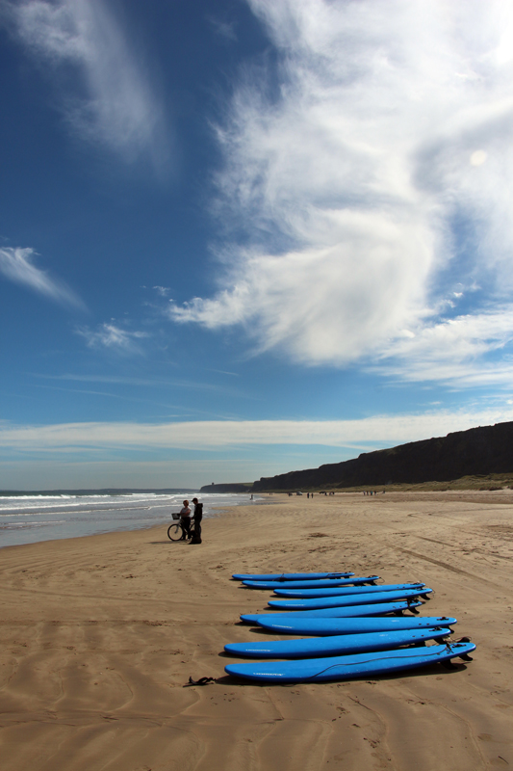

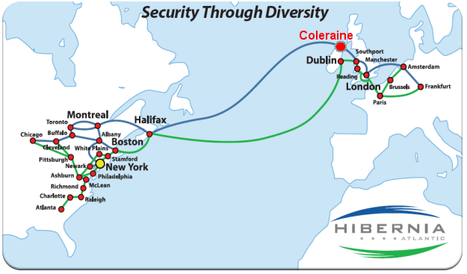

**Potential for Cost-effective Energy Resources**

The borough already contributes to cleaner, greener energy for Northern Ireland through extensive **wind farm** development; however, further strides in this field are being taken with the proposed development of a sustainable, localised **microgrid** for the area, coupled with planned **underwater marine energy arrays** off the north coast.

**Unique Data Communication Capabilities**

Coleraine was selected as the most suitable landing point in the North Atlantic for **an advanced high capacity telecommunications exchange centre** that links the North American, UK, Ireland and major European centres together, with a very fast data communications network.

**Cloud Computing Facilities. Research. Access to skills.**

The Computer Science Research Institute (CSRI), which is part of Ulster University, is carrying out **intensive levels of research** in emerging key technologies in computing and engineering.

The University’s research leadership in **biotech, clinical care, and Cloud Computing competence,** provides a talent base for medical systems companies delivering on their ‘connected for health’ product strategies.

**The Enterprise Zone**

Coming soon, a zone connected to the **Kelvin Data Cable** which connects the north coast to the markets of Europe and North America. **Enhanced Capital Allowances permit 100% first year write-off for qualifying plant and machinery expenditure.**

**The Digital Causeway**

An emerging hub for information technology, stemming from our University links, our proposed Enterprise Zone and superb information technology infrastructure

What makes us different?