North West Regional College
PART
-
TIME ENROLMENT FORM
PLEASE COMPLETE AND RETURN
ALL 4 PAGES
OF THIS FORM
Course Title xxx
: xxx
Course Ref: xxx
Full Fee Payable: ☐ Concessionary Fee Payable: ☐
Day Release: ☐
PT Day: ☐
Start Date: xxx Day: xxx

Time: xxx
Location: xxx
PT Evening: ☐
Office Use Only
:
AOS Pathway / Session
:
Student ID:
xxx
xxx
Personal Details
Surname xxx
:
Permanent Home Address: xxx
xxx

Date of Birth
:
/ /
D
D
M
M
Y
Y
Y
Y
☐ Mr ☐ Mrs ☐ Miss ☐ Ms ☐ Dr
Please complete
(
ALL
details clearly)
Home Phone: xxx
Mobile Phone: xxx
Work Phone: xxx
Email: xxx
Residency
:

☐ EU ☐ Non-EU
Nationality: xxx
Post Code
: xxx
Title
:
What is your country of birth?
Please write the present name of the country: xxx
Sex

:
☐ Male ☐ Female
Unique Learner Number (ULN): xxx
Learning Support
If you have indicated any disability or medical condition which may affect
your studies, your details will be passed to the College Learning Support
Co-ordinator who will contact you to discuss your learning needs in
confidence.
☐ Yes ☐ No
☐ Yes ☐ No
Please state nature of disability & support required:
Forename: xxx
:
Office Use Only
:

Support letter issued
Please indicate if you have any learning
difficulties/disabilities:
Do you require additional help from us?
Safeguarding
Have you ever been convicted of / received a caution for:
● a criminal offence of a violent or sexual

nature?
● an offence relating to the distribution

and/or sale of illegal drugs?
Failing to complete this section or providing misleading or false
information may lead to your application/enrolment being withdrawn.

Ticking ‘Yes’ to any of the questions above will result in a follow up meeting
in order to obtain further details.
☐ Yes ☐ No
☐ Yes ☐ No
Where did you hear about the Course?
(
Please tick where appropriate
)
Career Guidance:
☐ School / Careers Teacher
☐ DfE Careers Service Adviser
☐ College Careers Service / Tutor
☐ Newspaper Advertisement
☐ TV Advertisement
☐ Radio Advertisement
☐ Billboard / Bus / Bus Shelter Advertisement
☐ TV / Radio Interview or Newspaper Article
Advertising:
Web / Digital:
☐ NI Direct
☐ College Website
☐ Social Media (Facebook, Twitter)
College
☐ College Information Day
☐ College Literature / Prospectus
☐ Word of Mouth (friend, parent etc)
☐ Employer
☐ Jobs and Benefits Office
☐ Other
What is your main language OR what is your first language?
☐ English
☐ Other
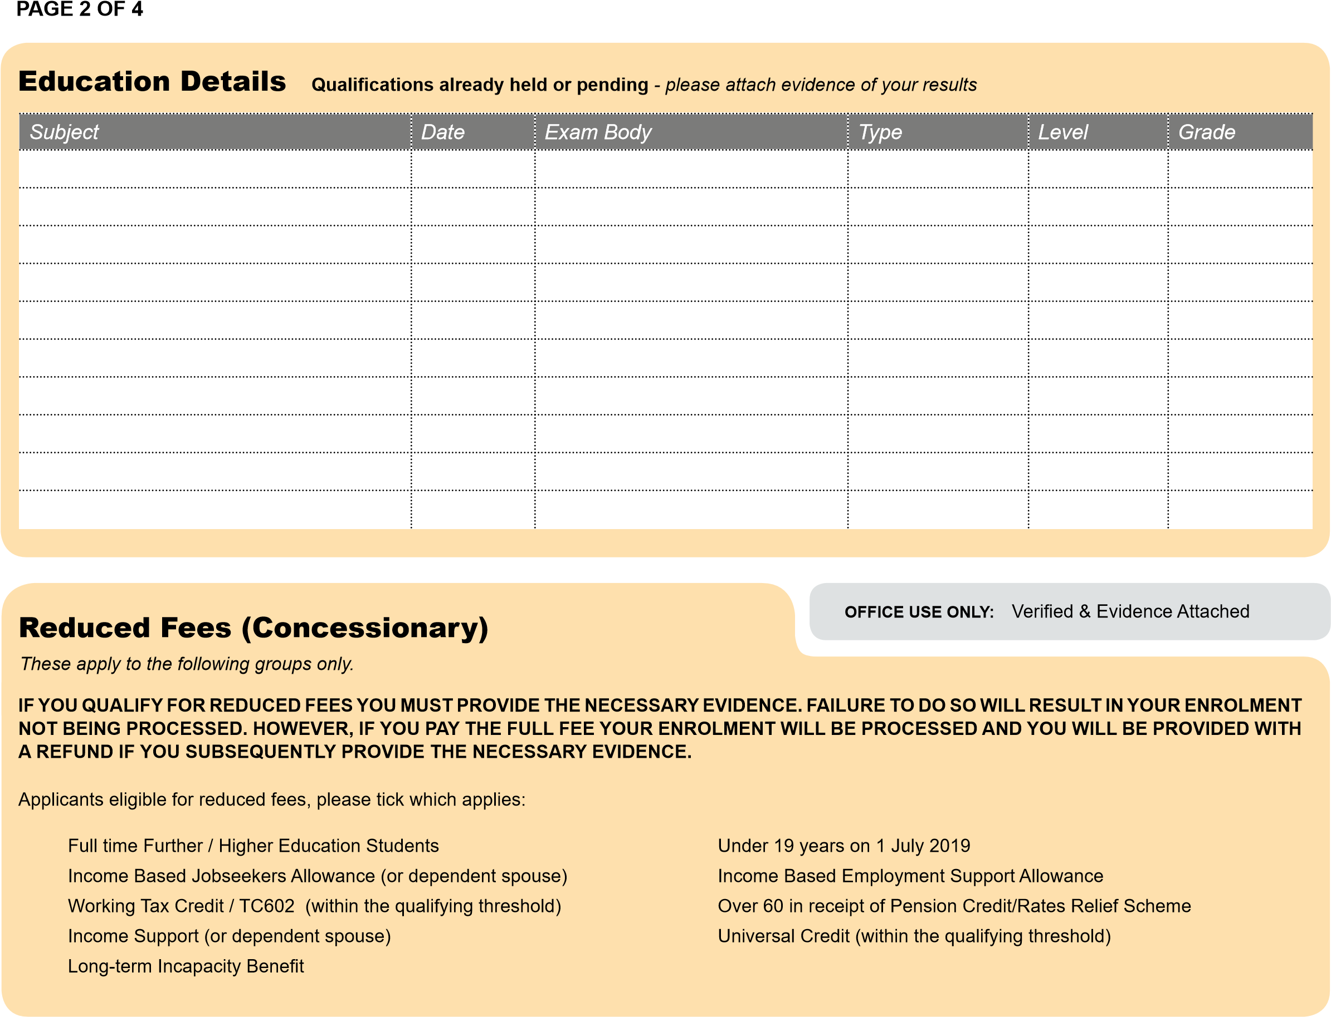
☐
☐
☐
☐
☐
☐
☐
☐
☐
xxx
xxx
xxx
xxx
xxx
xxx
xxx
xxx
xxx
xxx
xxx
xxx
xxx
xxx
xxx
xxx
xxx
xxx
xxx
xxx
xxx
xxx
xxx
xxx
xxx
xxx
xxx
xxx
xxx
xxx
xxx
xxx
xxx
xxx
xxx
xxx
xxx
xxx
xxx
xxx
xxx
xxx
xxx
xxx
xxx
xxx
xxx
xxx
xxx
xxx
xxx
xxx
xxx
xxx
xxx
xxx
xxx
xxx
xxx
xxx
Fee Category*
Are you paying:

☐ Full Fee ☐ Reduced Fee
(
please attach evidence
)
*Financial assistance may be available to students aged 19 or
over enrolled on a vocational course. For more information visit:
www.nwrc.ac.uk/faq
Employer / Agency Address
: xxx
Company Stamp and Authorised Signature:
Please state who will be paying your fees: ☐ Self ☐ Employer ☐ Other
Tel No: xxx

INVOICE DETAILS

Please have the Company Details and Stamp or Authorised Signature above completed or attach a letter from the organisation stating that they will pay your
fees. Your fees are not deemed paid until a responsible organisation provides payment.
Post Code
: xxx
xxx
xxx
Finance Section
Payment Method:

Cash Cheque Switch Credit Card Invoiced
Cash Transactions:
Amount Paid: Receipt No.: Date: Received By:
Amount Invoiced: Invoiced to: Date: Processed By:
(
OFFICE USE ONLY
)
PAGE 3 OF 4

Student Declaration
I certify that the details on this form are correct and that if accepted I wish to be enrolled for the above course and accept that payment of any fees incurred is my responsibility. I understand that I will cease to be a student of the College if I have an absence without explanation for more than four consecutive weeks or if it becomes clear I have provided false statements or have withheld relevant information. In such circumstances, I also understand I will have to apply to be re-admitted as a student. By signing this form I agree to comply with all College regulations, policies and guidelines. Copies of these can be obtained from College Libraries.
Enrolment on a course at this College WILL NOT be processed if the form is not signed by the student.
Signed xxx Print Name xxx Date xxx

Enrolment Form Privacy Notice
North West Regional College (Data Controller) is permitted to process personal data where there is a lawful basis to do so. NWRC recognises and respects the importance of your privacy and is committed to treating your information responsibly and in compliance with the data protection legislation. The lawful basis for the processing of personal data included and associated with this Enrolment Form (including your results and benefit evidence) is; ‘that processing is necessary for the compliance with a legal obligation’ and/or ‘processing is necessary for the performance of a task carried out in the public interest’.
The information that you provide on this form will be processed to administer your studies, to deliver your programme and to monitor your performance and attendance. We also use your information to manage recruitment, admission, registration, enrolment, study, examination and graduation. Your information will be used to provide you with College facilities and services, to provide you with support and to process any payments to be made to you. We may also use your information to conduct research and surveys to identify ways to enhance learning, teaching, assessment and the whole student experience. Information will be passed between relevant Curriculum Schools and support Departments within the College for operational purposes and will be disclosed to external agencies where we have an obligation to do so and where a lawful basis exists, such as; Government Departments and their Nominees, Statutory Bodies, Higher Education Statistics Agency, Student Loans Company, Funders, Learning Records Service for allocation of your Unique Learning Number, Placement Providers, UCAS, Universities, Credit Reference Agencies, Crime Prevention Organisations. Employers (who pay your fees and allow you time off work to attend courses) may request information regarding your attendance, progress and results. All personal data will be held in line with the Sector Retention & Disposal Schedule. For further information on your individual rights and to access our Data Protection Policy, please visit www.nwrc.ac.uk/policies.
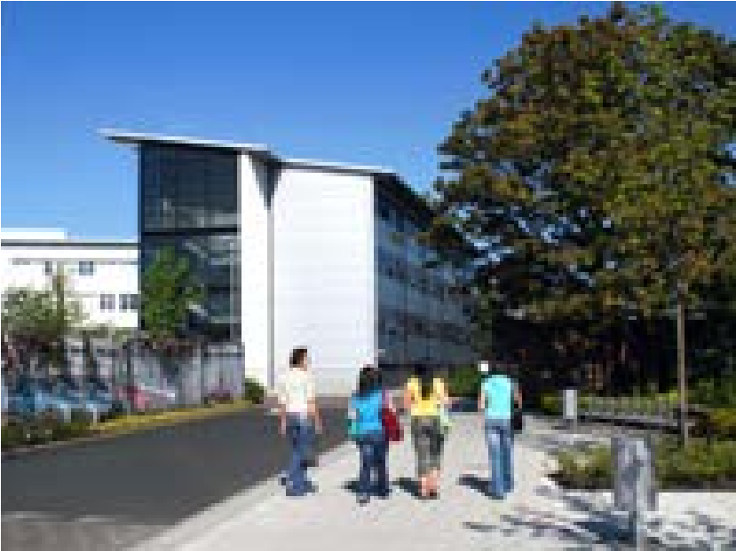
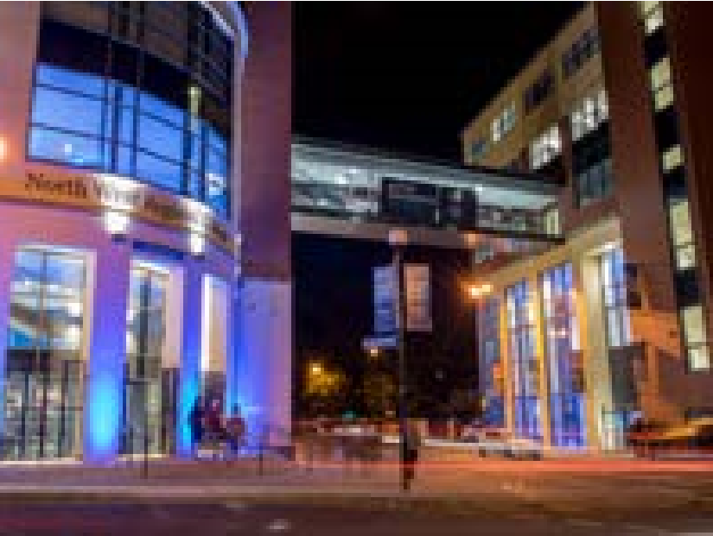
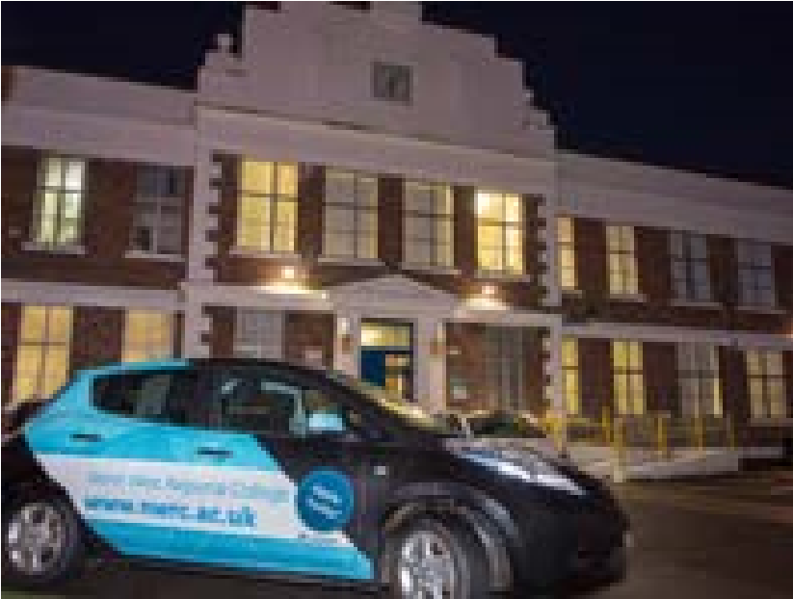
NWRC Terms & Conditions are available online at www.nwrc.ac.uk/policies. Please read through the Terms & Conditions online or request a copy from the College.
Please return completed Enrolment Form AND Monitoring Form
to the admissions office suitable for the location of your chosen course:
Limavady
Administration Office
North West Regional College
Main Street, Limavady
BT49 0EX
Derry Londonderry
Administration Office
North West Regional College
Strand Road, Londonderry
BT48 7AL
www.nwrc.ac.uk/parttime
Strabane
Administration Office
North West Regional College
Derry Road, Strabane
BT82 8DX
College Signature: Print Name: Date:
OFFICE USE ONLY:
Enrolment/FESR Processed by: Print Name: Date:
Please attach any additional information you feel will support your application when returning your form.
NOTE: You are not enrolled on a course until you have paid the relevant tuition fees. Fees are non-refundable except where a class is cancelled. If the College cancels your chosen course, you will automatically receive a refund. Refunds will be issued in the form of a cheque to the student named on this enrolment form.
This is a Blank Page

Please continue to Equality Monitoring Form on next page

PAGE 4 OF 4
North West Regional College EQUALITY MONITORING FORM
Explanatory Note:
The North West Regional College wishes to ensure that its services are accessible to everyone regardless of their gender, age, nationality, race, marital status, religious belief, sexual orientation, political opinion, and whether or not they have a disability or dependents. Whilst the completion of this monitoring form is optional, there is a requirement for data to be collected from students in line with equality legislation in Northern Ireland. The College would appreciate your co-operation in order that it may monitor and evaluate IT services for students.
Please note: This page is strictly private and confidential and will be separated from your form by our Administration Staff
☒
Disability
Are your day to day activities limited because of a health problem or
disability which has lasted, or is expected to last at least 12 months?
☐ Yes ☐ No
☐ A specific learning disability such as dyslexia / dyspraxia / AD(H)D
☐ Blind or serious visual impairment uncorrected by glasses
☐ Deaf or serious hearing impairment
☐ A Physical impairment or mobility issues, such as difficulty using
arms or using a wheelchair or crutches
☐ A social/communication impairment such as Asperger’s Syndrome/
other autistic spectrum disorder
☐ A mental health condition, such as depression, schizophrenia or
anxiety disorder
☐ Longstanding illness or health condition such as cancer, HIV,
diabetes, chronic heart disease or epilepsy
☐ A disability, impairment or medical condition not listed above
If YES to the above, please state the type(s) of impairment that apply
to you
please tick all that apply
)
(
Ethnic Group
☐ Bangladeshi
☐ Chinese
☐ Asian Other
☐ Irish Traveller
☐ Mixed Ethnic Group
☐ Any Other Ethnic Group
☐ White
☐ Black Caribbean
☐ Black African
☐ Black Other
☐ Indian
☐ Pakistani
To which of these ethnic groups do you consider you belong to?

)
please select the option that is most appropriate for you
(
Care Background
Are you in care or have been in care?
In care is to mean either fostering, adopted, care home or other
supported residential care.
☐ Yes ☐ No
Dependants
Do you have a personal responsibility for the care of?

(
tick each box that applies to your circumstances
)
☐ A Person(s) with disability
☐ No I do not have any dependants
☐ A Child (or Children)
☐ A Dependant Adult(s)
Community Background
What religion, religious denomination or body were you brought
up in?
☐ Other Religion
☐ None
☐ Roman Catholic
☐ Protestant
☐ Other Christian
Religious Belief
☐ Roman Catholic
☐ Presbyterian Church in Ireland
☐ Church of Ireland
☐ Methodist
☐ Other Christian
☐ Buddhist
☐ Hindu
☐ Jewish
☐ Muslim
☐ Sikh
☐ Other Religion
☐ None
What religion, religious denomination or body do you belong to?
Sexual Orientation
Heterosexual / Straight
Bisexual
Gay
Which of the following options best describes how you think of
yourself?
☐ Lesbian
☐ Other
☒ Prefer not to say
Marital Status
)
(
please tick one box
☐ Divorced / Dissolved
☐ Widowed / Surviving Civil
☐ Partner
☐ Single
☐ Married / Civil Partner
☐ Separated
Are you...?
Employment Status
(please tick one)
☐ Employed Full Time (30 hours out more per week)
☐ Employed Part-Time (less than 30 hours per week)
☐ Self Employed
Not in work and not looking for work
☐ Retired/looking after family OR home/long-term sick
☐ Student/Waiting to start a course
☐ College or University
☐ Other (e.g. voluntary unpaid work)
Unemployed (out of work and looking for work) for
☐ less than 6 months
- 11 months
☐ 6
☐ 12
or more months
What is your current main employment status?
Alternative formats of this form are available on request

