Age-Friendly Strategy And Action Plan

For Causeway Coast and Glens Borough Council

2024–2027

Prepared by

**Contents**

Introduction 2

Age-Friendly in Context 3

Why an age-friendly strategy and action plan for Causeway Coast and Glens? 6

What it’s like to grow older around here 8

Strategic context 11

The Age-Friendly Strategy for Causeway Coast and Glens 14

Appendix 1: Action plans 19

Appendix 2: Summary of relevant strategies and policies 40

# Introduction

The Causeway Coast and Glens Age-Friendly Strategy is a recognition that our ageing population should be celebrated for the wealth of skills, experience, and knowledge it brings to our society. Negative narratives on ageing tend to dominate in society. Ageing is spoken about in association with health, disease, and loneliness. Older people are presented in the media as physically and cognitively frail, vulnerable, and dependent on care. By contrast, the age-friendly movement values our older citizens and fosters the conditions which support them to age well and enable them to be, and to do, what they value[1].

In 2020, Causeway Coast and Glens Borough Council began its journey in becoming a more Age-Friendly community. Supported by funding through the Public Health Agency and working closely with public, community and voluntary sector partners, the Council has put in place the foundations and infrastructure to listen to, and act upon, the needs and aspirations of our older residents.

Aligning closely with A Better Future Together, the community plan for the Borough, this Age-Friendly Strategy and Action Plan is based on wide community engagement. The Council and its partners will take forward a range of actions which will seek to improve the quality of life of our older citizens, focusing on the themes which people told us mattered most or areas where they wanted to see the most improvement.

We are committed to continuing to reflect the needs and interests of our older residents and so we will ensure that we speak to them and update our evidence regularly. In the interim, the Older People’s Champions supported by COAST, and our connections with other age-sector organisations across the Borough will help ensure the voice of older people is sought and included in our plans going forward.

don't be afraid of getting older, gain from the good and difficult times, keep socially engaged (survey respondent)

# Age-Friendly in Context

Age-friendly communities are designed to account for the wide diversity of older people, promote their autonomy, inclusion, and contributions in all areas of community life, respect their decisions and lifestyle choices, and anticipate and respond flexibly to ageing related needs and preference[2]

In 2006, the World Health Organisation (WHO) led research in 33 cities and 23 countries to identify what actions could be taken to encourage active ageing and hence be “age-friendly”. The research led to the development of the WHO age-friendly cities approach, and the Global Network of Age-Friendly Cities and Communities was established in 2010.

In 2015 the WHO released the World Report on Ageing and Health which set out a new concept for healthy ageing which has since become the focus of age-friendly initiatives. Subsequently, a United Nations General Assembly resolution declared 2021-2030 the Decade Of Healthy Ageing, the four action areas of which are to:

* Change how we think, feel and act towards age and ageing
* Ensure communities that foster the ability of older people
* Deliver person centred integrated care and primary health services that are responsive to older people
* Provide access to long term care for older people who need it

Against this backdrop, in 2020 Causeway Coast and Glens Borough Council agreed to move forward in striving to become more age-friendly. Since then the Council has:

* Joined the UK Network of Age-friendly communities and became member of the WHO Global Network for Age-Friendly Cities and Communities.
* Established an Age-friendly Alliance which comprises key statutory partners.
* Established an Age-friendly Forum which includes representatives from community, voluntary and social enterprise sector organisations with an interest in older people’s issues.
* Undertaken a baseline mapping of the Borough including collation of relevant statistics and survey information.
* Launched the Age-friendly Charter for the area which sets out the visions for an age-friendly Causeway Coast and Glens community and which is based on feedback from older people in the Borough.

Being age-friendly is not a defined state, and it doesn’t have an end point. Rather, it is a journey along which we will continue to adapt to support the health and wellbeing of older people.[3] The cycle of engaging, planning, implementing, and evaluating (Figure 1) is one of continuous development and improvement, allowing age-friendly plans to respond to the changing circumstances and environment in which it is delivered.

Figure 1: Model of principles and steps for creating age-friendly environments

Source: National Programme for age-friendly cities and communities. A Guide. World Health Organisation

Figure 2: Age-friendly City/Community Domains of Action

Source: National Programme for age-friendly cities and communities. A Guide. World Health Organisation

Age-Friendly is framed in eight “domains” as illustrated above:

* Housing
* Social Participation
* Respect and Social Inclusion
* Civic Participation and Employment
* Communication and Information
* Community Support and Health Services
* Outdoor Spaces and Buildings
* Transportation

The eight domains of age-friendly cover all the aspects of community life that need to be considered to support citizens to age well. They can be summarised as actions to improve the physical environment, social environment, and delivery of key services.

Recent research highlights that social participation can also be understood as social connection, and that to be truly reflective of the challenges and issues, transportation could be read as transport and mobility.

# Why an age-friendly strategy and action plan for Causeway Coast and Glens?

Where people live affects healthy ageing. As we age, our physical and social environment should provide us with the basic resources and support necessary to lead a healthy active life. However the opportunities and challenges we encounter affect our decisions and behaviour as well as our experience of older age. Through an age-friendly action plan, Causeway Coast and Glens Borough Council and partners can develop and promote local actions which foster the full participation of older people in community life and promote healthy and active ageing.

In age-friendly places, age is not a barrier to living well. People live long, healthy and fulfilling lives enhanced by a range of activities, services and support in an environment that is welcoming, safe, and easy to move around. Age-friendly ensures that older people are valued for their experience and that they are actively involved in decisions that affect them. It is not simply a case of having a strategy and action plan, it is also about taking a long term, co-ordinated approach to supporting the delivery of the plan through:

* Listening to diverse voices and enabling meaningful engagement of older people
* Nurturing leadership and building capacity across sectors to take appropriate action,
* Connecting various stakeholders to share and learn from the experience of others
* Strengthening data, research, and innovation to accelerate implementation

## How the strategy and action plan was developed

Co-design is a way of thinking and a way of working that recognises that people are part of the solution because they are experts in their own experience. It then supports people to become equal collaborators in decisions that affect them.

Following the Council signing up to the age-friendly agenda in 2020, it has established an Age-Friendly Alliance comprising key statutory and regional partners, and an Age-Friendly Forum comprising the local age sector networks and age focused community and voluntary organisations. Work has also been done through COAST (the local age sector network) to recruit Older People’s Champions from across the Borough who could provide an engagement forum and voice for older residents.

The co-design process used these existing groupings, alongside a variety of other methods, to identify the positives and the challenges of growing older in Causeway Coast and Glens, and to draw out suggestions for action.

The co-design process included:

* Engagement workshops with the Age-friendly Alliance and Age-friendly Forum
* Engagement with regional and local age-sector organisations and organisations whose services users include older people living in Causeway Coast and Glens
* Focus groups and meetings with statutory, community and voluntary organisations
* An online survey with open, narrative style questions which encouraged older people to share their experiences and opinions.
* Results from a quantitative survey that Causeway Coast and Glens had undertaken in 2021
* Postcard surveys on age-friendly themes, which were distributed through the Alliance and Forum members as well as public buildings, such as community and leisure centres and libraries.
* Focus groups and drop-in sessions in each of the Council’s seven District Electoral Areas (DEAs)
* Creative workshops and other targeted engagement with groups who might otherwise have not been heard.

Findings from the engagement were brought back to the Age-friendly Alliance to reflect on what works and what matters most for people as they grow older.

Age-friendly aims to ensure that as we grow older, we remain active participants in our communities. As such, a commitment to age-friendly should also be a commitment to the continued engagement of older people in the design, delivery and review of actions delivered through the strategy. Causeway Coast and Glens area benefits from many people and groups committed to making the Area a place where people age well. Many gave generously to developing the strategy and action plan, and their expertise and experience was invaluable.

# What it’s like to grow older around here

“I stand on the very first day of the rest of my life.”

Causeway Coast and Glens is home to over 46,000 older people. That means one in every three people here are aged 55 and over.[4] By 2043, it is estimated that 2 in every 5 people will be aged 55 and over.[5]

Over 430 older people living in the Causeway Coast and Glens area gave generously of their time and wisdom to help shape this age-friendly strategy and action plan. We also heard from people working in health and in the voluntary and community sector, which provides vital support to older people. This section summarises, briefly, what we heard.

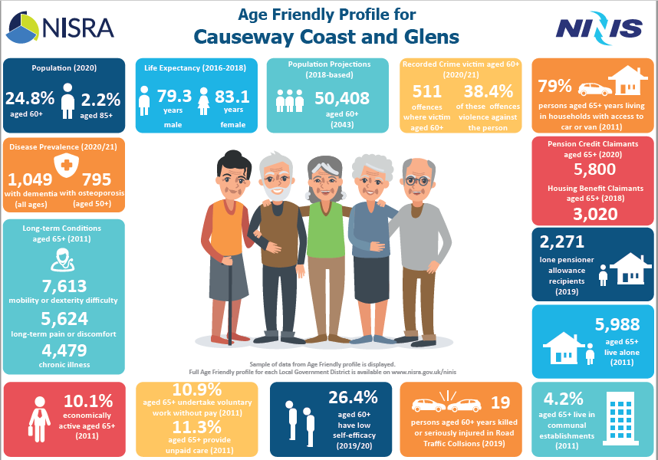

NINIS Age Friendly Infographic Profile for Causeway Coast and Glens Council

## Why Causeway Coast and Glens is a good place to grow older

“There’s a lot goes on here for a small community.”

95 per cent of older people in the Causeway Coast and Glens are satisfied or very satisfied with where they live.[6]

We heard that people love the beauty and greenery of the area, from its glens and forests to its parks and beaches.

People also generally loved their local community, and in many places, there is lots to do, whether its walking groups or lunch clubs, Men’s Sheds or Knit and Natters, church, or University of the Third Age.

People also generally feel safe in their homes and local area, and there are relatively few crimes against older people.[7]

## What matters most as people grow older

### Health

Compared to older people across NI, in the Causeway Coast and Glens older people are more likely to feel that their age and their health prevents them from doing the things they want to do.[8]

Health professionals reported a decline in health, strength, and mental wellbeing in the older population, particularly since the pandemic, and among most older people we spoke, health was the most pressing concern.

We heard frustrations about changes to the health service and that fears that treatment would not be available when needed. And while there is a good menu of support and services to address various health inequalities, they aren’t joined up, people aren’t accessing all the support available, and some are falling through the gaps altogether.

While there is no doubt the health sector is under immense strain, there are underused services and opportunities to work more closely with the voluntary and community sector.

### Transport

42 per cent of older people in the Causeway Coast and Glens area never use public transport compared to 36 per cent of older people across NI.[9]

As a large and largely rural area, most older people in the Causeway Coast and Glens area feel driving is essential. Public transport generally was considered infrequent and inconvenient, particularly in rural areas, and against a backdrop of cuts to community transport and Translink’s 60+ SmartPass, many are fearful of giving up their licences.

Older people are also more likely to live in carless households.[10] Not being able to get to places they need or want to go impacts on other parts of their lives – whether it’s getting to a medical appointment, going to an exercise class, or meeting friends and family. We heard, for example, from older people who got the train just to get out of the house and have somewhere to go.

### Housing

People like where they live, but a lot of houses are old, large and, increasingly, expensive. Opportunities to move or downsize are limited by the holiday home and rental markets, so people are keen to adapt their homes and want support to help maintain and look after them.

### Social care

People also want help to live in their homes, safely and independently, for as long as possible. This includes flexible care packages, and for over 6,700 older people who currently care for a loved one, more respect for the work they do.

In residential care, we heard that older people can feel lonely and that it is difficult to provide them with fun, enriching and social activities.

### Information and inclusion

“We want to be part, not parked”

Again, while there is lots happening, it isn’t joined up, and just over 1 in 10 older people often or sometimes feel like they are missing out.[11] Word of mouth is the most powerful tool for finding out what’s on, but for those who have smaller social circles or don’t use social media, it can be difficult to hear. Local papers tend to carry press releases after events have happened, but this is where many would prefer to get information.

With “powerful wisdom” born of a lifetime’s experience, older people also want to be part of decision making, helping to design services and support that meet their needs, and holding others accountable – including in the delivery of the Causeway Coast and Glens age-friendly action plan.

# Strategic context

Causeway Coast and Glens benefits from regional, cross border, UK-wide, and European connections to support our age-friendly work. Regionally, the NI Age-friendly Network launched in 2019 with the aim of promoting the age-friendly ethos and supporting the eleven local councils to advance age-friendly planning and practices.

The purpose of age-friendly could be understood to be ensuring that the needs and aspirations of older people are a consideration of all strategies and policies and actions. The age-friendly strategy and action plan for Causeway Coast and Glens area connects to, and complements, other strategies and policies which impact on the lives of older people.

Appendix 2 considers several key Northern Ireland and Causeway Coast and Glens strategies and how they relate to an age-friendly community. Of particular importance are the Programme for Government, the Department for Communities’ Active Ageing Strategy 2016–22, *Making Life Better* 2012-2023 the public health strategic framework; and *A Better Future Together*, Causeway Coast and Glens Borough’s Community Plan.

In addition, the ongoing development of the new Integrated Care System (ICS), currently being piloted in the Southern Health and Social Care Trust, signals a new way of planning and managing our health and social care services based on the specific needs of the population.

## Active Ageing Strategy 2016–22

“Our vision is one of Northern Ireland being an age-friendly region in which people, as they grow older, are valued and supported to live actively to their fullest potential; with their rights respected and their dignity protected.”

This strategy aims to increase understanding of the issues affecting older people and promote and emphasise their rights, value and contribution.

The outcomes of the strategy are informed by the five themes of the United Nations Principles for Older Persons:

1. Independence
2. Participation
3. Care
4. Self-fulfilment
5. Dignity

## A Better Future Together (Community Plan for Causeway Coast and Glens)

Community planning is a process led by Causeway Coast and Glens Borough Council in conjunction with partners and communities to develop and implement a shared, long-term vision to improve the social, economic, and environmental wellbeing of the Causeway Coast and Glens area.

The plan has three strategic population outcomes, each of which has a number of intermediate outcomes:

**A Healthy Safe Community**

* All people of the Causeway Coast and Glens benefit from improved physical health and mental wellbeing
* Our children and young people will have the very best start in life
* All people of the Causeway Coast and Glens can live independently as far as possible and access support services when they need it
* The Causeway Coast and Glens area feels safe
* The Causeway Coast and Glens area promotes and supports positive relationships

**A Sustainable Accessible Environment**

* The Causeway Coast and Glens area is widely recognised and celebrated for its unique natural and built landscapes
* The Causeway Coast and Glens area has physical infrastructures and facilities that further growth, access, and connections
* The Causeway Coast and Glens has a sustainably managed natural and built environment

**A Thriving Economy**

* The Causeway Coast and Glens area provides opportunities for all to contribute to, engage in and benefit from a prosperous and inclusive economy
* The Causeway Coast and Glens area attracts and grows more profitable businesses
* The Causeway Coast and Glens area drives entrepreneurship and fosters innovation
* All people of the Causeway Coast and Glens will be knowledgeable and skilled

Development and delivery of an Age-Friendly Strategy is an explicit action under A Healthy Safe Community (action 2) but there are numerous other links between the Community Plan and the age-friendly agenda in Causeway Coast and Glens. Detail is provided in Appendix 2 however some examples include:

* Action 1 Increase opportunities for participation in physical activity and wellbeing initiatives
* Action 3 Development of a loneliness network
* Action 4 Anti-poverty interventions
* Action 7 Promoting and encouraging positive mental health through the Take 5 Steps to Wellbeing initiative
* Action 9 Partnership working between primary care and the CVSE sector
* Action 12 Provision of a borough wide inclusive, participative engagement platform to connect citizens voices to local decision-making bodies
* Action 20 Identify and respond to key local transport concerns around rural connectivity and access needs

## Causeway Coast and Glens Borough Council Corporate Strategy

Vision: We will maximise the benefits of our unique location and landscape by providing accessible, efficient and sustainable services fulfilling local and visitor expectations

The five strategic priority themes of the plan are:

* Cohesive Leadership
* Local Economy
* Improvement and Innovation
* Healthy, Active and Engaged Communities
* Climate Change and Our Environment

Within these priority themes, the outcomes which dovetail with the age-friendly agenda are:

* Citizens and communities are supported to develop improved approaches to health and wellbeing and lifestyle choices as they progress through the Covid 19 recovery journey
* Citizens will have access to a range of leisure, recreational, green and play environments which support better physical and mental health and wellbeing
* Citizens and communities will be centrally involved in Council’s planning and decision-making processes

# The Age-Friendly Strategy for Causeway Coast and Glens

## Our Vision

As we get older, we have access to the information, knowledge and services which will support us to grow old comfortably, securely and confidently.

## Causeway Coast and Glens Age-Friendly Charter (updated)

In 2021, the Council published its Age-Friendly Charter which set out eight visions for an age-friendly Borough which aligned with the eight WHO age-friendly domains. Through the co-design process, these visions (or outcome statements) have been updated to reflect the challenges and opportunities identified through our engagement with older people.

* (Older) people in the Borough feel included in their community
* (Older) people in the Borough have opportunities to improve health and wellbeing and can access appropriate services
* (Older) people in the Borough can access work and volunteering opportunities
* (Older) people in the Borough can access suitable forms of transport
* (Older) people in the Borough are aware of and can access spaces with suitable facilities
* (Older) people in the Borough can access relevant knowledge and information
* (Older) people in the Borough are supported to live independently, safely, and efficiently
* (Older) people in the Borough believe that they make a meaningful contribution to decision making

The strategy is underpinned by the five themes of the United Nations Principles for Older Persons. These principles acknowledge that older people are not a uniform, singular group but that there is tremendous diversity in our older population; and that not only are people living longer, but they are doing so in better health, and they are both willing to, and capable of, participating in their communities.

1. Independence
2. Participation
3. Care
4. Self-fulfilment
5. Dignity

transportation

**United Nations Principles for Older People**

**Independence**

1. Older persons should have access to adequate food, water, shelter, clothing and health care through the provision of income, family and community support and self-help.

2. Older persons should have the opportunity to work or to have access to other income generating opportunities.

3. Older persons should be able to participate in determining when and at what pace withdrawal from the labour force takes place.

4. Older persons should have access to appropriate educational and training programmes.

5. Older persons should be able to live in environments that are safe and adaptable to personal preferences and changing capacities.

6. Older persons should be able to reside at home for as long as possible.

**Participation**

7. Older persons should remain integrated in society, participate actively in the formulation and implementation of policies that directly affect their well-being and share their knowledge and skills with younger generations.

8. Older persons should be able to seek and develop opportunities for service to the community and to serve as volunteers in positions appropriate to their interests and capabilities.

9. Older persons should be able to form movements or associations of older persons.

**Care**

10. Older persons should benefit from family and community care and protection in accordance with each society's system of cultural values.

11. Older persons should have access to health care to help them to maintain or regain the optimum level of physical, mental and emotional well-being and to prevent or delay the onset of illness.

12. Older persons should have access to social and legal services to enhance their autonomy, Protection and care.

13. Older persons should be able to utilize appropriate levels of institutional care providing protection, rehabilitation and social and mental stimulation in a humane and secure environment.

14. Older persons should be able to enjoy human rights and fundamental freedoms when residing in any shelter, care or treatment facility, including full respect for their dignity, beliefs, needs and privacy and for the right to make decisions about their care and the quality of their lives.

**Self-fulfilment**

15. Older persons should be able to pursue opportunities for the full development of their potential.

16. Older persons should have access to the educational, cultural, spiritual and recreational resources of society.

**Dignity**

17. Older persons should be able to live in dignity and security and be free of exploitation and physical or mental abuse.

18. Older persons should be treated fairly regardless of age, gender, racial or ethnic background, disability or other status, and be valued independently of their economic contribution.

## Outcomes

For this initial three-year period, the focus of the plan is on achieving those outcomes that people told us mattered most in their lives, or where they would like to see greatest improvement. It was clear from talking to older people in the area that by focusing in on these key areas, it would lever improvement across more than one age-friendly domain.

|  |  |  |
| --- | --- | --- |
| Outcomes | Link to WHO Age-Friendly Domains | Community Plan Link |
| (Older) people in the Borough have opportunities to improve health and wellbeing and can access appropriate services | Community Support and Health Services | All people of the Causeway Coast and Glens benefit from improved physical health and mental wellbeing |
| Social Participation |
| Outdoor spaces and buildings |
| (Older) people in the Borough can access suitable forms of transport | Transportation | The Causeway Coast and Glens area has physical infrastructures and facilities that further growth, access, and connections |
| Social Participation |
| Community Support and Health Services |
| (Older) people in the Borough are supported to live independently, safely, and efficiently | Housing | All people of the Causeway Coast and Glens can live independently as far as possible and access support services when they need it |
| Communication and Information |
| Community Support and health services |
| (Older) people in the Borough can access relevant knowledge and information | Communication and Information | The Causeway Coast and Glens area promotes and supports positive relationships |
| Social Participation |
| Respect and Social Inclusion |
| Community Support and Health Services |
| Civic Participation and Employment |

The research found that there is a lot of activity and opportunity in Causeway Coast and Glens but that access to transport and information were the two primary barriers to older people’s participation. It was generally acknowledged that if enabled to participate in these activities, or avail of services and supports, that there would be a positive benefit to people’s mental and physical health as well as to their sense of belonging to, and value in, their community.

## How we will work together to deliver the action plan

Design of the strategy and action plan has involved individuals and organisations from across Causeway Coast and Glens and from a range of sectors. This involvement and partnership working continues with the implementation stages of the action plan.

The Age-friendly Alliance will continue to provide strategic direction and leadership in the delivery of the action plan. Linking closely with Community Planning activity, it will be the role of key partners to lead on, and take responsibility for, the delivery of specific allocated actions. They will work together with other Alliance partners to further develop joined-up delivery plans.

Through the co-design process, stakeholders examined the priorities identified through the lens of where a collective effort in Causeway Coast and Glens could yield the most benefit. In doing so, they acknowledged that there are areas of concern which are best addressed at a regional level, and that it should be the role of both the Age-Friendly Coordinator and the local Age Sector Network (COAST) to advocate for Causeway Coast and Glens along with their peers from other Council areas. The Northern Ireland Age-Friendly Network will be an important mechanism in developing this collaborative approach to addressing shared concerns.

Going forward the Age Friendly Alliance and Age-Friendly Forum will merge into a single grouping with membership from across the statutory, community and age-related sectors. This amalgamation will foster a more collaborative approach and will ensure that the wealth of knowledge and experience held in these different groups can be shared.

## How will we know we are making a difference?

An Outcomes Based Accountability (OBA) framework is increasingly being adopted as a method to monitor, evaluate, and review the results of actions and activities facilitated by central and local government.

OBA uses two layers of data to measure progress.

1. Performance measures show the difference a particular project or service is making. They help us know that we are making the difference we intended to make for the people who come in to direct contact with a project or service. These are identified in the action plan as “How we will measure success”.
2. Population indicators show change for whole populations – in this case the people of Causeway Coast and Glens Borough Council. Making life better for large populations can only be done by lots of different actions and organisations working together over time, so population indicators help us know whether life is generally getting better for all people regardless of which project or service (if any) they have come in to contact with. These are identified as “Key statistics” in the action plan.

Our population indicators include statistics from a range of sources including the Northern Ireland Neighbourhood Information Service (NINIS), the 2021 Census, the NI Health Survey 2022 and the Causeway Coast and Glens Borough Council age-friendly quantitative survey, first conducted in 2021 which could be repeated biennially.

Using the key statistics as indicators to measure change, with all actions contributing to improving these figures and provides us with a mechanism to track progress over time. Further performance measures will be developed with delivery partners and some initial measures have been included within the Action plan.

The action plan and anticipated timescales will be reviewed and revised annually, and the strategy will be reviewed and revised after three years. This will consider what has worked well and less well and new challenges and opportunities.

# Appendix 1: Action plans

**Planned actions have been prioritised on the basis of ‘must do’ – a priority for action years in 1-3; ‘should do’ – less pressing priorities but should be explored further; and ‘could do’ – subject to the wider strategic environment and availability of resources.**

## Older people in the Borough have opportunities to improve their health and wellbeing and can access appropriate services.

### Key Statistics[12]

Figure 3: Proportion of people in Causeway Coast and Glens in Good or Very good health by age

Source: Census 2021 Northern Ireland.

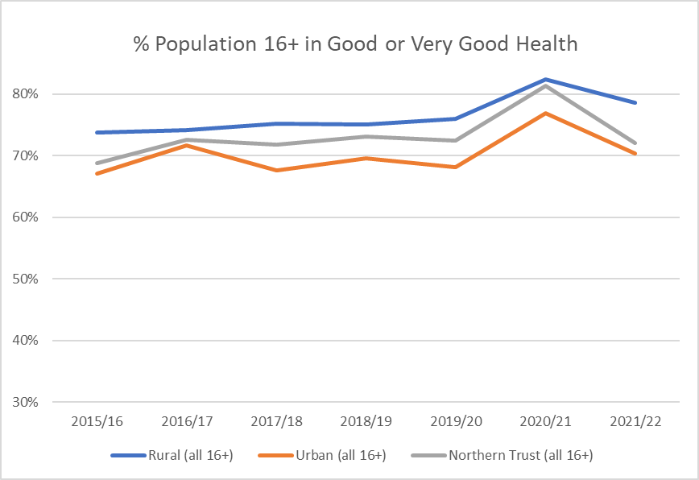

Figure 4: % Population in Good/Very Good Health Figure 5: % NI Population in Good/Very Good Health by age

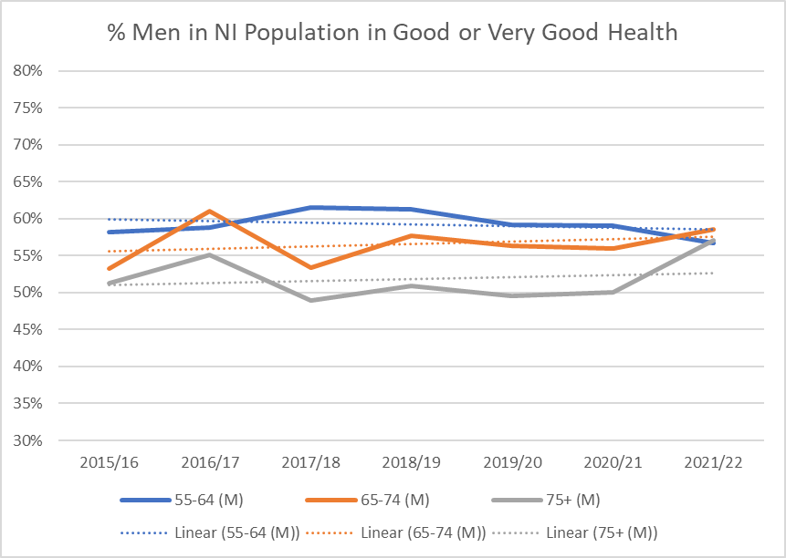 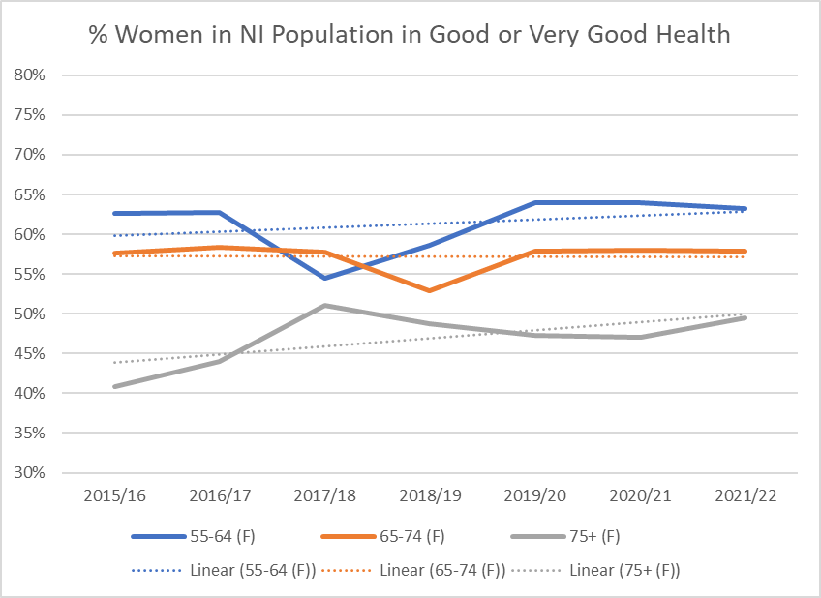

Figure 6: % Men in NI Population in Good/Very Good Health Figure 7: % Women in NI Population in Good/Very Good Health by age

Source: Health Survey Northern Ireland 2022 (NB there are no figures available for men/women in 2020/21 due to smaller sample size – for the purposes of the graph the figure was kept at the same % as the previous year)

77% of people regularly take part in activities but 13% feel isolated and disconnected from their community[13]

More than 1 in 2 people aged 66 and over in the Borough reported a long-term health condition or disability that limited their day-today activity, compared to 1 in four people of all ages[14]

33% agree there is an adequate range of health and community support services oﬀered for promoting, maintaining, and restoring their health[15]

49.4% of older people in Causeway Coast and Glens feel that their health often (15.9%) or sometimes (33.5%) stops them from doing things they want to[16]

48.7% of older people in Causeway Coast and Glens feel that their age often (11.6%) or sometimes (37.1%) prevents them from doing things they would like to do[17]

### What our residents told us…

‘it can be hard to accept help as it’s accepting that you’re getting older’

‘{it can] feel like you’re put on a list and then forgotten about’

Action Plan to address issues raised…

| What we’ll do | | Priority | Who should be in the lead | Who else should be involved | Where we’ll begin | How we will measure success |
| --- | --- | --- | --- | --- | --- | --- |
| 1a | Offer annual health MOTs for older people | Must do | Health and Social Care Trusts, Causeway Coast and Glens | GPs, pharmacies, voluntary and community sector, private sector | Identify options available across the UK, ROI and further afield such as NHS health checks, mobile units, minor services hub, community hubs, community pharmacies, etc. | 1 health MOT programme  Number of participants  Case studies |
| 1b | Join-up and promote wraparound health services (such as occupational health, district nursing, psychological and talking therapies, comfort call service, handyman services, good morning calls, luncheon clubs, benefits checks, social prescribing and so on) | Must do | Health and Social Care Trusts, social work teams in GP surgeries (MDTs), Age-friendly Alliance | Community and voluntary organisations | Networking and scoping event for Trusts and voluntary and community sector | To be agreed |
| 1c | Age-friendly grant scheme supporting health and wellbeing activities for older people | Must do | Causeway Coast and Glens Borough Council | Western Health and Social Care Trust, Northern Health and Social Care Trust voluntary and community groups, Housing Executive | Identify what works well in similar grant schemes | 1 grant scheme  £ invested  Number of grants  Number of older people benefitting |
| 1d | Reduce loneliness among looked-after older people, disabled older people and older people with dementia | Must do | Causeway Coast and Glens Borough Council, Causeway Loneliness Network, Health and Social Care Trusts, Age-friendly Alliance | Causeway Loneliness Network, Care providers, disability groups, Alzheimer’s Society, voluntary and community groups, Linking Generations NI | Identify what initiatives are already available | Number of older people benefitting  Change in feelings of loneliness |
| 1e | Development a CCGBC internal Age Friendly Working Group | Must do | Causeway Coast and Glens Borough Council | Representative from all Causeway Coast and Glens Borough Council departments | Explore the feasibility and development of an CCGBC internal Age Friendly Working Group | Number of internal Age-Friendly meetings  Number of Age-Friendly initiatives developed by Council |
| 1f | Develop and deliver an Intergenerational & older Peoples Programme through PeacePlus Programme | Must do | Causeway Coast and Glens Borough Council | SEUPB, Linking Generations NI, Cause Loneliness Network, Age-Friendly Alliance, community and voluntary sector | Partnership with PeacePlus team in Council to develop proposed project and associated programming | Successful completion of and implementation of €180k Older People’s and Intergenerational Programme |
| 1g | Promote usage of and improve access to outdoor spaces and buildings in Council area | Should do | Causeway Coast and Glens Borough Council | Internal Council departments | Audit of provision of outdoor spaces and buildings for older people in Council area | Accessibility improvements made to outdoor spaces and buildings |
| 1h | Deliver joined-up health campaigns including in memory loss, dementia awareness, self-care, nutrition, falls prevention and so on | Should do | Health and Social Care Trusts, Age-friendly Alliance, Alzheimer’s Scoiety | Community and voluntary sector, older people (as co-designers) | Map and review existing campaigns | Number of campaigns  Case studies |
| 1i | Communicate and promote changes in health services (e.g., GP appointment system, MDTs in GP surgeries, Frailty Direct Assessment Unit in Causeway Hospital) | Should do | Health and Social Care Trusts, Age-friendly Alliance | COAST older people’s champions, GP surgeries, pharmacies | To be agreed | To be agreed |
| 1j | Improve desirability of caring as a career | Could do | Causeway Coast and Glens | Community planning partnership, care providers, | Identify opportunities to promote and support caring careers | To be agreed |
| 1k | Provide leisure centre concessions for older people | Could do | Causeway Coast and Glens Borough Council | Older people (as consultees) | Audit of concessions across NI, ROI, and UK | 1 concessionary scheme  Increase in usage by older people |

## Older people in the Borough have access to suitable forms of transport.

### Key Statistics

Figure 8: How access to a car declines with age in Causeway Coast and Glens

Source: Census 2021 NI

Car ownership was highest amongst older people living in rural areas. (91%, compared to 75% in urban areas) and public transport usage lowest (16% weekly before the pandemic, compared to 29% in urban areas)[18]

42% of older people in the Causeway Coast and Glens area never use public transport compared to 36 per cent of older people across NI.[19]

86% of respondents to the council’s survey have access to their own car, while 31 per cent use public transport.[20]

When asked why they don’t use public transport more often, 13.2% older people cited that there was none available, 18.3% said it doesn’t take them where they want to go; 9.5% said it was infrequent and 29.1% said it wasn’t convenient[21]

### What our residents told us…

‘if you hadn’t a car, you couldn’t live’

‘have to use a car-buses infrequent, especially setting home to the village’

‘At the moment I drive but I am concerned for the future if I can no longer drive’

‘if it wasn’t for rural transport I wouldn’t get out’

‘more access to this service [rural transport] as a lot of older people don't know about it, as some people rely on family to take them to places especially hospital appointments’

‘I used to cycle but feel the roads are too dangerous’

Action Plan to address issues raised…

| What we’ll do | | Priority | Who should be in the lead | Who else should be involved | Where we’ll begin | How we will measure success |
| --- | --- | --- | --- | --- | --- | --- |
| 2a | Advocate for 60+ SmartPass | Must do | Age Friendly Network NI | Age-friendly Officer, COAST older people’s champions, Age-friendly Alliance | Depending on the outcome of the public consultation | |
| 2b | Review and promote transport advice and information services | Must do | Causeway Coast and Glens Borough Council | Translink, North Coast Community Transport, older people (as consultees) | Seek representation from Translink on Age-friendly Alliance | Depending on outcome of review |
| 2c | Advocate for improved rural transport | Must do | Age Friendly Network NI | Age-friendly Alliance, Translink | Consultation with older people in rural areas | Satisfaction with rural transport among older people |
| 2d | Advocate for increased investment in community transport | Must do | Age Friendly Network NI | Age-friendly Alliance, North Coast Community Transport, COAST older people’s champions | Gather lived experience case studies and present to Department for Infrastructure and relevant MLAs | £ invested in community transport |
| 2e | Review transport links to hospitals including car parking and transport across Trust lines | Must do | Causeway Coast and Glens Borough Council, Health and Social Care Trusts, Translink, North Coast Community Transport | Older people (as consultees) | Meeting to agree scope and next steps | 1 review  Action to join up transport links |
| 2f | Review council car parking with a focus on costs for blue badge holders and accessible parking bays | Should do | Causeway Coast and Glens Borough Council | Older people (as consultees) | To be agreed | 1 review  Resulting actions |

## Older people in the Borough are supported to live independently, safely, and efficiently.

### Key Statistics

86% of older residents agree that their home is safe and adequate[22]

59% of older residents have improved the energy efficiency in their homes.[23]

On Census Day 2021 1 in 10 people aged 55 and over were living alone

On Census Day 2021, there were 31 care homes or establishments in the area with 951 residents

### What our residents told us…

‘Challenge of maintaining it [home] – it lifts my mind to have things look well’

‘why can't … produce a list of workmen who are trustworthy to do home repairs/garden etc’

‘[I need] help finding plumbers, electricians etc to do small jobs’

‘support families more so I can stay with my daughter - she can't manage on her own’

‘It’s very difficult to know where to find such people [trades] especially for women on their own’

‘[I wish I had done] all the jobs that needed doing round the house and garden while I had the strength to do them’

Action Plan to address issues raised…

| What we’ll do | | Priority | Who should be in the lead | Who else should be involved | Where we’ll begin | How we will measure success |
| --- | --- | --- | --- | --- | --- | --- |
| 3a | Provide cost-of-living support for older people | Must do | Causeway Coast and Glens Borough Council | Central government, energy suppliers, private sector | Scope support that is already available | Number of older people benefitting |
| 3b | Provide telecare services, occupational therapy and other aids and modifications to support independent living | Must do | Health and Social Care Trusts, MDTs, Causeway Coast and Glens Borough Council, Age NI | Voluntary and community | Scope support that is already available | Number of older people benefitting |
| 3c | Provide a range of “compassionate” support services for independent living such as housework, home maintenance, shopping, good morning calls and befriending | Must do | COAST | Voluntary and community sector | Scope support that is already available | Number of interventions  Number of older people benefitting |
| 3d | Develop a directory of trusted tradespeople | Should do | COAST | Causeway Coast and Glens Borough Council | Audit similar directories available across NI, ROI, and UK | 1 directory  Use of directory |
| 3e | Develop a repair café(s) organised by older people for older people | Should do | Causeway Coast and Glens Borough Council | COAST, U3A, Men’s Sheds, Repair Café NI, voluntary and community sector | Explore Repair Café model | Number of repair cafes  Number of older volunteers  Number of older people benefitting |
| 3f | Provide administrative services to help older people fill in forms to apply for passported benefits, such as blue badges, including support for online form filling | Should do | COAST | Voluntary and community sector, statutory sector | Map breadth and complexity of forms | 1 service  Number of applications completed  Number of older people benefitting |
| 3g | Lobby for the development of age-friendly housing such as retirement villages, bungalows, and affordable homes | Could do | Age-friendly Alliance | Housing Executive, housing associations, Causeway Coast and Glens planning service, COAST older people’s champions | Meeting to gauge feasibility | Change in planning priorities |

## Older people in the Borough can access relevant knowledge and information

### Key Statistics

Just over 1 in 10 older people often or sometimes feel like they are missing out.[24]

21% older residents agree that older people are consulted by public, voluntary and private organisations on ways to serve them better[25]

25% older residents are connected to a local forum or age sector network to voice my views and local decisions[26]

21% older residents agree that there is an eﬀective communication system that reaches community residents[27]

### What our residents told us…

‘sometimes I only hear through word of mouth’

‘The problem is not knowing that things exist’

‘we need info in plenty of time’

‘open up an office that offers all kinds of services for our older people’

Action plan to address issues raised…

| What we will do | | Priority | Who should be in the lead | Who else should be involved | Where we’ll begin | How we will measure success |
| --- | --- | --- | --- | --- | --- | --- |
| 4a | Improve information sharing between statutory organisations and between statutory and community organisations | Must do | Causeway Coast and Glens Borough Council, Health and Social Care Trusts | Other statutory agencies, Age-friendly Alliance, voluntary and community organisations | Statutory sector networking event  Statutory and community sector networking event | Number of events  Number of participants |
| 4b | Age-friendly Alliance to act as a consultation hub, ensuring older people have a voice | Must do | Age-friendly Alliance | COAST older people’s champions, network of older influencers (see below), other statutory organisations (that are running public consultations) | Promote Age-friendly Alliance as a key consultee, ensuring that it is notified of relevant consultations | Number of consultations responded to  Number of consultations promoted through network |
| 4c | Develop a joined-up, targeted communications plan considering a range of tactics (such as, information packs, monthly campaigns, print and other media advertisement, event listings and so on) and harder-to-reach audiences (such as the LGBTQ+ community, BAME residents and older men) | Must do | Age-friendly Alliance | Age-friendly Alliance, voluntary and community groups | Review of current services and promotion | 1 communications plan  Associated actions |
| 4d | Promote one point of contact for all services | Must do | Causeway Coast and Glens Borough Council | Health and Social Care Trusts (Connect North), community and voluntary groups | Promote Connect North | 1 campaign  Usage of Connect North |
| 4e | Maximise the accessibility and inclusivity of age-friendly events, publications, websites, and listings including, for example, including translation | Must do | Causeway Coast and Glens Borough Council | Age-friendly Alliance, disability groups, voluntary and community groups, older people (as consultees) | Develop an Age-friendly event checklist | 1 checklist |
| 4f | Develop programme to support older people to increase their digital skills and confidence | Must do | Causeway Coast and Glens Borough Council, Libraries NI | Age-Friendly Alliance | Review of current provision in Causeway Coast and Glens area and benchmark against provision in other Council areas | Increase in digital skills of older people in Council area.  Reduction in digital exclusion |
| 4g | Work with partner organisations to support Age-Friendly employment and volunteering | Must do | Causeway Coast and Glens Borough Council | Business in the Community, Age NI, Centre for Ageing Better, Labour Market Partnership Programme, Causeway Volunteer Centre | Age-Friendly Coordinator to join Business in the Community – Age Advisory working group | Increase in businesses in Causeway Coast and Glens undertaking programmes through Age NI and Business in the Community.  Increase in older volunteers in Causeway Coast and Glens area |
| 4h | Develop libraries as age-friendly hubs | Should do | Libraries NI | Age-friendly Alliance | Pilot the concept in a selected library | Number of age-friendly hubs |
| 4i | Develop a network of older people as “influencers” | Should do | COAST older people’s champions | Age-friendly Alliance, voluntary and community groups | Review comparable initiatives (e.g., community blogging, journalism, etc.) across UK and ROI | 1 network  Number of participants  Associated actions |
| 4j | Build relationships between residential and day care and the third sector | Should do | Health and Social Care Trust | Private care providers, Volunteer Now | Information event to gage interest | 1 event  Number of connections made |
| 4k | A to Z for carers | Should do | Causeway Coast and Glens, Northern Health and Social Care Trust (Carers Hub) | Carers NI | Set up a steering group | 1 directory |

# Appendix 2: Summary of relevant strategies and policies

## NI Programme for Government (draft)

### Relevant age-friendly priorities

#### We have an equal and inclusive society where everyone is valued and treated with respect

Key priority areas include:

* Inclusion and tackling disadvantage – tackling the issues that lead to inequality and disadvantage in terms of welfare and poverty and providing support where it is needed in both urban and rural communities
* Rights and equality – promoting and protecting the rights of individuals to ensure we are recognising and respecting diversity, ensuring everyone feels included

#### We all enjoy long, healthy, active lives

Key priority areas include:

* Access to health – tackling health and social care reform to ensure we can deliver safe, high-quality care services to meet the challenges of the future and provide the right services where they are needed.
* Mental health and wellbeing – promoting positive attitudes towards mental health and wellbeing and ensuring access to comprehensive early intervention and healthcare services to address mental health issues
* Older people – considering the health and social care needs of an ageing population, promoting positive attitudes to older people and tailoring support to enable them to enjoy better health and active lifestyles
* Physical health and wellbeing – promoting positive public health measures, increasing awareness, and supporting safe, active, and healthy lives

#### Everyone can reach their potential

Key priority areas include:

* Capability and resilience – supporting personal development opportunities for everyone and building confidence and capability

#### Everyone feels safe – we all respect the law and each other

Key priority areas include:

* Address harm and vulnerability – supporting and putting protection in place for those who are vulnerable, including the complex needs of children, and meeting the needs of those who have experienced serious crime, including delivering for victims and survivors

#### We have a caring society that supports people throughout their lives

Key priority areas include:

* Disability – improving the quality of life for those of us with disabilities, empowering people to have more influence over their own lives and providing opportunities for people to participate in decisions that affect them
* Housing – tackling homelessness, facilitating and supporting housing associations, providing and maintaining appropriate social housing and investing in new social and affordable homes
* Inclusion and tackling disadvantage – supporting people to build a route out of poverty, administering an effective social security system to those who need it and tackling the issues that lead to inequality.
* Mental health and wellbeing – promoting positive mental health and wellbeing, addressing social issues, risk factors and environmental impacts such as isolation and loneliness and providing access to supportive services and promoting early intervention
* Older people – considering the health and social care needs of an ageing population, promoting positive attitudes to older people and tailoring support to enable them to participate fully in society

### Why does this matter for an age-friendly Causeway Coast and Glens Borough?

It is important that local plans demonstrate alignment with the outcomes of the Programme for Government. The people living in the Causeway Coast and Glens area identified many of the same priorities as those included in the Programme for Government. This strategic link can focus attention to their needs and aspirations and potentially attract resources.

## Active Ageing Strategy 2016–22

“Our vision is one of Northern Ireland being an age-friendly region in which people, as they grow older, are valued and supported to live actively to their fullest potential; with their rights respected and their dignity protected.”

The Department for Communities’ regional Active Ageing Strategy aims to increase understanding of the issues affecting older people and promote and emphasise their rights, value, and contribution.

The outcomes of the strategy are informed by the five themes of the United Nations Principles for Older Persons. The themes are:

* Independence
* Participation
* Care
* Self-fulfilment
* Dignity

### Outcomes

1. Older people live independently for as long as they can, free from poverty and in suitable, safe homes.
2. Older people are involved in their family and community and in civic life.
3. Older people are healthier for longer.
4. Older workers remain in employment for as long as they wish or need to.
5. Older people participate in cultural, education and physical activity.
6. Older people’s dignity and human rights are effectively safeguarded.

### Why does this matter for an age-friendly Causeway Coast and Glens Borough?

The current Active Ageing Strategy was extended by 12 months to May 2022 due to Covid. It is a reasonable assumption that a further strategy will continue to be aligned with the UN Principles for Older Persons. People living in Causeway Coast and Glens told us how they valued their independence and their involvement in community and civic life. They also told us about how important participation in a variety of activities is to both their mental and physical health. The policy framework provided by the Active Ageing Strategy, and the impetus it puts on central government departments and related bodies, aligns with the needs and aspirations of the people of Causeway Coast and Glens.

## Making Life Better 2013–2023

Making Life Better’s vision is:

“All people are enabled and supported in achieving their full health and wellbeing potential.”

Its aims are to achieve better health and wellbeing for everyone and reduce inequalities in health.

### Relevant age-friendly priorities

Making Life Better is structured around six themes:

1. Giving every child the best start
2. Equipped throughout life (takes account of particular needs at different stages of life)
3. Empowering healthy living (addresses support for individual behaviours and choices and embeds prevention in health and social care)
4. Creating the conditions (acknowledges that there are many factors which contribute to poor and good health – the social determinants of health)
5. Empowering communities
6. Developing collaboration

Outcomes which are relevant to age-friendly and older people include:

* Outcome 6: Active, healthy ageing
* Outcome 12: Making the most of our physical environment
* Outcome 13: Safe and healthy homes
* Outcome 16: Safe and healthy workplaces
* Outcome 18: Strengthened collaboration for health and wellbeing

### Why does this matter for an age-friendly Causeway Coast and Glens Borough?

Many of the people who informed this plan referred to their health and wellbeing and their desire to retain a full and active life as far as is possible.

## Mental Health Strategy 2021–31

“Our vision for Northern Ireland is a society which promotes emotional wellbeing and positive mental health for everyone with a lifespan approach, which supports recovery, and seeks to reduce stigma and mental health inequalities.”

### Relevant age-friendly priorities

Theme 2, “Providing the right support at the right time” includes a particular focus on mental health and older adults:

* All older adults who need mental health services will receive the care and treatment they need
* Old age psychiatry services are no longer based on an age threshold but on the needs of the person

### Why does this matter for an age-friendly Causeway Coast and Glens Borough?

A lifespan and person-centred approach acknowledges that there is no universal template for growing older, meaning services can be more responsive to needs throughout the ageing process. Mental health is identified as just as important as physical health as we grow older, and isolation and loneliness have the potential to have a negative impact on mental health, potentially increasing the need for services.

## Transforming your Care, A Review of Health and Social Care, 2011

### Relevant age-friendly priorities

Transforming your Care made 99 proposals for change across the range of health and social care services. It also identified 12 major principles for change which would underpin the future model of health and social care in Northern Ireland. Of particular relevance to an age-friendly strategy are:

* Placing the individual at the centre of the model by promoting a better outcome for the service user, carer, and their family
* Providing the right care in the right place at the right time
* A focus on prevention and tackling inequalities
* Integrated care – working together
* Promoting independence and personalisation of care
* Safeguarding the most vulnerable

Key outcomes for Transforming your Care include:

* more services will be provided locally with opportunities to access specialist hospitals where needed
* more people will be cared for at home where it’s safe and appropriate to do so
* doctors, nurses, social workers, and everyone providing care will work together in partnership to help keep people healthy
* people will get support to stay healthy, make good health decisions or manage their own conditions
* investment in new technology will help people stay at home or receive care locally rather than in hospitals

### Why does this matter for an age-friendly Causeway Coast and Glens Borough?

People told us how important it was to them to be able to access health services locally and how much they valued being able to remain in their own homes and part of their own communities. They also told us of the need for more easily understood and readily accessible information about healthcare support but also expressed a preference for that support to be available in their own community.

In addition, the ongoing development of the new Integrated Care System (ICS), currently being piloted in the Southern Health and Social Care Trust, signals a new way of planning and managing our health and social care services based on the specific needs of the population.

## Active Living More People, More Active, More of the Time, The Sport and Physical Activity Strategy for Northern Ireland

The vision is:

“Lifelong involvement in sport and physical activity will deliver an active, healthy, resilient and inclusive society which recognises and values both participation and excellence.”

### Relevant age-friendly priorities

* Recovery from the impact of the pandemic
* Promoting participation, inclusion and community engagement
* Addressing barriers to participation in sport and physical activity through co designing programmes and initiatives in partnership with key stakeholders
* Improving the physical and mental health and wellbeing of those who participate in sport and physical activity
* Ensuring that sport and physical activity is inclusive, safe, diverse, shared, fun and offers equality of opportunity to participate for all
* Improving physical literacy and increasing lifelong participation in sport and physical activity for all
* Increased awareness of the benefits of participation in sport and physical activity
* Everyone has access to inclusive, shared, safe, welcoming, and high quality indoor and outdoor sport and physical activity infrastructure

The strategy acknowledges that older women and men (and other underrepresented groups) are prevented from participation in sport and physical activity for a number of reasons, not just physical ability, and commits to a co-design approach to reducing these barriers.

### Why does this matter for an age-friendly Causeway Coast and Glens Borough?

The benefits of physical activity are widely acknowledged. 77 per cent of respondents to the 2021 survey said that they regularly walk or take part in activities, and there are many fit and active people over 50 who appreciate the opportunity to participate in a range of physical activity. Barriers to remaining active include the availability and awareness of appropriate activities. Feedback indicates that there is a need for low(er) impact exercise opportunities to meet the needs of older people in addition to the existing variety of higher impact classes and activities.

## NI Housing Executive Older Peoples Housing Strategy 2021/22 to 2026/27

“Our vision is to enable older people to live as independently as possible with dignity; with opportunities and options to meet their housing needs; and to be supported to engage and participate in community life to create vibrant sustainable communities”

The themes of the strategy are:

* Planning for the future – looking at different housing options and housing models for older people and supporting independent living
* Promoting and maintaining dignity – looking at ways to develop new and existing services to promote and maintain the dignity of tenants and customers
* Providing housing advice for older people
* Promoting participation – recognising how engaging, enabling, and empowering older people to participate actively in community life can have positive impacts on their health, wellbeing, and happiness. Working in partnership with others to support opportunities for older people to become involved in shaping, informing, and enjoying services delivered on their behalf.

### Why does this matter for an age-friendly Causeway Coast and Glens Borough?

The Social rented sector share of the housing market in the Causeway Coast and Glens Borough Council area was at 11% in 2016,[28] and older people made up approximately 17 per cent of waiting list applicants in March 2022.[29] The availability of affordable, appropriate housing was identified as an issue for many people as they grow older. People identified the need to think about new and different housing models which can enable people to remain in their own home or community for as long as possible.

## Public Realm/Environmental Improvement (Department for Communities)

The Department for Communities plays an important role in investing in the improvement and appearance of neighbourhoods, towns, and city centres. Improving the appearance of an area is not just to make people feel good when they visit, shop, work or live there, although that is very important. If an area has been upgraded and is attractive it will be healthier, safer, and cleaner and more people will want to go there.

The aim is to create high quality public spaces and footpaths to encourage better access for all people including those with mobility or sensory issues. This will create spaces where people from all communities can meet, relax, and enjoy the surroundings.

The type of work undertaken includes:

* improving street lighting
* widening footpaths for pedestrians
* adding street furniture such as seating, bins and hanging basket stands
* replacing paved walkways with new long-lasting surfaces
* improving how the traffic flows
* providing public art which reflects the history and personality of the area
* planting trees, shrubs, and flowers
* creating or improving facilities such as multi-use games areas or play parks

### Why does this matter for an age-friendly Causeway Coast and Glens Borough?

People told us about the importance of feeling that spaces such as town centres and parks were “for them”. This includes taking mobility, lighting and access to seating and toilets into account in the design of public realm.

## Causeway Coast and Glens Borough Council Strategies and Policies

The following strategies and policies within Causeway Coast and Glens Borough Council provide direction for an age-friendly community locally.

## A Better Future Together Community Plan for Causeway Coast and Glens

Community planning is a process led by Causeway Coast and Glens Borough Council in conjunction with partners and communities to develop and implement a shared, long-term vision to improve the social, economic, and environmental wellbeing of the Causeway Coast and Glens area. It will also guide how public services will work together locally to plan and deliver better services.

The plan has three strategic population outcomes, each of which has a number of intermediate outcomes:

### A Healthy Safe Community

* All people of the Causeway Coast and Glens benefit from improved physical health and mental wellbeing
* Our children and young people will have the very best start in life
* All people of the Causeway Coast and Glens can live independently as far as possible and access support services when they need it
* The Causeway Coast and Glens area feels safe
* The Causeway Coast and Glens area promotes and supports positive relationships

### A Sustainable Accessible Environment

* The Causeway Coast and Glens area is widely recognised and celebrated for its unique natural built landscapes
* The Causeway Coast and Glens area has physical structures and facilities that further growth, access, and connections
* The Causeway Coast and Glens has a sustainably managed natural and built environment

### A Thriving Economy

* The Causeway Coast and Glens area provides opportunities for all to contribute to, engage in and benefit from a prosperous and inclusive economy
* The Causeway Coast and Glens area attracts and grows more profitable businesses
* The Causeway Coast and Glens area drives entrepreneurship and fosters innovation
* All people of the Causeway Coast and Glens will be knowledgeable and skilled

Development and delivery of an Age-Friendly Strategy is an explicit action under health and wellbeing (action 2) but there are numerous other links between the Community Plan and the age-friendly agenda in Causeway Coast and Glens.

**Health and wellbeing actions**

Action 1 Increase opportunities for participation in physical activity and wellbeing initiatives

Action 3 Development of a loneliness network

Action 4 Anti-poverty interventions

Action 7 Promoting and encouraging positive mental health through the Take 5 Steps to Wellbeing initiative

Action 8 Enhancing interagency co-operation to address homelessness

Action 9 Partnership working between primary care and the CVSE sector

**Community / community safety actions**

Action 12 Provision of a Borough wide inclusive, participative engagement platform to connect citizens voices to local decision-making bodies

Action 14 Support for the community and voluntary sector

Action 16 Accidental fire prevention

**Infrastructure / environment Actions**

Action 17 Create opportunities to explore develop and maintain public spaces

Action 20 Identify and respond to key local transport concerns around rural connectivity and access needs

**Economic / Education / Tourism Actions**

Action 27 Support the development of the labour market partnership – supporting education and skills initiatives

Action 29 Developing and delivering collaborative town centre management projects

### Why does this matter for an age-friendly Causeway Coast and Glens Borough?

The purpose of community planning is to develop a long-term vision and plan for the Causeway Coast and Glens area and all its s citizens based on needs, priorities, opportunities, and collaboration. The purpose of the Age-Friendly strategy is the same only with a focus on older people.

## Causeway Coast and Glens Borough Council Corporate Strategy

Vision: We will maximise the benefits of our unique location and landscape by providing accessible, efficient and sustainable services fulfilling local and visitor expectations

The Council’s Mission Statement is to improve the quality of life for our citizens and visitors by:

* Providing effective, accessible and sustainable local public services
* Improving economic prosperity
* Ensuring local communities are at the heart of decision making
* Protecting, promoting and enhancing our unique natural environment and assets
* Advocating for the area and our citizens in local and international arenas

The five strategic priority themes of the plan are:

* Cohesive Leadership
* Local Economy
* Improvement and Innovation
* Healthy, Active and Engaged Communities
* Climate Change and Our Environment

Within these priority themes, there are several outcomes which dovetail with the age-friendly agenda:

* Citizens and communities are supported to develop improved approaches to health and wellbeing and lifestyle choices as they progress through the Covid 19 recovery journey
* Citizens will have access to a range of leisure, recreational, green and play environments which support better physical and mental health and wellbeing
* Citizens and communities will be centrally involved in Council’s planning and decision-making processes

### Why does this matter for an age-friendly Causeway Coast and Glens Borough?

With the Council, departmental strategies and business plans contribute to this overarching plan. Embedding consideration of older people and the age-friendly agenda in the development and implementation of these plans not only furthers the Council’s corporate objectives but also contributes to the outcomes of the Age-Friendly Strategy.

### Notes

1. World Health Organisation
2. National Programme for age-friendly cities and communities. A Guide. World Health Organisation
3. Creating age-friendly environments in Europe, a tool for local policy makers and planners, WHO Europe 2016
4. 2021 Census
5. NI Statistics and Research Agency
6. Queen’s University Belfast’s Northern Ireland Cohort for the Longitudinal Study of Ageing (NICOLA). Run by Queen’s Centre for Public Health since 2014, NICOLA aims to understand what it is like to grow older in NI by gathering data from a representative sample of people aged 50 and over.
7. According to PSNI statistics for 2021/22, the recorded crime rate against people aged 55 and over in Causeway Coast and Glens Borough Council was 19 people in every 1,000 compared to 59 per 1,000 for the entire NI population.
8. According to NICOLA, 32.0 per cent of older people in the Causeway Coast and Glens reported that their age prevents them from doing the things they want to do “often” or “sometimes” compared to 27.6 per cent of older people across NI. 32.4 per cent also reported that their health prevents them often or sometimes compared to 30.6 per cent across NI.
9. NICOLA
10. According to the 2021 Census, 42 per cent of carless households include a person or people aged 55 and over.
11. NICOLA
12. Health Survey Northern Ireland Results are due for publication 19 November 2023
13. Causeway Coast and Glens Age-Friendly Survey 2021
14. Census 2021 Northern Ireland
15. Causeway Coast and Glens Age-Friendly Survey 2021
16. NICOLA
17. NICOLA
18. Older Persons Transport and Covid 19 Research Summary Report, NI Consumer Council 2021
19. NICOLA
20. Causeway Coast and Glens Age-Friendly Survey 2021
21. NICOLA
22. Causeway Coast and Glens Age-Friendly Survey 2021
23. Causeway Coast and Glens Age-Friendly Survey 2021
24. NICOLA
25. Causeway Coast and Glens Age-Friendly Survey 2021
26. Causeway Coast and Glens Age-Friendly Survey 2021
27. Causeway Coast and Glens Age-Friendly Survey 2021
28. NI Housing Conditions survey 2016
29. NI Housing Executive Housing Investment Plan Annual Update 2022