Process for issue of Temporary Pavement Cafés Licences during
Covid-19 pandemic

From 3rd July 2020 Causeway Coast and Glens will be ensuring compliance with the Licensing requirements of the Pavement Cafés Act (Northern Ireland) 2014 as part of the economic revitalisation of the hospitality sector.

In this regard a streamlined process and the issue of a conditional temporary licence from the date of application to 31st December 2020 will be afforded to those premises that make an application to place tables and chairs in an outside space adjacent to their fixed premises and can comply with the necessary conditions to safeguard pedestrians and other road users.

In order to obtain a licence the following is required:

- Licence Fee–No fee (to be reviewed by 31st December 2020).

- Location plan – to a scale of 1:1250 showing sufficient area around the proposed pavement café to enable consideration of all related issues.

- Site plan – to a scale of not less than 1:100 showing access points, building lines, boundaries, kerbs, table and chair arrangement, bins, lighting, trees, other items.

- Details of the furniture – including photographs/manufacturers details.

- Risk Assessment - to include Covid 19 measures.

- Public Liability Insurance – cover with minimum indemnity of £5 million. A copy of the certificate must be included.

- Planning Permission – Will not be required for temporary applications. The grant of a temporary licence should not infer that a permanent licence will be issued.

- Notice of Application Fixed to Premises - for 28 days for public to view and representations to be made.
- Council will conduct a 28 day consultation with the Department for Infrastructure and if a licensed premises with the PSNI before a decision is made.
- Council aims to make a determination within 8 weeks from the receipt of a completed application.
- If an application for a temporary licence is refused the applicant will be informed.
- An applicant can appeal to the Magistrate’s Court within 21 days of Council’s notification of refusal.
- If a business operator fails to submit an application for a temporary pavement café licence and operates an unlicensed pavement café this will be deemed to be an offence and subject to Councils current Enforcement policy Operators may be liable to a fine of up to £1,000 on summary conviction.

For any further information please contact our Licensing Section Tel: 028 2766 0233
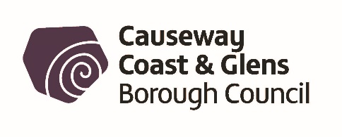

FLOWCHART

Pavement Cafés –Temporary Licence Application Process

Apply for Pavement Café to Council

Fix Public Notice at Premises
Premises can open during consultation period

Council consult with *DFI and **PSNI
Premises can open during consultation period

Fix Public Notice at Premises

DFI/PSNI consent not given
DFI/PSNI consent given

Temporary Pavement Café Licence Issued

Pavement Café Licence
not issued

*Department for Infrastructure
APPEAL to Magistrates Court within 21 days of notification of decision

**PSNI to be consulted where the premises
is licensed to sell alcohol

APPEAL SUCCESSFUL
APPEAL UNSUCCESSFUL

