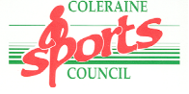

Causeway Coast & Glens Sports Awards
2016

Sports Personality Awards

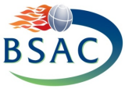
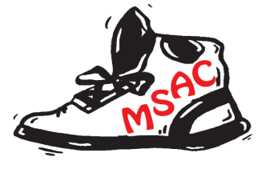
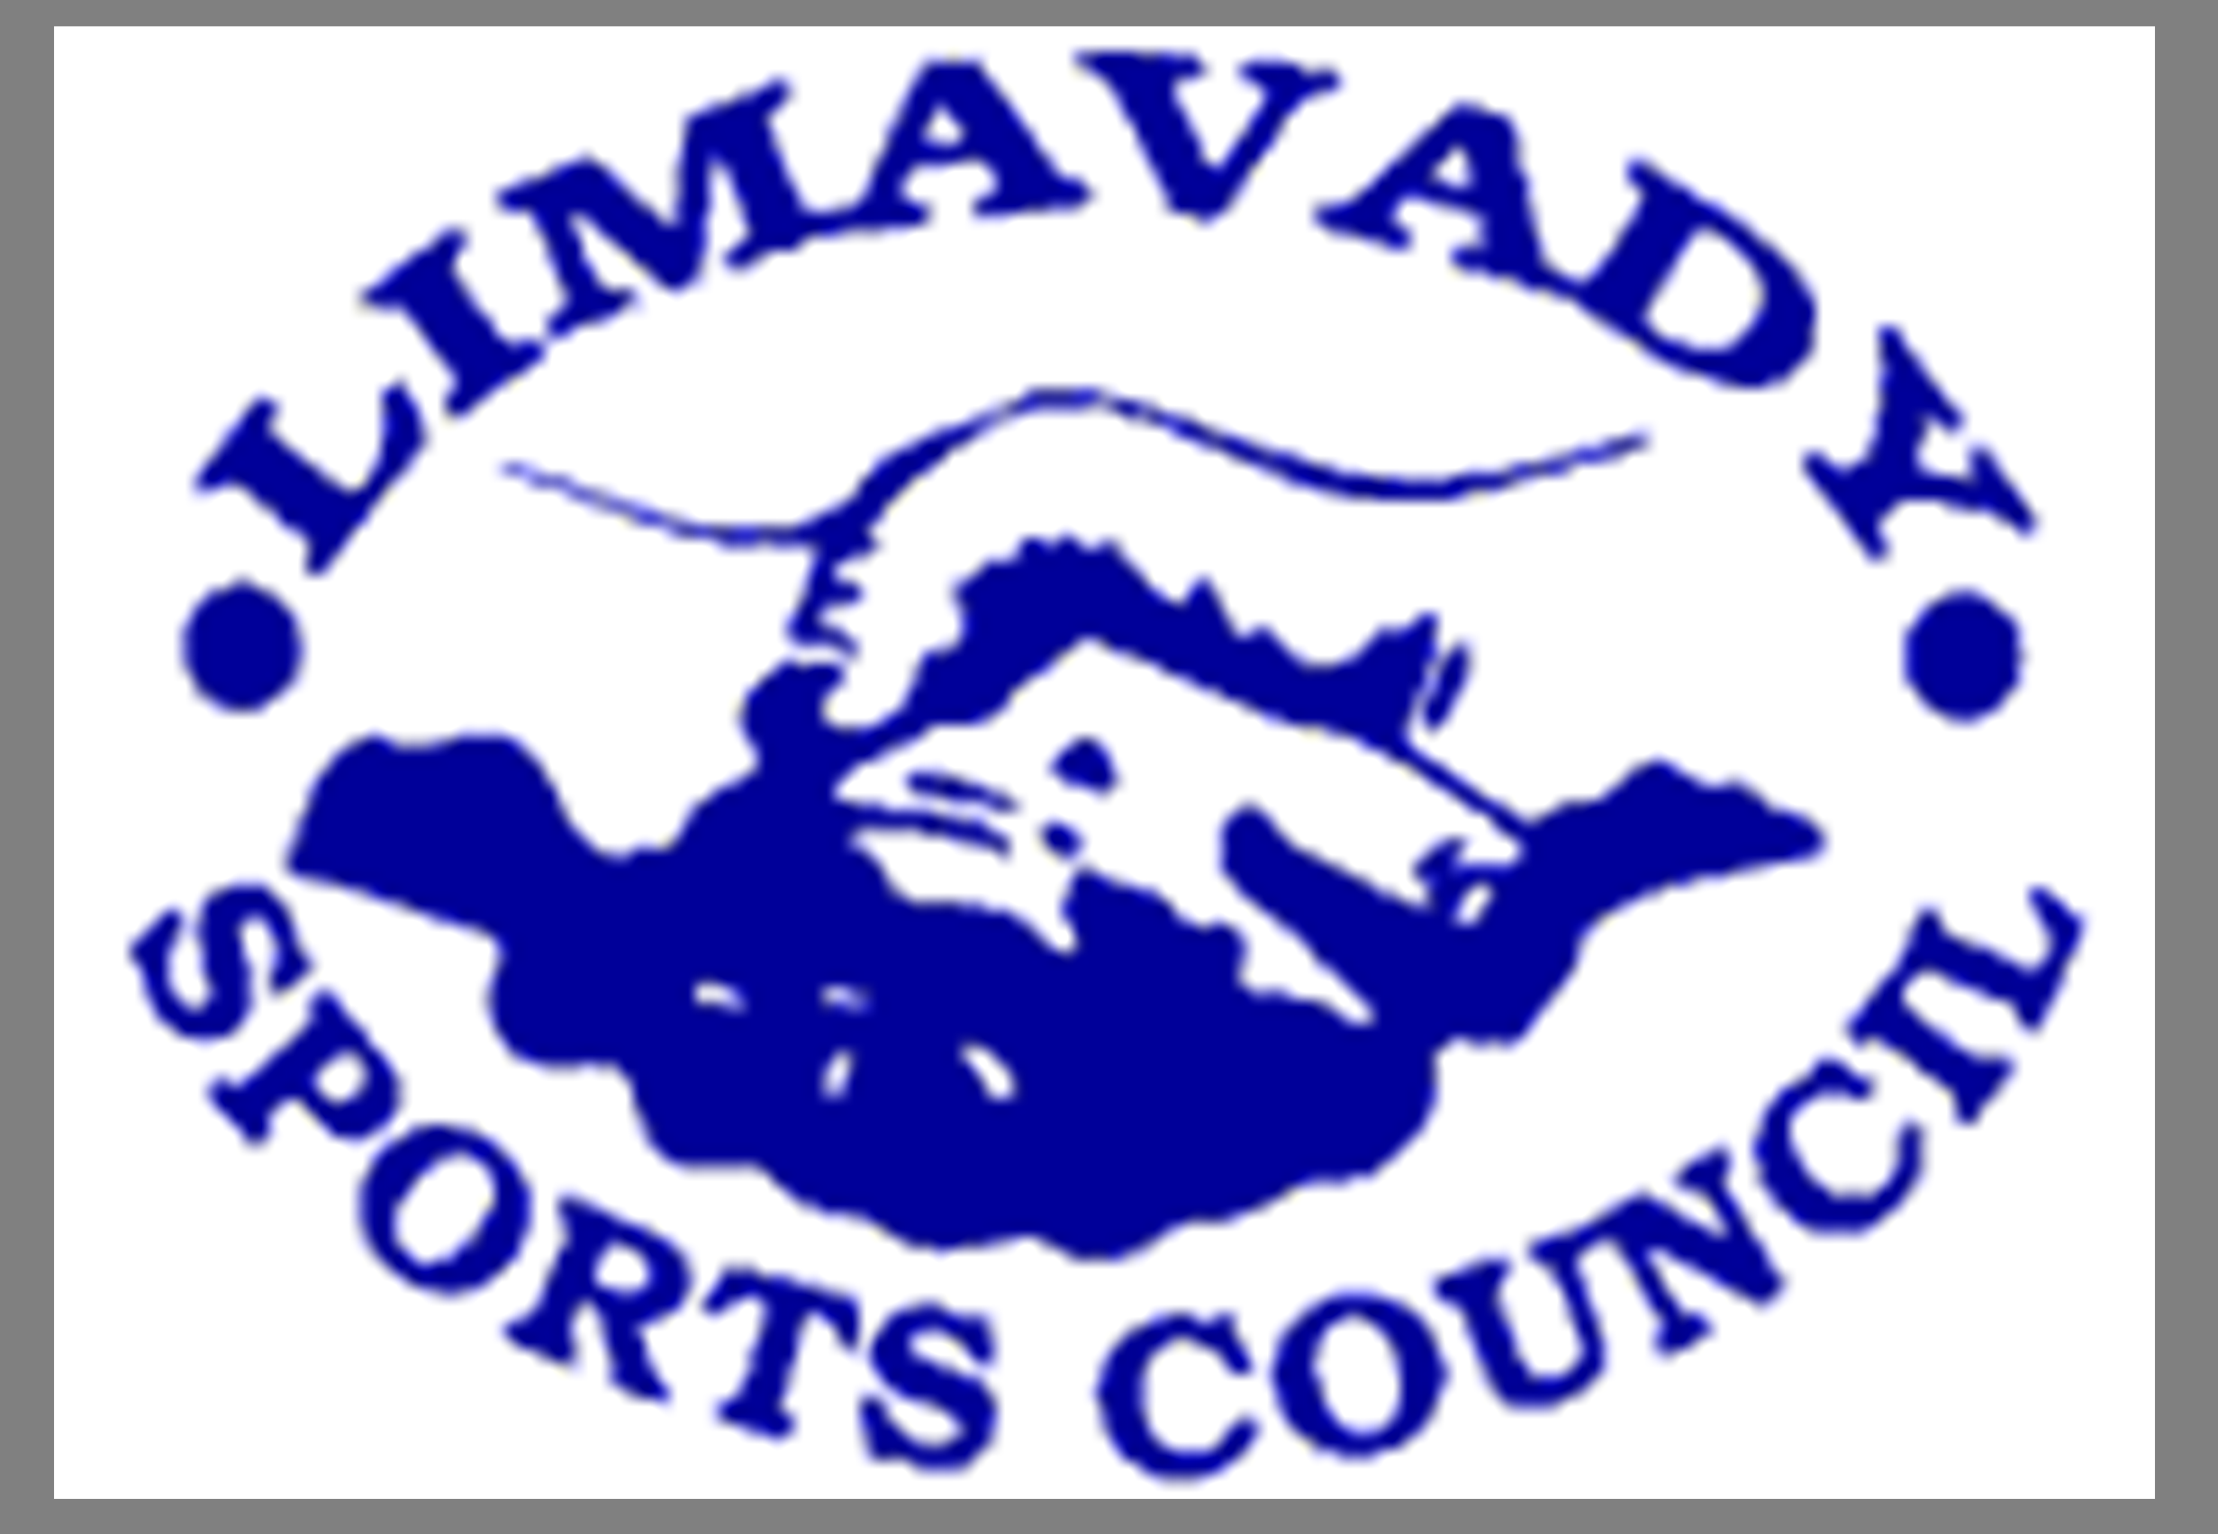

NOMINEE’S NAME: …………………………………….. ….. DATE OF BIRTH: ………………………………..

NOMINEE’S ADDRESS: ………………………………………………………………………………………………………

AWARDS CATEGORY: (PLEASE TICK)

SPORTSMAN |  | SPORTSWOMAN
SPORTS ADMINISTRATOR |  | SPORTS PERSON WITH A DISABILITY
SENIOR TEAM (OVER 19) |  | JUNIOR TEAM (UNDER 19)
JUNIOR SPORTSMAN (UNDER 19) |  | JUNIOR SPORTSWOMAN (UNDER 19)
SERVICES TO SPORT |  | COACH OF THE YEAR
INTERNATIONAL SPORTS PERSON OF THE YEAR |  | MERIT AWARD
(SEE NOTES ON BACK OF FORM FOR AWARD CRITERIA)

AREA: (PLEASE TICK) COLERAINE BALLYMONEY LIMAVADY MOYLE

SPORT: ………………………………………………………..

ACHIEVEMENTS/QUALITIES/ PARTICULAR CONTRIBUTIONS: (CONTINUE ON A SEPARATE SHEET)
Based on Sporting Achievement during the period 1st September 2015 – 31st August 2016

……………………………………………………………………………………………………………………………………..

……………………………………………………………………………………………………………………………………..

……………………………………………………………………………………………………………………………………..

ANY OTHER COMMENTS:

……………………………………………………………………………………………………………………………………..

……………………………………………………………………………………………………………………………………..

……………………………………………………………………………………………………………………………………..

NOMINATED BY:

NAME: ………………………………… (PLEASE PRINT) SIGNED: …………………………………………………..

ADDRESS: ………………………………………………………………………………………………………………………

TEL: …………………………….


PLEASE RETURN TO EITHER:
Coleraine Leisure Centre/Joey Dunlop Leisure Centre/Roe Valley Leisure Centre/Sheskburn Recreation Centre

OR: Causeway Coast & Glens Sports Awards, Leisure & Development Department, Cloonavin,
66 Portstewart Road, COLERAINE BT52 1EY

BY: MONDAY 26TH SEPTEMBER 2016

CATEGORIES
Sportswoman |  | Awarded to a performer who has achieved success competing at Senior level either Provincially or Nationally.
Sportsman |  | Awarded to a performer who has achieved success competing at Senior level either Provincially or Nationally.
Sports Administrator |  | Awarded to a person working in the running of sport either within a club, school or governing body.  The winner should have made a significant contribution to their sport over a number of years.
Sports Person with a Disability |  | Awarded to a sports person with a disability who has achieved success in their sport.  The standard should be at local, National or International level.
Senior Team  (Over 19) |  | Awarded to a team who has achieved success at County or higher standard of competition.
Junior Team  (Under 19) |  | Awarded to a Junior Club or school team who has achieved success at Regional or National standard of competition.
Junior Sportsman  (Must be Under 19 years old as of 31st August 2016) |  | Award may be for achievement within a team or as an individual performer.  The standard is at Provincial, National or International level.
Junior Sportswoman  (Must be Under 19 years old as of 31st August 2016) |  | Award may be for achievement within a team or as an individual performer.  The standard is at Provincial, National or International level.
Services to Sport |  | Awarded to an ‘unsung hero’ who has dedicated their life to sport in the Causeway Coast & Glens Borough area without necessarily always taking the limelight.
Coach of the Year |  | Awarded to an ‘active’ coach who has had helped others achieve success or contributed highly to developing their sport in the borough. This person must hold a coaching qualification from their National Governing Body.
International Sportsperson of the Year |  | Awarded to a person with an outstanding achievement at International level.
Merit Award |  | Awarded to a team or individual who have achieved success at a local level of competition.

