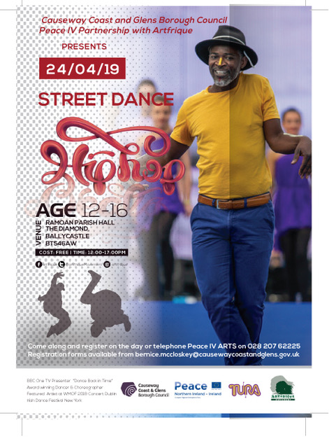

ARTS PROGRAMME (GR Out of School) 2019. PEACE IV Partnership/Causeway Coast & Glens Borough Council (CCGBC). Street Dance Workshop, early booking advised.
Parental / Guardian consent for pupils aged 12-16. Open to school pupils in the CCGBC area.
I give permission for: (participant name)…………………………………. to take part in the following activity:
Name of course……Street Dance Workshop………………………………………………....
Venue: Ramoan Parish Hall, The Diamond, Ballycastle, BT54 6AW
Dates of course…Wednesday 24 April 2019……12noon- 5pm………………………………………………..
Date of Birth…….. Age……
Name of Participant’s School………………………………………..
Medical details & dietary requirements…………………
Participant will make their own way to and from the venue: YES/NO
OR Participant will be collected by………………………..…(eg parent)
I give permission for (insert name)…………………………………to be photographed and / or filmed while during activities associated with CCGBC/Peace IV Arts Programme: YES/NO
I would like to receive further information on future arts courses e.g. Music, Street-Dance, DJ Skills, Street-Art, Pottery, Drama, YES/NO
I have already participated in some of the Peace IV ARTS or SPORTS programme: YES/NO
Name of parent/guardian………………………………………………
Mobile & landline of parent/guardian………………………………….
Address of parent/guardian…………………………………………….
……………………………………………………………………………….
Email of parent/guardian……………………………………………….
Parent/Guardian Signature……………………………. Date………..
Please register your interest to ensure free lunch by Wednesday 17th April 2019 at 12.00 noon by:
POST: Peace IV ARTS, Bernice McCloskey, Causeway Coast and Glens Borough Council, Sheskburn House, 7 Mary Street Ballycastle BT546QH
EMAIL: sent from parent/guardian email address to bernice.mccloskey@causewaycoastandglens.gov.uk Tel:028 20762225
TELEPHONE: Peace IV ARTS programme on 028 207 62225
Or just come along and register on the day (subject to availability).
- Beginners welcome. Open to school pupils aged 12-16 in the CCGBC area.
- People with mixed abilities are very welcome
- Please wear comfortable clothes & soft shoes or trainers
- Free lunch will be provided.
- Early booking advised but not essential.
- Tutors are fully trained, insured and Access NI checked
- Courses will run with sufficient numbers. Priority given to those who have started, but not yet completed, 26 hours of the Peace IV ARTS or SPORTS programme. Supported by the European Union’s Peace IV Programme, managed by the Special EU Programme’s body (SEUPB)
