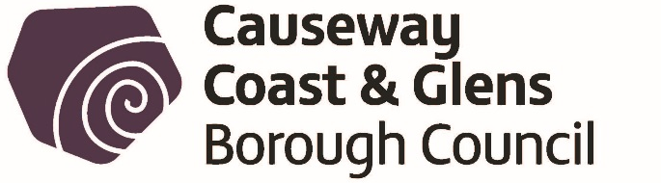
Licensing of Pavement Cafes Act (Northern Ireland) 2014
PUBLIC NOTICE
APPLICATION FOR A PAVEMENT CAFÉ LICENCE

NOTICE IS HEREBY GIVEN THAT
Name of applicant:

Address of applicant:

Has applied to Causeway Coast and Glens Borough Council for a Pavement Café Licence at:-

Name and address of premises:

Any objection relating to the application should be made within 28 days of the date of this Notice. The objection should be addressed to Causeway Coast and Glens Borough Council Licensing Section Riada House 14 Charles Street Ballymoney BT53 6DZ.

Any objection must be in writing and must specify the grounds of the objection, the name and address of the person making it and must be signed by them or their agent.

It should be noted that where an objection is made after the 28 day time period referred to, but before a final decision is taken on the application, it is appropriate for the Council to consider it, if there is sufficient reason why the objection was not made within the stated time period.
Applicant’s Signature:
Date:
This site notice must be displayed for the whole of the period of 28 days in a prominent place at or near the premises so that it can be conveniently read by the public.

