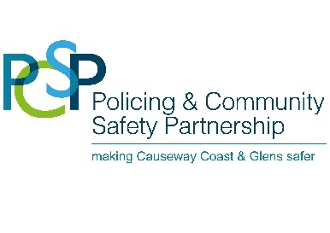

Causeway Coast and Glens Policing and Community Safety Partnership
Top Priorities!
As you may be aware Causeway Coast and Glens Policing and Community Safety Partnership (PCSP) has been working to help improve Community Safety and Policing throughout this area. PCSPs are statutory bodies established under the Justice Act (Northern Ireland) 2011 to help make communities safer. As part of the development of a Policing and Community Safety Strategy and Action Plan we are asking you what you think to prioritise what the police should be focusing on and what programmes we should be implementing as a result.
This is a one question survey but the information you provide will be considered by the Partnership along with various other consultations completed in the past two years.
Thank you for your time.
Ald Adrian McQuillan
PCSP Chairperson

What do you believe are the main crime-based issues in your area? Please choose the top 5 issues
- Anti-social behaviour
- Attacks on vulnerable people
- Bogus callers
- Burglary
- Crime against business
- Criminal damage
- Domestic abuse/Sexual violence
- Drug dealing/drug abuse
- Fear of Crime
- Hate Crime - (racist, homophobic, disability or sectarian)
- Perceived paramilitary activity
- Perceived criminal gang activity
- Road traffic offences
- Rural crime
- Robbery
- Vandalism or graffiti
- Vehicle crime
- Violent Crime/ assaults
- Cyber crime (eg Sextortion, SCAMs)
- Human trafficking
- Other (Please specify)

You can also email this to: pcsp@causewaycoastandglens.gov.uk
Or post a hard copy to PCSP, Causeway Coast & Glens Borough Council, Cloonavin, 66 Portstewart Road, Coleraine, BT52 1EY

