2019

MOSSIDE VILLAGE PLAN

** **

*Mosside vISion statement*

*“A vibrant and welcoming village and community where people support one another and are committed to improving the environmental, social, cultural and economic quality of village life for residents and visitors.”*

**Mosside Village Plan**

**Contents Page**

|  |  |  |
| --- | --- | --- |
|  |  | **Page** |
| 1. | Introduction | 3 |
| 2. | Village Plan Process | 4 |
| 3. | A Better Future Together, A Community Plan for Causeway Coast and Glens 2017 – 2030 | 5 |
| 4. | Area Profile | 6 |
| 5. | Spatial Analysis Audit | 9 |
| 6. | SWOT Analysis | 16 |
| 7. | Engagement Events | 17 |
| 8. | Summary from Engagement Findings | 18 |
| 9. | Key Messages from Engagement Findings | 23 |
| 10. | Priority Actions | 24 |
| 11. | Next Steps – Working Together | 33 |
| **Appendices** | |  |
| Appendix 1 – Engagement Open Day Findings | | 34 |

**This Plan was prepared by Community Places, March 2019**

1. Introduction

The Village Plan process for Mosside plays an important role in supporting local people to identify priorities and to plan and shape activities, projects and programmes to promote sustainable village renewal, vibrant and cohesive communities, and to deliver long-term benefits and investment to the whole community in line with the ambitions set out in the ‘A Better Future Together’ Community Plan.

The Village Plan is a working document that will help local communities to lobby and influence the local council, statutory partners and other service providers to respond to local needs and priorities as well as evidencing need and identifying potential funding opportunities. The plan includes a number of priority actions that have emerged from engagement with the local community and other key stakeholders. This plan builds on the previous Village Plan for Mosside which was developed in August 2011.

The Village Plan process took place between January and March 2019 and was commissioned by Causeway Coast and Glens Borough Council.

A new community group the Mosside Community Association was established in 2018 and has been instrumental in building the confidence of the local community. This has included the removal of paramilitary markings and emblems within the village. The association has already had a number of successes including accessing support from the Housing Executive’s Community Cohesion Fund to hold a Christmas Celebration event for local residents from the village; and a Bonus Ball has been set up which has generated resources for the work of the Community Association.

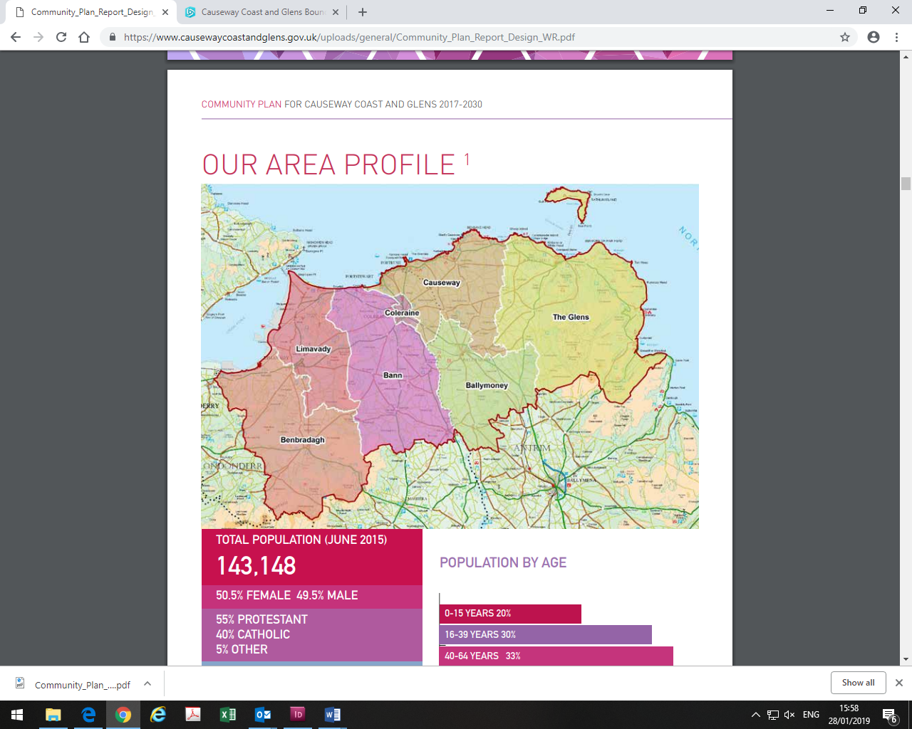

*Fig 1: Map of the Causeway Coast and Glens Borough Council Area, A Better Future Together, p.8*

1. Village Plan Process

The Village Plan process followed a number of key steps including:

* Development of a robust socio-economic profile of the area;
* Preparation of infographics to animate area statistics;
* Analysis of the existing Village Plan (2011) and other documents;
* A walk-about the village with representatives from Mosside Community Association;
* Spatial analysis audit and mapping of physical and community assets;
* Community engagement;
* Developing priority actions;
* Agreeing the Village Plan.

Each step informed and complemented the next drawing together the research and engagement findings to develop a village plan which sets out a long-term vision for the village to meet local needs and those of visitors. The plan itself and the process for developing and agreeing it has brought people together, strengthened relationships and has built support to implement the plan.

Posters and flyers were distributed throughout the village and shared on social media to raise awareness of the plan process and opportunities to get involved in helping to shape the future of Mosside. The Community Association was active in promoting the engagement events and encouraged local people to come along and have their say.

Two Community Engagement events were held at the Community Centre, one in the afternoon and one in the evening. A short on-line survey was also prepared to accommodate those who were not able to attend the engagement events.

1. A Better Future Together, A Community Plan for Causeway Coast and Glens 2017–2030

The Community Plan sets out a long-term shared vision for the Causeway Coast and Glens area and all who live in, work in and visit the area. It concentrates on three main issues:

* **A Healthy Safe Community**: where people will contribute to and benefit from a healthy, connected and safe community that nurtures resilience, promotes respect and supports everyone to live well together;
* **A Sustainable Accessible Environment**: where people will value and benefit from a diverse, sustainable and accessible environment with an infrastructure that is fit for purpose and that enables connections; and

* **A Thriving Economy**: where people will contribute to and benefit from a thriving economy built on a culture of growth, entrepreneurship, innovation and learning.

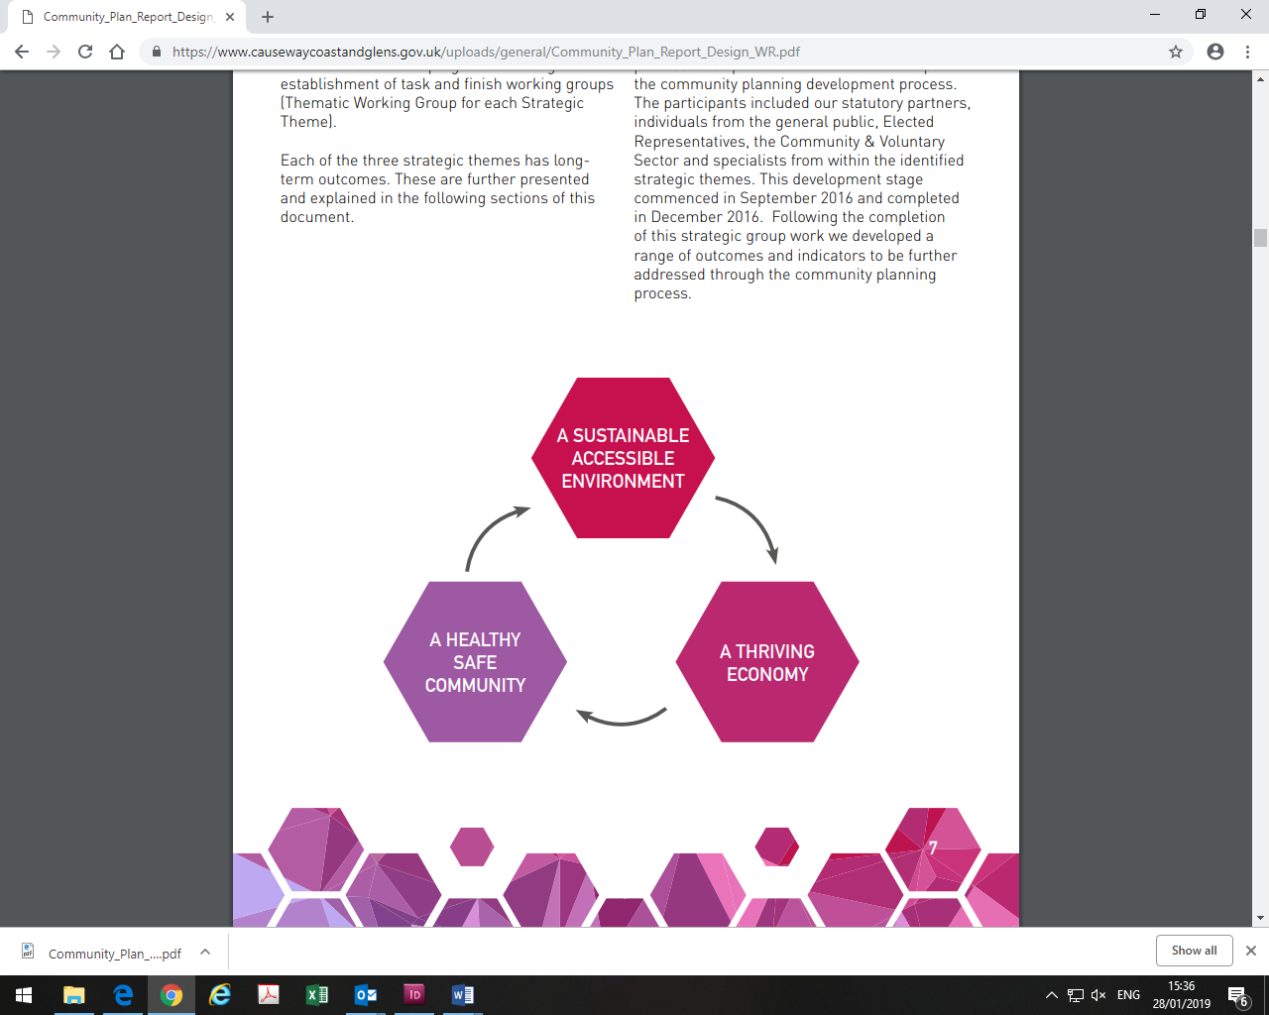

*Figure 2, Community Plan Outcomes, A Better Future Together, p.7.*

The Community Plan is the overarching framework for the area and acts as a strategic planning tool bringing key statutory and support partners together to plan and deliver better outcomes for people in relation to health, education, housing, public safety, communities, the economy and the environment at a council wide area and at local and neighbourhood levels. The Community Plan was developed in close collaboration with key partners and with extensive engagement with local communities, groups and individuals.

The Community Plan is linked to and reflects other key strategies and plans. This includes the new Local Development Plan 2030 which will provide the spatial framework for the Borough and will consider any land use planning aspects which emerge through the Community Plan such as housing, employment, open spaces and connectivity. Where relevant, linkages to and between the Community Plan and this Village Plan have been highlighted.

1. Area Profile

Mosside, grew up around a local mill and is located adjacent to the main B67 road between Coleraine, 17 Kilometers to the west, and Ballycastle, 11 kilometers to the north east and lies within the Mosside and Moyarget Ward.

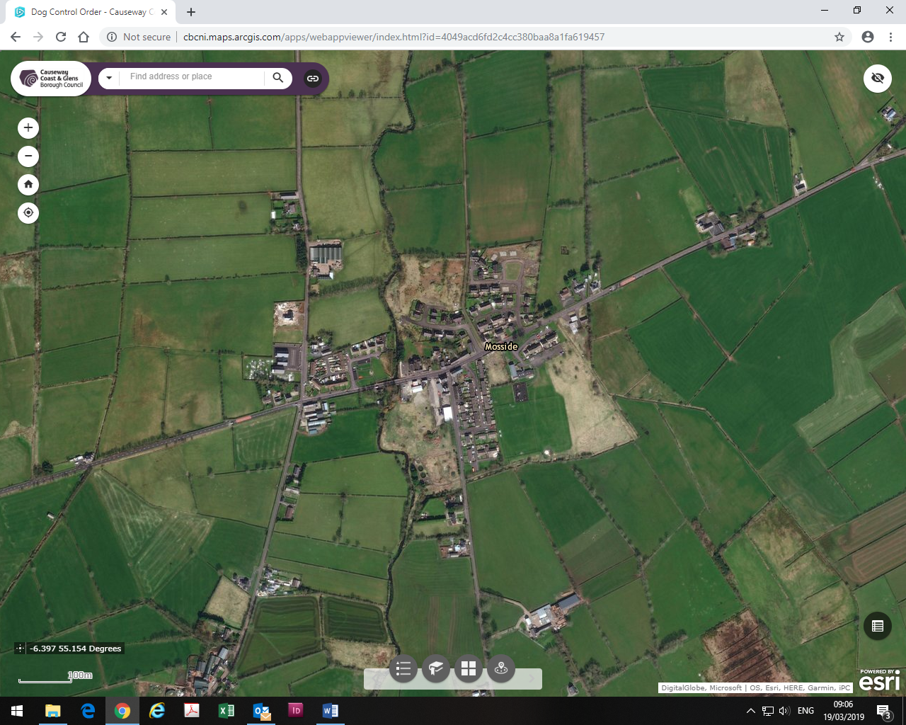

*Figure 3: Map of Mosside, CCGBC Interactive Maps.*

**Population**

The estimated population of Mosside and Moyarget Ward at 30 June 2017 was **997**, of which **516** **(51.8%)** were male and **481** **(48.2%)** were female. This was made up of: **199** children aged 0-15 years; **282** people aged 16-39 years; **349** people aged 40-64 years; and **166** people 65 years and older. One fifth of the population is 15 years and under and 17% are 65 years and older. Between 2007 and 2017 the population increased by 116 people (13.2%).

**Ethnicity, Identity, Language and Religion**

On Census Day 27 March 2011, of the usually resident population, 98.73% were from the white (including Irish Traveller) ethnic group. 17.83% belong to or were brought up in the Catholic religion and 76.37% belong to or were brought up in a ‘Protestant and Other Christian religion. 70.89% indicated that they had a British national identity, 11.39% had an Irish national identity and 25.95% had a Northern Irish national identity.

Considering the population aged 3 years and over: 6.39% had some knowledge of Irish; 38.37% had some knowledge of Ulster-Scots; and 0.55% did not have English as their first language.

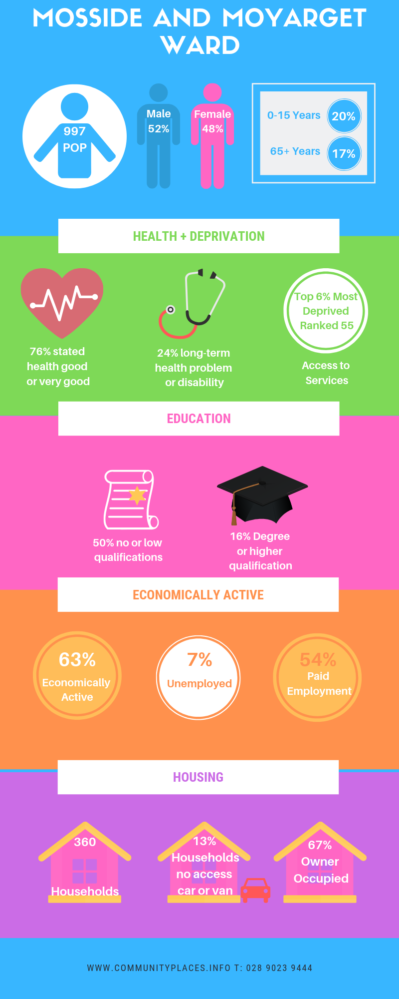

**Health**

On Census Day, 76.16% of people stated their general health was either good or very good; 23.5% of people had a long-term health problem or disability that limited their day to day activities. 14.66% of people stated that they provided unpaid care to family, friends, neighbours or other.

**Housing and Accommodation**

On Census Day, there were 945 people living in 360 households, giving an average household size of 2.63. 67.22% of households were owner occupied; 28.61% were rented; and 38.61% of households were owned outright. 10% of households were comprised of a single person aged 65+ years; 4.72% were lone parent households with dependent children; and 13.33% of households did not have access to a car or van.

**Applicants and Allocations at March 2018**

In Mosside there were <10 Applicants, <10 of which were experiencing Housing Stress (30 points or more) and there were <10 allocations.

**The Causeway Coast and Glens Housing Investment Plan Annual Update 2018**

Housing Executive Stock (*Sold Stock in Bold*)

|  |  |  |  |  |  |  |  |
| --- | --- | --- | --- | --- | --- | --- | --- |
| Mosside | Bungalow | Cottage | Flat | House | Mais | Total | Void |
| 15 | 6 | 0 | 46 | 0 | 67 | 4 |
| **19** | **20** | **0** | **28** | **0** | **67** |

**Qualifications**

Considering the population aged 16 years and over, on Census Day, 16.43% had a degree or higher qualification; while nearly half of the population (49.80%) had no or low (Level) qualifications. (Level 1 is 1-4 O Levels/CSE/GCSE any grades or equivalent).

**Labour Market**

On Census Day, of the population aged 16-74 years old: 62.8% were economically active, 37.20% were economically inactive; 54.22% were in paid employment; and 6.87% were unemployed.

**Multiple Deprivation Measure (MDM) 2017**

The NI MDM provides information on seven types of deprivation and an overall measure of deprivation for small areas. The 2017 NI Multiple Deprivation Measures are very concerning. The Armoy and Mosside and Moyarget SOA falls within the top 19% (169) of multiple deprived SOAs across NI. It also ranks high across a number of the domains. In relation to Access to Services and Income Deprivation affecting older people it falls within the top 6% (55) most deprived; in relation to Income Domain it falls within the top 8% (72) most deprived; and with reference to Income Deprivation affecting children it falls within the top 9% most deprived Super Output Areas.

1. Spatial Analysis Audit

An audit was undertaken of the physical and community infrastructure and asset base of the village, this is detailed and mapped below:

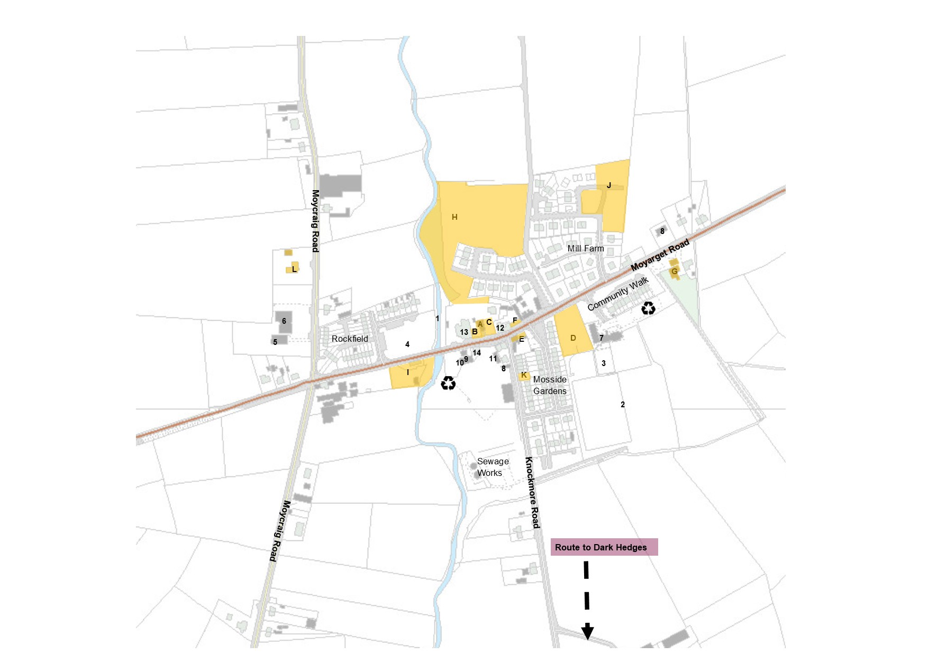

*Figure 4: Infrastructure and Asset Base*

|  |  |  |
| --- | --- | --- |
| **Asset** | **Name** | **Baseline Map Number** |
| **Key Services and Facilities** | Mosside River  Playing Fields  Mosside Play Park  Rockfield Gardens  Ulsterbus service  Community Notice Board  Recycling Banks | **1**  **2**  **3**  **4**  Black Recycling Symbol |
| **Churches** | Mosside Presbyterian Church | **5** |
| **Halls** | Mosside Presbyterian Church Hall  Mosside Community Centre  2 No. Orange Hall | **6**  **7**  **8** |
| **Businesses** | Mosside Filling Station (Day-to-day)  The Chip Stop (at filling station)  Moyle Fuels Ltd  Cochrane’s Newsagents  Public House | **9**  **10**  **11**  **12**  **13** |
| **Associations in the area** | Mosside Community Association |  |
| **Derelict/ Opportunity Sites** | 31 Main Street- commercial opportunity site  Land between 31 and 33 Main Street  Land between 23 and 31 Main Street  Land between 1A Mosside Gardens and the Mosside Community Centre  16-20 Main Street -Planning permission for new shop unit and 6 No. apartments (expired 2014)  Listed buildings adjoining 19 Main Street  246 Main Street- Abandoned Service Garage after community walk  Lands abutting Riverdale Estate  Lands opposite Rockfield Gardens  Lands to the rear of Mill Farm Estate  Land adjoining 10 Knockmore Road  201 Moycraig Road- Abandoned Primary School Site | **A**  **B**  **C**  **D**  **E**  **F**  **G**  **H**  **I**  **J**  **K**  **L** |
| **Tourism** | Dark Hedges Cottage – Self-catering accommodation  Dark Hedges | **14** |

**Key Services: Programme Delivery and Outreach Activities**

|  |
| --- |
| **Mosside Presbyterian Church**   * Sunday School * Boys Brigade * Girls Brigade * Monday Club (elderly social club) * Presbyterian Women (PW) Group * Children’s Church * Creche |
| **Mosside Community Centre**   * See-Saw Nursery * Summer Scheme * Football Pitches * Changing Facilities * Room Hire * Kitchen Facilities * Play Park * Horse Shoe Throwing Pitch * Recycling Facilities |
| **Mosside Community Association**   * Bonus Ball * Community Events * Facebook Page * North Antrim Village Forum – Armoy, Dervock, Mosside, Stranocum |

**Northern Area Plan (2016)**

The Northern Area Plan designates Mosside as a village in the Settlement Hierarchy and notes its role as a minor service centre providing a limited range of facilities, with both long established and more recent housing. The main zonings as indicated below relate to Open Space; Housing; and a Local Landscape Policy Areas.

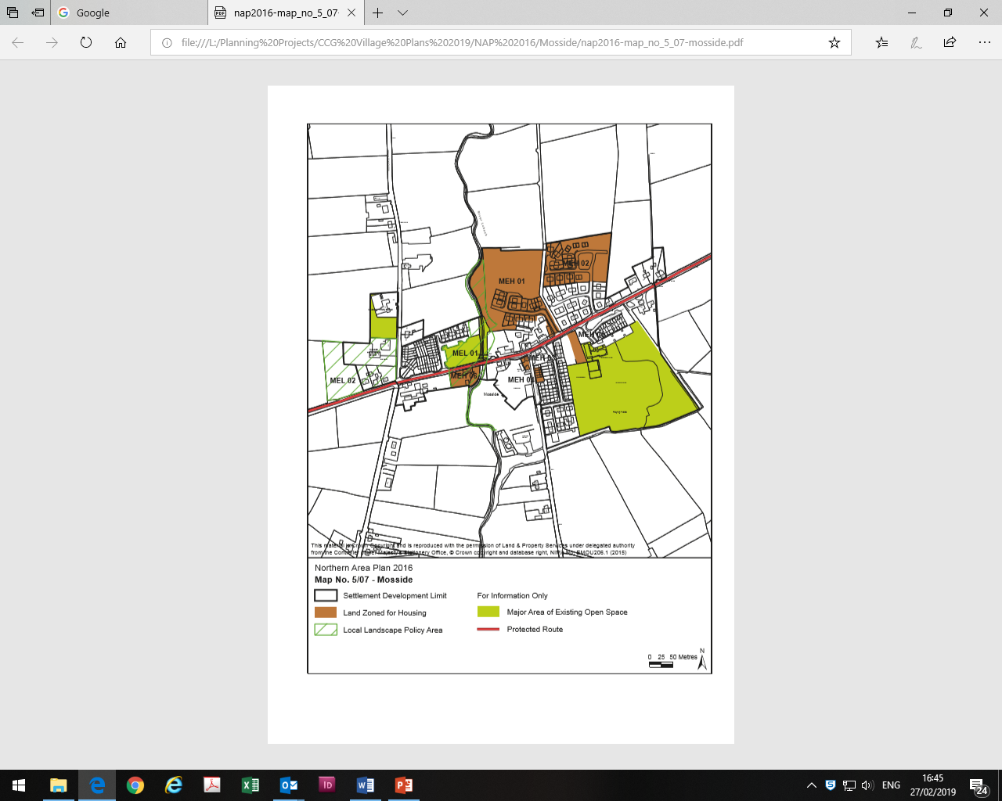

*Figure 5: Mosside, Northern Area Plan 2016*

There is a large area of Open Space to the rear of the Mosside Community Centre which includes football pitches and a play park, open space associated with Rockfield Gardens and open space to the rear of the Mosside Presbyterian Church on the Moycraig Road.

There are two Local Landscape Policy Area Designations. MEL 01 Mosside Water LLPA which seeks to protect the features which contribute to the environmental quality, integrity and character of the area including the banks and associated open spaces along the stream, which provides a distinctive river corridor through the village. MEL 02 Mosside Crossroads LLPA which includes locally significant buildings and associated mature planting which form an important part of the entrance to the village.

Six areas are zoned for housing – these are highlighted in brown overleaf.

**Planning History Map**

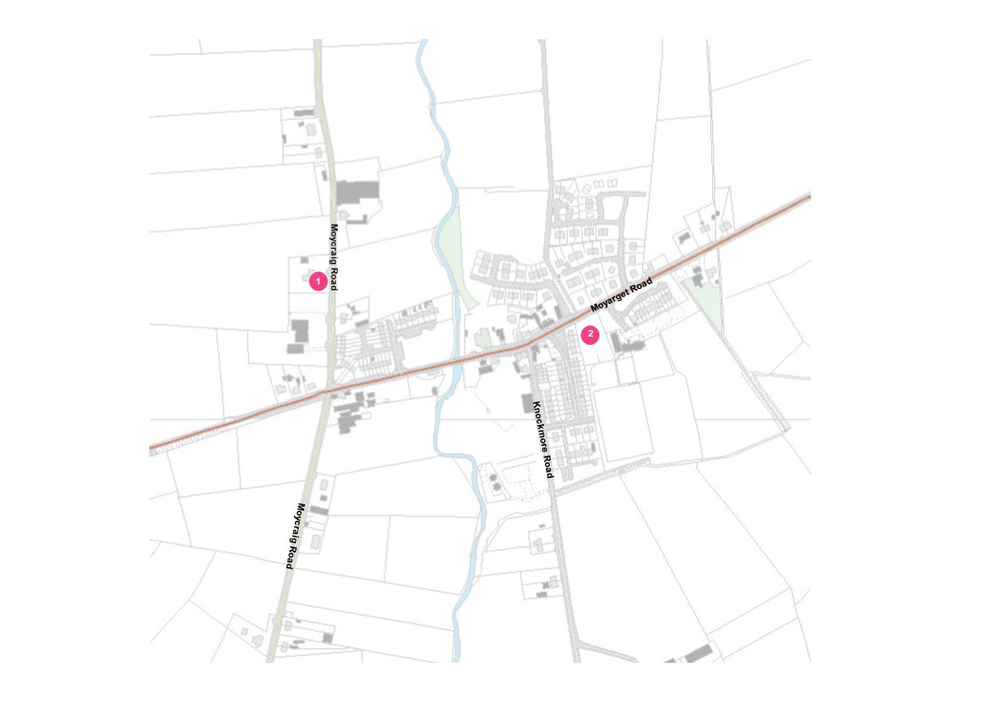

*Figure 6: Mosside Planning History Map*

**Key Planning History Results, February 2019**

|  |  |  |  |  |  |  |
| --- | --- | --- | --- | --- | --- | --- |
| **­Map**  **Ref** | **Planning Reference** | **Site Address** | **Proposal** | **Application Received** | **Planning decision** | **Decision Date** |
| 1. | E/2014/0002/F | 201 Moycraig Road, Mosside | Proposed replacement of existing abandoned Primary School building with new dwelling and detached garage | 10/01/14 | Granted | 8/06/14 |
| 2. | LA01/2018/1292/F | 2-4 Main Street, Mosside | 11 No. residential dwellings comprising of detached, semi-detached and townhouses with associated car parking and associated works | 5/10/18 | Pending |  |

1. SWOT Analysis

|  |  |  |
| --- | --- | --- |
|  | **Strengths** | **Weaknesses** |
|  | * Local People and Community Spirit * Community Association * Bonus Ball * See-Saw Play Group * Existing shops and facilities * Removal and ongoing efforts to reduce the influence of paramilitaries * Positive working relationship with Housing Executive * Support from Local Councillors | * Derelict buildings and sites * Condition of the Community ‘Barn’ and facilities within the Community Centre * Inadequate lighting at the Community Centre * Isolation * Transport connections |
|  | **Opportunities** | **Threats** |
|  | * Redevelopment of the Community Centre and in particular the ‘Barn’ * Renewed confidence and energy within the community including removal of paramilitary markings and influences * Tourism * North Antrim Village Forum | * Derelict buildings * Speeding traffic  Top 6% most deprived in relation to Access to Services and Income Deprivation affecting older people (Ranked 55)Top 19% (169) of multiple deprived SOAs across NI.Top 8% most deprived in relation to Income Domain (72);Top 9% most deprived with reference to Income Deprivation affecting children |

1. Engagement Events

After discussion with representatives from Mosside Community Association it was agreed that two community engagement events would be held in the village at the Community Centre on Friday 22 February 2019. One in the afternoon immediately after the See-Saw Play Group and another in the evening time to maximise participation.

At each event infographics were displayed to illustrate area statistics in an engaging and accessible style. Participants were invited to comment on the existing strengths of the village; the greatest challenges facing the community and to share their ideas and ambitions on how the village could be enhanced and improved in relation to a range of thematic issues including the environment, youth facilities and education and lifelong learning to name a few.

|  |  |
| --- | --- |
|  |  |
|  |  |

1. Summary from Engagement Findings

Participants were invited to share their ideas and comments under a number of thematic issues and to consider the biggest assets of and challenges facing Mosside.

**Assets and Strengths of the village**

Respondents noted that the local people, sense of community spirit and energy of the new community association were key assets to be celebrated. The See Saw Playgroup was highlighted as an essential asset to the village. Others emphasised that the Church Hall is well used for groups such as the Girls Brigade and Boys Brigade and that this could be built upon further. The shop at the petrol station was also noted as it plays an important role providing people with a reason to stop in the village. Others stated that working with the Housing Executive has been very productive and positive. There was a sense that things were improving in the village and the community spirit recently has been more like the old days which is considered positive.

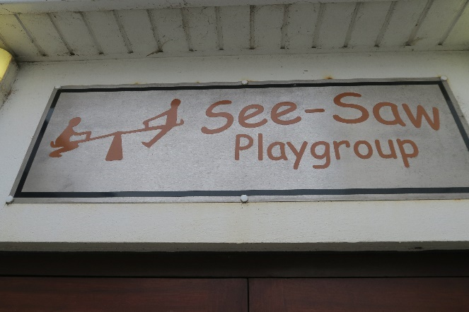 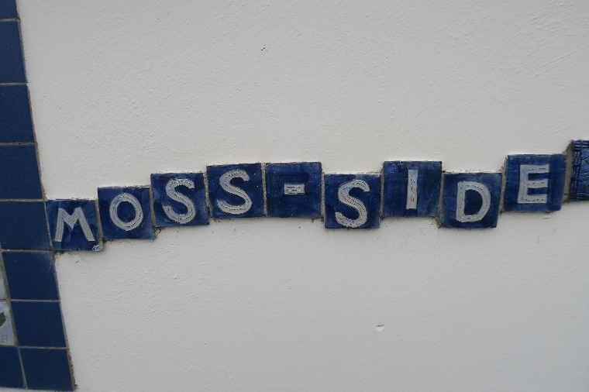

**Biggest Challenges facing the village**

The derelict buildings within the village were considered to be an eyesore and dangerous and a significant challenge to the appearance of the village. A consistent message coming from local people was the need for these to be redeveloped and the old Post Office building in particular demolished as it is unsafe. Others noted that the existing community centre and facilities which it provides are in need or refurbishment or replacement. In particular, people commented on ‘the barn’ and that while it is a good size if it were to be upgraded it could provide a range of additional community facilities for the whole village. Others noted that the use and accessibility of the community centre should be increased so that more people from across the village can avail of it. The lack of lighting outside of the Community Centre was identified as a key concern.

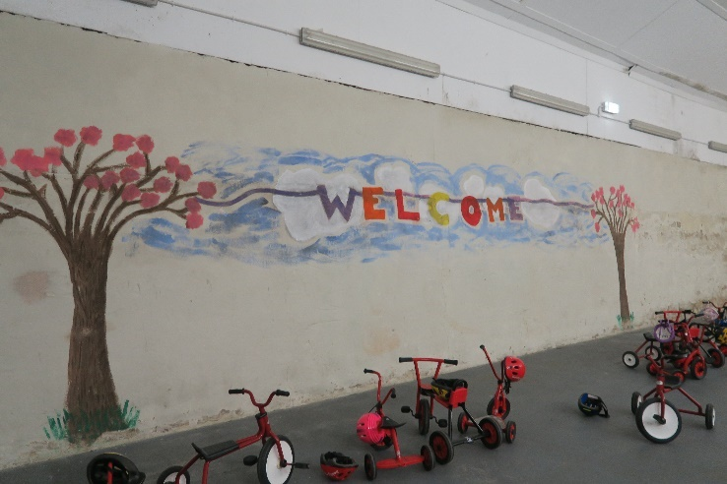 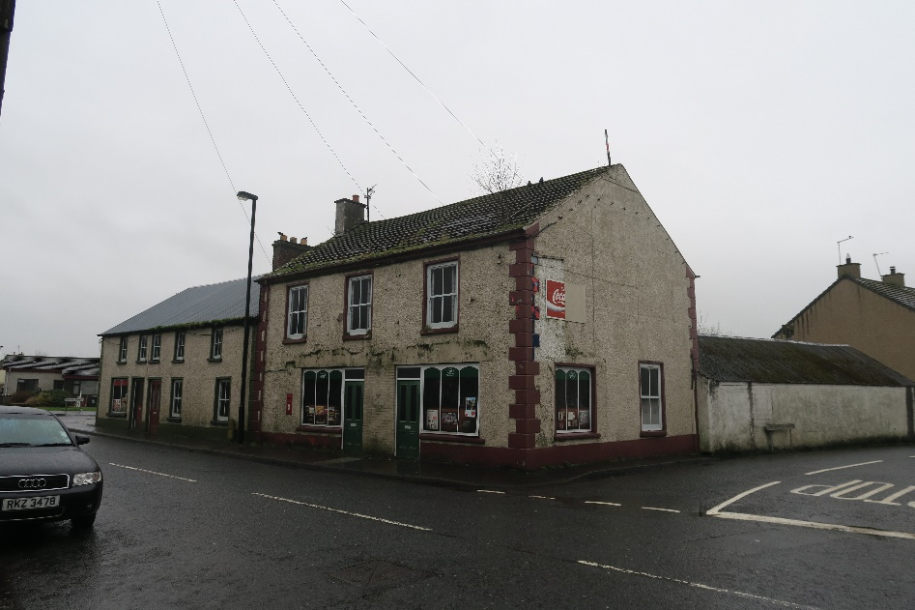

*The ‘Barn’ Community Centre and the Derelict former Post-Office Building*

Dog fouling appeared to be a major concern for people and although the community association have been encouraging people to pick up after their dogs this remains an issue. It was suggested that additional bins and even dog bag dispensers similar to those in Bushmills could help to redress this nuisance. It was also noted that additional bins would help to reduce littering. Some people stressed the frustrations they faced in getting the local council and the Roads Service to address their concerns with a number noting that they felt forgotten about on the edge of the new super council. Speeding through the village is a problem and people outlined the need for traffic calming measures such as speed ramps.

People emphasised the importance of maintaining the good work which has been done in the village recently to ensure that paramilitary influences do not return. A number of individuals stated that there have been several burglaries in the Rockfields area and that improved lighting particularly to the rear of properties might help to address this.

**Environmental Improvements**

Comments in relation to environmental improvements centred on the need for improved lighting outside of the Community Centre (including the carpark) and in the Rockfields area as well as additional bins for litter and dog waste and the provision of free dog bag dispensers.

|  |  |  |
| --- | --- | --- |
|  |  |  |

The speed of vehicles on the road through the village is a major concern for many residents and participants highlighted the need for traffic calming measures including the introduction of speed ramps to slow traffic. It was also noted that the bus shelter needs to be improved and that an additional bus shelter could be provided for those accessing services in Ballycastle. Respondents were also concerned that in icy weather the footpaths are not gritted, and that additional salt/grit boxes would be useful. Other suggestions included new flower beds and planting by the Housing Executive which could then be maintained by the Community Association. Others noted that the Housing Executive should wash the roofs of houses. Upgrading the park was a priority for many and one suggestion included the addition of an outdoor gym at the park so that a range of age groups could use this area including parents and grandparents. Others suggested painting the outside of the centre with a fun community mural. Another suggestion was a ‘River Walkway’ accessed at the side of the shops and going down to the bridge would be good for walkers including dog walkers.

**Celebrating Village Life**

Many of the participants suggested that community events throughout the year would encourage more people, especially younger people, to get involved in village life. These included: an Easter Event; a Fun Day; a Sports Day; and a Car Boot Sale. Others stressed that children and younger people should be more involved and active in the village and suggested that intergenerational activities such as planting hanging baskets and flowers in the village would encourage the development of a sense of ownership and pride. Another person suggested that they could fundraise for the community group by having a stall at the Aul Lammas Fair.

**Education and Life-long Learning**

Suggestions included computer classes, healthy eating classes, cookery classes, dementia education and mental health awareness.

**Youth Facilities or Activities**

Participants suggested that a Youth Club would be beneficial in the village and that a Hub for teenagers would be useful. Respondents noted that activities such as football for older children from the village and additional clubs during the summer months would be welcome. Some younger people noted that lighting on the pitch would allow extended play in the winter months. In general, respondents would like Mosside to have more activities and facilities for the youth and suggestions included a Skate Park and improvements to the play park such as a roundabout, a trampoline and replacing broken equipment including the bike and tyre swing in the playpark.

|  |  |
| --- | --- |
|  |  |

**Sports, Active Living and Health and Well-being**

Ideas and suggestions under this theme included improving or developing new sporting facilities e.g. an all-weather 3G pitch, resurfaced football pitch with new nets, closed cages for football, BMX ramps and a community gym. Several people noted that activities in the village such as indoor hockey, table tennis, a 5-a side football tournament (this could potentially develop into the establishment of a football team for Mosside) and exercise classes would be welcome additions. Others would like the playpark extended and improved with respondents also suggesting the need for improved lighting at the park. Participants highlighted that a Walking Group and a variety of walkways could be established. Others suggested different fitness classes such as Spin and Pilates. An outdoor gym and junior assault course were also suggested.

**Older People Facilities or Activities**

Suggestions for activities included social club, tea dances, and bingo for both older and younger people. Participants suggested a gardening club could prepare flower pots offering older people the opportunity to share their green finger skills with younger people in the village. Others noted that there was the correct flooring in the Church Hall for bowls and that this would be suitable for an older people’s bowls evening.

**Tourism, Heritage, Culture**

There was recognition of the need to promote the history of the village which includes farming, agriculture, and horse shoe throwing. It was suggested that these could be incorporated into a welcoming entrance feature to the village. Others commented that the existing war memorial is inside the Church and people felt that a more accessible memorial within Rockfields could be developed to remember people from the village who served in the war.

|  |  |  |
| --- | --- | --- |
|  |  |  |

**Community Facilities**

The main suggestion under this theme was the need to upgrade the community centre and provide better access to the centre for events and activities. In particular, the community ‘barn’ needs to be updated to provide a useable and warm space for the community and the kitchen facilities could also be upgraded. Office provision for the Community Association was also stressed as essential to the functioning of the newly established community group. Others suggested that the community centre should be demolished and replaced. Respondents would like more activities in the community centre for all age groups e.g. chess, pool, snooker and air hockey. Others welcomed plans for a community garden beside the park and suggested that public toilets in the village would be beneficial. Access to transport was considered problematic and several people suggested there should be improved bus schedules and information made available about North Antrim Community Transport.

**Other Ideas or Comments**

Ideas included the introduction of a dog park and signage for the Dark Hedges at Knockmore Road. Others suggested that there were opportunities through the North Antrim Villages Forum to lobby on common issues with Armoy, Stranocum and Dervock. Another idea was to apply to NACN for a small grant for a Community Newsletter jointly with Mosside and Dervock.

1. Key Messages from Engagement Findings

* Community Centre and in particular ‘the barn’ needs to be refurbished or redeveloped to enable additional community activities to be made available at the Community Centre
* Local people are a key asset and the energy of the new community association provides a great opportunity to progress the village
* See- Saw Playgroup is an important asset within the village
* Derelict buildings in the village are an eyesore and some are in a dangerous state of repair.
* Office space within the Community Centre for the Community Association
* Lighting at the Community Centre and car park
* Activities and events throughout the year are needed to encourage more people within the community to get involved and develop a greater sense of ownership of the village, especially younger people
* Environmental improvements such as planting, flower beds, paths, lighting, bus shelters, ongoing removal of red, white and blue markings, additional bins and free dog bag provision and gritting boxes
* Upgrading the park area and further developing adjacent areas to incorporate a community garden, horse shoe throwing area, upgrade playing fields and green gym
* Provision of a Youth Club and Teenager Hub for younger people in the community
* Traffic calming measures are required to improve road safety
* Opportunities to celebrate and promote the history of the area and signage to the Dark Hedges
* Intergenerational activities such as flower planting

1. Priority Actions

**Building Community Confidence and Involvement**

There is a clear opportunity to continue to build on the momentum and positive energy generated by the recently established Community Association. To continue to develop and build the confidence and spirit of the community a programme of community events and activities should be developed including an annual Community Festival and other seasonal celebratory events to encourage greater community participation by all, especially younger people, and to build positive relationships and confidence within the community.

The Mosside Community Association Facebook Page has played an important role in sharing information with the community and reaching out to the wider community. This could be built upon further with the introduction of a quarterly newsletter or community leaflet to let people know what is happening in the area, how they can get involved and to share and celebrate the work of the association.

The ongoing transformation of the area and removal of paramilitary markings should be maintained to continue to build community confidence and develop a positive sense of ownership of the village for the whole community. Welcome features could be developed at the entrances to the village to celebrate the history of the area including the agricultural traditions, the Mill, horse-shoe throwing and Ulster Scots heritage. A community mural could also be developed outside of the Community Centre with the involvement of younger people in the village to develop their sense of ownership of the area and to improve the vibrancy and aesthetic of the village.

The positive working relationship with the Housing Executive and the PSNI should be continued and further strengthened to develop and promote community cohesion across the village.

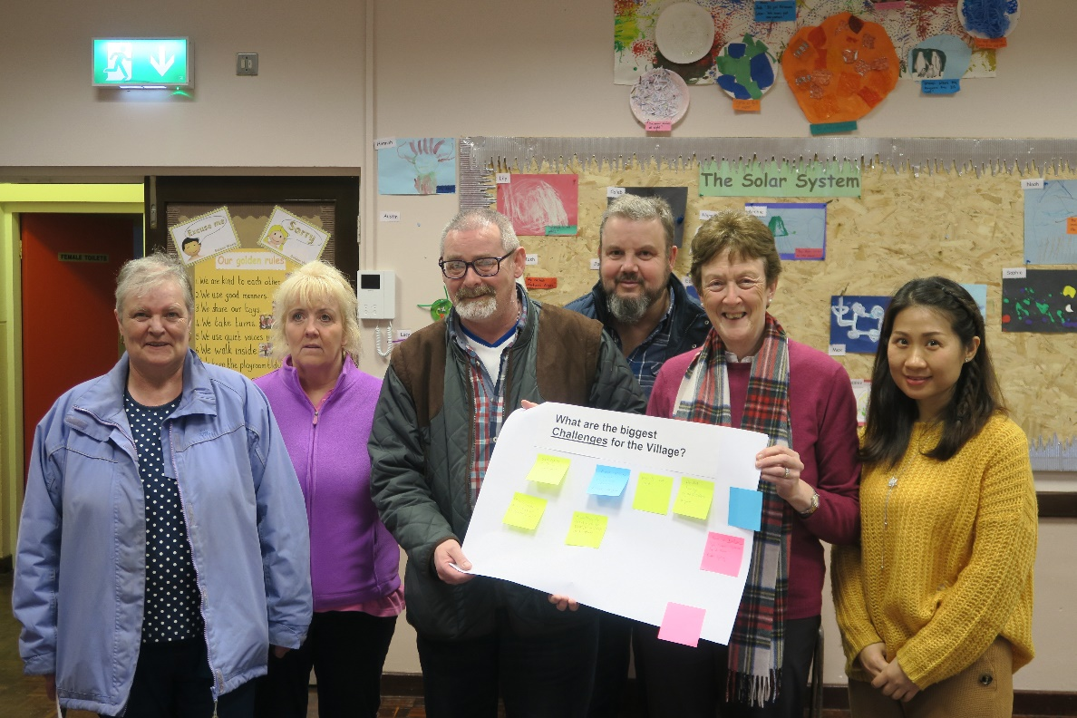

|  |  |  |  |  |  |
| --- | --- | --- | --- | --- | --- |
|  | **Actions** | **S** | **M** | **L** | **Lead Partners** |
|  | Develop a programme of community events including a Community Festival and seasonal events to build confidence and community spirit |  |  |  | Mosside Community Association, Causeway Coast and Glens Borough Council, Housing Executive |
|  | Build ownership and confidence in the community through the development of welcoming entrance features and a community youth mural adjacent to the Community Centre |  |  |  | Mosside Community Association, Housing Executive, See-Saw Play Group, Boys and Girls Brigade |
|  | Develop a Memorial in the Rockfields Area to honour those from the Village who served in the World War I |  |  |  | Mosside Community Association, Local Councillors, Causeway Coast and Glens Borough Council |
|  | Build on information sharing and communications through the introduction of a Community Newsletter or leaflet |  |  |  | Mosside Community Association, Housing Executive, North Antrim Community Network |
|  | Avail of any training to support the work of the Community Association and continue to work together with the North Antrim Villages Forum to enhance the village |  |  |  | Mosside Community Association, North Antrim Villages Forum |

**Links to ‘A Better Future Together’ Community Plan**

* A Healthy Safe Community
* A Sustainable Accessible Environment

**Potential Funding Opportunities or other Useful Links**

* National Lottery Community Fund [www.tnlcommunityfund.org.uk/northern-ireland#section-1](http://www.tnlcommunityfund.org.uk/northern-ireland#section-1) Awards for All £300- £10,000
* Housing Executive www.nihe.gov.uk/index/community/community_cohesion.htm
* Causeway Coast and Glens Borough Council – Community Development Support Grant <https://www.causewaycoastandglens.gov.uk/grantsandfunding/community-development-support-grant>

**Lobby for redevelopment of the Community Centre**

A feasibility study should be commissioned to assess options to improve or replace the Community Centre. Any redevelopment should include: improved ‘Barn’ space; upgraded kitchen facilities; flexible use spaces for a range of community activities; modern facilities for the See-Saw Play Group an important asset and service within the village; office space for the community association; and improved lighting immediately outside the centre and at the car park. The redevelopment or replacement of the Community Centre would facilitate greater participation from the wider community; provision of a range of activities and services for all ages; exercise and mental health and well-being classes; the introduction of a Hub for Teenagers and a Youth Club.

|  |  |
| --- | --- |
|  |  |

In the meanwhile, an assessment should be undertaken to scope how better use could be made of other buildings in the area including the Church and Orange Halls and to explore extended hours usage of the Community Centre for a range of additional activities to improve the accessibility of the centre for the wider community e.g. Hub for Teenagers, Exercise Classes, Pilates.

|  |  |  |  |  |  |
| --- | --- | --- | --- | --- | --- |
|  | **Actions** | **S** | **M** | **L** | **Lead Partners** |
|  | A Feasibility Study should be undertaken to identify options for the redevelopment or replacement of the Community Centre |  |  |  | Mosside Community Association, Causeway Coast and Glens Borough Council, See-Saw Play Group |
|  | Assessment exercise to explore making better use of existing facilities |  |  |  | Mosside Community Association, Causeway Coast and Glens Borough Council |
|  | Identify community volunteers and establish a Youth Club and Teenager’s Hub |  |  |  | Mosside Community Association, Community Volunteers, Causeway Coast and Glens Borough Council |

**Links to ‘A Better Future Together’ Community Plan**

* A Healthy Safe Community
* A Sustainable Accessible Environment
* A Thriving Economy

**Potential Funding Opportunities or other Useful Links**

* National Lottery Community Fund [www.tnlcommunityfund.org.uk/northern-ireland#section-1](http://www.tnlcommunityfund.org.uk/northern-ireland#section-1) Awards for All £300- £10,000; People and Communities £10,000 – 500,000; Empowering Young People £10,000 – 500,000
* Tesco Community Grants <https://www.groundwork.org.uk/tesco-local-community-scheme-uk-programmes>
* Asda Foundation <https://www.asdafoundation.org/>

**Environmental Improvements and Traffic Calming**

Improving the general appearance and upkeep of Mosside was consistently identified as an important issue for action from across respondents. Issues of derelict buildings *(the old post office site building which was a major safety concern was demolished in March 2019)*, dog fouling, litter, poor lighting, poor condition of pathways and footpaths, and the upkeep and maintenance of flower beds and planting were identified. A two-fold approach is required: improving cleansing and bin provision alongside, changing attitudes to litter and dog fouling in particular.

A programme of Environmental Improvements should be developed to enhance the local environment:

* Improved lighting at the Community Centre, to the rear of properties at Rockfields and along the path leading to Mosside Presbyterian Church. This will help to improve accessibility and also reduce crime and perceptions of crime
* Street cleansing and the provision of additional bins on the Rockfields side of the road and throughout the village
* Additional Gritting Boxes throughout the village
* Additional Bus Shelter for younger people accessing schools and others accessing services in Ballycastle
* Extend virtual street scene/re-imaging of shop fronts to the remaining derelict buildings and sites
* Liaise with Housing Executive regarding condition of existing planting, public art features and flowerbeds. Mosside Community Association, community volunteers and local Primary Schools should work in partnership with Housing Executive to keep and maintain these green assets
* Liaise with the Housing Executive regarding provision of off-street car parking for homes along Mosside Gardens
* Replace broken play equipment and upgrade the park to include a trampoline and roundabout
* Introduce directional signage to the Dark Hedges

|  |  |
| --- | --- |
|  |  |

Traffic calming measure should be introduced including digital speed displays, Go Slow Signage, speed ramps adjacent to the petrol station and shop and greater visibility of traffic police along the Main Road within the village to improve road safety.

The Neighbourhood Watch Scheme should be extended throughout the village to reduce crime, burglary, anti-social behaviour and environmental problems.

|  |  |
| --- | --- |
| cid:ce593b3f-a9bf-4929-8674-7ef38444588a@eurprd02.prod.outlook.com | cid:1a67c1dd-1489-4fe6-b271-4473d219ada5@eurprd02.prod.outlook.com |

|  |  |  |  |  |  |
| --- | --- | --- | --- | --- | --- |
|  | **Actions** | **S** | **M** | **L** | **Lead Partners** |
|  | Develop a Programme of Environmental Improvements as detailed above |  |  |  | Mosside Community Association; Housing Executive; Local Councillors, Causeway Coast and Glens Borough Council |
|  | Develop a Keep Mosside Tidy Campaign including a Big Spring Clean |  |  |  | Mosside Community Association, Housing Executive, Community Volunteers, Local Primary Schools |
|  | Lobby Department for Infrastructure Roads and local Councillors for the introduction of traffic calming measures including slow signage, digital speed displays and speed ramps |  |  |  | Mosside Community Association, Local Councillors, PSNI |
|  | Extend Neighbourhood Watch Scheme and work with PSNI and Housing Executive to reduce fear of crime |  |  |  | Mosside Community Association, Housing Executive, PSNI |

**Links to ‘A Better Future Together’ Community Plan**

* A Healthy Safe Community
* A Sustainable Accessible Environment

**Potential Funding Opportunities or other Useful Links**

* National Lottery Community Fund [www.tnlcommunityfund.org.uk/northern-ireland#section-1](http://www.tnlcommunityfund.org.uk/northern-ireland#section-1) Awards for All £300- £10,000; People and Communities £10,000 – 500,000; Empowering Young People £10,000 – 500,000
* Tesco Community Grants <https://www.groundwork.org.uk/tesco-local-community-scheme-uk-programmes>
* Housing Executive [www.nihe.gov.uk/index/community/community_cohesion.htm](http://www.nihe.gov.uk/index/community/community_cohesion.htm)
* Causeway Coast and Glens Borough Council – Community Development Support Grant <https://www.causewaycoastandglens.gov.uk/grantsandfunding/community-development-support-grant>
* Keep NI Beautiful Initiative [www.keepnorthernirelandbeautiful.org](http://www.keepnorthernirelandbeautiful.org)

**Promoting Active and Healthy Lifestyles**

The Community Association have had recent success with plans to develop a community garden immediately adjacent to the playing fields and playpark. There is an opportunity to further enhance the immediate lands around the play park.

* A Community Garden Project alongside an Incredible Edibles initiative should be developed to improve community interaction and intergenerational connections, mental health and wellbeing awareness and healthy food choices.
* A green gym or trim trail could also be developed in close proximity to the existing play-park to enable parents and grandparents to improve their health and fitness while children/ grandchildren use the play park facilities.
* The existing Horse Shoe Throwing Arena should be upgraded to include a sheltered area and a Youth Tournament established to ensure this unique cultural activity is enjoyed by the next generation.
* A five-a-side Football Tournament should be organised to encourage both younger and older people to be more active in the community. This could eventually lead to the development of a new Mosside Village football team. Danderball- walking football for the over 50s could also be introduced as a fun exercise which allows participants to get back into the sport and get more active.
* A Walking Trail could also be developed along the River from the bridge on Main Street and looping back to the Community Centre via Knockmore Road. This would provide an off-road safe walking route and improve access to the redeveloped Play Park area and Community Garden Project.

|  |  |
| --- | --- |
|  | cid:4f08230a-4194-4e9f-883c-4399d9ce259c@eurprd02.prod.outlook.com |

|  |  |  |  |  |  |
| --- | --- | --- | --- | --- | --- |
|  | **Actions** | **S** | **M** | **L** | **Lead Partners** |
|  | Develop a Community Garden Project and complementary Incredible Edibles Initiative |  |  |  | Mosside Community Association, Causeway Coast and Glens Borough Council, Housing Executive |
|  | Undertake a Scoping Exercise to re-develop and enhance the immediate area adjacent and to the Play Park and Playing Fields for greater community use including a green gym/trim trail and Riverway Walking Trail |  |  |  | Mosside Community Association, Causeway Coast and Glens Borough Council |
|  | Lobby for the repair and upgrade of the Play Park |  |  |  | Mosside Community Association, Local Councillors, Causeway Coast and Glens Borough Council |

**Links to ‘A Better Future Together’ Community Plan**

* A Healthy Safe Community
* A Sustainable Accessible Environment

**Potential Funding Opportunities or other Useful Links**

* National Lottery Community Fund [www.tnlcommunityfund.org.uk/northern-ireland#section-1](http://www.tnlcommunityfund.org.uk/northern-ireland#section-1) Awards for All £300- £10,000; People and Communities £10,000 – 500,000; Empowering Young People £10,000 – 500,000
* Tesco Community Grants <https://www.groundwork.org.uk/tesco-local-community-scheme-uk-programmes>
* Housing Executive [www.nihe.gov.uk/index/community/community_cohesion.htm](http://www.nihe.gov.uk/index/community/community_cohesion.htm)
* Causeway Coast and Glens Borough Council – Community Development Support Grant <https://www.causewaycoastandglens.gov.uk/grantsandfunding/community-development-support-grant>
* Cloughmills Incredible Edible [www.cloughmills.org.uk/incredible-edible-cloughmills](http://www.cloughmills.org.uk/incredible-edible-cloughmills)

1. Next Steps - Working Together

Central to the successful implementation of the plan will be the continued commitment from the Mosside Community Association and joint working with key stakeholders including the Housing Executive, Causeway Coast and Glens Borough Council and the PSNI to drive the plan forward.

It is important to note that during the Plan period other actions or development opportunities may arise to improve and enhance Mosside. It is clear that Mosside Community Association, and with the support of the wider community is committed to continuing to enhance and improve the village for all.

Appendix 1 - Engagement Open Day Findings

**Walk about with Chair of the Committee – Key Issues**

* Lighting at Rockfield
* Ramps at Rockfield and back path
* Bus Stop needs refurbished and additional Bus Stop on the Ballycastle side
* Hall needs to be refurbished
* Kitchen in centre needs to be updated
* See-Saw Play Group a real strength
* Icy weather footpaths are not gritted
* Salt boxes
* Additional bins to address dog fouling
* Flower beds and planting HE upgrade, and community can maintain them
* Signage for Dark Hedges at Knockmore Road
* Developed a Community Facebook
* Lighting in the car park of the Community Centre
* 30 Mile speed limit – but cars still speed
* Nearest Youth Club is Stranocum

**Mosside Community Engagement Open Day – Friday 22 February 2019**

**What are the biggest assets and strengths of the village?**

* The people in the village are great- the best
* Community Spirit
* Nursery School is fantastic
* Shop at the Petrol Station – opened 4-5 years ago gives people a reason to stop in the Village
* The Church Hall is well used – with Boys Brigade / Girls Brigade – could build on this
* The new Committee- energy of the people
* Things are improving – getting better
* Working with the Housing Executive has been very positive
* Community Spirit is great- recently more like the old days

**What are the biggest challenges for the Village?**

* Derelict buildings e.g. old post office is very dangerous and needs to be knocked down
* No lighting up to the Church – people use the path a lot
* Back of Rockfields – large ramps which you can easily trip on an as there is no lighting
* Better lighting at Rockfields – has been burglaries at back of Rockfields
* New Community Centre – activities and things for children to do
* Miss the old Mill
* Removing the derelict buildings or tidying them up
* Maintain the good work so that paramilitaries don’t return
* More bins in the village to stop litter and dog fouling
* Doggy bag dispenser e.g. like in Bushmills
* Community centre never open for people in the village
* Being forgotten about on the edge of the Super Council
* Getting through to the Council and Roads Service
* Dog fouling
* Speed Ramps, traffic calming – cars speed through the village

**Sports and Active Living**

* Community Gym
* Plans for a 5- a-side Football tournament – eventually develop a new football team
* Permanent nets to play football
* All weather 3g Pitch – would save money resurfacing pitch/upkeep e.g. cutting the grass and line pitch
* Refurbish football pitches and play park (bike area)
* Resurface pitch with potential flood lights and nets
* Repairs needed to play park
* Closed cage for Football
* Indoor Hockey, Table tennis
* Nike ramps, BMX near the play park
* Exercise classes in the centre

**Youth Facilities or Activities**

* Youth Club would be beneficial
* Hub for teenagers
* Football for older children and other clubs during the Summer time
* Skate Board area for youth
* More activities for youth
* In the Park – play equipment broken – Bike and tyre swing these need to be replaced
* In the Park- remove the bikes and replace with a roundabout and trampoline
* Extend and improve the play park
* Lighting on the pitch for extended play especially during the Winter time

**Older People Facilities or Activities**

* Gardening – flower pots, older people in village with green fingers
* Social group for OAPs
* Bowls for older people – correct flooring in Mosside Church Hall
* Tea dances for older people
* Bingo for older and younger people

**Health and Wellbeing**

* Walkway would be good in Mosside
* Walkway a good idea for taking kids out
* Walkways
* Fitness classes
* Spin class
* Pilates
* Walking Club
* Outdoor gym and Junior Assault course

**Environmental Improvements e.g. lighting, walkways, derelict sits, allotments, flower planting/maintenance**

* Paint outside of the centre – even a fun community mural
* Speed of cars on the road is very dangerous need traffic calming
* Upgrading the park is a big priority
* Bins on the Rockfields side of the Village
* No lighting up behind Rockfields
* Outdoor gym is a good idea
* Lighting around the Community Centre
* Speeds ramps – slow down the traffic through the village
* Upgrade the park
* New and better facilities
* More dog bins
* Bus Shelter going to Ballycastle (schools, shops)
* River walkway – good for dog walkers – accessed at the side of the shop down to the Brig

**Community Facilities**

* Connect People
* Upgrade the community centre
* Access to transport- bus timetables especially for return journeys
* Public Toilets
* Access to the Community Centre for events and activities
* Events and activities throughout the Winter
* Games in the centre e.g. chess, pool, snooker, air hockey, - start competitions
* Community Barn needs to be updated – space for the community to use
* Plans for a community garden beside the park
* More activities in village for all age groups
* More information about North Antrim Community Transport

**Education / Lifelong Learning**

* Computer classes for Adults
* Cooking classes – healthy eating
* Dementia / Mental health classes

**Celebrating Village Life E.g. Volunteering, Good Relations**

* Easter Event – Fun Day and Car Boot Sale – opportunity to get younger people interested and involved
* Fun Days e.g. Sports Day
* Fundraising at the Lammas Fair to raise money for the Community Group
* Get kids to be more active in the village
* Getting younger people involved e.g. help plant the flower beds etc. to develop a sense of ownership and pride
* Hanging baskets and flowers – get the school children involved -intergenerational and feel more involved
* Getting more people involved

**Tourism, Heritage or Culture**

* War Memorial at Rockfields – the existing memorial is on the wall of the Church – people from the village served in the War
* Promote the history of the Village (farming, agriculture, Horse Shoe throwing etc.) with an Entrance Feature

**Other comments or ideas to improve the village**

* Dog Park or agility course
* Community Barn – facility needs to be replaced so it can be used more by the community
* More activities that both young and old can participate in (rather than separate age groups)
* Replace derelict buildings
* Upgrade the Park behind the Community Centre
* Housing Executive – wash down the roofs of houses
* Part of North Antrim Villages Forum (along with Armoy, Stranocum and Dervock) lobbying on common issues
* NACN small grant for a Community Newsletter jointly with Mosside and Dervock

 