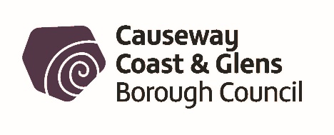
Towards a LitterSmart Borough
Causeway Coast and Glens Borough Council’s
Litter Strategy 2022 to 2026

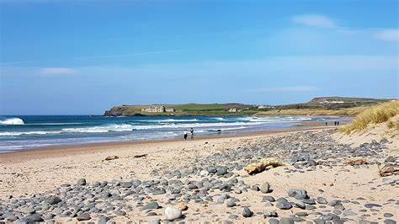

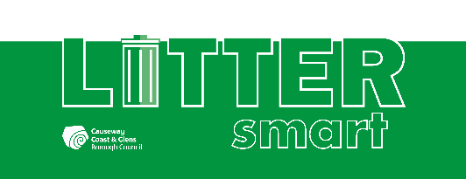

Table of Contents

Introduction 3
Our Borough 5
Legislation 6
LitterSmart Vision 7
Changing Behaviour 7
Communication 8
Send a Clear Message 10
Cleaning up the Borough / Infrastructure 11
Enforcement 12
Monitoring and Review 15
Action Plan 16
Other Initiatives 20
Get in touch 23

1.0 Introduction
Litter is an ongoing environmental challenge for Causeway Coast and Glens Borough Council. Litter has a negative impact on the aesthetic beauty of the Borough and its natural habitats and creates negative experiences for residents and visitors.
There are many causes of littering. Behaviour, how we communicate, approaches to enforcement, infrastructure, strategy and societal attitudes are all factors. Littering is not an issue that can be tackled alone.
For all these reasons, Causeway Coast and Glens Borough Council is committed to reducing litter. As outlined in the corporate plan, Council’s five main strategic priorities include ‘Healthy and Engaged Communities’ and ‘Climate Change and Our Environment’.
Causeway Coast and Glens Borough Council spends over £2million annually on services relating to litter and street cleansing. This level of expenditure would be greatly reduced if no litter was dropped, no fly tipping occurred and no dog fouling was left uncollected.
Reducing littering in our Borough requires best practice in education, engagement, enforcement and infrastructure.
Research suggests there are 1.3 million pieces of litter on Northern Ireland's streets at any one time. This equates to 28 tonnes of rubbish, of which 1 tonne is made up of dog waste. (Keep Northern Ireland Beautiful Cleaner Neighbourhoods Report 2019/20).
Most people agree that discarded litter is unsightly, damaging to our environment, poses a danger to wildlife, pets, livestock, our seas and oceans and is expensive to clean up.

Every year our Council spends precious financial resources cleaning up litter and illegally dumped rubbish from our towns, villages, housing estates, verges, roads, countryside and beaches.

Council provides weekly kerbside household bin collections, 11 Household Recycling Centres and a bulky household waste collection service, however, despite this, nearly two-thirds of indiscriminate fly-tipping involves household waste.

Every day around 1,400 plastic bottles and 1,300 disposable cups are littered around our Borough. Much of this discarded litter makes its way into our rivers and eventually the North Atlantic Ocean. An estimated 80% of beach litter contains plastic, which if not lifted, will enter our oceans and cause untold damage to marine life and its ecosystem.

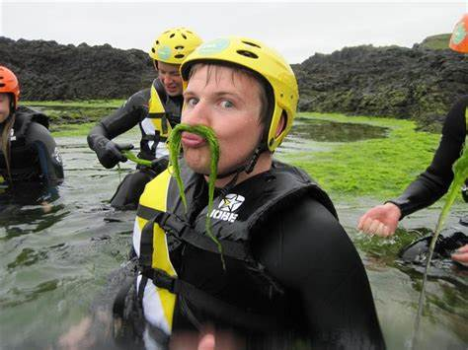

25% of smokers do not think discarding a cigarette butt is littering, however, cigarette butts are so light and small that the vacuum brushes on our mechanical street sweepers cannot pick them up and they are nearly impossible to lift with litter pickers. This leaves staff having to brush and pick up around half a million cigarette butts in our Borough every year.

It is a minority of people who are littering in our Borough. 80% of people agree that littering is wrong and practice positive behaviour with their rubbish. We want this behaviour to become the norm.

2.0 Our Borough
Our Borough covers an area just under 2,000 square kilometres. We have a coastline which stretches over 140 kilometres along the Atlantic Coast from Lough Foyle to the Glens of Antrim. There are also four areas of outstanding natural beauty encompassing Antrim Coast and Glens, Binevenagh, Causeway Coast and Sperrin.

Causeway Coast and Glens Borough Council recognises that an awakening of civic pride and duty among all sectors of society is required if the problem of littering is to be tackled successfully. Individuals need to take personal responsibility for the litter they generate and how they dispose of it.

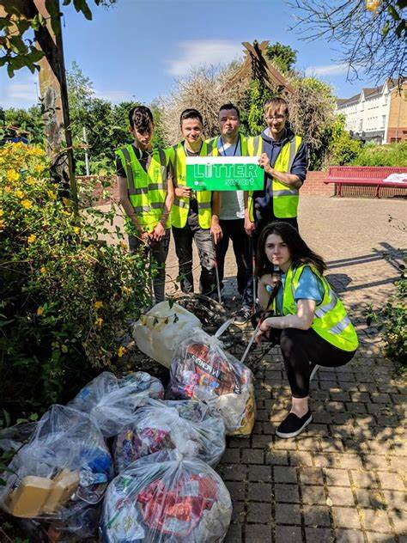

3.0 Legislation

Causeway Coast and Glens Borough Council has responsibility for managing litter in our area. Key pieces of legislation that direct the Council’s functions regarding street cleansing are as follows:-

- The Litter (Northern Ireland) Order 1994 and the associated Code of Practice on Litter
- Clean Neighbourhoods and Environment (Northern Ireland) Act 2011
- The Fouling of Lands by Dogs (Causeway Coast and Glens Borough Council) Order 2018.

4.0 LitterSmart Vision

LitterSmart is a strand of the wider LiveSmart project. Its aim is to reduce litter through education and engagement, encourage responsible litter disposal and support local communities to live in areas free from litter.
We want to create a litter conscious population who are aware of the sources, cost (environmental and financial) and impacts of litter in our Borough, and who take it upon themselves to routinely dispose of litter responsibly. We want to mobilise our whole community to take personal and collective action to reduce, and eliminate as far as possible, littering in our Borough. In addition, we want to facilitate the removal of littering promptly and use available enforcement powers where necessary.

5.0 Changing Behaviour

Improving or changing behaviour with regards to littering will require a multi-faceted approach. Communication is a key aspect to reducing littering. Collaboration between community, social and statutory organisations to change attitudes towards the dropping of litter and how it effects residents and the perception of communities is necessary.

Reducing littering will require behaviour change in the one in five people who admit to dropping litter. We want to make using the nearest bin, holding on to litter until you can properly dispose of it or taking litter home the norm. Combining enforcement and infrastructure with education and engagement will together help address the problem.
Communications have a key role to play in engaging and motivating people to change their behaviour through effective and accessible messaging.

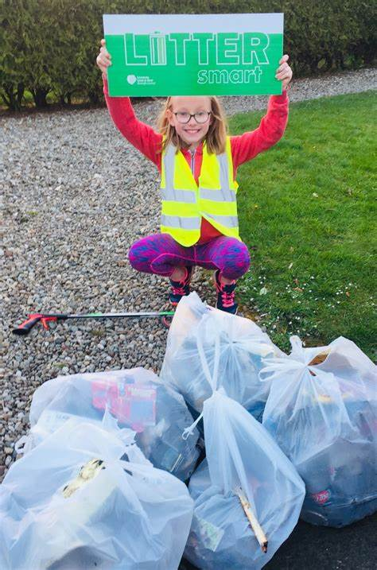

Our residents and visitors need to understand the impact of littering, the cost to clean it up, the danger it presents to pets, wildlife and farm animals, the pollution it causes to our land, rivers and seas and the negative psychological impact it has on people. We must all understand the personal responsibility we have when we want to be rid of our rubbish. Behaviour change, which requires a range of interventions, including education and awareness-raising, is key to stopping the minority of people who drop litter. Those who responsibly dispose of their litter, and particularly those who are engaged in volunteer litter picks, must be acknowledged and thanked.

6.0 Communication

Messaging must be positive. If people believe the problem is insurmountable or “everyone does it” we are making it the norm to litter. We want being responsible for your litter to be the norm and anything else frowned upon and socially unacceptable.

Research suggests littering behaviour is affected by location, amenity, time of day, social situation, audience and perception of individual litter types. Therefore, context-specific communication materials will be developed to target relevant audiences.

Generally found to be the worst when it comes to littering, 18 to 34 year olds are a harder group to reach with anti-littering messages. This group is best targeted via social media, the shops and retail outlets they frequent and advertising with target market specific messaging. Messaging taken home from school may also encourage current and future behaviour change in both children and parents.
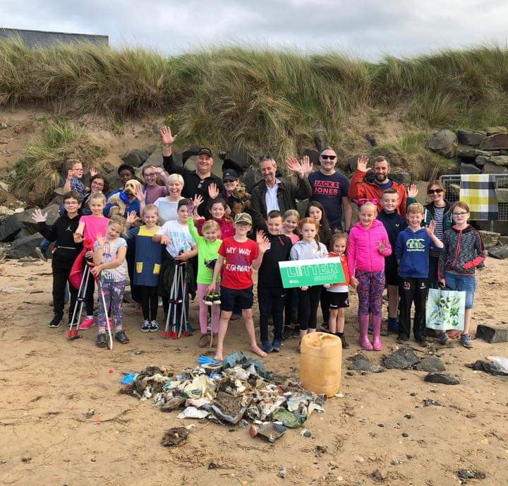

Litter picks are a great way to engage our community in practical and positive action
on littering. It’s amazing how many people want to be involved and do their bit.

Urgent action is needed, however, many businesses, community groups, individuals, sporting organisations and schools are already carrying out litter picks around our Borough.

Litter picks continue to be carried out on our beaches, in our towns and villages, in the countryside, resulting in the collection of thousands of bags of rubbish. Some of this litter has been washed ashore, thrown out of car windows or just discarded carelessly.

The LitterSmart section of our LiveSmart story map encourages the wider public to be part of the solution and it raises awareness of the harmful effects of litter. The story map, and associated campaign, aims to encourage others to join in and to ensure people feel they are part of a larger movement acting positively to address littering.
7.0 Send a clear message
We will:
- Participate in anti-litter campaigns
- Support our community to carry out clean-ups
- Encourage people of all ages to care about their local area
- Support schools to raise awareness of litter
- Encourage businesses and their customers to eradicate littering
- Ask catering establishments to stock products which will reduce litter
- Research new ways to encourage more recycling and reduce litter
- Target offenders through education, nudge signage and enforcement

Council’s Environmental Resource Officer (ERO) Team has developed an engaging and proactive LitterSmart campaign.
A range of interactive workshops have been developed for target audiences including pre-school, primary and post-primary school children, young people and adults. The aim of the workshops is to raise awareness of what litter is, where it happens, why we shouldn’t litter, the damage and expense it causes and what we can all do about it. Many of our schools already engage with the ERO team for education, practical action and policy change to reduce litter in and around their premises.

For details on our Communication Plan(s), please see blue / section one of our Action Plan.

8.0 Cleaning up the Borough / Infrastructure
We will:
- Work to reduce littering from vehicles
- Make it easier for people to dispose of their rubbish properly
- Clear up litter promptly as resources allow
- Support and advise organisations and event organisers to ensure they have the means to deal with litter
- Support and encourage our stakeholders to share their experience of what works to reduce littering
- Make it easier for the public to report overflowing and damaged litter bins
- Identify partner groups who can contribute to the solution and provide guidance on how to get involved
- Continue to develop and expand relationships with statutory and community groups currently collecting litter
- Celebrate community involvement with events to recognise and thank those groups and individuals for giving up their time to improve the look and environmental well-being of their communities
- Review our assets and infrastructure regularly to match service requirements and developments
- Continually review bin location and type, collection vehicle type, staff numbers, shift patterns, signage type and location

For details on our plans to Clean up the Borough / Infrastructure, please see green / section two of our Action Plan.

9.0 Enforcement
Causeway Coast and Glens Borough Council is currently responsible for enforcing two relevant offences in relation to this strategy
- Failing to remove dog foul from open spaces
- The illegal deposition of litter
The main legislation for these offences are
Dog foul – Under Article 40 of the Clean Neighbourhoods and Environment (Northern Ireland) Act 2011, District Councils have the power to make dog control orders in relation to several aspects of responsible dog control. In 2018, Council passed The Fouling of Lands by Dogs (Causeway Coast and Glens Borough Council) Order 2018. This Order makes it an offence for anyone to fail to remove their dog’s faeces from any open land. Anyone who commits such an offence is liable to a Fixed Penalty Notice of £80.
Litter – Under Article 3 of the Litter (Northern Ireland) Order 1994 it is an offence for anyone to throw down, drop or otherwise deposit and leave litter in any space open to the air. Article 2(2) of the 1994 Order provides a definition of litter which states litter is any refuse, filth, garbage or any other nauseous, offensive or unsightly waste or any waste which is likely to become nauseous, offensive or unsightly but not animal droppings. This definition is regarded as ‘wide’ and includes smoking-related litter such as cigarette ends, cigars and like products, and discarded remains of other products designed for chewing such as bubble gum. In practice, litter is assumed to include materials that are discarded and left by members of the public otherwise than in proper receptacles such as litter bins. Anyone who commits such an offence is liable to a Fixed Penalty Notice of £80.
We will:
- Take a firm enforcement approach to any detected offences of littering and dog fouling and all detected offences will be dealt with by way of a Fixed Penalty Notice. Failure to pay any Fixed Penalty Notice will result in prosecution for the original offence.
- We will increase the levels of Fixed Penalty Notices issued for the offences of dog fouling and littering comparable with other District Councils.
- Litter Clearing Notices – Under Article 12 of the Litter (Northern Ireland) Order 1994 (as amended), District Councils have the power to issue Litter Clearing Notices. These notices require the owner or occupier of open land to clear the land of litter where there is a problem of litter that is detrimental to the amenity of the area. The notice can also require the owner/occupier of that land to take reasonable steps to prevent the land from becoming so defaced again. Any person who fails without reasonable excuse to comply with any requirement imposed by the notice is guilty of an offence & liable on summary conviction to a fine not exceeding level 4 on the standard scale (£2,500).

Where Litter Clearing Notices have not been complied with, council may carry out the work in default and recover reasonable costs from the landowner for so doing. Where appropriate council will serve Litter Clearing Notices upon owners or occupiers of relevant land that is substantially littered.
Street Litter Control Notices – Under Article 13 of the Litter (Northern Ireland) Order 1994 a District Council can serve a Street Litter Control Notice. These notices can be served upon commercial or retail premises whose activities are giving rise to recurring litter problems on the street. The Notice allows council to specify reasonable requirements the premises should take to remedy the litter problem. If it appears to the council that a person has failed or is failing to comply with any requirement imposed by a notice, the council may apply to a Magistrate’s Court for an order requiring the person to comply with the requirement within such time as may be specified in the order.
A person who, without reasonable excuse, fails to comply with an order from the Court shall be guilty of an offence and shall be liable on summary conviction to a fine not exceeding level 4 on the standard scale (£2,500).
Where appropriate we will use the provisions of Street Litter Control Notices where there is a substantial problem of littering outside commercial premises.
We will:
- Continue to provide education and encouragement to the public to be responsible for their own litter through the use of press releases.
- Carry out daily patrols across the Borough to detect littering and dog fouling offences. Anyone found committing any such offences will be dealt with initially by way of a Fixed Penalty Notice.
- Enforcement - carry out up to four scheduled enforcement initiatives per year focusing on problem areas with a view to issuing Fixed Penalty Notices. This will involve a cross-section of staff patrolling an identified problem area to detect and action offences.
- Employ the services of an external enforcement organisation - Waste Investigations and Support Services (WISE) - to work alongside our Enforcement Officers.
- Focus on town centres - provide focused enforcement patrols in town centres where litter is commonly dropped.
- Implement a programme of “out of hours” working patterns to detect offences at the weekend or other times beyond ordinary working hours especially at events or other large gatherings of crowds where litter is likely to be a problem.
- Provide an increased focus on detecting and investigating litter from vehicles.
- Investigate the use of detection tools such as CCTV in problem areas.
- Continue to promote the Green Dog Walkers scheme to increase responsible dog ownership with a view to reducing dog fouling.
- Further develop internal policies and procedures to ensure the best outcomes when investigating incidents of dog fouling and littering. We will also ensure all Officers are adequately trained and competent to carry out successful enforcement.
- Promote a “whole Council” approach whereby other employees of the council can easily refer observations of offences for the enforcement team to progress.
- Work with the Police Service of Northern Ireland, Northern Ireland Environment Agency and other partners to detect and progress enforcement of offences.
- Promote good enforcement results such as successful prosecutions through the use of press releases.
For details on our Enforcement Plan(s), please see pink / section three of our Action Plan.

10.0 Monitoring and Review
- Make information accessible via council reports and by publishing relevant information via website and/or social media.
- Design and carry out training to assist and inform staff.
- Seek customer feedback.
- Monitor complaints for trends or local issues.
- Use performance indicators as an evaluation tool.

11.0 LitterSmart Action Plan
Below you will find the strategy’s communication, enforcement and infrastructure objectives, key messages, delivery methods and timeframes planned with stakeholders.
Communication
blue / section 1.
Cleaning of the Borough / Infrastructure
green / section 2.
Enforcement
pink / section 3.
Stakeholder | Objectives | Message content | Delivery methods | By when
Section 1
Cafés | Reduce take-out coffee cup littering | Promote reusable coffee cups, avoid single use plastic (SUP) | Posters promoting SmartCup in cafés | December 2022
Cafés | Reduce take-out cutlery litter | Promote reusable cutlery and alternatives to SUP | Via CaféSmart audits | March 2023
Cafés | Increase number of CaféSmart cafés | Promote CaféSmart audits | Interactive map, social media | Ongoing
Schools | Encourage local schools to sign up to anti-litter policy/pledge | Clear anti-litter policy/pledge | Downloadable anti-litter policy/pledge | June 2023
Schools | Engage 20+ schools in anti-litter presentations | Impact of litter on local and marine environment & wildlife/animals | Presentations to school (in person and virtual) | Ongoing
Schools | Support schools to carry out litter clean-ups | Support available – litter pickers, bags, collection of bags | Presentations, direct contact, virtual meetings | Ongoing
Schools | Increase number of PlasticSmart schools by 5+ | What are single use plastics? How can we reduce them? | PlasticSmart presentations (in person and virtual) | June 2023
Groups (adult) | Engage 5+ groups in anti-litter presentations | Impact on local & marine environment, financial costs, spoiling pristine beaches/environment | Presentations to adult groups | December 2023
Groups (child & young people) | Engage 15+ groups in anti-litter presentations | Impact of litter on local and marine environment & wildlife/animals | Presentations to child & young people groups | December 2023
PR & ICT Team | Publicise clean-up activity by groups and individuals | Area, times, key contact, accessibility | Interactive story map, website | Ongoing
Community | Raise general litter awareness | Raise awareness with public of fines issued, cost of littering, tonnes of litter cleaned up, benefits of a litter free environment | Presentations, websites, social media, print media | Annual
Community | Help keep our coastline free from litter | Minimise litter along our coast, highlight benefits of coastline free from litter pollution | Support and map clean-ups | Ongoing
Community | Reduce littering of single use plastics (SUP) | Help people understand what single use plastics are and how to avoid them | Website, social media, presentations, CaféSmart audits, CupSmart posters | Annual
Community | Reduce littering among 18 to 34 year olds. | Make using a bin the norm. | Targeted social media | Ongoing
Vehicle drivers and passengers | Reduce littering from vehicles | Rural roads are difficult to clean up | Provide information to engage drivers and passengers | March 2023
Dog owners | Increase awareness of dog fouling disposal options | Bagged dog foul can go in any bin | Bin stickers on dog walking routes | March 2023
Dog owners | Promotion of Green Dog Walkers* scheme | Clean up after your dog | Green dog collars, dog foul bags, pledge sign-up | Ongoing
Dog owners | Encourage dog walkers to pick up plastic litter | Sign up to Paws on Plastic* and pick up 2 pieces of plastic | Provide information via dog licensing service | Ongoing
Gum chewers | Reduce chewing gum litter | Bin your gum | Stickers on bins, special gum bins | Ongoing
Business | Help retail and businesses understand the importance of a litter free environment | Litter can put consumers off shopping | Encourage customers to use a bin | Annual
Section 2
Groups & Individuals | Support groups and individuals wishing to organise clean-ups | Support groups/individuals by making litter pickers, bags, collection of bags available | Website, social media | Annual
Street Cleansing | Co-operate with schools, groups and businesses in areas prone to littering | Feedback from crews | Offer posters, presentations and clean-up support | Ongoing
Street Cleansing | Help reduce obstructed routes for street cleansing vehicles | Crews can’t clean obstructed routes | Information/advice provided to vehicle owner(s) | Ongoing
Community | Respond to littering efficiently with creation of dedicated point(s) of contact | Encourage public to report littering | Publicise point(s) of contact on website, social media, at talks | October 2022
Community | Respond promptly to overflowing and damaged bins | Ask public to report overflowing and damaged bins | Sticker on bins | Ongoing
Smokers | Reduce cigarette litter | Keep butts off our streets | Installation of cigarette ballot bins, butt bins | December 2022
Business | Encourage litter picking of premises and surrounding area | Customers are attracted to litter-free and clean environment | Encourage litter picks | Ongoing
Section 3
Enforcement Team | Reduce/monitor number of dog fouling incidents | Officers will investigate complaints and carry out patrols | Website, social media, bin stickers, presentations | Annual
Enforcement Team | Target areas identified as litter hot spots | When caught littering, you will be fined | Presentations, website, social media, presentations | Annual

12.0 Other Initiatives
* Paws on Plastic

A new initiative, which started in Scotland, based on the mind-set that simple changes can have a big impact.

Paws on Plastic encourages dog owners to pick up 2 pieces of plastic when out walking their canine friends. Dog walkers are a powerful force. With around 9 million dogs in the UK alone, imagine the impact if we all did our own small bit in stopping plastic pollution!

The instructions are simple - pick 2 items up using a spare poo bag and take them home to empty, into a recycling bin if possible, saving the bag to use again, then post your efforts on the "Paws on Plastic" Facebook page to celebrate your efforts and spread the word.

With nearly 8,000 members spread across over 50 countries, that's over 16,000 pieces of litter a day, or 6 million pieces a year being saved from ending up in the sea! To join in, find Paws on Plastic on Facebook, Twitter or Instagram.
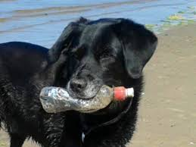
Green Dog Walkers
The Green Dog Walkers scheme is a UK wide community-based campaign to change attitudes about dog fouling. It is an innovative approach to dog fouling, one of the most controversial and most complained about issues we deal with in Causeway Coast and Glens Borough Council.
Dog owners and dog walkers support the scheme by signing a pledge to clean up after their pets. They support other owners to do the same by giving free poop bags. They are responsible dog owners demonstrating the importance of cleaning up dog mess.
If you see a dog wearing the Green Dog Walkers collar, this means the owner has taken the pledge:
- to always clean up after their dog
- to carry extra poop bags
- to give other dog walkers free dog poop bags
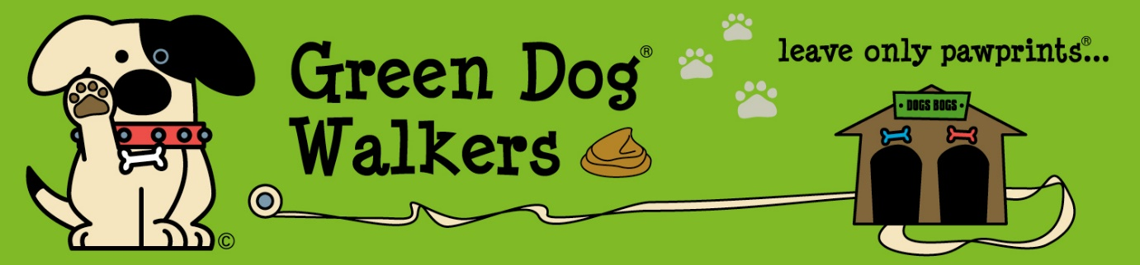

Cigarette ballot bins

Highlighting the issue of cigarette butt littering in an eye catching way whilst directly linking it to the problem.

A cigarette butt may look insignificant but it can pollute up to 7.5 litres of water in one hour and have a hugely detrimental effect on marine life.
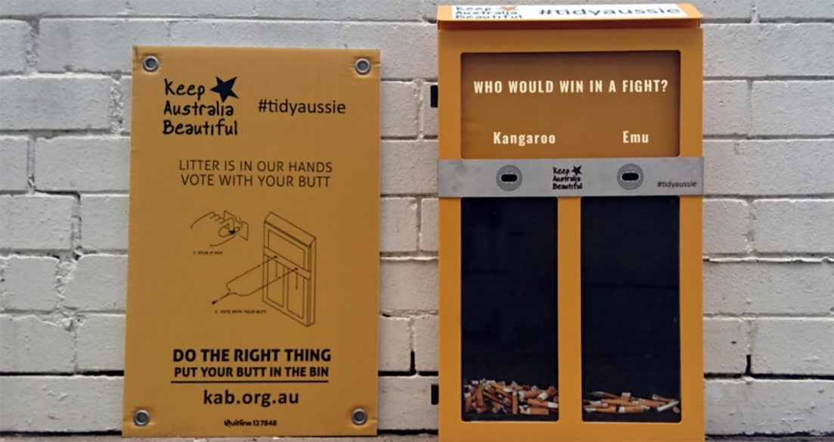

Business case study: Bruce Bailie, McDonald’s, Coleraine.

McDonald’s has set standards and guidance for all its restaurants to take action in litter control. Restaurants carry out daily litter patrols in the area, collecting all the litter found (not just McDonald’s-branded items). For operators that are open 24 hours, at least four litter patrols are carried out each day. Working with Keep Britain Tidy and its equivalents in the devolved administrations, McDonald’s restaurants also delivered over 400 clean up events in their communities in 2017 alongside their daily litter patrols. As part of their 2017 litter campaigns, many restaurants contacted local authorities and community groups to identify areas which they could support in collecting litter or spruce up. McDonald’s also has a number of other anti-litter projects ongoing, including: • A roadside littering intervention with Keep Britain Tidy looking at methods to reduce roadside littering in carefully selected locations; • A partnership with a media platform using gamification techniques to encourage drive thru customers to dispose of their litter responsibly. McDonald’s have also altered their guidance to all restaurants to ensure that any customer that wishes to refill their water bottle or to have a coffee in a reusable coffee cup can do so.
13.0 Get in touch - contact details
1. Operations Department (street cleansing enquiries)
Ballycastle – (028) 2076 2225
Ballymoney – (028) 2766 0222
Coleraine – (028) 7034 3453
Limavady – (028) 7776 0305
2. Environmental Resource Officer Team (EROs)
(028) 2766 0248
or/
email: recycle@causewaycoastandglens.gov.uk
3. Health & Built Environment (enforcement and fly-tipping)
(028) 2766 0233
or/
email: enforcement@causewaycoastandglens.gov.uk

