Labour Market Partnership
Action Plan 22-23
2022-2023
Labour Market Partnership Action Plan

Our team has a plan to help local people find jobs.

We work with lots of groups so people can:
- find jobs
- learn new skills, or
- start working for themselves.
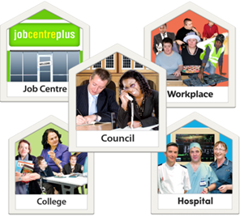
The groups include:
- Council staff,
- Schools and Colleges,
- The National Health Service,
- Careers Service,
- Enterprise Centres and
- Job Centre staff.
The plans help people to find a job or learn new skills.

We want lots of website visitors so people see how they can help.

Contact us:
If you are looking for a job, or want to learn a new skill.
You can contact us by:
Phone: 028 7034 7034
ask for extension: 3186
Email: LMP@causewaycoastandglens.gov.uk

By post to:
Labour Market Partnership
7 Connell Street
Limavady
BT49 0HA

