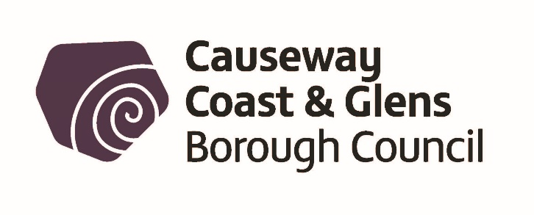

Health & Safety/Consumer Protection Registration Form

Business Details

Name of Proprietor of Business:

Premises Name:

Trading as:

Address (or address at which moveable premises are kept):

Postcode: |  | Telephone Number:

Email:

Nature of business/main activities:

Range of products supplied, where applicable:

Total number of employees: Full time: |  | Part time:

Number of males: |  | Number of females:

Name of Business/Organisation if different from above:

Address of business head office or registered office (if different from address of premises):

Telephone number:

Email address:

Is it a Limited Company? Yes/No

Name of nominated Company Representative:

Name of Manager:

Is the employer the owner of the building(s)/part of the building(s) containing the premises?
Yes/No

If no, state the name and address of the owner(s)

Name of owner of premises:

Address:

Telephone number:

State the name of the person(s) to whom the rent is paid if different from the premises owner.

Name of person(s) to whom rent is paid:

Address:

Telephone number:

Signature of employer:
(or persons authorised on his/her behalf)

Causeway Coast and Glens Borough Council
Riada House
14 Charles Street
BALLYMONEY
BT53 6DZ
Tel No: (028) 2766 0257
Email: healthandsafety@causewaycoastandglens.gov.uk

Privacy

As a public authority, Council takes your rights and freedoms seriously and is collecting this information in order to perform its statutory duties under legislation enforced by Council. The full privacy notice is available on the Council website:

https://www.causewaycoastandglens.gov.uk/footer-information/privacy-statement
or alternatively email environmentalhealth@causewaycoastandglens.gov.uk to obtain a copy.

Council will only release information when required under law or with your consent. Further information about your rights, how long information is held for, or how to contact the Data Protection Officer can be found on the privacy section of the website.

