Environmental Services
Estates Department

CEMETERY AND OLD BURIAL GROUNDS
RULES AND REGULATIONS

24th February 2016
(rev 9th Nov 2021)

DOCUMENT PROFILE
Guide Line No. 1.0 –Feb 2016
Document Purpose Rules & Regulations
Short Title Rules and Regulations for Council Cemeteries and Old Burial Grounds

Author Gareth Doyle
Publication Date 24 February 2016
Target Audience Public
Circulation List As requested
Description A Council rules and regulations document for Cemeteries and Old Burial Grounds
Linked Policies
Action Required
Review Date When any changes implemented
5th August 2019: Clause 9: Use of NAMM CoP revised to advisory (not obligatory)
6th March 2020 Clarification on memorial sizes/layout
9th Nov 2021 Change to memorial base height
27th Sept 2022 Removal of ambiguity on number of committals in one grave

Contact Details
Head of Estates
Environmental Services
Riada House
14 Charles Street
Ballymoney
BT53 6DZ

CAUSEWAY COAST & GLENS

CEMETERY AND OLD BURIAL GROUNDS RULES AND REGULATIONS

Cemeteries and Old Burial Grounds are managed and maintained by Council’s Estates Department located at Riada House, Ballymoney which is open Monday to Friday normal office hours (normal public holidays excepted). For further advice or information please call 028 2766 0200. A number of old graveyards within the Borough are also owned and maintained by Council.

Causeway Coast & Glens Borough Council (CC&GBC) welcomes all visitors to its cemeteries and old graveyards and would ask that visitors respect the peace, dignity and reverence of the facilities.

Cemeteries are managed and operated in accordance with the requirements of The Cemeteries Clauses Act, 1847, the Public Health (Ireland) Act 1878 and The Local Government (Miscellaneous Provisions) Order 1985 which also empowers the Department of the Environment to make regulations as to the management, regulation and control of burial grounds of borough councils.

The Old Burial Grounds are maintained in accordance with schedules agreed with the Environment and Heritage Service and are subjected to these Rules in so far as they apply.

These Rules & Regulations replace any previous policies/guidelines/approval process for Cemeteries. Existing Approvals cannot be taken as a precedent for future approval as previous approvals were granted by previous legacy councils and not by Causeway Coast & Glens Borough Council. Alterations to existing Approvals will need to comply with this Policy.

The Council shall not be responsible for carrying out any instructions to the Council made solely by telephone unless verified by the receipt of the correct documentation relating to the instruction within any specified time and delivered to the correct Council office.

1. Definitions

"Authorised Officer" means any officer or his nominee for the time being appointed by the Council, responsible for management and maintenance of cemeteries and maintenance of old burial grounds under the control of the Council.

“Cemetery Administrator” means the Council officer responsible for cemetery administration. Contact details contained in Appendix A

“Cemetery” refers to the cemetery provided by the Council at:

- Agherton Cemetery, Agherton Road, Portstewart
- Ballymoney Cemetery, Knock Road, Ballymoney
- Ballywillan Cemetery, Magherabuoy Road, Portrush
- Coleraine Cemetery, Portrush Road, Coleraine
- Enagh Cemetery, Scroggy Road, Limavady
- Kilrea Cemetery, Blackrock Road, Kilrea
- Portstewart Cemetery, Coleraine Road, Portstewart
- Rasharkin Cemetery, Finvoy Road, Rasharkin

“Old Burial Grounds” refer to the graveyards at:

- Aghanloo, Limavady
- Agherton Old, Portrush
- Agivey, Coleraine
- Ardclinnis, Glenariff
- Ballylintagh, Coleraine
- Ballywillan, Portrush
- Banagher, Limavady
- Bonamargy, Ballycastle
- Bovevagh Limavady
- Camus, Coleraine
- Derrykeighan, Ballymoney
- Desertoghill, Garvagh
- Glenariff Road
- Glenullin, Garvagh
- Downhill, Castlerock
- Dunluce, Portrush
- Kilraughts, Ballymoney
- Layde, Cushendall
- Loughan, Coleraine
- Priory, Limavady
- Queen Street, Ballymoney
- Ramoan, Ballycastle
- Tamlaght Finlagan, Limavady
- Templastragh, Port Bradden
- The Knockans, Ballymoney
- Vow, Ballymoney
- Walworth, Limavady

“Council” means Causeway Coast & Glens Borough Council (CC&GBC).

“Cemetery” means a burial ground operated by Council.

“Grave” means a burial place formed in the ground by excavation without any internal wall, brickwork or stonework or any other artificial lining.

“Burial” means the interment of human bodies or cremated remains including still born children.

“Memorial” means a ‘headstone’ or monument as described in these rules for the purposes of marking a grave. It excludes for example, footstones, railings, landings, surrounds, plinths or other adornment.

“Public Ground” means ground acquired for the purpose of a single burial. Graves shall be opened consecutively in such order as the Council shall from time to time determine. No monument, headstone, headblock, plinth, railing or other erection shall be erected or placed on or around the graves, nor shall the graves be permitted to be planted or otherwise decorated or dressed.

“Resident” means a person residing within the Borough of Causeway Coast & Glens.

“Scale of charges” means the scale of charges from time to time in force for the use of the cemetery.

“Un-purchased, public or common grave” means a grave in which no exclusive right of burial has been or will be granted by the Council and in which unrelated persons may be interred.

2.0 Management of Cemeteries

2.1 Cemeteries will be open to the public daily from 8.30 .a.m. to 8.00 p.m. April to September and 8.30 .a.m. to 4.30 p.m. October to March unless otherwise determined by Council.

  - Old Burial Grounds are accessible during daylight hours.

  - No person other than a person authorised by CC&GBC shall enter or remain in the cemetery at any hour when it is closed to the public.

  - All persons entering the cemetery will be subject to the orders and control of CC&GBC or any person authorised by the Council.

  - Application forms and forms of notice in connection with burials and interments may be obtained from the Cemetery Administrator’s office (see Appendix A).

3.0 Conduct within Cemetery and old burial grounds

3.1 All persons shall conduct themselves in a decent quiet and orderly manner. Anyone committing any of the following acts shall be guilty of an offence:-

- Enter or leave the Cemetery except by one of the entrance gates; or
- Walk, or trespass upon any of the shrubberies; or
- Injure any tree, plant or shrub; or pluck any flower; or
- Meddle or interfere with any gravestone.
- Wilfully create any disturbance in a cemetery
- Commit any nuisance in a cemetery
- Willfully interfere with any burial taking place in a cemetery
- Willfully interfere with any grave or any other memorial or any plants on any such grave, or
- Play at any game or sport in a cemetery
An authorized officer may remove from the cemetery any person who shall conduct himself or herself improperly therein, and may prevent any person from entering the Cemetery during such prohibited hours as may be fixed from time to time by the Council.

3.2 Any person found vandalising any part of the cemetery or desecrating any grave plot will be liable for prosecution by the Council under the provisions of The Cemeteries Clauses Act, 1847, the Public Health (Ireland) Act 1878 and The Local Government (Miscellaneous Provisions) Order 1985.

3.3 All enquiries, complaints and requests by members of the public relating to cemetery operations must be made to the Estates Department of the Council, Riada House, Ballymoney, and not to the workmen in the cemetery or old graveyards.

3.4 Subject to the provisions of the Rules with respect to the cemetery and old graveyards, dogs shall not be admitted. This rule shall not apply to a blind person in respect of any accompanying guide dog.

3.5 Children under 16 years of age are not permitted in the cemetery except under the care and supervision of a responsible adult.

3.6 No person shall sell or offer for sale any article, commodity or thing of any kind whatsoever or solicit for orders for the same within a cemetery.

3.7 Any person using a motor vehicle in a cemetery shall only do so on a carriageway suited to the purpose and with the consent of the Council, and shall abide by the speed limit in force at that time. Permits/fobs allowing vehicles to be driven into the cemetery for any purpose other than attending a funeral must be obtained from Estates Department on application. The criteria for obtaining a permit/fob can be obtained from the Council office, Riada House, Ballymoney. Please note there may be variations in access arrangements to different Council Cemeteries due to their unique layouts.

3.8 No person shall ride a bicycle, skateboard or other similar equipment in the cemetery or old graveyards.

3.9 No person shall drop, throw or otherwise deposit and leave in the cemeteries any wastepaper or refuse of any kind except in the litter bins provided.

3.10 No person shall operate any sound reproducing equipment or play any musical instrument in the cemeteries without the prior consent of the Council.

3.11 No photographs for commercial purposes may be taken in the cemetery without the prior consent of the Council and where applicable the holder of the deed of the Exclusive Right of Burial.

3.12 Funerals should arrive on time as failure to do so may conflict with other funerals.

3.13 Regard shall be given to any Byelaws applicable to the cemetery concerned.

4.0 Interments

4.1 No grave shall be opened for interment except on application in writing of the registered owner thereof or of some person purporting to act on his/her behalf and producing the Certificate.

4.1.1 A person requiring to have an interment made in any grave should liaise with his/her Funeral Director/Agent who shall submit the appropriate application form to the Registrar (Appendix A). No public announcement of funeral arrangements should be made until agreed with Council. Requests for weekend interments must be made before 12 noon on Friday and 1pm Saturday for Monday interments. Note that it is not possible to provide interment times before 12 noon on a Monday

4.1.2 In addition to the foregoing, details of the size of opening required in the lawn plot must be advised e.g. standard coffin, oversized coffin (which may necessitate purchase of double grave) or in the case of cremations, still-born and infants under 1 year old any requirement which differs from Council’s policy in respect to these burials.

4.1.3 To facilitate this all requests for interment and payment therefore shall be made to the Registrar’s Office during normal working hours Monday to Friday (see Appendix A).

    - All written applications must be submitted on the prescribed form of Notice of Interment to CC&GBC at least 24 hours prior to the appointed time of the interment, signed by the holder of the Exclusive Right of Burial (if applicable) and accompanied by the appropriate fee for interment. At weekends Bank and Statutory Holidays written notice must be emailed to the relevant office (Appendix A) and payment made on the next working day. The application forms are available from the Register’s Office or Estates Department.

4.2 The Council shall not be responsible for:

- Any discrepancies, errors or omissions in any notice of interment or other document which is required to be given or served on the Council or for liability arising from such discrepancies, errors or omissions.

- The late receipt of any notice of interment or other document which is required to be given to or served on the Council or for liability arising from such late receipt.

4.3 Hours of Interment

4.3.1 The standard hours during which the Cemetery will be open for interment will be:- from 10.00am .to 4.00p.m. from 1st April to 30th September and, from 10.00 a.m. to 3.00 p.m. from 1st October to 31st March.

4.4 Any form of religious service may be used, but any other ceremony is subject to the approval of the Council. Alternatively, the coffin may be committed without a service.

4.5 A certificate for disposal issued by the Registrar of Births, Deaths, Marriages and Civil Partnerships or a Coroners Order for Burial or a duplicate thereof must by law be delivered to the Council or its Authorised Officer

4.5.1 In the event of a Certificate signed by a qualified medical practitioner being produced, certifying that immediate interment of a body is essential to public health, the Authorised Officer shall make arrangements for the interment of such body without requiring the prescribed length of notice.

4.5.2 In the event of the Borough being visited by an epidemic of disease or other disaster the Council may make special orders regulating the order of interments, and the length of notice to be required therefore.

4.6 In the case of an interment of cremated remains (ashes), the cremation certificate/death certificate will be required for burial purposes by the Council.

4.7 In the case of a non-viable foetus, the Medical Practitioner or Midwife's certificate of delivery will be required.

4.8 All graves will be prepared by persons employed by the Council and situated as near as possible to the centre of the lawn plot and subject to: -

    - The depth for opening a grave for the first time shall be a maximum of 2.75m (dependent on ground conditions which may limit the number of committals in one grave).

    - Subject to discussion with the family (or their representative) Council will either
- Bury the remains of still born and very young infants at the bottom right hand corner of the grave at a depth of approximately 1.2m or
- Bury at full depth.
Option 1 allows the grave to be used for up to three further occasions (depending on ground conditions) for family burials without interference or disturbance of the child’s coffin.

4.8.3 No coffin shall be laid in any grave nearer to the surface of the ground than 0.9m, measured from the upper surface of the coffin.

    - Having regard to the regulations as to interments and the depth at which
coffins are to be placed below the surface of the ground, the appropriate Council official’s decision shall be final.

4.10 No interment will be permitted unless the body of the deceased person is contained in a coffin considered suitable for interment in a grave.

4.11 Every coffin must bear details of the deceased person therein and may only contain one body except in the case of a mother and her baby(ies).

4.12 Save as specially provided for in these Rules, no grave shall be opened nor shall any body nor the remains of any body be removed from a grave nor transferred from one place of burial to another, nor exhumed, except under circumstances and subject to the conditions specially provided by law in that behalf. Original documents will be required for this purpose.

4.13 Before a burial can take place, Funeral Directors must supply a Risk Assessment and Method Statement (RAMS) covering the burial process.

4.14 Funeral Directors are solely responsible for delivering coffin to graveside. Council can supply two staff to assist in lowering of coffin into grave and for no other purpose.

4.15 Interment of cremated remains (ashes) in the cemetery.

4.15.1 Cremated remains (ashes) may be interred in caskets or container of biodegradable material in conventional purchased graves. There is no facility for the scattering of cremated remains (ashes).

4.15.2 Interment of cremated remains (ashes) in the Cemetery is permitted on payment of the fees prescribed on the Scale of Charges.

4.16 No purchase in reserve will be available and graves will be allocated and numbered sequentially.

4.17 Floral tributes

On the day of the funeral, flowers and wreaths may be placed upon the grave in which the burial takes place.

    - The Council does not provide vases for floral tributes.

4.17.2 Glass covered wreaths on graves and erection of pillars, railings, fences, plinths, hoops or other structures around graves are prohibited and if so placed will be removed immediately by the Estates Department staff.

4.17.3 No trees or shrubs may be planted.

4.17.4 Wreaths or other floral tributes may remain for up to two months and will then be removed at the discretion of the Estates department if/when they get into a poor state. Following this period floral tributes must be confined to an area 1200 x 900mm at the memorial end of the grave.

4.17.5 No other receptacles will be permitted including those for pot plants.

4.17.6 Donations of seats, trees or rosebushes are not permitted for placement within cemetery.

4.17.7 The Council will not be responsible in any circumstances for any loss, injury or damage to monuments, wreaths, shades, flowers or other mementos at or upon the graves. The Council reserves the right to remove any of these which in its opinion are detrimental to the appearance of the Cemetery.

5.0 Fees and Charges

5.1 Fees for all cemetery services will be determined by the Council annually to take effect from 1st April each year (refer to Registrar’ Office – see Appendix A).

6.0 Non-residents

6.1 Non-residents fees will be charged as determined by Council.

6.2 Non-residents may be interred in graves where the Exclusive Right of Burial has been purchased. Residents shall include a person who at the time of purchasing a grave was a resident within CC&GBC.

6.3 Resident status may be granted to other persons at the discretion of the Registrar. If a resident subsequently leaves the Borough they lose residency rights after 5 years.

6.4 Where the “exclusive right of burial” in a grave space owned by a resident, the spouse, widow or widower, father, mother, father in law, mother in law, sons, daughters (or their spouses) brothers, sisters (or their spouses) of such owners if residing outside the borough may be interred in such grave on payment of the non-resident fee prescribed in the scale of charges.

7.0 Exclusive Right of Burial

7.1 The Exclusive Right of Burial in a grave may only be purchased at the time of the interment on payment of the appropriate fee and completion of the relevant application form including the signature of the proposed owner. The right of burial in more than 3 graves will not be sold to, or vested in any one person, and no-sub-division of any plot purchased shall take place without the prior consent of the Council. There is no provision for the pre-booking of a specific grave plot.

7.1.1 A person desiring to purchase the exclusive right of burial shall sign an application therefore binding himself, his heirs and assigns, to take all responsibility for the nature of the ground and to conform to all rules and regulations in force or thereafter to be made by the Council for the regulation, management and control of the cemetery.

7.1.2 The purchaser of grave space shall obtain from the Council a grant of exclusive right of Burial (in the prescribed form) stating the name and residence of the purchaser, the amount of purchase money paid, the number of the grave or graves and the number in the Register - such grant to be signed by the Town Clerk and Chief Executive or other authorized officer.

7.1.3 One person only shall be registered as the proprietor of a right of burial; joint ownership is prohibited.

7.1.4 If the registered owner of a right of burial shall prove, by statutory declaration or otherwise, to the satisfaction of the Council that he has lost his Certificate, he shall be entitled, upon payment of the prescribed fee to receive a duplicate thereof. Provided that if the original Certificate should afterwards be discovered, the duplicate certificate shall not have any force or effect, and it shall be endorsed with a memorandum to that effect.

7.2 Exclusive Rights will not be sold to Funeral Directors, their agents or other persons for re-sale. The Council will mark every grave space according to the official plan.

7.3 The Exclusive Right of Burial entitles the deed holder to determine who is buried in the grave and whether a memorial can be erected on the grave. All such private graves will be excavated to the standard depth determined by the Council. The Council will not be held responsible if due to factors outside its control the full number of interments cannot be achieved.

7.4 New graves will be allocated in strict rotation.

7.5 A plan showing the division of the cemetery with grave spaces marked thereon may be inspected by prior arrangement with the Registrar or Estates Department during normal office hours.

7.6 Transfer of the Exclusive Right of Burial

7.6.1 No person claiming to be entitled to the right of burial in a grave under a transfer or bequest of such right, or as the heir-in-law of a proprietor dying intestate, shall be entitled to have such claim recognised, or the name of such person entered in the Register as proprietor thereof, until the transfer or probate under which such person claims to be entitled, or particulars of the intestacy and succession and the Certificate issued to the original proprietor shall have been produced to the Registrar and such further or other evidence of the claim produced as may be required of the right thereto. Upon production of such documents, particulars and evidence and the claim being duly proved to the satisfaction of the Council and upon payment by the claimant of the prescribed fee, and entry thereof shall be made in the Register. Until such entry shall be made, and Council indemnified against any future claims arising over rights to burial, no right of burial shall be acquired under any such transfer, probate or intestacy.

7.6.2 The Grantee or his legal personal representative may transfer the right of burial in a grave space, subject to the proper notice of such transfer being given to the Council in the appropriate form (obtainable from the Registrar. The Council will then register the transfer and endorse a note thereof on the grant.

7.7 Following the decease of the grantee, the exclusive right of burial in any grave space, must be transferred and re-registered before the grave can be further re-opened or any headstone erected thereon or any existing headstone repaired, altered or removed.

8.0 Cemetery Memorials

8.1 Subject to the provisions of these regulations, memorials must be of a hard natural stone such as granite of a design approved by the Council and must conform to the following dimensions and may only take the form of:

- Memorials at the head of each grave must not exceed 1.2m in height above ground level, measured from mid-point of grave; 915mm in width (pro rata for 2 or 3 graves) with a minimum thickness of 75mm and a maximum of 150mm erected on a base not exceeding 1070mm in length (pro rata for 2 or 3 graves), 300mm in width and 125mm thickness. Where memorial extends across 2 or 3 graves, bases should be constructed to ensure the maximum height of 1.2m must not be exceeded at the mid-point of each grave.

- Monuments including carved figures, scroll, open books or other type of monument approved by the Council must not be greater in dimension above ground level than could be cut from a solid block 1.2m high 600mm long and 380mm wide erected on a base not exceeding 760mm in length, 450mm in width and 75mm thickness and to be placed within the designated area at the head of the grave.

- All memorials must be capable of being freestanding and must be so fixed that they are bonded firmly to a concrete foundation. This would normally entail the use stainless steel/galvanized dowels along with adhesive.

- The method of fixing and positioning of all memorials shall be carried out to the satisfaction of Estates Department.

- No footstones, kerbs, landings, surrounds or memorials of any other description will be permitted.

- Sections laid out and maintained in a ‘lawn system’ shall have all memorials set in an area 1.2m wide by 0.9m at the end of the grave consistent with the other memorials in that row. Note that the ‘lawn system’ layout dictates that memorials shall be at the head or foot of the grave depending on which row the grave is located. The remaining portion of each grave shall be sown or planted in grass and left clear of any vases, holders and/or other tributes.

8.2 All headstones or monuments to be erected on graves and all inscriptions to appear thereon shall be subject to the prior approval of the Council. In this respect a drawing showing (1) the dimensions with particulars of materials to be used of the proposed erection and (2) any inscriptions to appear thereon shall first be submitted to the Cemetery Administrator. Any additional inscriptions at a later date require Council approval.

8.3 No headstone or monument of any kind will be allowed to be set up unless on a substantially built foundation, and in the event of any encroachment on neighbouring ground taking place the Council reserves to itself the right to remove the headstone or monument at the expense of the person so offending (See Regulation No.8.1).

8.4 Purchasers of an exclusive right of burial shall employ their own workmen to erect any memorial or to remove and replace the same at the re-opening of a grave. Such workmen shall comply with such conditions as may be specified by the Council, and in case of any contravention of such conditions, the Authorised Officer of the Council shall be empowered to order any workmen to leave the cemetery and to prevent their re-entry thereto.

8.5 No masons, letter cutters or other workmen engaged in fixing, delivering, painting or repairing memorials will be admitted to the cemetery on Saturdays, Sundays, Christmas Day, Good Friday and public holidays, or on any other day before 9.00am and must leave the cemetery no later than the official closing time.

8.6 Should any memorial conflict with a re-opening of a grave, it will be the responsibility of the family to remove the memorial. It may be stored within the cemetery only by agreement until such times as the family return it to its permanent location.

8.7 Any memorial removed from a grave to facilitate an interment shall be replaced as soon as practicable by the family, but in any case within 3 months of interment.

8.8 The Council will not accept responsibility for any accidents to memorials etc., occasioned by storm, wind, lightning, subsidence or other cause, or by third parties, but reserves the right to remove any damaged article subject to and in accordance with the provisions of these rules.

8.9 Any persons found soliciting orders within the cemetery for the erection or repair of memorials will be required to leave the cemetery and will not be admitted gain without the permission of the Council.

8.10 Any erection placed on a grave without the approval of the Council shall be removed, and any erection allowed to get into a bad state of repair may be repaired, or if necessary, removed by the Council, and the cost of doing so in either case shall be a debt from the registered owner of the grave to the Council and recoverable as such.

9.0 Memorial applications

9.1.1 A memorial may only be erected on a grave space within the cemetery subject to obtaining the Council's permission and upon payment of the appropriate fee. (The relevant application form may be obtained from the Registrar or Estates Department.) The right to erect a memorial rests with the Exclusive Right deed holder or their next of kin or executor.

9.1.2 The erection of a memorial on an unpurchased/public/common grave will be subject to the discretion of the Council and in accordance with these regulations and upon payment of the appropriate fee. Where permission is granted to erect a memorial on such a grave, it will be subject to the right of the representatives of other persons interred in the grave to have those persons commemorated thereon. As there is no right to erect a memorial on an unpurchased, public or common grave, such a memorial does not in itself confer any rights and remains at the pleasure of the Council.

9.2 Application for the approval to place a new memorial in the cemetery, alter or add any inscription, or replace, add to or remove from the cemetery any memorial must be submitted to the Council on the appropriate Memorial Application Form provided by the Council.

9.3 Memorials will only be permitted to be erected by stonemasons, who have submitted to the Council appropriate risk assessments and safe working procedures for the erection of memorials and who also possess valid public liability and employer’s insurance cover. Stonemasons may wish to refer to the Code of Practice issued by the National Association of Monumental Masons for guidance on memorial erection.

9.4 The name, address and signature of the person placing the order for the memorial work to be undertaken must be the owner of the Exclusive Right of Burial. No other signature will be accepted. If such owner of the Exclusive Right of Burial is deceased, the next of kin must make application to transfer such exclusive rights or on production of proof of identity, make application as the executor for the deceased.

9.5 The approval of the Council for any such application will be confirmed by the issue of a Memorial Permit which will be valid for 6 months but this may be extended at the discretion of the Authorised Officer. No works will be undertaken unless a permit has been issued. The permit is issued on the understanding that the work undertaken will comply with the details specified within the application form and the requirements of these regulations.

9.6 Prior to commencing work stonemasons must hand over the official memorial permit (issued by Registrar) to the person at the cemetery appointed for that purpose.

9.7 Anyone erecting a monument or who undertakes any Memorial work within the cemetery not in compliance with these regulations will be required to remove the said memorial and pay all costs involved.

9.8 All memorials shall be kept in repair by the owners, and in the event of any memorial falling into disrepair and the necessary repairs not being carried out within 6 months after notice from the Council, the memorial may be removed by the Council subject to and in accordance with the provisions of these rules.

9.9 The Council reserves the right to:

9.9.1 Remove any memorial which has become or is likely to become dangerous or which is in a derelict or unsightly condition.

9.9.2 Exclude or remove from the cemetery any memorial not executed in a workmanlike manner or from sound materials or which in the opinion of the Council disfigure the cemetery or offend public decency.

9.9.3 Remove any memorial which has not been approved by Council.

9.10 Drawings of all proposed memorials with particulars of materials to be used and inscriptions shall be submitted on the appropriate form to the Council together with the appropriate fee.

9.11 Metal clamps or dowels for memorials shall be of a non-corrosive type.

9.12 Every memorial shall have the grave number cut conspicuously on the base of the memorial

9.13 Photographic plaques of an approved size may be affixed to monuments. Images shall be monitored by Council for appropriateness

9.14 Temporary memorials in the set form of a wooden cross can be erected providing they do not exceed 910mm (3'0") in height above the ground.

9.15 All workmen employed on behalf of the owner of the exclusive right of burial or personal representative of such person, to erect any monument shall carry out their work strictly under the direction of the Council and shall:-

- At the cost of the owner, or personal representative, fill up and level the ground, remove all waste and unwanted material and make good any damage or injury whatsoever occasioned in the process of work.
- Provide their own tools and equipment and complete the work with due dispatch.
- The Council must be informed of the removal of any memorial from the cemetery.

10.0 Maintenance and upkeep

10.1 Items of pottery, tin, plastic or glass, wire mesh or plastic fences or other materials are not permitted and will be removed by the Council without notice.

10.2 As soon as convenient after the interment and during the appropriate season the Council will add soil, if necessary, sow grass seed or lay turf over the area of the grave. Artificial grass will not be allowed to be placed over the area of the grave.

10.3 No persons other than duly authorised officers of the Council shall interfere with or alter the grass area of the grave, which will be maintained by the Council at no cost to the owner of the grave.

10.4 Flowers, shrubs or trees of any kind or wreaths or flower containers etc. will not be allowed to be taken out of the cemeteries without permission of the Estates Department or the written permission of the owner of the article concerned.

10.5 No trees or shrubs including rosebushes shall be planted on any lawn plot whether the exclusive right of burial has been purchased or not. The Council reserves the right to cut down any existing shrub, tree or plant which becomes unsightly or overgrown or causes encroachment.

11.0 Memorial Garden

11.1 Trees/shrubs may be purchased and planted in Memorial Garden sections adjacent to cemeteries. The location within the Garden will be determined by Cemetery staff.

11.2 Any additional adornment around the base of the tree/shrub must conform with the following restrictions:

- All adornments must not extend beyond 0.5m from the memorial tree (paviors, stone chippings etc).

- Height is restricted to a maximum of 200mm for stone/concrete plinths/surrounds.

- Memorial plaques restricted to a maximum height of 450mm.

- Items of pottery, tin, plastic or glass, wire mesh or plastic fences are not permitted.

- All adornments shall be kept in repair by the owners, and in the event of any adornment falling into disrepair and the necessary repairs not being carried out within 3 months after notice from the Council, the adornment may be removed by the Council subject to and in accordance with the provisions of these rules.

11.3 Cemetery staff should be consulted to ensure any proposal meets with approval and is in line with these Rules & Regulations.

12.0 Miscellaneous

12.1 Undertakers shall give notice to the Registrar or Estates Department whenever they have a funeral which is likely to be numerously attended.

12.2 The Register of Burials is kept at the Registrar’s office or Estates Department of the Council. The Register is held and searches may be requested and extracts obtained there from upon payment of the fees prescribed in the Scale of Charges.

12.3 Gratuities are not allowed to be paid to persons employed at the cemeteries.

12.4 Questions arising for which no provision is made in the Regulations shall be referred to the Council (or any Committee or Officer of the Council to which the Council has delegated its powers on this behalf) whose decision shall be final.

12.5 The Council reserves to itself the right to revise these regulations at any time.

12.6 Any complaint relating to any aspect of the Cemetery Service should be made in writing to the Head of Service for Estates & Facilities.

13.0 Revocation

13.1 All other regulations for cemeteries and old burial grounds previously made by Ballymoney Borough, Coleraine Borough, Limavady Borough and Moyle District Councils are hereby revoked.

Appendix A

CEMETERIES ADMINISTRATION
Opening Hours 9:00am to 12:30pm

Cemeteries@causewaycoastandglens.gov.uk
Cloonavin
66 Portstewart Road
Coleraine
BT52 1EY
Tel 028 7034 7094

Registrar Offices
Opening Hours 9am -12 pm and 2pm -5pm (last appointment 4.30pm)
Except Moyle – no afternoon appointments

BALLYMONEY
janet.mccaughey@causewaycoastandglens.gov.uk
Riada House
14 Charles Street
Ballymoney
BT53 6DZ
Tel 028 2766 0206

COLERAINE
gwyneth.kerr@causewaycoastandglens.gov.uk
Amanda.Cochrane@causewaycoastandglens.gov.uk
Cloonavin
66 Portstewart Road
Coleraine
BT52 1EY
Tel 028 7034 7020/028 7034 7021

LIMAVADY
monica.anderson@causewaycoastandglens.gov.uk
7 Connell Street
Limavady
BT49 0HA
Tel 028 7772 2226

MOYLE
imelda.mcauley@causewaycoastandglens.gov.uk
Sheskburn House
7 Mary Street
Ballycastle
BT54 6QH
Tel 028 2076 2225

Appendix B – Lawn Cemetery Zones

Portstewart New Cemetery

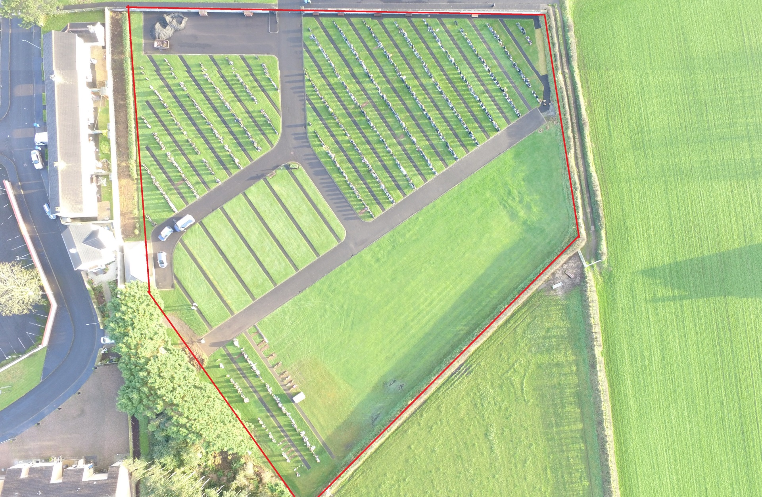

Agherton Cemetery

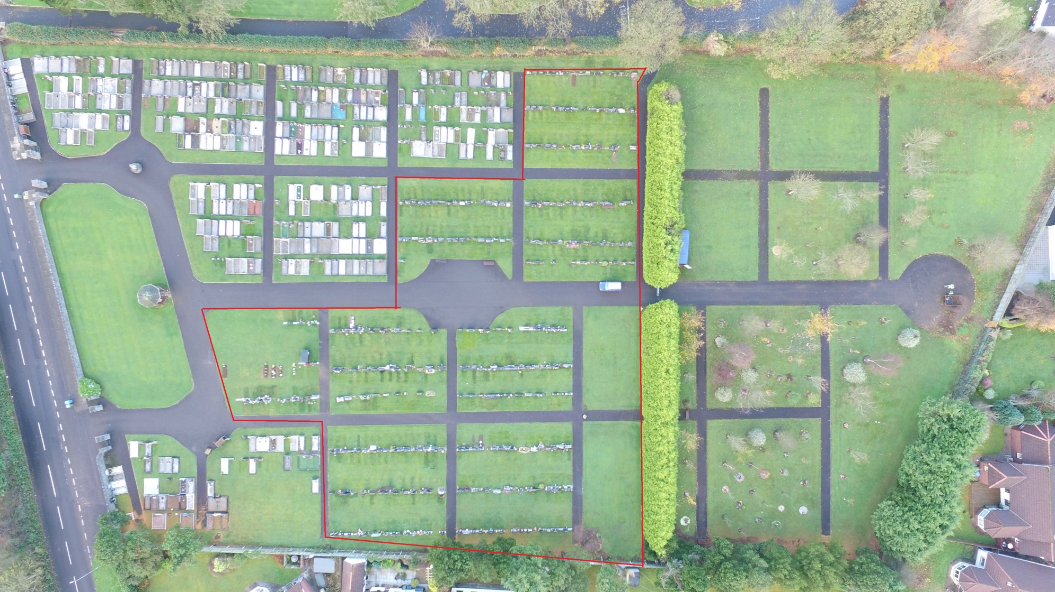

Limavady Cemetery

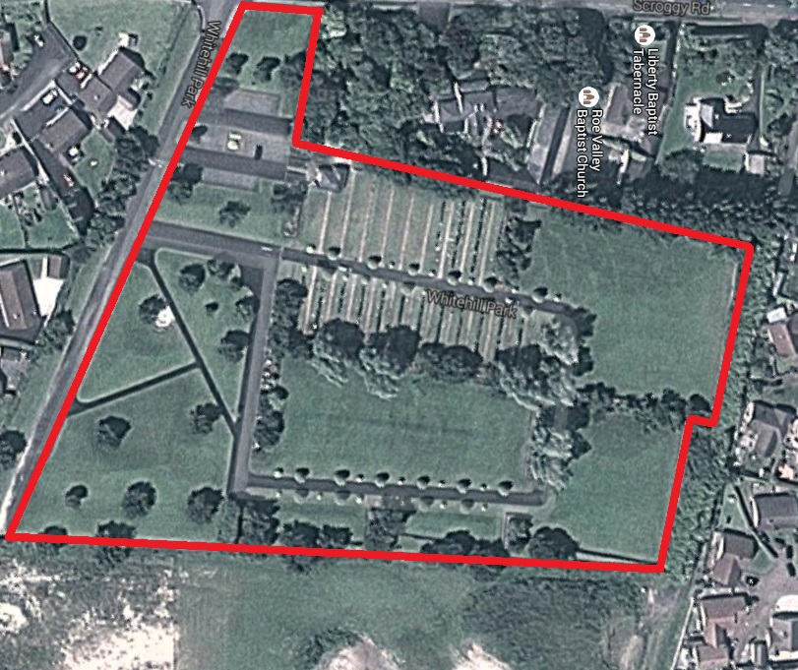

Rasharkin Cemetery

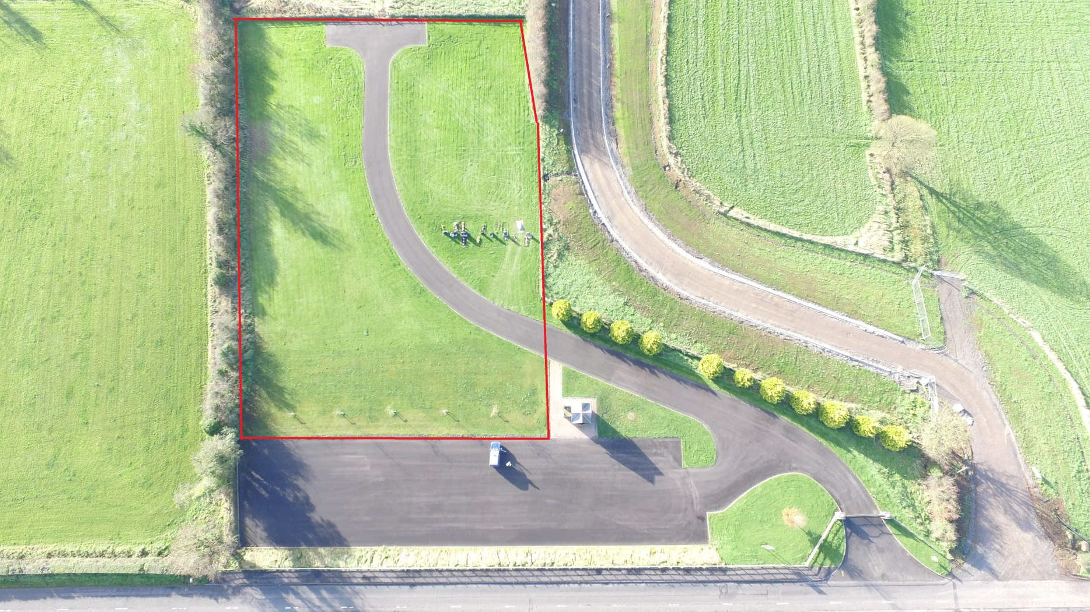

Kilrea Cemetery

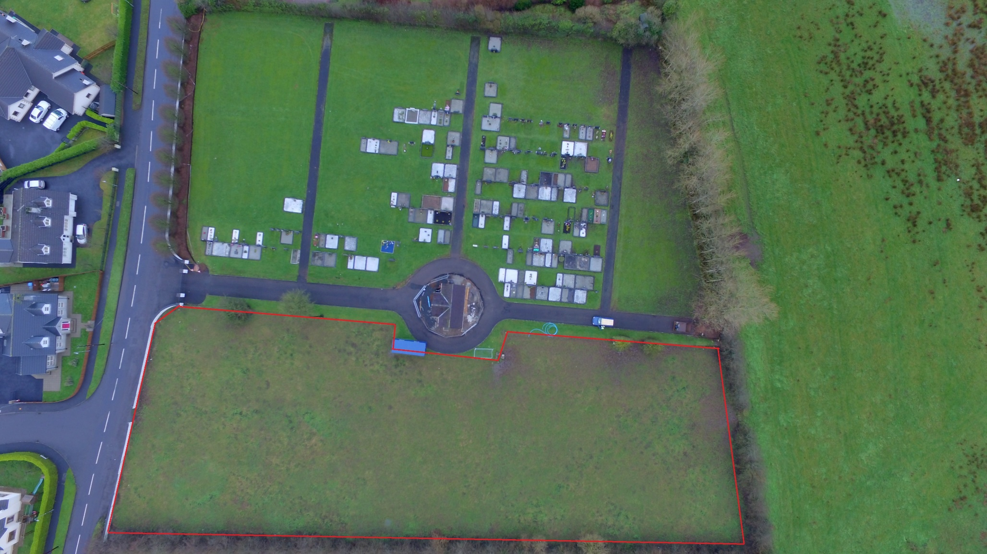

Ballywillan Cemetery

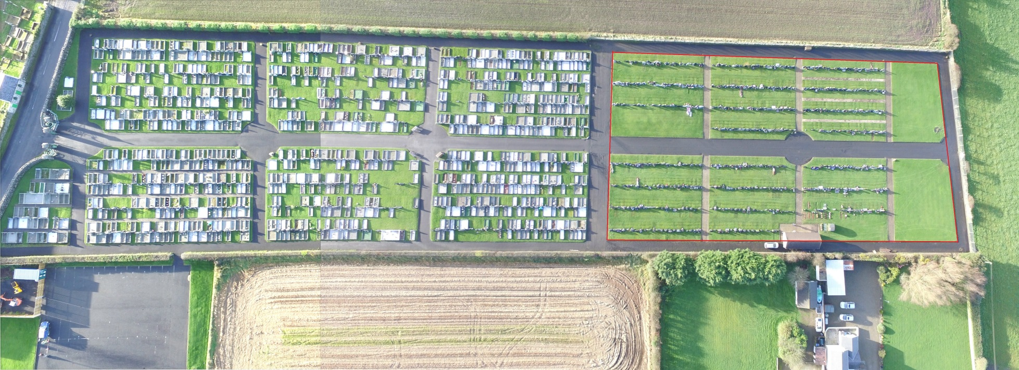

Portstewart Central

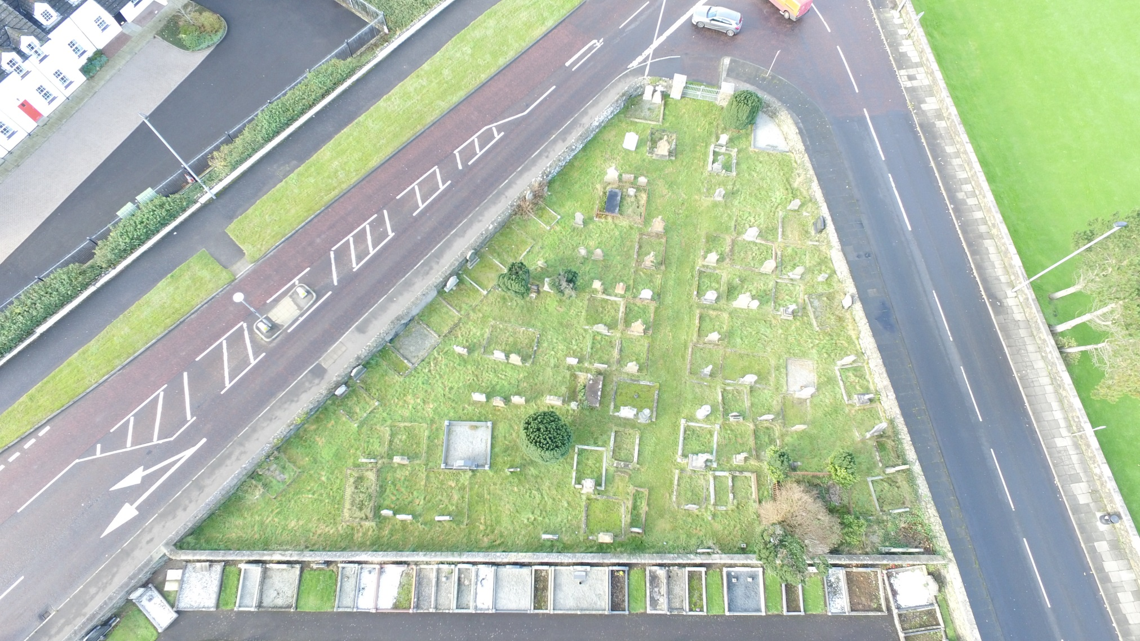

Coleraine Cemetery

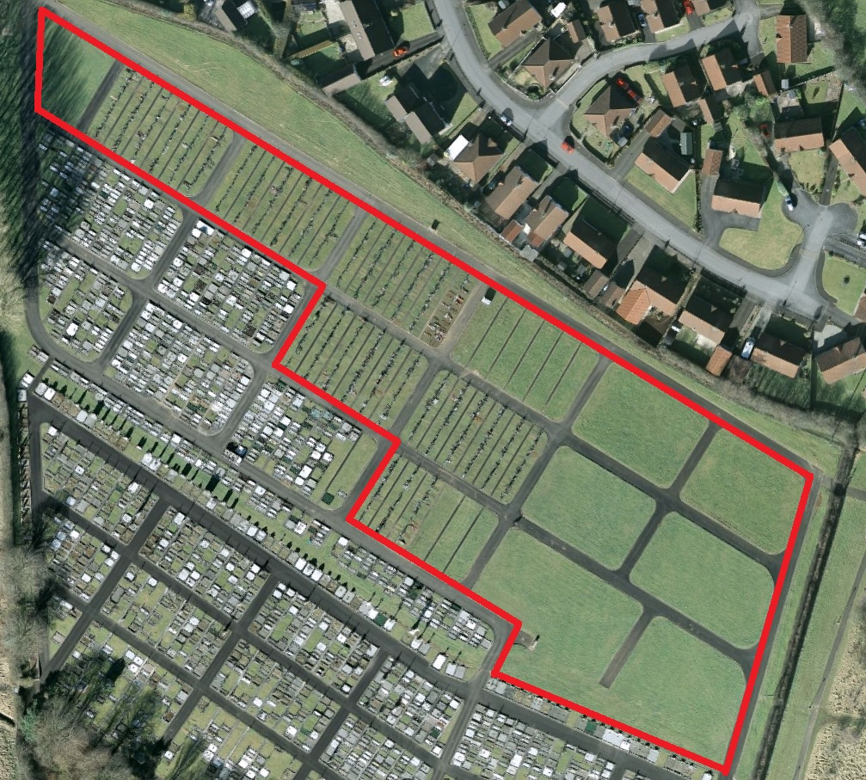

Ballymoney Cemetery

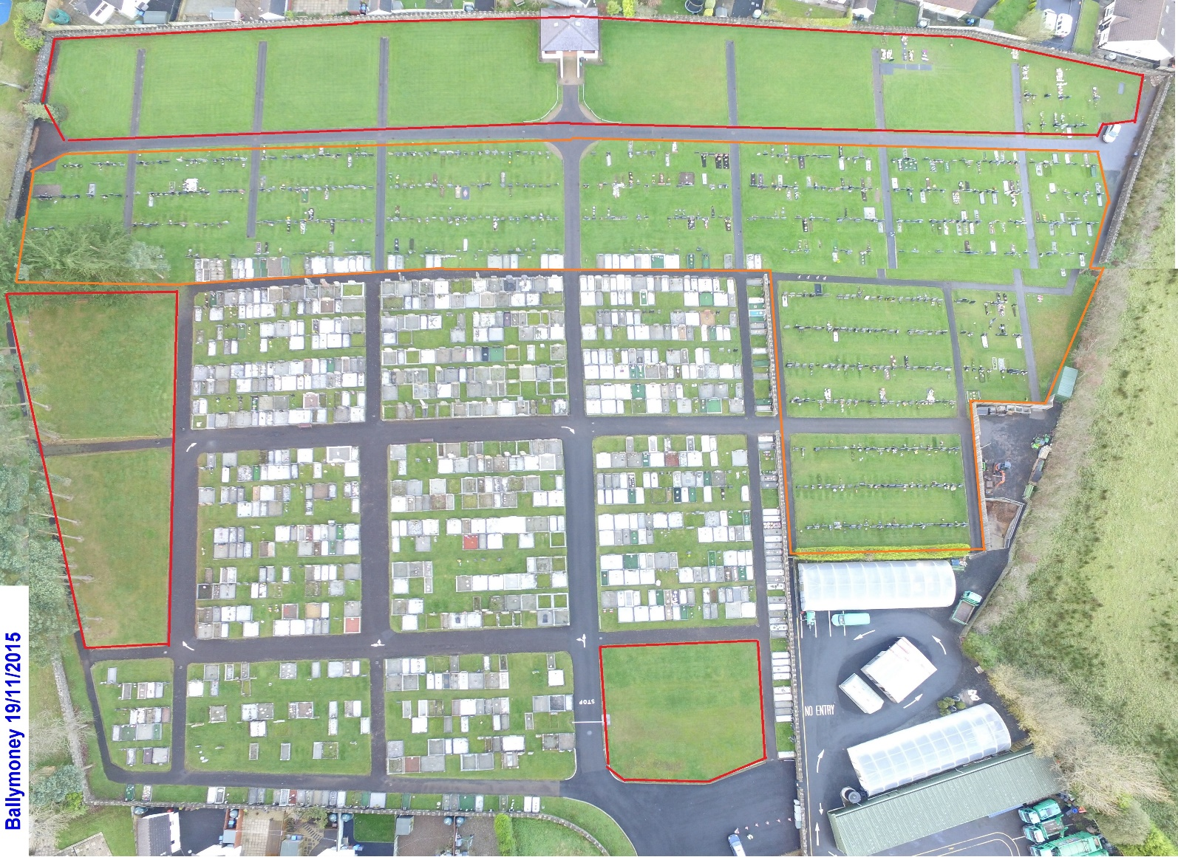

NB.

At the Council meeting on 23rd February 2016 Causeway Coast and Glens Council approved these Cemetery Rules and Regulations and agreed that all unauthorized surrounds or memorabilia installed in lawn cemetery zones prior to this date were to remain in place.

