Easter Sport Camps
For young people aged 5-14 years

£24 for each child and for each camp they come to

Camp dates:
Wednesday 12 April 2023
Thursday 13 April 2023 and
Friday 14 April 2023

Come and try:
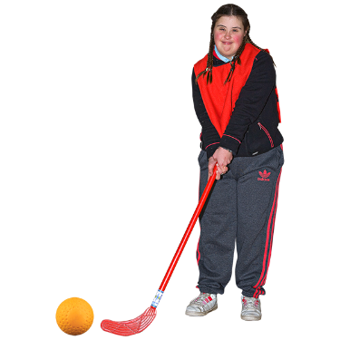
Hockey
10am to 12 noon
Roe Valley Leisure Centre
Gaelic Sports (Football & Handball)
10am to 12 noon
Glens Youth Club Cushendall

Football
10am to 12 noon
Quay Road Ballycastle

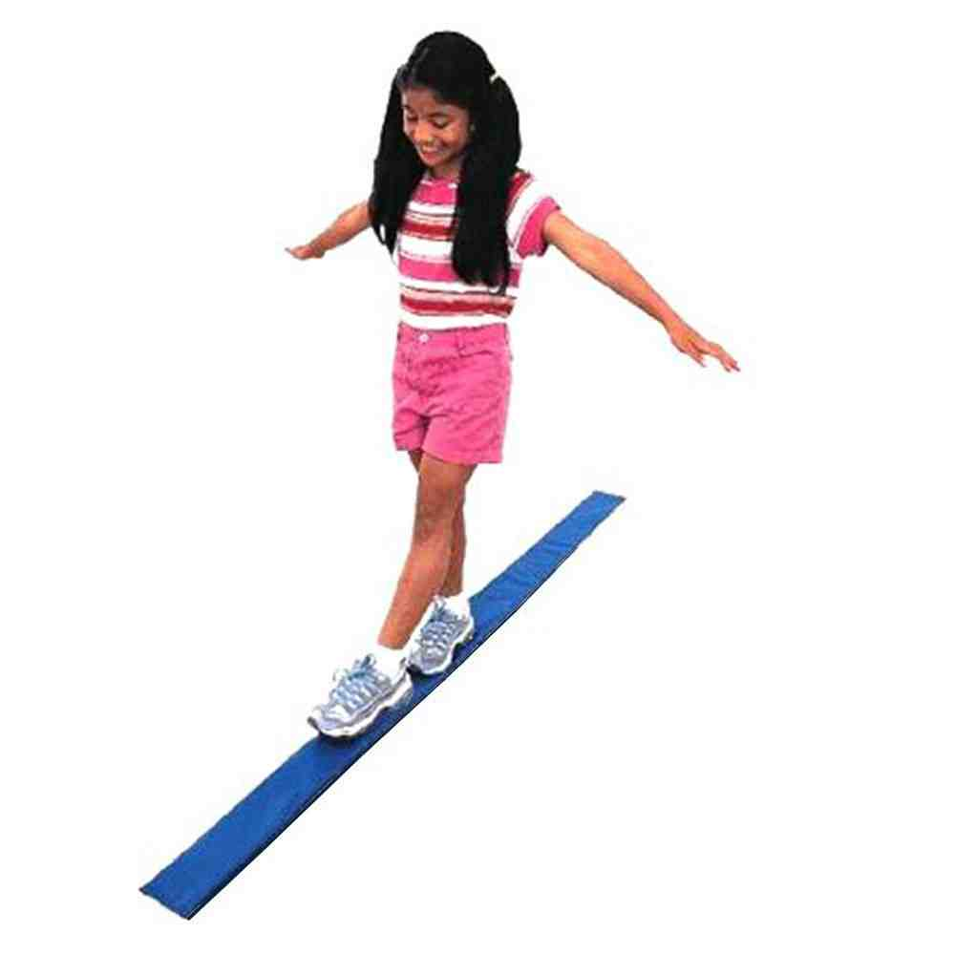
Gymnastics
For ages 5-7, 10am to 11.30am
For ages 8-11, 12 noon to 1.30pm
Dungiven Sports Centre

Cricket
10am to 12 noon
Rugby Avenue Coleraine
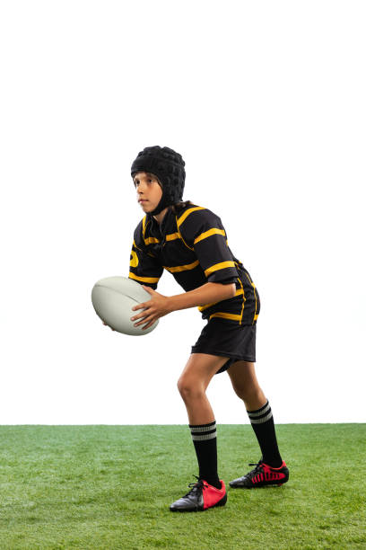
Rugby
10am to 12 noon
Ballymoney Rugby Club

Book a place
You can book a place at:
Coleraine Leisure Centre
Joey Dunlop Leisure Centre
Roe Valley Leisure Centre
Book all sports (except hockey) on-line using this link:
Easter Recreation Programme2023 - Causeway Coast & Glens Borough Council (causewaycoastandglens.gov.uk)
Book hockey on-line using this link: https://www.facebook.com/
limavadyladieshc

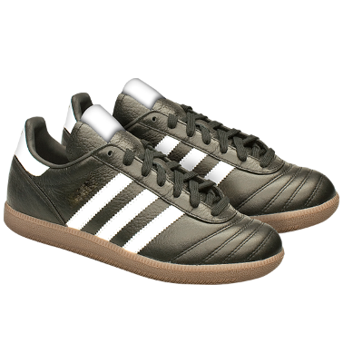
What to bring

Trainers without metal or aluminium studs, moulded boots allowed

Shin guard and mouth guard for Football, Gaelic sports and Hockey

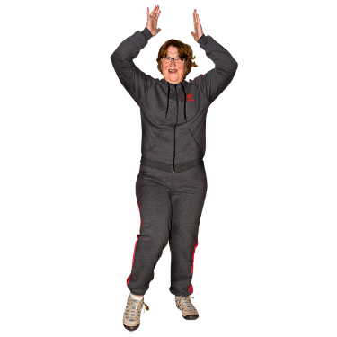
Tracksuit, sweatshirt, shorts, t-shirt or similar

Rainproof jacket and hat for outdoor activities only

A towel and a change of clothes

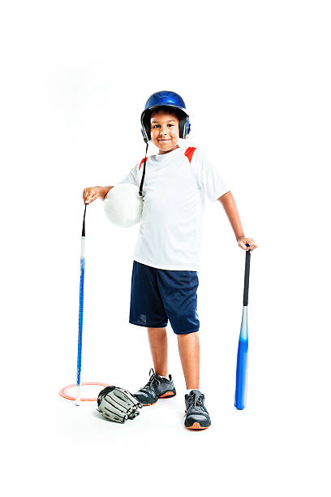

The right sports equipment if you have them

A change of footwear

