# 

|  |
| --- |
|  |
|  |
| 2019 |





**Youth Engagement Art and Poetry Competition Winning Entries**

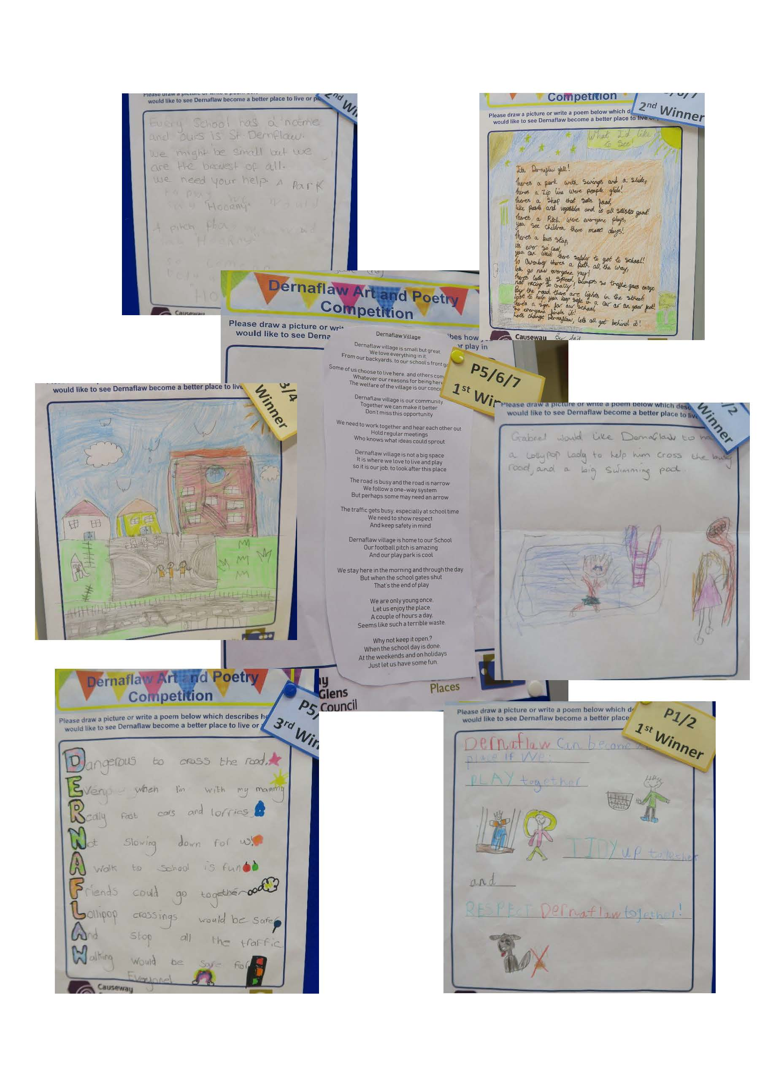

# Dernaflaw Village Plan

# Contents

1. Introduction 5

2. Village Plan Development Process 6

3. A Better Future Together, A Community Plan for Causeway Coast and Glens 2017-2030 7

4. Area Profile 8

5. Spatial Analysis Audit 11

6. Summary of Engagement Findings 14

7. Dernaflaw Village Action Plan 19

8. Implementation - Next Steps 22

Appendix 1 - Comments recorded at Community Meeting and Online Survey 23

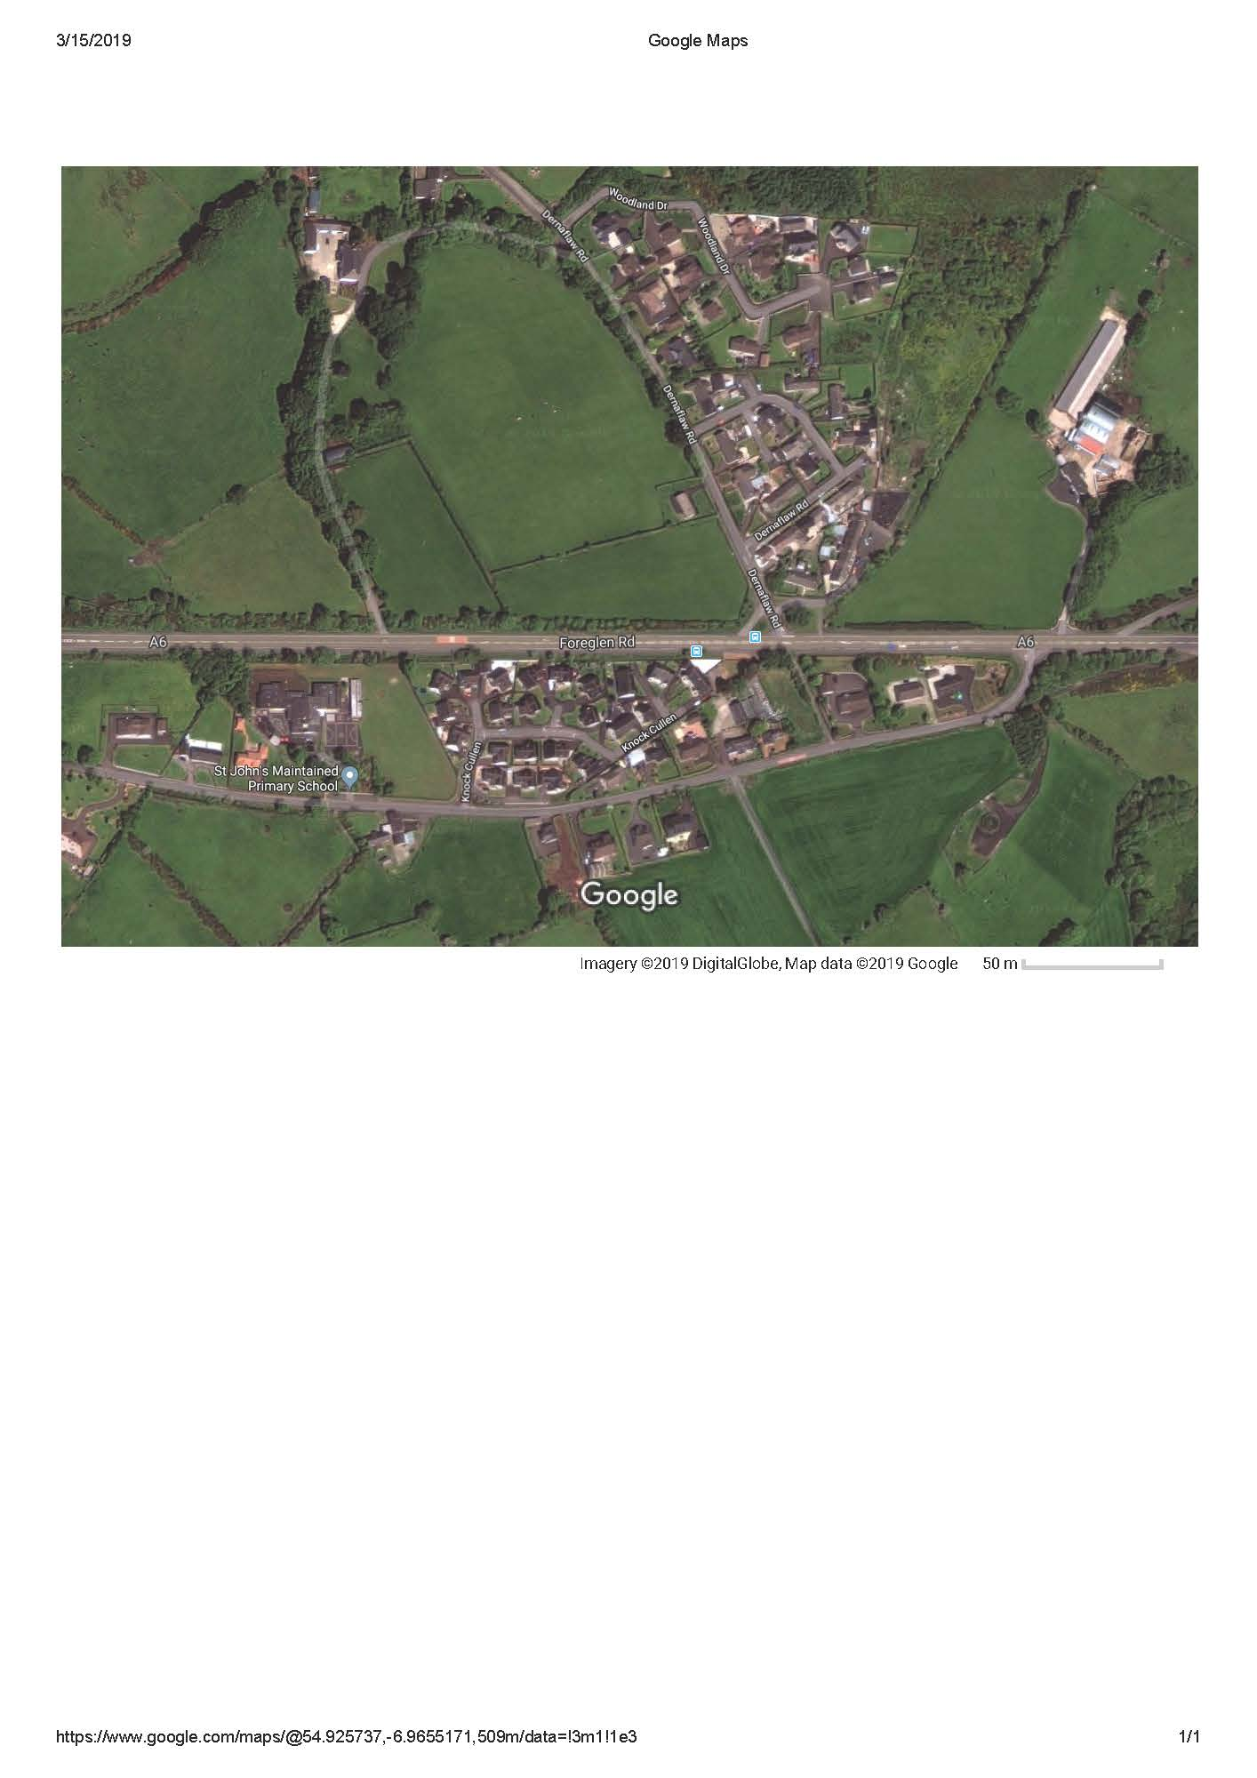

1. Introduction

The Village Plan process for Dernaflaw enabled local people of all ages to identify priorities and to plan and shape activities, projects and programmes to promote sustainable village renewal and a vibrant and cohesive community. The Plan will support the community’s efforts to deliver long-term benefits and investment for the whole community in partnership with the Council and in line with the ambitions set out in the ‘A Better Future Together’ Community Plan.

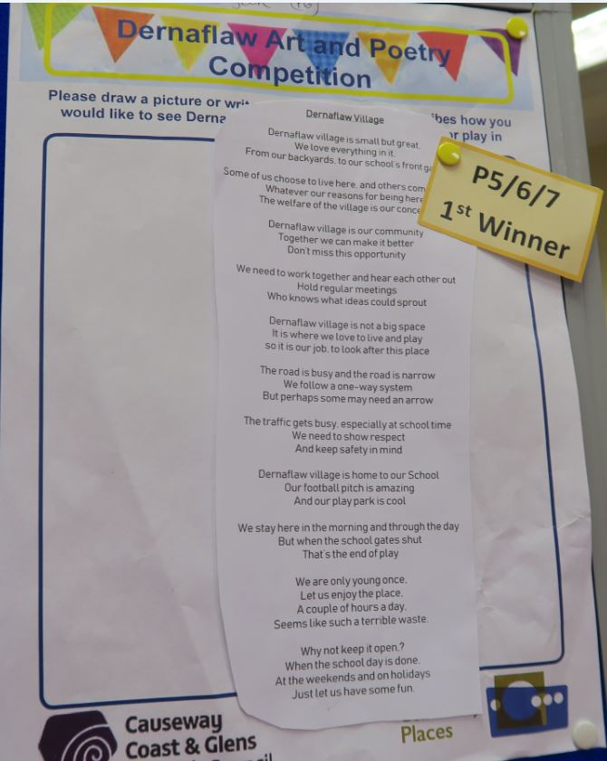The Village Plan is a working document that will help the community to lobby and influence the council, statutory partners, departments and other service providers to respond to local needs and priorities. The plan includes a series of priority actions which have emerged from the engagement with the residents.

The Village Plan process took place between January and March 2019. Community Places was commissioned by Causeway Coast and Glens Borough Council to work with the newly formed Community Association and residents to prepare the Plan.

Constituted in January 2019, the objectives of the **Dernaflaw Community Association** are:

1. To promote the benefit of the people of Dernaflaw and its neighbourhood, without distinction of sex, sexual orientation, race or of political and religious beliefs, or other opinions.
2. To work with the residents of Dernaflaw, in association with local authorities, voluntary and other organisations to facilitate educational, recreational and leisure time activities for the benefit of the residents.
3. To work closely with St John’s Primary School to provide a suitable community hub for promoting the aims and objectives of the Association.
4. To promote other charitable purposes as may from time to time be determined.

2. Village Plan Development Process

The Village Plan process followed a number of key steps including:

* A socio-economic profile;
* Preparation of infographics;
* Analysis of existing documents and plans;
* Spatial analysis audit of physical and community assets;
* Community engagement meeting;
* Children’s Art and Poetry Competition;
* Online Community Survey;
* Developing priority actions;
* Agreeing the Village Plan

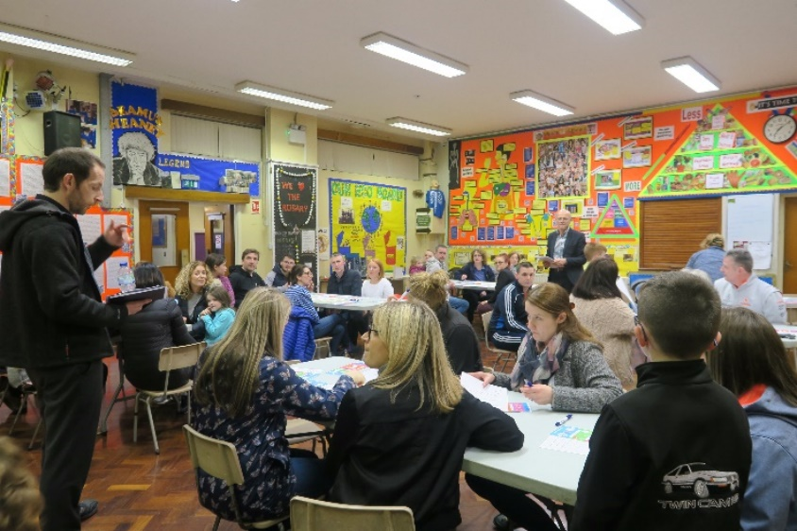Each step informed and complemented the next drawing together the research and engagement findings to develop a village plan which aims to meet local needs and improve the village for all. The plan itself and the process for developing and agreeing it has brought people together, strengthened relationships and has built support to implement the plan.

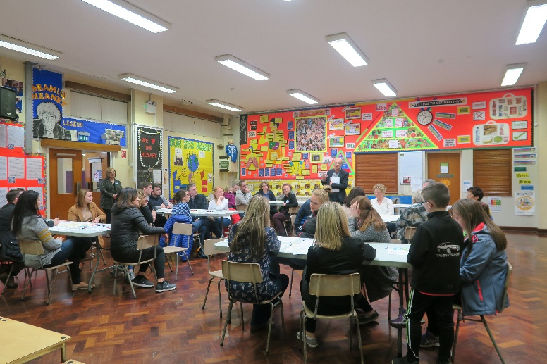Posters and flyers were distributed throughout the village and shared on social media to raise awareness of the plan process and the opportunities to get involved in helping to shape the future of Dernaflaw.

A Community Meeting was held on the evening of 27 February 2019 in St John’s School. Local pupils attending the school took part in an Art and Poetry Competition highlighting how they would like to see the village improve and become a better place to live and play. A short online survey was also prepared to accommodate those who were not able to attend the engagement event.

3. A Better Future Together, A Community Plan for Causeway Coast and Glens 2017-2030

The Community Plan sets out a long-term shared vision for the Causeway Coast and Glens area and all who live in, work in and visit the area. It concentrates on three main issues:

* **A Healthy Safe Community**: where people will contribute to and benefit from a healthy, connected and safe community that nurtures resilience, promotes respect and supports everyone to live well together;
* **A Sustainable Accessible Environment**: where people will value and benefit from a diverse, sustainable and accessible environment with an infrastructure that is fit for purpose and that enables connections; and

* **A Thriving Economy**: where people will contribute to and benefit from a thriving economy built on a culture of growth, entrepreneurship, innovation and learning.

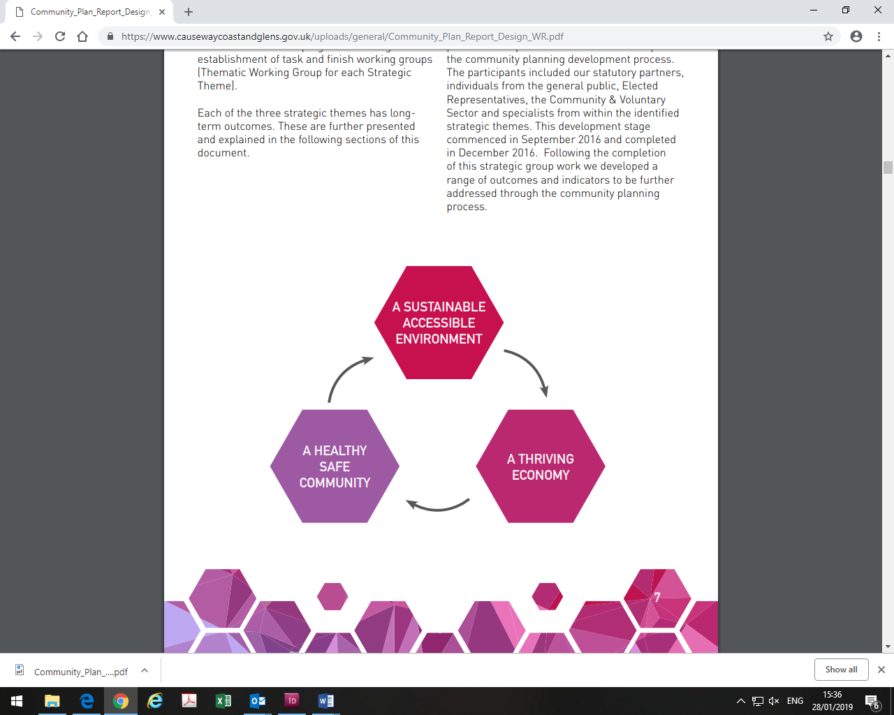

*A Better Future Together, p.7.*

The Community Plan is the over-arching framework for the area and acts as a strategic planning tool bringing key statutory and support partners together to plan and deliver better outcomes for people in relation to health, education, housing, public safety, communities, the economy and the environment at a council wide area and at local and neighbourhood levels. The Community Plan was developed in close collaboration with key partners and with extensive engagement with local communities, groups and individuals.

The Community Plan is linked to and reflects other key strategies and plans. This includes the new Local Development Plan 2030 which will provide the spatial framework for the Borough and will consider any land use planning aspects which emerge through the Community Plan such as housing, employment, open spaces and connectivity.

4. Area Profile

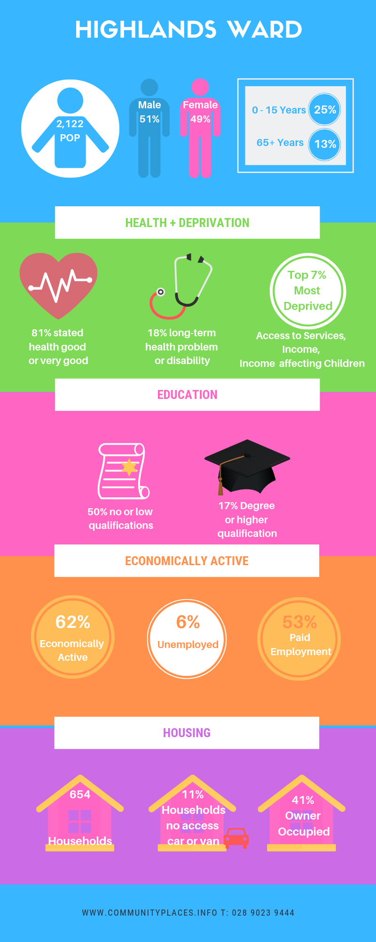Dernaflaw is approximately two kilometres west of Dungiven on the A6 Foreglen Road, a key transport corridor linking Belfast to the North West. The Road bisects the settlement with a housing cluster on either side.Dernaflaw sits within the **Highlands Ward** is an isolated rural community, with the local school the only focal point for the community.

**Population**

The estimated population of the Highlands Ward at 30 June 2017 was **2,122**, of which **1,083** **(51%)** were male and **1,039 (49%)** were female.

This was made up of:

523 children aged 0-15 years; 645 people aged 16-39 years; 677 people aged 40-64 years; and 277 people 65 years and older. Just under one quarter of the population (24.64%) was 15 years old and under and 13% of the population was 65 years and older.

Over the last 15 years a number of new housing developments have been built in the area which is evident in the population estimates. Between 2007 and 2017 the population of the Highlands Super Output Area increased dramatically i.e. by **337** people or 18.9%; three times higher than the average growth estimates for NI as a whole for the same period (6.2%).

**Multiple Deprivation**

The 2017 MDM (Multiple Deprivation Measure) provides information on seven types of deprivation and an overall measure of deprivation which enables ranking of 890 areas (called Super Output Areas – SOAs) within the region. Dernaflaw is within the Highlands SOA. Overall, the Highland SOA is ranked within the top 21% multiple deprived SOAs across the region.

Three of the seven types of Multiple Deprivation Measures are very significant for the Highlands SOA. It is within the top 7% most deprived SOAs in the region under: Income deprivation; Access to Services; and Income deprivation affecting children. At the same time in relation to Crime and Disorder the Highlands SOA has a ranking which places it in the 10% least affected.

**Ethnicity, Identity, Language and Religion**

On Census Day in 2011 the make-up of the resident population of the whole ward was: 99.75% from the white (including Irish Traveller) ethnic group; 49.11% belonged to or were brought up in the Catholic religion and 49.01% belonged to or were brought up in a ‘Protestant and Other Christian’ religion; 48.60% indicated that they had a British national identity, 31.59% said they had an Irish national identity and 23.21% indicated a Northern Irish national identity. Of the population aged 3 years old and over: 10.03% had some knowledge of Irish; 9.82% had some knowledge of Ulster Scots; and 0.37% did not have English as their first language.

**Health**

On Census Day in the Highlands Ward: 80.80% of people stated their general health was either good or very good; 17.62% of people had a long-term health problem or disability that limited their day-to-day activities; and 9.09% of people stated that they provided unpaid care to family, friends, neighbours or others.

**Qualifications**

Of the ward population aged 16 years old and over on Census Day 2011: 17.42% had a degree or higher qualification while 50.33% had no or low (Level 1) qualifications (Level 1 is 1-4 O Levels/CSE/GCSE any grades).

**Labour Market – Economic Activity**

On Census Day of the ward’s population aged 16-74 years old: 62.37% were economically active; 37.63% were economically inactive; 53.75% were in paid employment and 5.96% were unemployed.

**Housing and Accommodation**

On the Census Day in the ward there were: 1,960 people living in 654 households (giving an average household size of 3.01); 79.66% of households were owner occupied and 17.43% were rented; 41.44% of households were owned outright; 8.10% of households were comprised of a single person aged 65+ years; 6.88% were lone parent households with dependent children and 11.16% of households did not have access to a car or van.

*Causeway Coast and Glens Housing Investment Plan Annual Update 2018*

Housing Executive Stock *(sold stock in bold)*

|  |  |  |  |  |  |  |  |
| --- | --- | --- | --- | --- | --- | --- | --- |
| Dernaflaw | Bungalow | Cottage | Flat | House | Mais | Total | Void |
| 4 |  |  |  |  | 4 |  |
| **26** |  |  |  |  | **26** |  |

*Housing Applicants and Allocations at March 2018*

In Dernaflaw there were fewer than 10 applicants for housing and fewer than 10 of these were experiencing Housing Stress (30 points or more). There were no allocations.

**Summary**

Dernaflaw village has a growing young population and is part of the wider Highlands area which is within the region’s 7% most severely disadvantaged in terms of: income, access to services and income deprivation affecting children. In addition to these issues of disadvantage Health and Well-being, economic inactivity and lack of access to facilities for the growing population are all issues which need to be addressed.

5. Spatial Analysis Audit

An audit was undertaken of the physical and community infrastructure and asset base of the village and is detailed and mapped below:

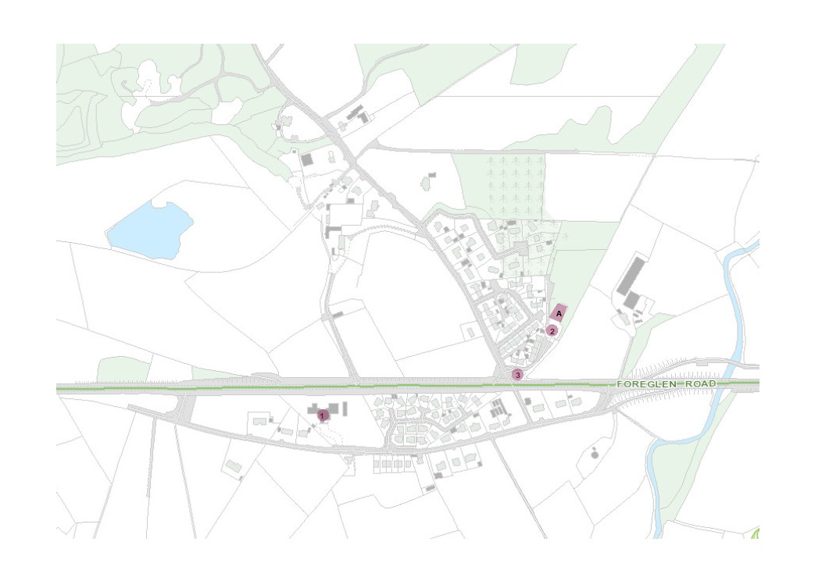

**Spatial Analysis Audit**

|  |  |  |
| --- | --- | --- |
| **Asset** | **Name** | **Baseline Map Number** |
| **Key Services and Facilities** | St John’s Primary School and Nursery.    Dernaflaw Road Play Park | **1**  **2** |
| **Groups in the area** | Dernaflaw Community Association |  |
| **Opportunity Sites** | Lands West of Dernaflaw Cottages (near Play Park and subject to planning application for housing – see planning history map below) | **A** |
| **Other** | Bus Stop on main A6 Foreglen Road | **3** |

**Northern Area Plan (2016)**

The Northern Area Plan (NAP) designates Dernaflaw as a hamlet which provides basic community facilities for the local population. The NAP notes that private sector housing development complements the longer-established public authority housing. The main zonings include: Open Space; Local Landscape Policy Area (LLPA); and a Site of Local Nature Conservation Importance (SLNCI).

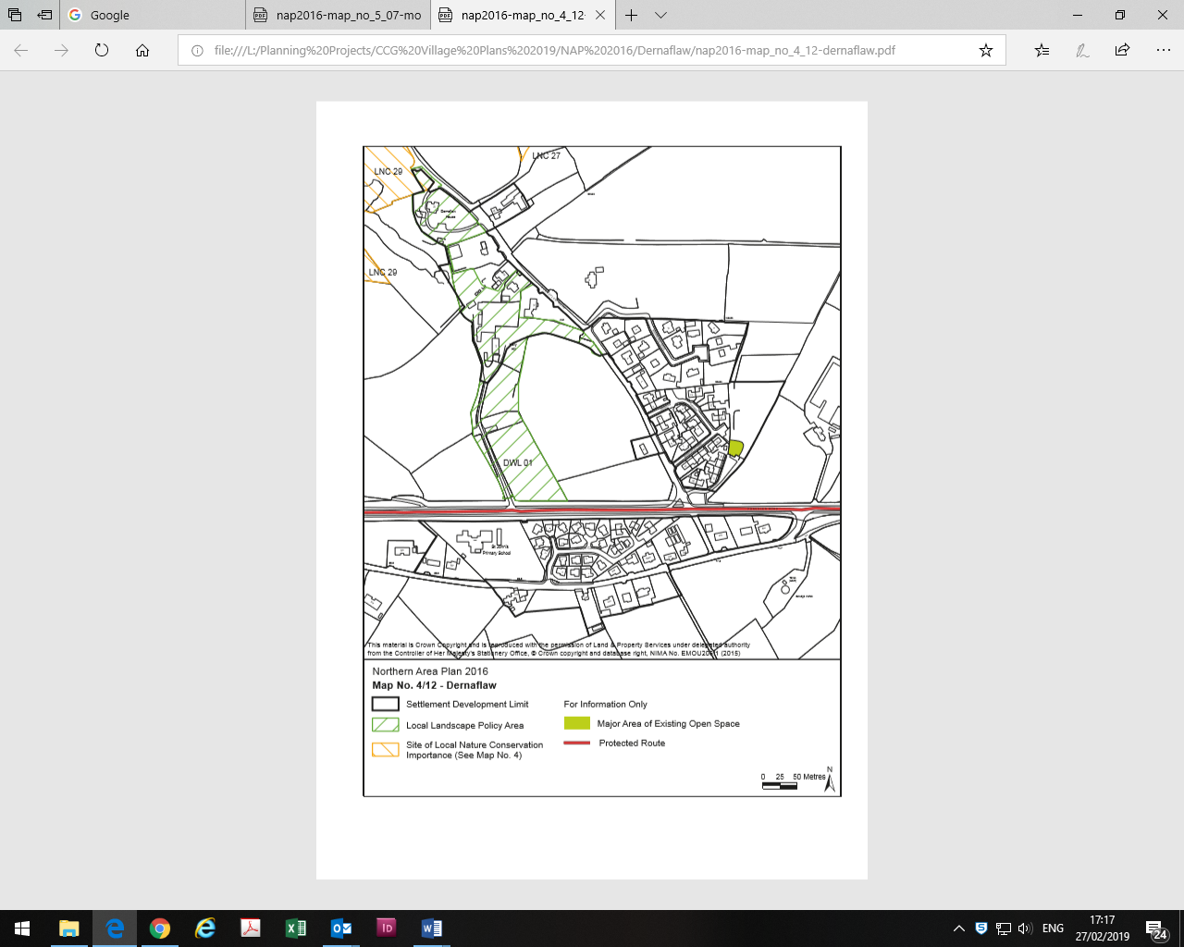

The Local Landscape Policy Area DWL 01 seeks to safeguard the features which contribute to the environmental quality, integrity and character of the area including the Dernaflaw Sand Pit which is a SLNCI; Holly Hill and Dernaflaw House, both of which are significant buildings on the footprint of the early 19th Century settlement, and their associated structural planting. The zoned Open Space area includes a Play Park.

**Planning History**

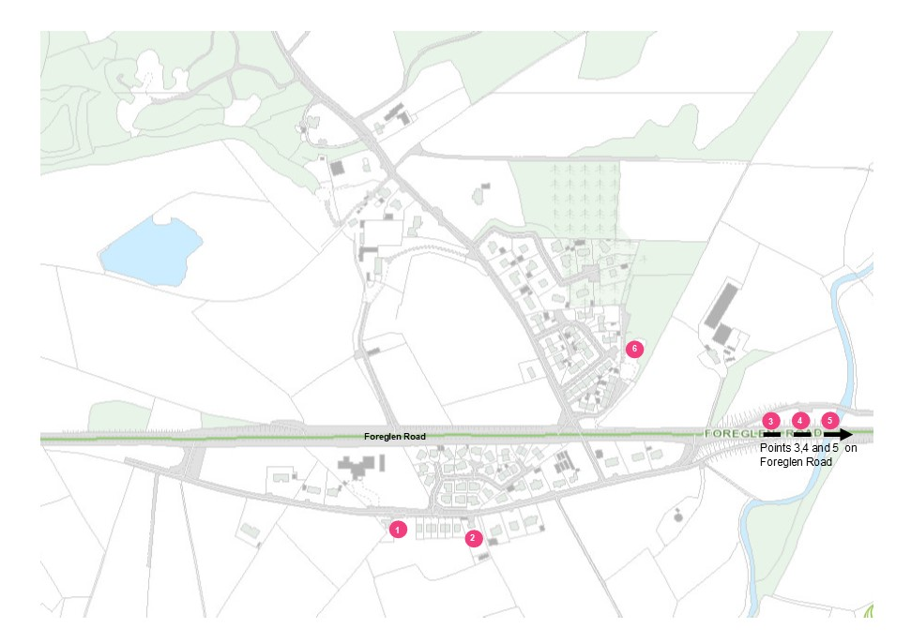

**Planning History at January 2019**

|  |  |  |  |  |  |  |
| --- | --- | --- | --- | --- | --- | --- |
| **­Map Ref** | **Planning Reference** | **Site Address** | **Proposal** | **Application Received** | **Planning decision** | **Decision Date** |
| **1.** | B/2010/0289/F | Lands at and adjacent to 427 Foreglen Road, Dernaflaw, Dungiven | Residential development of 3 detached two storey dwellings, 4 semi-detached two storey dwellings & 3 two storey townhouses | 01/09/10 | Approval | 27/01/11 |
| **2.** | B/2010/0326/O | 431 Foreglen Road, Dungiven | 2 detached and 2 semi-detached houses with private roadway | 01/10/10 | Approval | 20/01/11 |
| **3.** | B/2011/0191/F | GAA Owenbeg Centre of Excellence | Provision of floodlighting and spectator fencing of existing main pitch | 08/08/11 | Approval | 26/10/11 |
| **4.** | B/2013/0211/F | 100m south east of GAA Owenbeg Centre | Erection of 1 no. 150kw wind turbine with a hub height of 31m | 30/09/13 | Approval | 03/02/14 |
| **5.** | B/2014/0022/F | Derry GAA Centre Owenbeg Dungiven | Emergency access onto the Foreglen Road, Dungiven | 10/02/14 | Approval | 03/04/14 |
| **6.** | LA01/2017/0736/O | West of Dernaflaw Cottages | Residential development of 9 detached two storey dwellings | 31/05/17 | Pending |  |

**Summary**

This spatial analysis confirms the area profile assessment – Dernaflaw has a growing young population with limited access to facilities and amenities. The population is set to increase with the school being the only community asset availability to an expanding population. Finding the resources to make further use of this asset will be key to addressing some of the issues highlighted in the area profile. The village is dissected by the A6. However, a new by-pass of both Dernaflaw and Dungiven is under construction and will provide opportunities for addressing the severe road safety issues and concerns.

6. Summary of Engagement Findings

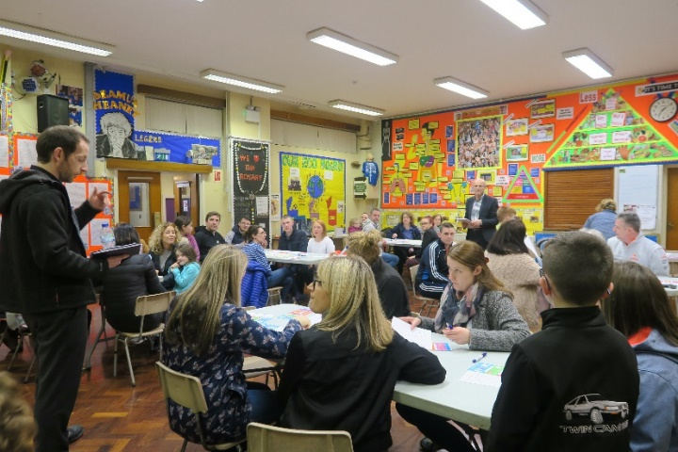Participants were invited to share their ideas and comments in focus groups during the Community Meeting and through an online survey.

There was also a Children’s Art and Poetry Competition and meetings were held with the Community Association Committee.

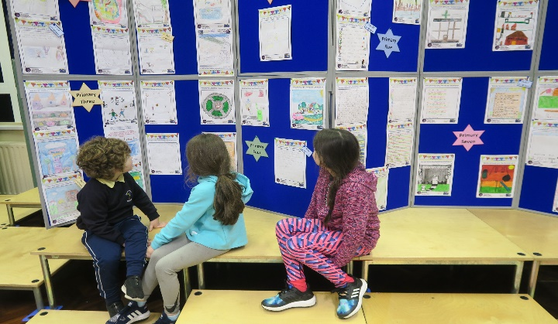

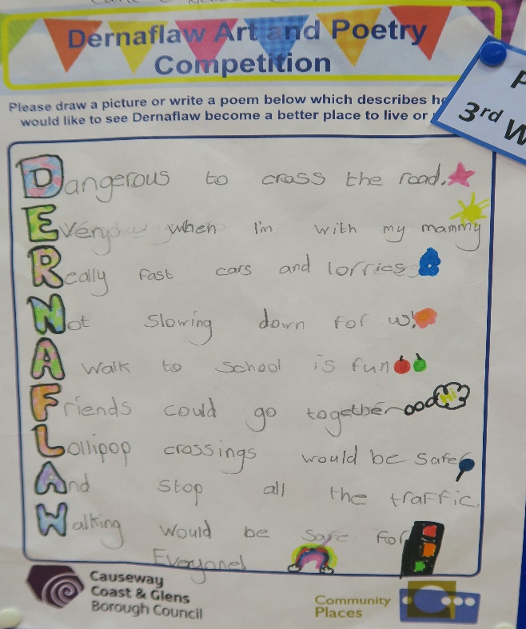

People were asked to consider the assets of and challenges facing the village and the types of improvements needed and community activities which would be welcome by all. All the views expressed during the roundtable discussions at the Community Meeting are presented in Appendix 1.

**Assets**

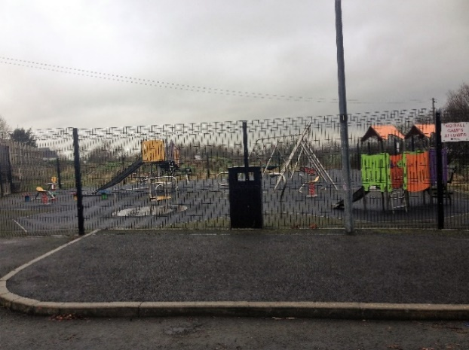Participants emphasised that the local people, great sense of community, friendly residents and shared nature of the village were key assets and strengths to be celebrated. The quiet, private and rural nature of the village and the proximity to Dungiven and Limavady were also referred to as was the location on the main road with easy access to Belfast and Derry.

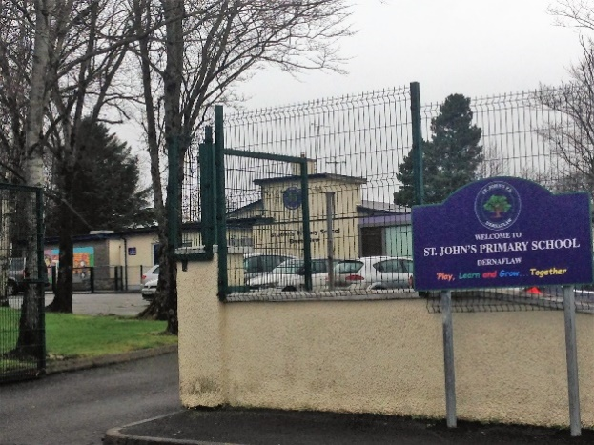The village environment where people know each other and look out for each other makes it an attractive and safe place to live with some saying that they could not imagine living anywhere else. The school was considered a key asset by all - acting as a focal point for the community. The play park was also considered an asset but one which is not safely accessible to children living in the ‘school road’ area of the village.

**Improvements and Safety**

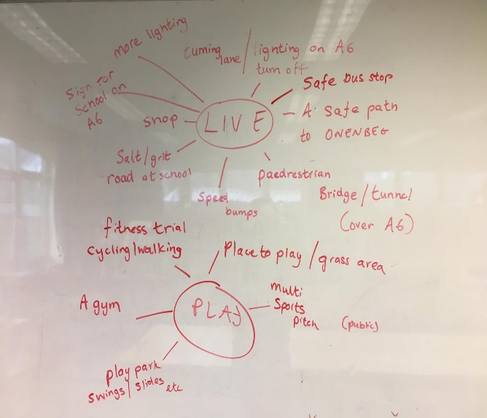Many participants (including children – see diagram below) highlighted the dangers of the main A6 Foreglen Road for both pedestrians and drivers accessing the village. Suggestions for improving safety included central reservations/islands, slip roads, speed limits, ripple strips, speed ramps, traffic lights, crash barriers, cycle lanes, and a pedestrian bridge.

People were also keen that there would be more salting of the ‘school’ road in bad weather with a gritting/salt box near the school.

Other physical improvements suggested included: signage (visitors and delivery drivers often have difficulty locating the village and school); planting and an environmental ‘facelift’ for the area; better grass cutting and the verges tidied; and entrance features to the village.

Some respondents would like improved lighting on the entrance roads and on the south side (the school road) and better streetlights along the road to Dungiven as well as close to the bus stops. Parking provision around the school at busy times is a concern and there were suggestions for speed ramps along the ‘school road’.

Also, parents were keen to stress that the school had limited storage facilities and therefore needed more storage space.

The opening of the school building and grounds for community uses outside school hours was suggested by people of all ages and interests. The existing playpark was considered an asset but is mainly for younger children and not safely accessible by children in the ‘school road’ part of the village.

**Facilities and Amenities**

To meet community needs, provide opportunities for better health and well-being and further education and social cohesion many participants suggested a community ‘hub’ or focal point. For most the school (with extended opening hours) could ideally act as this ‘hub of activity’ while a few others suggested a separate community facility.

Some suggested that the pitch at the school could be fenced off from the main building which would allow access after school hours with improved security. Many participants suggested a range of indoor and outdoor community uses of the school and its grounds ranging from leisure, health and sports activities to arts, music, dance and craft classes.

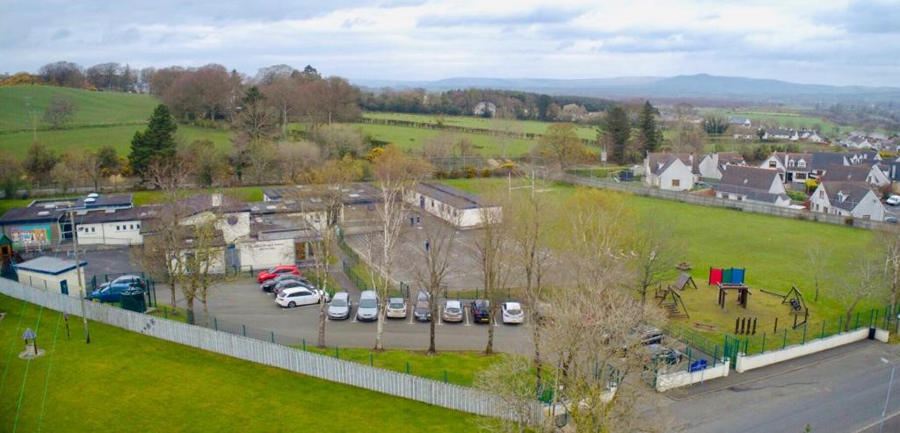

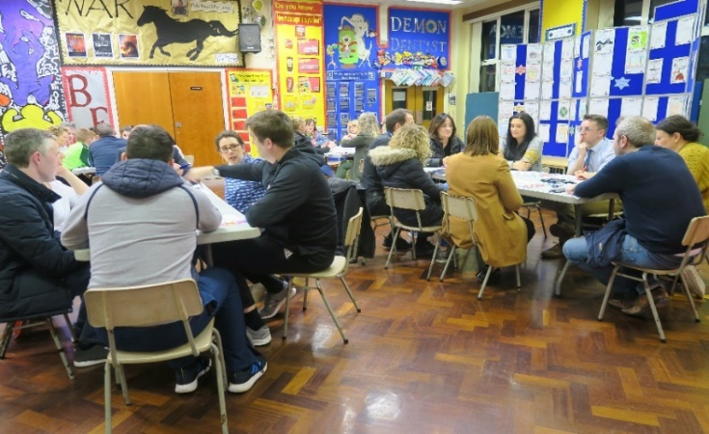People would also like access to a defibrillator 24 hours a day. Other participants would like more litter bins including dog foul bins.

The need for community transport services to enable access for all village residents to shops, banks, insurance and health care outside the area was mentioned with the absence of a local convenience store or mobile shop noted by some.

**Activities (Indoor)**

Respondents suggested a range of classes and indoor activities which could be facilitated in the school if it became available outside usual hours. These included: arts/crafts, cookery, education, health, fitness and exercise courses; music; dance; and first aid. Other suggestions were for a Parent and Toddler Group and a Men’s Shack/Shed as a community space for men to connect, converse and create.

For older members of the community people suggested activity classes, set dancing, bingo and ‘Silver Surfers’ IT classes. Youth Club activities and a Summer Scheme were also suggested.

**Activities (Outdoor)**

Ideas and suggestions for outdoor activities included: a Walking Club/Group for off-road walking routes or a walking path; a running club with a lit path away from traffic; a Bike Club/Group and a cycle track; and an outdoor gym. Sports activities for younger members of the community were suggested for out-of-school hours use of the school pitch.

Participants suggested a community festival and mentioned specific ideas such as a Community Barbeque, a Family Fun Day, a Hallowe’en Party, a Harvest Festival; and organised day trips.

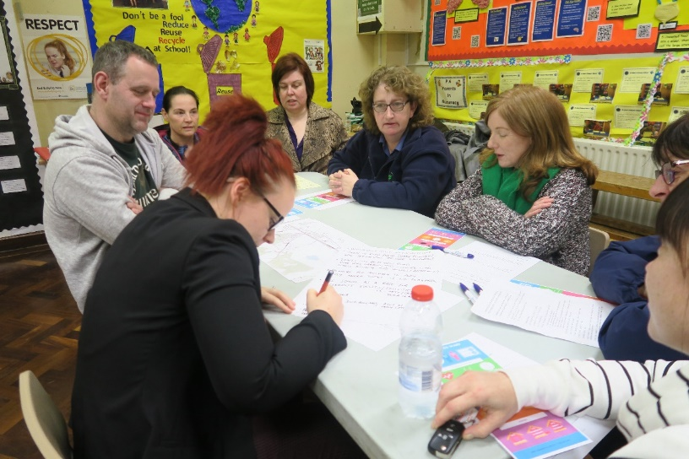

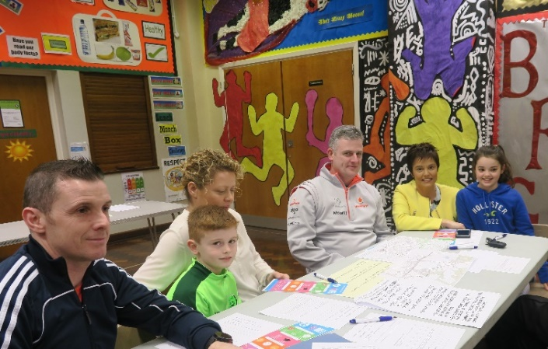

7. Dernaflaw Village Action Plan

|  |  |  |  |  |  |
| --- | --- | --- | --- | --- | --- |
| 1. **Road Safety and Transport** | | | | | |
| **Actions** | | **S** | **M** | **L** | **Partners** |
| 1. Identify measures to improve safety on **Foreglen Road** by considering:  * Controlled pedestrian crossing; * Reduced speed limits * Widening of both right turn lanes; * New and improved footpaths and cycle paths on both Foreglen Road and school road to connect village to Dungiven safely; * Enhanced street lighting and lighting all the way down to Dungiven; * Bus shelters on Foreglen Road * Entrance signs to village at all three road entrances.   *Note: If these measures to make the main road safer for pedestrians are not possible then a footbridge should be considered.* | |  | ✓ |  | * Community Association * DfI Roads * Elected Representatives * Causeway Coast and Glens Borough Council * Translink * Community Transport |
| 1. Measures required for the **‘School Road’** include:  * Speed reduction ramps; * Salt gritting boxes; and * Resurfacing of pathway from ‘school road’ to main road. | | ✓ |  |  |
| 1. To address the high level of poor access to services experienced by many in the ward there should be provision of:  * **Community Transport** to provide access to services and facilities. | | ✓ |  |  |
| **Links to ‘A Better Future Together’ Community Plan**   * A Sustainable Accessible Environment * A Healthy Safe Community | | | | | |
| **Potential Funding Opportunities or other Useful Links**   * National Lottery Community Fund [www.tnlcommunityfund.org.uk/northern-ireland#section-1](http://www.tnlcommunityfund.org.uk/northern-ireland#section-1) Awards for All £300 -£10,000 * Department for Infrastructure Roads <https://www.infrastructure-ni.gov.uk/topics/roads> | | | | | |
| 1. **Environment** | | | | | |
| **Actions** | **S** | | **M** | **L** | **Partners** |
| 1. Provision of additional bins including provision of free dog waste bags | ✓ | |  |  | * Causeway Coast and Glens Borough Council * Community Association and Residents * DfI Roads |
| 1. Planting to improve appearance of “School Road” | ✓ | |  |  |
| 1. More frequent grass cutting and a ‘tidying up’ of the whole village | ✓ | |  |  |
| 1. Planting and mitigation measures to reduce adverse visual and noise impacts of Foreglen Road (A6) |  | | ✓ |  |
| **Links to ‘A Better Future Together’ Community Plan**   * A Sustainable Accessible Environment * A Healthy Safe Community | | | | | |
| **Potential Funding Opportunities or other Useful Links**   * Causeway Coast and Glens Borough Council – Community Development Support Grant <https://www.causewaycoastandglens.gov.uk/grantsandfunding/community-development-support-grant> * Keep Northern Ireland Beautiful [www.keepnorthernirelandbeautiful.org](http://www.keepnorthernirelandbeautiful.org) | | | | | |
| 1. **Community Facilities** | | | | | |
| **Actions** | **S** | | **M** | **L** | **Partners** |
| 1. A defibrillator in the village | ✓ | |  |  | * Community Association * Causeway Coast and Glens Borough Council * St John’s Primary School |
| 1. ‘Community Hub’ at the school to enable community activities (*see below*) | ✓ | |  |  |
| 1. A safe and accessible play park in “School Road” area of village for out-of-school hours use | ✓ | |  |  |
| 1. Development of school pitch for leisure, community and sports use outside school hours |  | | ✓ |  |
| **As the only facility in the village the development of the school and its grounds is central to the realisation of the community’s plans for facilities and activities.** | | | | | |
| **Links to ‘A Better Future Together’ Community Plan**   * A Healthy Safe Community * A Sustainable Accessible Environment | | | | | |
| **Potential Funding Opportunities or other Useful Links**   * Causeway Coast and Glens Borough Council – Community Development Support Grant <https://www.causewaycoastandglens.gov.uk/grantsandfunding/community-development-support-grant> * Tesco Community Grants <https://www.groundwork.org.uk/tesco-local-community-scheme-uk-programmes> | | | | | |
| 1. **Community Activities** | | | | | |
| **Actions** | **S** | | **M** | **L** | **Partners** |
| 1. Community festival/fun day | ✓ | |  |  | * Community Association * Causeway Coast and Glens Borough Council * Health Trust/Public Health Agency * Sport NI * St John’s Primary School |
| 1. Outdoor and indoor sports/leisure activities for children and youth | ✓ | |  |  |
| 1. Leisure/fitness/health/first aid classes for adults of all ages | ✓ | |  |  |
| 1. Summer Scheme including trips | ✓ | |  |  |
| 1. Arts/Music/Dance/Craft/Cultural/Local History classes | ✓ | |  |  |
| 1. Walking/Cycling/Running Clubs | ✓ | |  |  |
| 1. Parent and Toddler Club | ✓ | |  |  |
| 1. Luncheon and Activity Group for Older Residents.   *Note: Most (though not all) of these activities are dependent on the school becoming available for out-of-hours community use.* | ✓ | |  |  |
| **The support and involvement of residents will be central to the success of these Community Activities. The Committee will continue to be mindful of this and will maintain good communications with all residents and will welcome their ideas and their inputs as volunteers.** | | | | | |
| **Links to ‘A Better Future Together’ Community Plan**   * A Healthy Safe Community * A Sustainable Accessible Environment | | | | | |
| **Potential Funding Opportunities or other Useful Links**   * Causeway Coast and Glens Borough Council – Community Development Support Grant <https://www.causewaycoastandglens.gov.uk/grantsandfunding/community-development-support-grant> * Tesco Community Grants <https://www.groundwork.org.uk/tesco-local-community-scheme-uk-programmes> * National Lottery Community Fund [www.tnlcommunityfund.org.uk/northern-ireland#section-1](http://www.tnlcommunityfund.org.uk/northern-ireland#section-1) Awards for All £300-£10,000 | | | | | |

8. Implementation - Next Steps

Central to the successful implementation of this Plan will be the continued commitment from the Community Association Committee and the support and involvement of all residents as volunteers and participants in events and projects. The St John’s Primary School and the Causeway Coast and Glens Council and Councillors will have a crucial role to play as facilitators and partners in the implementation of the Plan. Some issues in the Plan will require consistent lobbying and networking to persuade the partners listed to respond with flexibility to local concerns, views and ideas. It is important to note that during the Plan period other actions or development opportunities may arise to improve and enhance the Village. The Committee, with the ongoing support of the Council, will need to be alert to these opportunities.

Appendix 1 - Comments recorded at Community Meeting and Through the Online Survey

**What do you like about living in Dernaflaw?**

* Rural, but close enough to Dungiven town
* Couldn’t imagine living anywhere else
* Proximity of the school
* Great sense of community
* Playpark is great for children
* The school
* Friendly community
* Handy to Dungiven
* Tidy
* Play park (for younger)
* Country environment
* Quiet
* In country and not in it
* Easy access to main roads
* School
* Nice community
* Friendly
* Well behaved children
* Can go to neighbours
* Know everybody
* Quiet
* Not in middle of town
* Still in country/but everything you need
* Good sense of community
* People still know each other
* Children know each other
* Safe – looking out for one another/not for play. Local people know to slow down in areas of street where children are playing whereas a stranger may not
* Still access to main road – Derry/Belfast
* Children play in street/know boundaries and time
* Close to school
* Privacy from the town
* Safe
* Everybody knows each other
* Close to town
* Not as much traffic
* Location is good – near to Derry/Dungiven/Limavady
* Clean environment
* Kids have others to play with. Nice community and short distance from town but far enough to be quiet and peaceful
* Small Community, safe community
* It's a nice quiet area were neighbours look out for one another yet keep them self to their selves.
* Quiet. Private
* Local to the town
* Being able to live in a quiet rural area with all the benefits of country life but still within driving distance (2 miles) of Dungiven
* It’s quiet, safe, local to the school and easily accessible to the town
* I like that Dernaflaw is not in the town and is close to my children's school
* I don’t live in Dernaflaw my child attends school there
* It’s quiet and small wee area

**What improvements would you like to see?**

* Turn in road from Derry direction into Dernaflaw – traffic is dangerous.
* Traffic on Foreglen Road very narrow, this coupled with school activity and houses (accessibility).
* Nowhere for children to play safely where there is no playpark.
* Use school as a base for different events/facilities eg arts/crafts, yoga classes.
* Youth Club.
* Bins (for dog fouling) – a lot of dog fouling very little bins.
* 30 miles an hour at certain times?
* Road divides community
* No footpath to Owenbeg
* Somewhere to have community activities school is hosting
* Road salting in winter/substandard junction – busy road in north/light

**What kind of facilities and activities do you think are needed for children and young people in the area?**

* Youth Club
* Cook classes for kids
* Access to the pitches for sports – weekend activity (football, camogie/hurling “little ballers” activity
* Safe access to the park not possible – for school road children
* Is access to school pitch possible? (maybe fence off from rest of school)
* “Rascality” in past ((15 years) concerns of residents living nearest
* Green or open space – park
* Danger/parked car
* Controlled and managed
* All tarmac
* More houses are still being built
* Whilst surrounded by green space – there is none that is usable
* Walk your dog/fitness track/gravel path
* Green area to play sports or play park they do not need to cross a busy main road to access
* Youth Club – hang out with friends
* Long summer with no facilities – again school is the only building
* Feeny Summer Scheme as an example
* Access to park, especially as the main road divides the community from the other park
* Use of the school pitch during summer times for children to play
* None, we have a good park at the cottages and lots of GAA activity to attend
* A children’s play area, whether it’s a park or open space to play football, ride bikes etc. We never use the current play area as we live on the Dernaflaw road with the school and find it’s too dangerous to cross the road
* Playing fields with good access and to include all/variety of sports
* Better street lighting especially when getting off the bus
* I don't feel the children are lacking in much in this area as we have a park in Dernaflaw and most children attend after school clubs or hobbies they attend e.g. Football, Camogie, Swimming etc. We also have excellent facilities located in the town which is only a mile away. One that will include children with additional needs as stated above eg autism or ADHD
* Green areas to play, dance classes, youth club, music classes, mixed sports
* Access to park needs monitored
* Playpark expanded for older children
* Pre-teen activities – basketball court
* Children could help planting
* Signs (slow down) speed bumps
* Piece of land – to develop
* There is no need for facilities or activities in Dernaflaw the children and young people are more than catered for in Dungiven 2 miles in the road. Most children these days already attend after school activities: Irish dancing, music lessons, gymnastics, drama, camogie, football, hurling and swimming. St Johns also has an afterschools club. Dernaflaw has a play park over by the Dernaflaw cottages and I know there had been discussions about opening St Johns play area to the public which I feel is all wrong that play area belongs to the school who is going to supervise play, keep the playground clean of rubbish, dog foul, cigarettes etc. And if a child should be injured who is going to be responsible - the school? The council? The Dernaflaw committee?
* Improved service (bus) – school bus
* Cycle path
* Foot bridge/cycle lane – road safety
* Tennis court
* Jo Gingles (under 3)
* Parent and Toddler
* Fun day
* Multipurpose use of school space for children (classes, fitness, crafts, Summer Scheme)
* Insurance
* Defibrillator
* Youth club

**What type of community events or activities (for example arts and craft; leisure) would you be interested in?**

* Community BBQ
* Family fun day
* Adult classes using existing school space (yoga, jiving classes, arts and crafts, cookery, mindfulness classes and first aid classes)
* Mother/Father Toddler Group
* Organised day trip (school only has a trip once a year)
* Cookery class eg The Dernaflaw Bake Off (children)
* Bingo
* Table tennis
* Youth club
* Cycle track
* Couch 2 5k
* Hurling pitch
* CPR course (defibrillator access)
* Yoga – for all ages/ability
* Activity classes for older people
* Exercise club
* ICT courses – silver surfers
* Makaton/language etc
* Health MOT – blood pressure etc
* Harvest festival or similar
* Maths/English classes eg GCSE (low on stats)
* Fitness classes. Yoga etc
* Defibrillator (at school)
* Music
* Arts/crafts
* Hub of activity at school
* Walking/running club
* Primary school in Dernaflaw have to drive to Dungiven to play on pitch as own pitch is waterlogged
* Fitness classes – circuits/yoga
* Funding for classes to cover school costs
* First Aid Class/defibrillator
* Crafts
* Health and Fitness
* Music
* Somewhere just to play with our own children – at the minute we have to travel to Owenbeg which technically not allowed in – gates not always open – Greenspace
* Sewing/photography/music/Art
* Computers – cyber safety
* Set dancing
* Arts and crafts classes or fitness classes. Running club or lit path away from traffic. Activities for kids- Joe Jingles or sporting activities for kids
* Morning classes
* Walking club
* Yoga
* Any hobbies I am interested in I have my own arrangements which I am more than happy with. For anyone who wants to pursue arts or leisure activities the town is only 2 miles

away and there are great amenities there: New sports centre, Focus Gym, and Glenshane Community development runs courses and there is a beautiful library which also runs workshops there is no need for specific community activities out in Dernaflaw make proper use of what is on offer in Dungiven in a town setting

* Football – indoor – Dungiven/Gortnahey nearest 4G and indoor.
* Jo Jingles
* Sport
* Safety
* Children classes etc mother toddler, Joe Jingles
* Keep fit class
* A variety of art classes/sewing
* Kids - youth club, mixed sports
* If there were any of the above mentioned available I would be interested but I don't see where in Dernaflaw these could be facilitated?
* Any type of children’s activity eg youth club or sports that could also cater for a child with additional needs eg Autism
* Zumba
* Exercise classes
* Youth club
* Computer classes
* Crafts.
* Older people – Foreglen Live History Project – townland names etc

**Have you any other comments or ideas about how Dernaflaw could be improved?**

* Picnic area – a shared space everyone could use
* Soft play area.
* Speed reduction measures – ripple strips – to reduce.
* Better road maintenance (gritting in bad condition).
* When GAA games on at Owenbeg, cars on Foreglen Road – visibility onto main road is impaired.
* No street lights near main road.
* Christmas tree (entrance) children decorate etc.
* Grass cut/verges tidied.
* Bus shelter (new).
* Art/model on entrance to village (designed by children?).
* Village needs focal point/hub infrastructure.
* Bigger hut at school (or no huts) limited room/storage.
* Access for elderly/disabled.
* Co-ordinate classes/activities so children and parents can be in one place.
* Encourage more integration and sense of community.
* Community centre/facilities needs to be all inclusive across the community (outside GAA).
* Security around pitch after hours at school (CCTV).
* Ban the ice cream van!
* Swimming pool.
* A safer environment.
* Road Safety.
* Foot bridge to link both areas.
* Defibrillator access.
* Spinning bikes.
* Golf
* New community building even portacabin.
* Divide across – some way of linking.
* Danger of crossing road to access village.
* Lag in services catching up to higher than NI population increases.
* Access to funding.
* Lot of people in village at the minute with different skills so no need for a worker.
* Capital projects - play park/open space and smaller things such as community festive day/– BBQ.
* Train.
* Community Hall Hub.
* Community events such as summer BBQ/ Halloween and Christmas events for children.
* We would like to see more for children to do in the area. Owenbeg is not accessible by walking and the main road is unsafe for children to cross over.
* Better use of the school facilities would benefit everyone.
* Dog litter bins. Dogs fouling is terrible along the paths.
* Christmas tree.
* Provide dog foul bins.