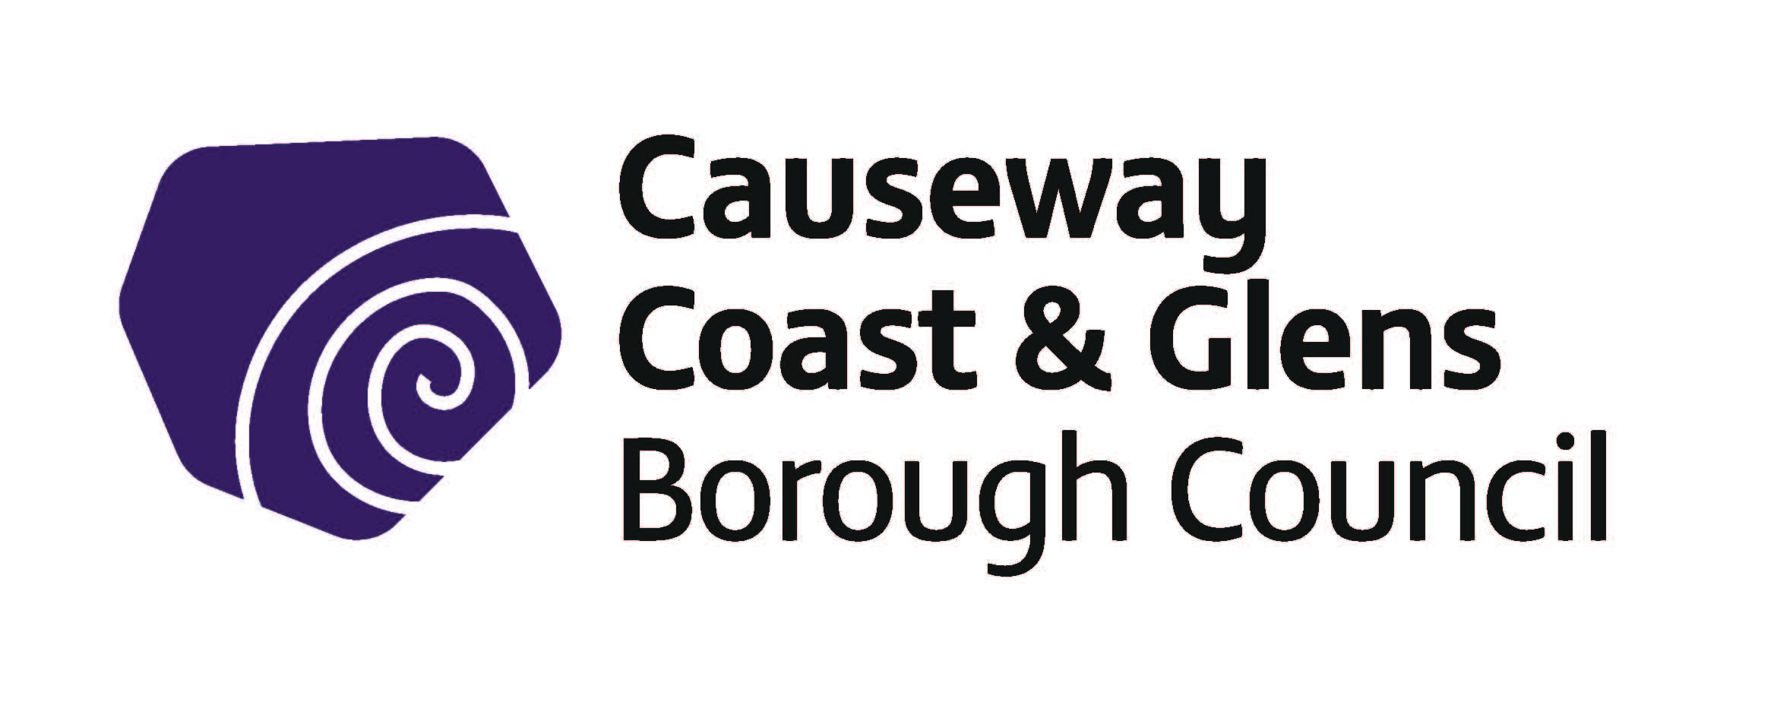

Causeway Coast and Glens Borough Council

Creative Practitioners’ Bursary Scheme 2020-21

Information & Guidance Notes

The deadline for applications for projects taking place between 1 April 2020 and
31 March 2021, is Friday 28 February 2020 at 12 noon.

Guidelines Number | CPBS
Version Number | 2
Author | P O’ Brien

Date of Screening of Policy
EQIA Recommended? | YES/NO
Date Adopted by Council
Date Guidelines Revised

Contents

1.0 Introduction
1.1. Purpose of Grant Programme
1.2 Overview of fund
1.3 Levels of grant award
1.4 General Principles
1.5 Who can apply?
1.6 What can be funded?
1.7 What cannot be funded?
1.8 Exclusions

2.0 How to answer the questions

3.0 How we assess and score your application
3.1 Eligibility assessment
3.2 What if an organisation is not eligible?
3.3 Assessment and Scoring
3.4 How decisions are made
3.5 What happens if an application is successful?
3.6 What happens if an application is unsuccessful?
3.7 Late applications

Appendix 1
Data Protection Act
Freedom of Information Act

1. Introduction

The Creative Practitioners’ Bursary Scheme has been established to help improve access to creative skills training or development programmes for creative practitioners residing or professionally based in the Causeway Coast and Glens Borough Council area.

These guidelines provide an overview of financial support available through the scheme and will help you decide if the financial assistance offered is appropriate for you.

If you are successful in securing a bursary, you will be contractually obliged to work closely with the Officers within the Cultural Services Unit of the Council, including active participation in any review processes and the provision of monitoring and evaluation information as required.

You may find it helpful to discuss your project with one of the named officers before submitting your application:

Arts

Elaine Gaston 028 2076 2225 elaine.gaston@causewaycoastandglens.gov.uk
Museums/Heritage
Nic Wright 028 2764 9484 nic.wright@causewaycoastandglens.gov.uk

  - Purpose of Bursary Scheme

Causeway Coast & Glens Borough Council recognises the enormous cultural, artistic and heritage assets within its geographical area and commissioned a 5-year Culture, Arts & Heritage Strategy to cover the period 2016-2021.

The primary objective of the cultural strategy is to ensure that both local ratepayers and visitors to the area have continuous access to high quality, accessible, inclusive and affordable cultural services, including arts, museums and heritage. It was developed following a wide-ranging and inclusive consultation process which took in the views, ideas and aspirations of stakeholders from community, cultural and related sectors.

The introduction of this scheme is in direct response to the findings from the consultation process which highlighted the need to support the development of our creative practitioners.

1.2 Overview of the Scheme

This bursary scheme links to Strategic Theme 2 in the Cultural Strategy - Investing in creative learning & skills development – by
Supporting the creative development of our creative practitioners through training, skills development and providing opportunities to showcase work

Applicants must be able to:

- Clearly show what the training or development opportunity is by producing a course programme, details of facilitators etc.
  - Demonstrate a quality professional practice (e.g. of published works, exhibitions etc.)
  - Have sufficient experience in their creative art form - please provide an up-to-date CV and artist’s statement with your application. Emerging artists who do not meet these criteria must provide two references from established artists in their field.
- Demonstrate how the training or development opportunity will be of benefit to them

If your application is successful, you will be contractually obliged to provide information to the Council. This will include monitoring progress and expenditure incurred, discussing challenges or obstacles and fulfilling the reporting requirements stipulated in the Letter of Offer.

1.3 Level of bursary award
Awards up to a maximum of £1,000 are available.

1.4 General Principles Applying to the Creative Practitioners’ Bursary Scheme.

Council is committed to distributing available bursaries fairly, efficiently and effectively. The following general principles will apply to Causeway Coast and Glens Council's administration of this scheme:

- As this bursary scheme is limited and subject to availability of funds, this is a competitive process and all awards will be determined on the basis of merit. The selection panel will look at the quality of the activity to be undertaken.

- While careful consideration will be given to each application, it may not be possible to assist every applicant even if all the criteria are met.

- Applicants who have been awarded a bursary in the past three years will not be considered for funding.

- It is a prime responsibility of the Council to ensure the proper and efficient use of and accountability for public funding. To this end, applicants will be required to provide relevant and accurate supporting information when applying for a bursary.

- Applicants must clearly demonstrate the benefits from investing in their creative skills development

- Causeway Coast and Glens Borough Council will pay up to a maximum of £1000.

- Causeway Coast and Glens Borough Council will not fund retrospectively and cannot accept applications for training or activity already undertaken.

- Successful applicants will be required to produce a short report on how they used their bursary and the benefit they gained from it both on completion of the training/project and a follow on report 6-12 months later. This should include supporting evidence eg photos, manuscript, recordings etc.

- Successful applicants must acknowledge Causeway Coast and Glens Borough Council support in press releases and other associated publicity.

- Causeway Coast and Glens Borough Council reserves the right to make public the name of any applicant who is awarded a bursary. Successful applicants should, where possible, be available to participate in PR opportunities which could include photo calls and showcasing events.

- In the interests of transparency, equality and accountability all applicants will have a right of appeal should their application be rejected.

- Awards can be used in conjunction with other schemes, such as the Arts Council of Northern Ireland’s Support for the Individual Artist Programme, but requests must be for different budget elements.

1.5 Who Can Apply?

To be eligible, the applicant must meet all of the following criteria:

- Be resident or professionally based within the Causeway Coast and Glens Borough Council Area
- A professional practitioner in any creative form – drama, dance, visual arts/craft, music, traditional arts, participatory arts, heritage.
- Applying to or have been accepted or invited onto a training course or residency or able to demonstrate proof of need for materials, practitioner’s time or similar.

(Please note you must provide proof/evidence that you have been accepted/offered a place, before any offer of assistance can be issued)

1.6 What can be funded?

Examples of the type of course/training or residency which can be funded:

  - Improve technical skills which relate to the creative practitioner’s professional practice
  - Improve the creative practitioner’s ability to manage their professional practice
  - Develop new skills which support the creative practitioner’s professional practice
  - Creative practitioner’s time to create new work
  - Materials

Please provide a copy of course advertisement, acceptance letter, invitation, course brochure or 500 word description of your creative project with your application.

Examples of eligible expenditure:

- Any aspect of the cost of a training programme or course or creative project in a related subject
- Travel
- Accommodation
1.7 What cannot be funded?

Grants will not be given for costs relating to full-time or long term part-time courses or study.

Exclusions

In general, it is important to note that this funding programme will not normally award bursaries to individuals who are resident outside the Causeway Coast and Glens Council area.2.0 How to answer the questions

Applications for financial assistance from Causeway Coast and Glens for 2020-21 should be submitted online at www.causewaycoastandglens.gov.uk
Guidance on completing the application online is provided on the website link.
Hard copies can be made available. Please contact the Central Funding Unit on email grants@causewaycoastandglens.gov.uk

An acknowledgement receipt will be electronically issued to you once your submission has been received. The Funding Unit will assess your application for eligibility. If your application is eligible to apply for grant aid, it will be forwarded to the relevant section for a full assessment and scoring against the stated criteria.

All questions must be completed as fully and concisely as possible. Please see below for help in completing your application:

Q1 Please describe the training or development opportunity or creative project for which you are applying for assistance including the following details:
- Title, dates, venue, venue location/address
- Course programme
- Details of facilitators etc.
- Creative project (500 words)

Q2 Demonstrate a quality, professional practice

Please demonstrate your experience in your creative practice by providing an up to date CV and creative practitioner’s statement with your application.
Emerging practitioners who do not meet these criteria must provide two references from established practitioners in their field.

Q3 Describe how the training/development opportunity for which you are applying for assistance, will be of benefit to you.

Q4 Please provide a full itemised breakdown of all costs.

3.0 How we assess your application:
Every application will be assessed on a pass/fail basis as detailed below:
Criteria | Assessment | Pass /Fail
Q1 Please describe the training or development opportunity or creative project for which you are applying for assistance | Has the applicant provided a bona fide letter of acceptance or confirmation of a place on a course; or a 500 word description of creative project
Q2 Demonstrate a quality, professional practice. Emerging creative practitioners who do not meet these criteria must provide two referees with full references from established practitioners in their field. | Evidence of experience/track record in this field. Provide an up to date CV and creative practitioner’s statement with your application, examples of work e.g. slides, publications or two references from established practitioners.
Q3 Demonstrate how the training/development opportunity for which you are applying for assistance, will be of benefit to you | Evidence provided of benefits detailed

3.4 How decisions are made:
Council officers will assess and score the applications after the deadline listed on the cover page of these guidelines. When the scores are finalised the officers will return the applications to the Central Funding Unit who will inform you of the decision within 7 days of your application being scored.

It will be at this point that all successful/unsuccessful applicants will be notified.

3.5 What happens if an application is successful?

If an application is successful, Council will issue a letter of offer which is a legal agreement.
Signed agreements will need to be returned before any funding is released

3.6 What happens if an application is unsuccessful?

An Appeals Process / Review Procedure is also available if an application is unsuccessful. The purpose of this is to ensure that the decisions taken and procedures followed by Committees for individual applications are applied fairly and consistently.
The Review will provide an independent process through which an applicant will have the opportunity to demonstrate to the Review Panel that either:
- the outcome was unreasonable; or
- that the proper procedures were not followed

Appeals on any other grounds will not be considered.
3.7 Late applications

It is the responsibility of each applicant to ensure that their application is submitted prior to the advertised time and date of closing. Applications received after the closing time/date will not be considered for funding. No exceptions will be made and there is no recourse to appeal. It is the responsibility of the applicant to ensure submission on time.

Appendix 1

Data Protection Act

- We will use the information you give us on the application form during assessment and for the life of any grant we award you to administer and analyse grants and for our own research.

- We may give copies of this information to individuals and organisations we consult when assessing applications, when monitoring grants and evaluating the way our funding programmes work and the effect they have. These organisations may include accountants, external evaluators and other organisations or groups involved in delivering the project.

- We may also share information with other government departments, organisations providing match funding and other organisations and individuals with a legitimate interest in applications and grants, or for the prevention or detection of fraud.

- We might use the data you provide for our own research. We recognise the need to maintain the confidentiality of vulnerable groups and their details will not be made public in any way, except as required by law.

Freedom of Information Act
The Freedom of Information Act 2000 gives members of the public the right to request any information that we hold, subject to certain exemptions that may apply. This includes information received from third parties, such as, although not limited to, grant applicants, grant holders and contractors. If information is requested under the Freedom of Information Act we will release it, subject to exemptions; although we may consult with you first. If you think that information you are providing may be exempt from release if requested, you should let us know when you apply. For further information please visit the Information Commissioner’s Office at www.ico.gov.uk

