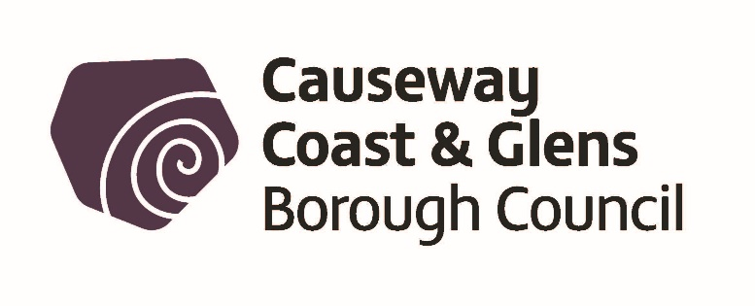

Causeway Coast and Glens Borough Council

Community and Voluntary Register
The Community and Culture Services of the Causeway Coast and Glens Borough Council is updating its register of Community and Voluntary groups within the Borough to ensure that it is up to date.

Purpose of Register
Community and Culture Services collects this detail in order to provide your organisation with any relevant information, including Council or 3rd party events, cultural and heritage activities, funding opportunities (internal and external) and Council wide consultations.

How Community and Culture Services will contact your organisation
In the first instance, Community and Culture Services will contact your organisation by email using MailChimp which stores the organisation name and email address provided. MailChimp Privacy Statement can be viewed at https://mailchimp.com/legal/privacy/. If you would prefer that we contact you by post or phone, please indicate.

How Community and Culture Services will use your data
Council will only use the information provided for the purposes it has been given for. This may mean that if your organisation engages with different services within Council, that due to changing legislation, consent will be required at different times to your organisational information being processed in different ways. Council will only release personal data with consent or where required under legislation. Your organisations contact details will only be released with permission. By giving your consent, you are giving permission for Community and Culture Services to provide this information to anyone who requests it. This includes sharing your contact details to any 3rd party and other business areas of Council. The register will be updated at any time upon request and contact details will be disposed of once updated.

What Community and Culture Services plans to do
Community and Culture Services plans to list the names of all community and voluntary organisations held on the register on Council’s website. www.causewaycoastandglens.gov.uk. Council is aware that in some cases, the contact name and address for organisations is a personal mailing address / mobile phone number / email address etc. and therefore will only publicise these details with permission. Your organisation may want to take the opportunity to create a generic email address that can be publicised in this way.

Please tell us if you need help to read or understand this information. If you need this information in an alternative format including large print, audio CD, Braille or in another language please contact us, Community and Culture Services on:

T: 028 7034 7032. Textphone 028 7034 7056

E: Community.Development@causewaycoastandglens.gov.uk

As a public authority, Council takes your rights and freedoms seriously and will only release information when required under law or with your consent. Further information about your rights, how to contact the Data Protection Officer and how long information is held or how we process any payments made can be found at:
https://www.causewaycoastandglens.gov.uk/footer-information/privacy-statement

REGISTRATION FORM
Name of Organisation / Group:
Named Contact:
Correspondence Address:
Town: |  | Postcode:

Contact Number:
Email:
Position in Group
Website: |  |  |  | Social Media Name:

CONSENT
☐ | On behalf of the organisation, I agree to Community and Culture Services contacting me for the purposes outlined and in connection with the range of activities outlined below
☐ | On behalf of the organisation, I agree to Community and Culture Services publicising the email address provided on Council’s website and when requested to any 3rd party, including other business areas of Council.
☐ | On behalf of the organisation, I agree to Community and Culture Services publicising the correspondence address provided on Council’s website and when requested to any 3rd party including other business areas of Council.
☐ | On behalf of the organisation, I agree to Community and Culture Services publicising the phone number provided on Council’s website and when requested to any 3rd party including other business areas of Council.
☐ | On behalf of the organisation, I agree to Community and Culture Services Sharing the contact details provided when requested to any 3rd party including other business areas of Council.
Date: |  | Signature:

ORGANISATIONAL FOCUS

Please tick the box which best describes your organisation
Amateur Sports Club |  | Over 50’s
Charity Fundraising |  | Parent and Toddlers
Church / Faith based |  | Pre-school playgroup
Community Transport |  | Primary School
Community Association |  | Residents Group
Community Support Organisation |  | Secondary School
Community Centre Management Committee |  | Social and Recreation
Cultural, Arts and Heritage |  | Social Economy Business
Disability |  | Uniformed Youth
Festival |  | Women
Health and Wellbeing |  | Youth
Historical |  | Insert other organisational focus

Please email to: community.development@causewaycoastandglens.gov.uk

Or alternatively post to:
Causeway Coast and Glens Borough Council,
Community and Culture Services,
FREEPOST BEL570, (NO STAMP REQUIRED)
66 Portstewart Road,
COLERAINE. BT52 1EY.

