Community Centre Conference
Round Table Conversations

A big thank you to all those who attended our Community Conference in March 2017, and for the insights that you shared in the ‘Round Table Discussions’. We just wanted to share this information with you as well.

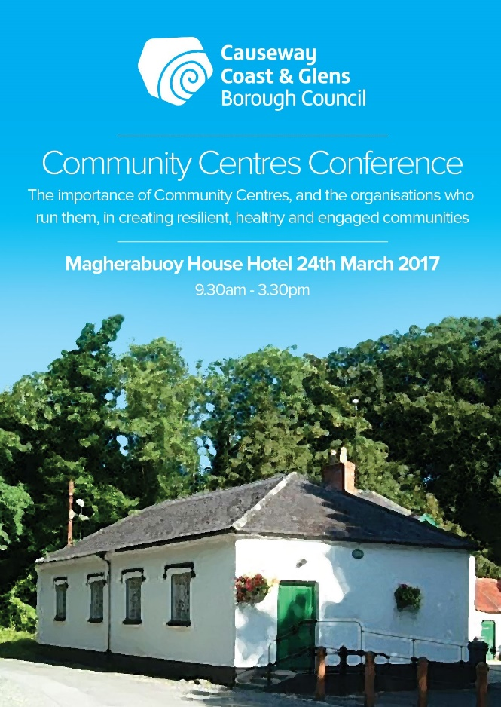
We asked you about the activities that you carry out across the Borough and the range and Scale that Community and Voluntary sector deliver in Causeway Coast and Glens is amazing, and we asked you to narrow this down to the most popular in your centres, and these seemed to be consistent across the whole Borough. (No particular order)

Youth Clubs Summer Schemes 50+ Clubs
Women’s Groups Allotments Community Engagement IT Classes
Football Community Festivals Luncheon Club

We also asked about how you contact your local community and these were the ways that you advised worked most effectively within your communities.

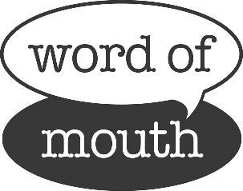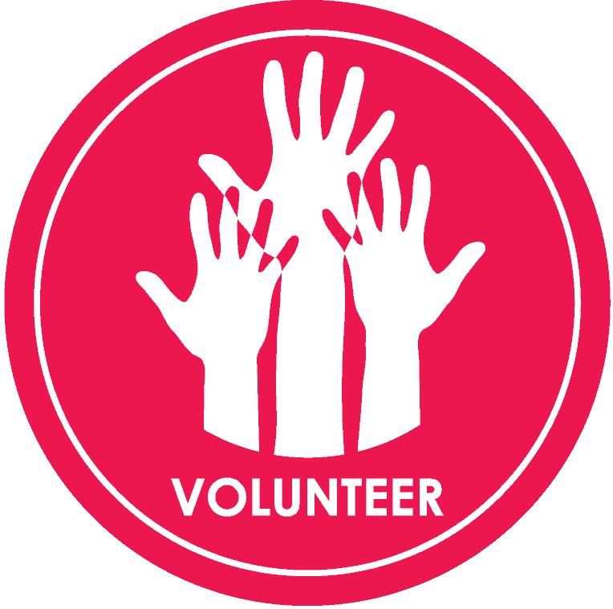

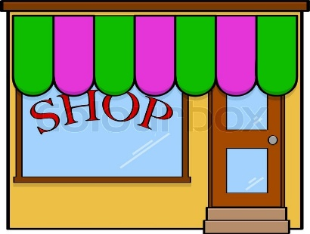

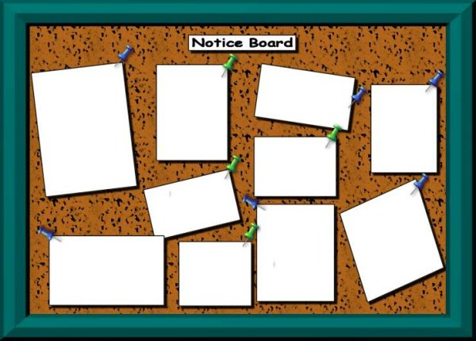

Word of Mouth, Local Schools, Community Volunteers, Local Churches, Social Media, Community Notice Boards

We asked you about how you measure the impact of your Community Centre, and not surprisingly when we grouped these together that the vast majority was done on an informal basis and revolved around listening to the Community in various ways.

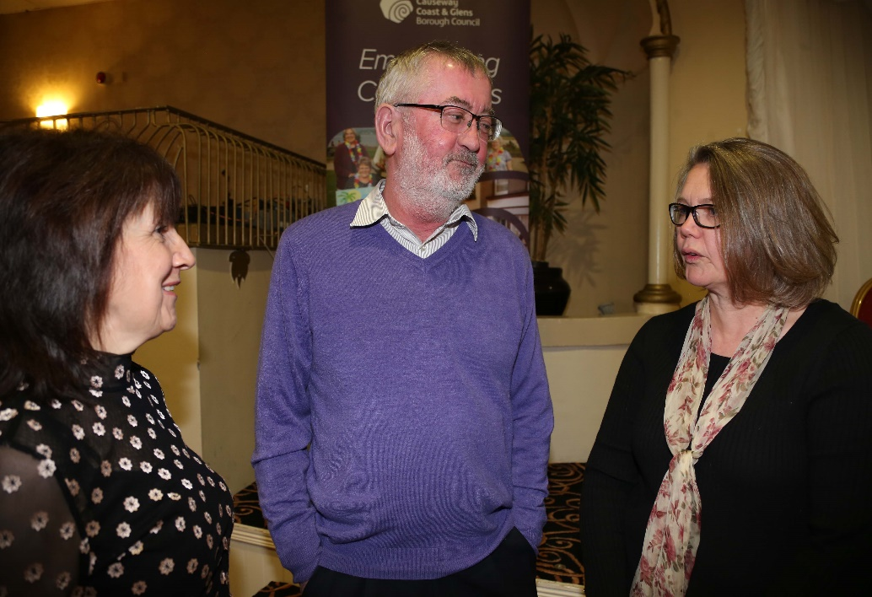

- The most popular ways to measure impact included was Face to Face, Listening to people, Positive complaints and word of mouth.

- Recording numbers, statistics, questionnaires

- Social media and in particular feedback on from Facebook

- Local councillors were also seen as a source of measuring the impact of projects

The next discussion that groups considered was around Peacebuilding and Legacy issues within Communities – we have grouped your comments together into four key areas.

Relationship building on normal issues  Normal Issues  Health and Wellbeing  Friends First  Respect is Key  Cohesion  Outreach to schools and education  Mixing Cultures/Different Drums  Engage across boundaries  Respect  Peacebuilding needs to start at Primary School  Work together to be inclusive and break the mould  WW1 Heritage | Getting people to come together in a single identity area  Imbalance in single identity area  Politicians  Too much money in wrong areas  Diverse People  Leaders have a role  Elections don’t help  Politicians are a challenge

Not everyone is at same level  Entrenched Attitudes  Peer Pressure  Breakdown perceptions  People can lose business  Separate sport cultures  Getting people to come to a single identity area  Tribalism  Rumours and Perceptions  One side doesn’t understand  Can’t all be right | No Shared Space  Shared, different cultures  Creation of new shared space  Distinction between shared space and physical buildings  Too many community centres, need more thought given to combining halls  Perceptions of buildings  Neutral spaces  Sharing of commonalities  No Shared space

Finally discussions moved towards the practical challenges voluntary committees and staff face running community buildings across the Causeway Coast and Glens Borough Council area.
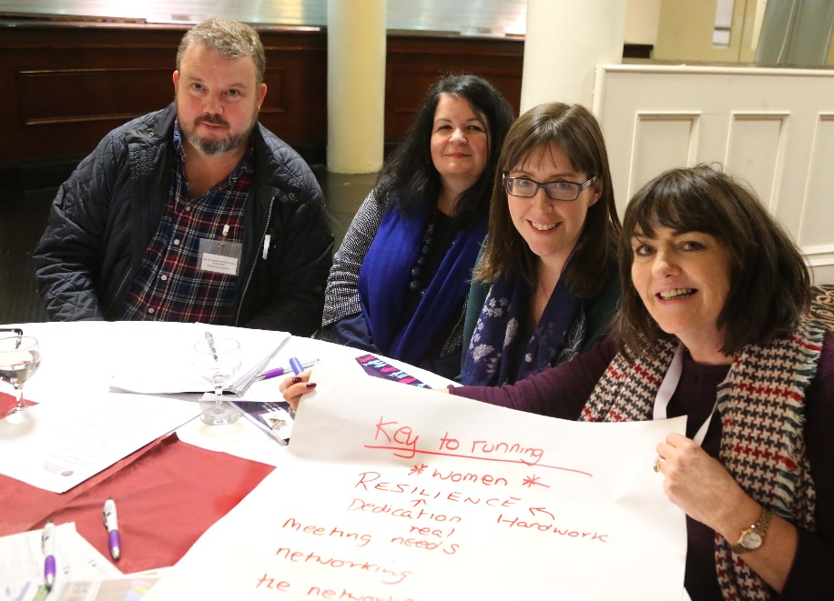

Paid Staff | Practical Support | Up skilling | Recruiting Volunteers
Communication | Funding Core Costs | Small Groups Undervalued | Value of Community intervention not recognised
Upgrade and Maintenance | Running Costs | Volunteer Rotas | Sustainability
Council Charges too high | Skills Upgrade | Real Listening to Residents | Involvement v’s Consultation
Lack of Participation | Covering Overheads | Council funding inconsistent | Volunteer legislation
Advice and Support needed | Insurance Costs | Funders Requirements All Different | VAT
Getting People to help | Paid Workers | Uncertainty | Paid Assistance
Money | Maintenance | Compliance | Social Economy
Single Point of Contact needed in Council | Governance | Staff | Pensions
Civility | Training | Community Engagement | Badly Served by politicians

Thank you for attending the Community Centre Conference and we hope that the findings are of interest to you.

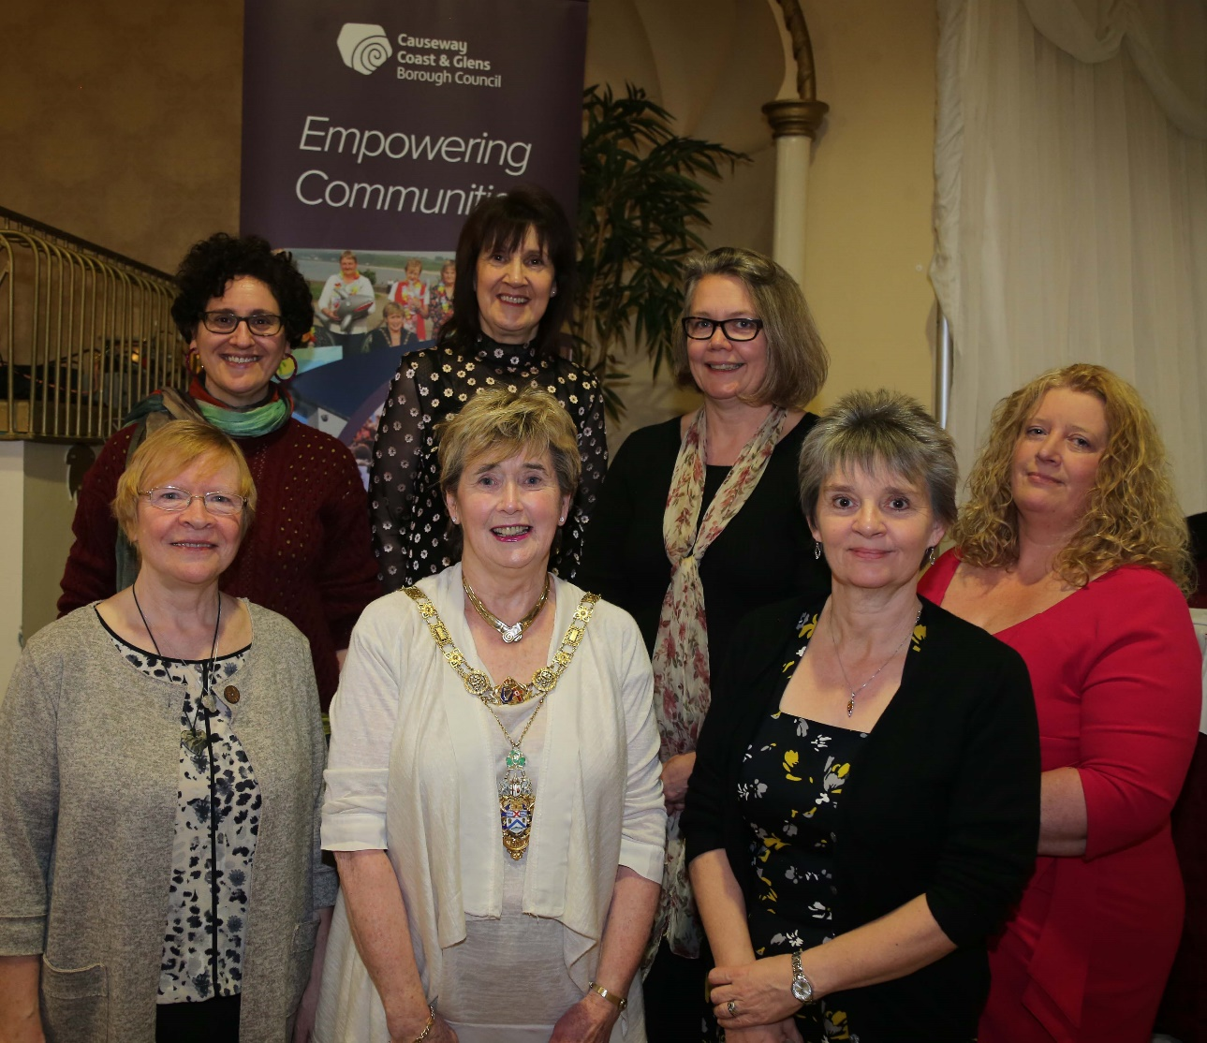

Please take 5 minutes to take our survey so we can plan future training.

