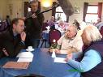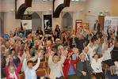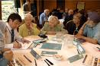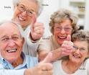

**C.O.A.S.T.**

**(Causeway Older & Active Strategic Team)**

**“TOGETHER WE HAVE A VOICE”**

**A strategic plan for COAST**

**2016 – 2021**

**Contents page**

Section 1 Executive Summary 3

Section 2 Introduction and background 5-9

Section 3 Strategic Context 10- 16

3.1 The wider context - PESTLE

3.2 Statistics

3.3 Stakeholders

3.4 SWOT

3.5 SOAR

Section 4 Strategic Plan 2017 to 2021 17-27

**Strategic Plan for C.O.A.S.T. Sub regional Network 2016 – 2021**

**Section 1: Executive Summary**

Causeway Older & Active Strategic Team (COAST) was set up eight years ago to mirror the new boundaries of the reformed super council area Causeway Coast & Glens. Its aim was to assist and support older people’s groups and organisations to work collaboratively to service the needs of the local age sector.

To date COAST has brought together 30+ different partner organisations all of whom want to be involved and influence the changes in older people’s services. COAST is one of the 11 sub-regional networks supporting the age sector across the new council areas in Northern Ireland as formed as part of an Age NI programme Fit for the Future”. COAST has strong relationships, commitment and dedication of key partners, with regular attendance at meetings and successful project planning, delivery and management.

COAST’s success was influential in the application to the Big Lottery Connecting Older People programme which secured further resources for work with older people in this area between 2013-2016. The funding has supported a collaborative programme of services and the on-going development to the wider partnership.

COAST has an excellent strategic direction for the next five years following on from the success of the Big Lottery’s Connecting Older People’s project. Strategic focus is essential to ensure the success of the partnership and developing the partnership to sustain age sector collaborative working.

The success of the Big Lottery funding is due to achievements over the past few years and partners working effectively together. Further to the appointment and training of staff and volunteers the funding has enabled the completion of a needs and services analysis for older people across Limavady, Coleraine, Ballymoney and Moyle. COAST is now officially recognised as an independent organisation that will improve the quality of life for older people. It is a partnership of relevant stakeholders from community, voluntary and statutory sector to engage with their own roles and responsibilities feeding into the wider interests of older people.

The partnership has achieved much in relation to information provision and communications: in practical terms through dissemination and co-ordination of support and advice; through raising awareness of the issues facing older people; and also through crucial collaborative work, engagement and lobbying for older people. Over the past six years the COAST work has helped to raise the profile of older people’s issues with key decision makers and budget holders locally and regionally.

This plan presents the priority areas of the Partnership in more detail at the Action Plan section. It also addresses a sustainability strategy after the Big Lottery project ends in 2017.

As part of the consultation process evidence was gathered in the form of:

An external evaluation of the Big Lottery Fund Project

* One to one interviews;
* Meeting with COAST board members;
* A web based survey of beneficiary views;
* Consulting beneficiaries;
* Online and telephone interviews.

**Section 2: Introduction**

**2:1 Background**

In December 2007 Age Concern and Help the Aged (now known as Age NI) founded the Fit for Purpose programme as a result of the incoming RPA policy. AgeNI subsequently supported the development of the COAST partnership which was set up within the new super council area to assist and support older people’s groups and organisations to work collaboratively to service the needs of the local age sector community.

After profiling key stakeholders in the area the need for an age sector network was agreed and since its formation in 2009 the partnership has built a strong, recognised network for engagement where 20+ partners plan, design and develop services together based on local issues and need.

COAST has engaged with decision making bodies in a structured, constructive way to advocate, to guide future policy and to plan and deliver frontline services and activities for the older people they represent. It has completed a needs analysis was conducted across the Causeway Coast and Glens through intense consultations with key stakeholders a Strategic Plan was produced for 2010-2015.

In 2010 A fundraising sub group formed to raise funds to carry out its Strategic Plan and in 2013 the COAST received its first funding from the Big Lottery Connecting Older People Programme, through the lead partner Ballymoney Reource Centre, to carry out a programme of service delivery responding to the needs in the survey. A steering group was set up to manage the Big Lottery project and feed back to the COAST on the progress from 4 identified service delivery partners at quarterly partnership meetings.

C.O.A.S.T. is, by the nature of its partnership model, an age sector led network. COAST now has two funded staff who acted as an interim secretariat role to support the Strategic Partnership meetings quarterly.

Consultations and focus groups were held to help review the current COAST strategic and action plans for the Strategic Partnership. This therefore required working with key partners and also the wider COAST Partnership with the support of Age NI in developing this plan.

A piece of desk top research was completed to inform this plan including an examination of:

* Big Lottery Fund External Evaluation
* The COAST Partnership Agreement
* Initial SWOT and PEST analysis

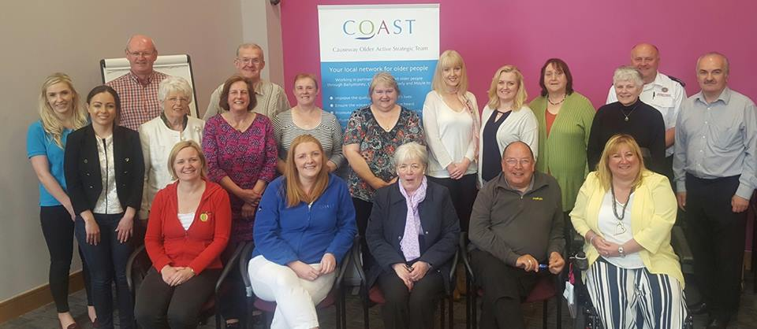

(COAST Strategic Partnership May 2016)

**2:2 Big Lottery Fund Project**

In March 2013, Big Lottery Fund agreed to fund the ‘Older and Active’ programme under its Reaching Out – Connecting Older People Grant programme. The project has been funded for a 3-year period from July 2013 to June 2016.

The Big Lottery connecting older people’s programme 2013-2017 appointed an external evaluator and the analysis, comments and recommendations have supported the development of this updated strategic plan.

With this funding COAST over the last 3 years has supported 406 Good Morning clients with 1316 referrals to social activities; 145 clients to luncheon clubs; 739 older people to events; 500 home safety jobs completed with referrals coming from 7 agencies. 2,000 information directories have been produced, 4 newsletters per year and 9 COAST representatives sit on external committees representing COAST on ageing issues with 5 partnership meetings held yearly.

**During Year 3 there has been continuing evidence that the work of C.O.A.S.T has contributed substantially to:**

* Improved access to information
* Improved knowledge of services available
* Increase in uptake of entitlements
* Access to services
* Awareness of entitlements
* Outreach support services
* Volunteer opportunities

The discussions, the research and the subsequent action planning session with key stakeholders have informed the following plan. Planning identified the main challenges for COAST as the need to:

* Focus on its wider Strategic role and not be side tracked by individual specific projects
* COAST is a Charitable organisation responsible to abide by charity commission legislation.
* Resourcing the work with staff and volunteers.
* React to the changes in the policy landscape and can influence the change to get the most out of these.
* Focus on development of the Strategic Partnership to serve the needs of older people in the Causeway Coast and Glens.

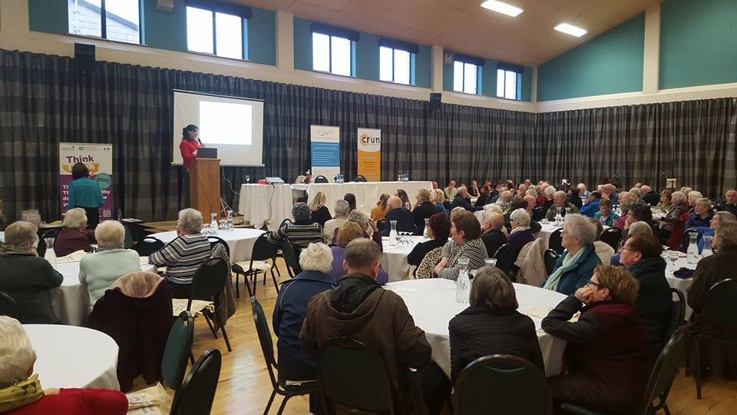

The project made a significant impact on the lives of beneficiaries with 91.7% agreeing strongly that they feel less isolated, 80.0% agreeing strongly that they feel more confident and 88.0% agreeing strongly that they feel more connected to groups and services. A fuller view of perceptions is set out in the table below.

|  |  |  |
| --- | --- | --- |
| **Areas Older People reported COAST helping in** | **Agree Strongly** | **Agree Somewhat** |
| **Less isolated** | 91.67% | 4.17% |
| **More connected to groups and services** | 88.00% | 12.00% |
| **Safer in my home** | 84.00% | 12.00% |
| **Safer when out and about** | 84.00% | 12.00% |
| **More confident** | 80.00% | 20.00% |
| **My physical health has improved** | 79.17% | 20.83% |
| **My mental health has improved** | 84.00% | 16.00% |
| **My self-esteem has improved** | 84.00% | 16.00% |

“C.O.A.S.T. has been a great organisation for supplying us with information of what is going on locally and further afield suitable for older people. C.O.A.S.T. has opened up travel opportunities for us to go to places of interest we would not have been able to consider”

**2.3 Added Value provided by The Older and Active Programme**

In addition to making excellent progress on projected outputs the Older and Active Programme delivered by C.O.A.S.T must be commended for providing additional added value. This can be evidenced through a range of activities including:

* Exhibited at many events throughout the council area to promote the work of COAST.
* Additional funding from Causeway Coast and Glens PCSP, Ballymoney Rotary, Gis A Hug Charity.
* Involvement in the organisation of Positive Ageing month in Coleraine Neighbourhood Renewal areas throughout October 2015.
* Distributed of 100 food hampers from the local food bank to older people.
* 11 social trips
* Developed new friendships and relationships
* Engaging People from Differing Community Backgrounds
* Creating New Opportunities
* COAST development – relationship and collaborative working

**Furthermore, the main opportunities COAST are the following:**

* The development of a revised Partnership Agreement to guide it forward
* The potential to build new relationships and represent a larger number of people and influence community plans
* Strengthening leadership to take COAST forward
* Influencing the changes in the policy landscape which can be of benefit to our members
* Capitalising on collective responsibility, shared learning and experience
* The opportunity to feed into and create a revised Strategic Plan 2017-2022

C.O.A.S.T. is a fantastic organisation and asset to have in the CCG council area for older people. It is a one stop shop for all things related to health, wellbeing, safety and so much more in relation to older people. Without this organisation drawing all the services and organisations together it wouldn't happen. This organisation is partnership working at its best!

**Section 3: Strategic Context**

**3.1 The wider context: PEST**

In developing the Strategic and Action plans for COAST and the legacy of the Big Lottery project 2012-2016 it was essential to first consider the wider environment within which they operate. This was facilitated through discussion structured by a PEST analysis. In scanning the environment the following issues and policies were deemed by those involved in the Connecting Older People project and COAST Steering group as the most relevant and most likely to impact on their work:

**Political**

* Government rebalancing the economy through the engagement of the private and third sector parties to deliver services
* Changes in policy landscape, in particular Transforming Your Care
* Comprehensive Spending Review – voluntary and statutory sector are both effected by this and it will dictate the level of public resources available
* Welfare Reform – huge impact on those reliant on government benefits, their wider family and community. (Noted that we are unable influence this policy).
* Commissioner for Older People: the existence of the post and the plans of the Commissioner’s office can provide opportunities for our work
* Reform of Local Government particularly the changes in relationships, budgets, plans, elections and introduction of community planning and age friendly regions
* Programme for Government offers opportunities to capitalise on government plans e.g. social care, fuel poverty, Active Ageing Strategy etc.
* Intergenerational Solidarity: balancing and positioning of COAST

**Economic**

* Recession and its broader impact on older people
* Tendering – specific to Partnership
* Social Enterprise development
* Longer working lives – people cannot afford to retire
* Grey Consumer – have very strong lobbying power as older people still have resources
* Individual giving/sustainability – will not keep organisation going as less people donate to our cause
* Urban Rural split and the complexity this can create in terms of service delivery and differing needs
* Public expenditure – statutory agencies and funders are expecting the same service for less

**Social**

* Demographics and diversity – there are many types of older people, Partnership needs to agree on who its target groups are
* Fuel poverty affecting more older people
* Reform of Care – TYC, ‘Who Cares?’ Report
* Eternal Youth – how we view ageing
* Volunteering – increase numbers of volunteers available to us; increasing their role in delivery
* Social housing needs for the delivery of older people
* Isolation and loneliness of older people
* Digital divide – are older people excluded? How do we include them?
* Older LGB&T – older people living with HIV and no services available
* Welfare Reform and its impact
* Intergenerational Solidarity – how do we do this without it being forced

**Technological**

* ‘Connected health’ e.g. Telecare – important for funding sub group
* Digital inclusion – access to information, social opportunities, access to services
* Social media – great way to touch base and keep in touch, but lack of control on it
* Advice/scam/frauds – need advice for older people
* New technology may be seen as a barrier

**3.2 Statistics**

In N. Ireland the population figures for those aged over 65: 263,720 (14.5%)

The Causeway Coast and Glens represents 21,697 of the older population (15.4%). (Source: NISRA Census 2001: Table P2- Resident Population; NISRA Census 2011 Table KS102NI)

The present age structure broadly reflects that in NI overall. However, within the Council area, there has been a decline in the young population, and a growth in the elderly population between 2001 and 2011. The following table provides a breakdown on the distribution, by percentage, of the various ages.

***Table 3.2: Age Structure as a Percentage***

|  |  |
| --- | --- |
|  | Total aged 65+ |
| Limavady | 33,536 |
| Coleraine | 59,067 |
| Ballymoney | 31,224 |
| Moyle | 17,050 |

**KEY FACTS:**

* The Northern Ireland trend is a growth in the proportion of people over 65 years of age. This is expected to reach 20% of the total population by 2027 (NISRA 2012- based population projections).
* Coleraine and Moyle have the highest percentage of retired residents.
* 44% of adults over state pension age were disabled.
* The Council has 72 SOAs out of 890 in total for Northern Ireland. Their rankings range from 40 to 862. Three SOAs are in the top 10% most deprived – these are Greystone in Limavady, Ballysally in Coleraine, and Coolessan in Limavady.
* The over 65 age sector of the population is concentrated in parts of the rural coastal areas along the North Coast and Rathlin Island. There are also concentrations in the main towns. Limavady Town demonstrates the concentration of older people in the north of the town in Roeside and Rathbrady. In Coleraine the concentration is in the town centre in Central and to the immediate south in Mount Sandel. Ballymoney’s over 65 population is located in the north west of the town in Glebe and Route, whilst Ballycastle’s lies to the east in Bonamargy and Rathlin and Glenshesk.
* The statistics show a steady increase in the ageing population between the two census years of 2001 and 2011. The percentage of population within the 40-64 year old range has increased significantly; the 65 to 84 category shows a slightly lesser percentage increase but significant all the same. The final 85+ category all evidences the ageing population and therefore the fact that people are living longer in the area.
* In Northern Ireland, life expectancy has increased generally since 1998 for both sexes. The life expectancy of those in the Council area is slightly higher than in Northern Ireland, with the differences between the two sexes again broadly similar to that for Northern Ireland. In the UK, life expectancy at birth is expected to increase by around five years between 2012 and 2037 (Office of National Statistics, 2013) for both men and women and it would be reasonable to assume that life expectancy will similarly increase in the Council area. An increase in life expectancy has an obvious impact on the demand for services and facilities, including health care and specialist housing sectors.
* Key findings of the 2012 based projections were that the population of Northern Ireland was projected to increase to 1.918 million by 2022, from 1.824 million in 2012, with an average annual growth rate of 0.5%. Natural growth is the driver of the projected population increase and, whilst the population aged under 65 years is projected to increase by 1.5% from 2012 to 2022, the population aged 65 years and over will increase by 26%. Longer term projections over 15 years to 2027 indicate the number of people aged 65 and over will increase by 44%.

(<https://www.causewaycoastandglens.gov.uk/wp-content/uploads/2015/08/Item5.pdf>)

**3.3 Stakeholder Analysis**

In developing this report the Strategic Partnership and staff were asked to consider and define their stakeholders.

**Key Stakeholders considered:**

* Age NI
* Causeway Coast & Glens Council
* The Western Health and Social Care Trust
* The Northern Health and Social Care Trust
* The NI Housing Executive
* PSNI

The following partners are full and active members of COAST

**Appendix 1 (review)**

|  |  |
| --- | --- |
| **NAME OF REPRESENTATIVE** | **NAME OF PARTNER** |
| **COUNCIL AREA** |  |
| Elaine Simpson | Age NI |
|  |  |
|  |  |
|  |  |
|  |  |
|  |  |
|  |  |
|  |  |
|  |  |
|  |  |
| **LIMAVADY AREA** |  |
|  |  |
|  |  |
|  |  |
|  |  |
|  |  |
| **COLERAINE AREA** |  |
|  |  |
|  |  |
|  |  |
|  |  |
| **BALLYMONEY** |  |
|  |  |
|  |  |
|  |  |
|  |  |
| **MOYLE** |  |
|  |  |
|  |  |
|  |  |
|  |  |
|  |  |

**3.4 SWOT**

As part of the wider strategic planning process the participants were asked to consider what the organisation’s own internal strengths and weaknesses are, and what external threats and opportunities it may face. The positive elements of this analysis will be built upon in the proposed plans and the negative issues will need to be overcome.

|  |  |
| --- | --- |
| **Strengths**   * Size of the group * Range of partners * Potential Growth * Pedigree/ proven track record * Leadership * Flexible- changed structure * Success created to date re: the Big Lottery project – 3 years delivery * Collaboration & Communication | **Weaknesses**   * Resources * Confusion around Big Lottery Project as main delivery mechanism * Leadership needs focus * Potential – lack of resourced focused leadership in regards to project * ‘All talk no action’ * Roles and responsibility issues (staffing) * Need staff member to lead and who will manage them |
| **Opportunities**   * Leadership * Change in policy landscape * Collective responsibility * New staff member * Strategic Plan * Fundraising and Marketing | **Threats**   * Side tracked by projects * Coasting – no one to lead partnership * Need additional staffing * Change in policy landscape * Dependency on Funding |

**3.5 SOAR**

Having established the strengths and weaknesses the participants used the SOAR model to identify a few key priority and achievable Aspirations. These form the core of the Action Plan.

|  |  |
| --- | --- |
| **Aspirations** | **Results** |
| * Secure resources for dedicated and focused member of staff to take the lead and sit on every sub group * COAST Manager needed * Sub groups set up * Develop forums for all partnership work | * Sustainability of partnership * Higher profile * Local * Regional * Lobbying * Clear communications * Older people/age proofing policy * Branding improved * Single point of contact |

**Section 4: Strategic Plan**

**Vision, Mission and Values**

In preparation for the session the participants had been asked to remind themselves of the current three statements. They were completed and all three were revisited at the planning session to allow for consensual and collective agreement. The group agreed that the current statements were still relevant and truly reflected their organisation and its work.

**Vision Statement:**

Older People are living in a vibrant and caring society where their voices are heard and respected.

**Mission Statement:**

COAST Sub regional Network is an interagency partnership working to improve the quality of life, health and well-being of older people across the Causeway Coast and Glen’s area promoting equal access to services.

**Values:**

Our work is underpinned by a number of core values which informs the functions of the sub regional network in what we do and how we do it:

**Creating Opportunities:** COAST wishes to support individuals and groups to unlock potential and promote active citizenship.

**Challenge and Influence:** COAST believes older people have the right to influence decisions affecting them, and we will empower older people to challenge key agencies to ensure they live healthy, happy, and fulfilled lives.

**Respect and Diversity:** COAST values older people, and believe they must be treated with respect and dignity, promoting equality, accessibility, and will be aware of flexibility.

**Social Inclusion:** COAST will actively promote social inclusion and committed to maintaining independence.

**Having the Older Voice heard:** COAST is committed to being an officially recognised voice for older people and communicating at different levels to bring about positive change.

**Strategic Planning Process**

In 2009 Causeway Older People’s Active Strategic Team (COAST) a sub-regional network for older people was set up with the support of Age NI to build age sector relationships across Limavady, Coleraine, Ballymoney and Moyle areas – now the Causeway Coast and Glens Council area.

Over a period of 12 months October 2015-October 2016 COAST have been looking at revising their 5 year strategic plan. COAST steering group and COAST Strategic Partnership have met 8 times and held a consultation day with groups and other stakeholders along with an external evaluation to gather ideas and determine action for

The following report outlines the priority areas of work and proposed action for the next 5 years of COAST. The draft has been circulated to all organisations who have participated in the process as well as a range of stakeholders whose comments were very much welcomed.

|  |  |
| --- | --- |
| **Theme 1: Performance & Governance**  **AIM 1: To promote Good Governance and improve the quality of life of older people** | |
| **What we want to do…**  **OUTCOMES:**  **The difference we wish to make**  **The benefits or changes we will see** | **How we are going to do it…**  **OUTPUTS:**  **Activities undertaken to make it happen** |
| * 1. **To improve the quality of life of older people in the Causeway Coast area**   Maintain a high quality sub regional network serving older people in the Causeway Coast and Glens | * Plan and review communication plans and awareness of COAST * Engage in regular reviewing and monitoring of Strategic plan * Sustainability Plan |
| * 1. **To maintain and develop COAST Strategic Interagency Partnership**   Building on key functions of the sub regional network | * Maintain and Identify relevant partnership stakeholders * Maintain fundraising sub group * To develop the membership base of older people’s groups * Identifying roles and responsibilities to COAST SP ensuring older people as leaders * Implement a 5 year Strategic & Operational Plan for 2016 – 2021 |
| * 1. **To secure resources and deliver on the strategic plan** | * Develop and review fundraising strategy for COAST * Develop fundraising sub group * Recruit, train and support staff and volunteers to undertake work of COAST |
| * 1. **To support and guide age sector groups to have good governance**   Demonstrating impact and added value of age sector work. | * Develop membership base of older people’s groups * Identify training opportunities and develop list of supporting organisations * Inform and signpost groups to training opportunities * Identify funding for delivering training needed by groups |

|  |  |
| --- | --- |
| **Theme 2: Communication and engagement**  **Aim 2:** **To communicate our work, engage and compliment other key stakeholders** | |
| **What we want to do…**  **OUTCOMES:**  **The difference we wish to make**  **The benefits or changes we will see** | **How we are going to do it…**  **OUTPUTS:**  **Activities undertaken to make it happen** |

|  |  |
| --- | --- |
| * 1. **To raise awareness of the sub regional network to other organisations**   To have a central base for the Sub regional network  Increase PR on issues affecting older people | * PR & Marketing sub group set up to develop a communication strategy * Identify and engage with key statutory & voluntary stakeholders * Develop a good model to link with various stakeholders * To promote and disseminate accessible and relevant information to groups on services, activities and policies which affect older people * Develop website for COAST |
| * 1. **Be recognised as a key engagement body with older people**   To have inter-sectoral links and represent Sub regional on other forums and networks  Older people prioritised into key stakeholder’s agenda’s and strategies | * To be the centre point for information and signposting * Publicity through existing stakeholders and PR materials i.e. Council newsletter, libraries, networks newsletters, shops etc. |
| * 1. **To strengthen, support and sustain older people’s groups**   Build on existing support work and enhance partnership working for older people in the Causeway & Glens Council area. | * To communicate with older people and support collaborative working i.e. Newsletters, talks, presentations, topical discussions, church bulletins etc. * Ongoing publicity on updates – quarterly newsletter * Organise networking events in existing community centres * To promote and disseminate accessible and relevant information to groups on services, activities and policies which affect them * Identify and provide social media/ marketing training * To develop an age sector forum to link into sub regional network and prioritise issues. * Strengthen the membership base for interacting with older people groups |
| * 1. **To promote participation and engagement of marginalised older people**   Raise awareness of older people’s services and share best practice | * Address diversity of older people’s groups and identify those at greatest risk of exclusion * Work in collaboration with other stakeholders to initiative new services and create more choice of services for older people * Encourage more men to attend services |

|  |  |
| --- | --- |
| **Theme 3: Collaboration**  **Aim 3: To collaborate with key organisations and promote opportunities for joint working to enable older people to enjoy healthy and safe lives** | |
| **What we want to do…**  **OUTCOMES:**  **The difference we wish to make**  **The benefits or changes we will see** | **How we are going to do it…**  **OUTPUTS:**  **Activities undertaken to make it happen** |
| * 1. ***To identify Collaborative opportunities*** | * Raise awareness of services for older people in causeway and glens area * Send strategic plan to key stakeholders to inform them of opportunities of joint working * Sharing of skills and resources. * Identify partnership opportunities with other sectors * Encourage organisations to attend COAST strategic partnership meetings to widen partners awareness of other current services available |
| * 1. ***To co-ordinate Interagency working to improve choice of services and activities for older people***   *Improved service delivery and increased opportunities for service delivery* | * To compliment Health Trust and Council services and activities for older people * To co-ordinate age well programmes for active living based on identified gaps * Work in collaboration with member groups to deliver health & well-being programmes to older people per year i.e. Health Fairs, Events, Community safety/ Falls prevention/ Fuel Poverty events * To support Good Morning and Handy person scheme |
| * 1. ***To promote Collaborative working*** | * To assist in producing a comprehensive directory for the causeway area on organisations providing services for older people * Share contact details of relevant organisations working with older people within each current District. * Elect representatives from COAST to join other forums and partnerships i.e. Age NI Consultative forum, Age Sector Platform, NHSCT Older People’s Panel * To hold yearly networking days across Causeway COAST and Glens * Encourage further signposting through a new referral system and website |

|  |  |
| --- | --- |
| **Theme 4: Campaigning and lobbying**  **Aim 4: To be one recognised voice for older people in COAST District Council area, challenging and influencing others.** | |
| **What we want to do…**  **OUTCOMES:**  **The difference we wish to make**  **The benefits or changes we will see** | **How we are going to do it…**  **OUTPUTS:**  **Activities undertaken to make it happen** |

|  |  |
| --- | --- |
| * 1. **To advocate on identified needs of local older people and engage with key decision makers to influence service delivery, policy and development**   *Represent the voice of older people to champion older people’s issues (*Transport/ Social opportunities/ Age Discrimination / fear of crime/ isolation)  Being influential on decisions on frontline services delivered by Trusts and Local Governments  Influencing others to meet needs of older people | * Develop lobbying sub group and work with other regional and local lobbying campaigns * Elect COAST representatives to sit on relevant local committees * i.e. Patient Client Council, Age * NI Consultative Forum, Age Sector Platform, NHSCT Older people’s panel and other relevant organisations * Organise MLA Question and Answer Time * Invite older person’s advocate/ OPC to meetings * Improve engagement with key decision makers – Western & Northern Health Trusts & Council (involvement with Patient & Client Council, PPI, Trust Community Development Strategies, Older people’s panel * To encourage Council to support older people’s organisations more |
| * 1. **To support age sector groups to campaign and lobby on identified unmet needs and inequalities experienced by older people in the Causeway Coast & Glens area**   Build local leadership capacity among other people’s groups  Introduction to policy – politicising older people. | * Develop good working relationships with the media * Link with work of Age NI Policy Department * Organise lobbying skills training for older people’s representatives * Have representatives attend ASP and Pensioners Parliament |
| * 1. **To assist with research and identify local older people’s needs**   Gathering evidence for campaigns | * Facilitate consultations on identified local needs * Identify research partners i.e. Universities to link students to research studies * Collating all national and local research/statistics referring to older people in the COAST area. I.e. CARDI, C.A.P, Age NI, RCN etc. |

|  |  |
| --- | --- |
| **Theme 5: Income and Sustainability**  **Aim 5:** **To develop an efficient and effective sustainable funding strategy to enable the delivery of services to older people** | |
| **What we want to do…**  **OUTCOMES:**  **The difference we wish to make**  **The benefits or changes we will see** | **How we are going to do it…**  **OUTPUTS:**  **Activities undertaken to make it happen** |
| 5.**1 To assist groups to be maintain services and be sustainable** | * Provide Fundraising Support to groups in collaboration with Age NI * Assisting research on gaps in services for older people * Add value to groups work * Have a sustainability plan |
| **5.2 To promote volunteering opportunities** | * To recruit more volunteer representatives for COAST operational plan * Formal process developed to recruit new COAST members * Leadership support to older people on COAST |
| 5.**3 To promote sharing of resources** | * To have COAST representatives sitting on decision making panels i.e. ICP’s and Local Government Community Planning sub groups * Sub group to address resources and invite stakeholders to meetings to discuss potential resources |
| **5.4 To develop and implement a fundraising strategy to support the work of COAST**  Sustainable services for older people in COAST area | * To set up a Fundraising Sub group to identify funding for suggested activities * Dedicated fundraising sub group to apply for funding for full time post to co-ordinate and manage the sub regional network * Complete joint fundraising applications for collaborative work |