

|  |  |  |
| --- | --- | --- |
| Version 1 |  |  |

Causeway Coast & Glens

Parking Strategy

Causeway Coast & Glens Borough Council

2017 - 2027

# Table of Contents

**1.** **Background and Need** 3

1.1 Existing Parking in Causeway Coast and Glens Borough 5

1.2 Wider Context 11

**2. Issues and Opportunities** 11

**3. Best Practice in Parking** 13

**4. The Parking Strategy** 18

4.1 Objectives 18

4.2 Actions 18

4.2.1 Parking Management 18

4.2.2 Parking Location and Events 21

4.2.3 Parking Quality 24

4.3 Action Plan 25

# Diagram

Diagram 1 – The need for a strategy ………………………………………………………………………………………4

# Figures

Figure 1 - Council car parks within the Borough 6

Figure 2 - Council car parks between Portstewart and Ballycastle 7

Figure 3 - Council car parks in Cushendun, Cushendall and Waterfoot 8

Figure 4 - Council car parks in Coleraine, Ballymoney, Garvagh and Kilrea 8

Figure 5 - Council car parks in Limavady, Ballykelly and Dungiven 9

Figure 6 - Map denoting locations of five main study sites in relation to Northern Ireland 17

# Tables

Table 1 – Council Car Parks 10

Table 2 - Parking Management Actions 21

Table 3 - Parking Location and Event Action 23

Table 4 - Parking Quality Actions 25

# Background and need

As part of Local Government Reform (LGR) in 2015, local councils in Northern Ireland received responsibility for public off-street parking. A number of car parks were transferred from the Department for Regional Development (now renamed as the Department for Infrastructure – DfI) to each of the councils, along with responsibility for the management and operation of these car parks through an Agency Agreement with DfI. The Agreement, for the provision of off-street parking enforcement and a penalty charge notice processing service will expire on 31st October 2019. Council will explore all future delivery options to investigate, prepare and ensure a comprehensive delivery of a competitive tendering process for the operational management, enforcement and revenue collection of Council car parks – in readiness for post TransportNI contract 2019. This is detailed in action point 16.

It is important to create a car parking policy to effectively manage car parks and generate a balanced revenue to share costs across an appropriate user spectrum and to collaborate this with stake holders to ensure business stimulation and revenue collection.

Local Government Reform also gave councils planning and place making powers, with a major deliverable being the development of Local Development Plans. To inform these plans, the Strategic Planning Policy Statement (SPPS) for Northern Ireland has stipulated that councils are to formulate parking strategies in order to inform the development of their Local Development Plans. The development of a parking strategy will also enable councils to ensure that parking is delivered in order to meet a number of other objectives. We will continue to work closely with the Department for Infrastructure to address all aspects of parking to provide best solutions to alleviate public concerns surrounding congestion.

This strategy document provides an understanding of the baseline in terms of parking, consideration of best practice and presents strategic objectives and actions for the parking strategy.

It should be noted that this document also has a particular focus on the parking related aspects of seasonal leisure events and tourism within the Borough.

Diagram 1 on page 4 clarifies the need and areas of delivery.

Abbreviations:

* SPPS - Strategic Planning Policy Statement
* VMS - Variable Message Signage
* LGR - Local Government Reform
* P&D - Pay and Display



## Existing parking in Causeway Coast and Glens Borough

The Causeway Coast and Glens Borough extends from Cushendall, Waterfoot in the east and on the Antrim Coast, over to Ballykelly and Dungiven in the west. The area also includes the principal settlements of Coleraine and Ballymoney as well as Portrush, Portstewart, Ballycastle, Bushmills and Limavady

The Council is currently responsible for a total of 79 car parks within the Borough, as shown in Figures 1 – 5 and table 1.

The Agency Agreement between the Council and DfI details a total of 37 car parks that were transferred as part of LGR in 2015; comprising 10 charged and 27 free car parks. This represented a transfer of just under 3,600 spaces in total. Council is proposing to develop the ‘Market Yard’ site in Coleraine to deliver a multi-use facility to include a car park with approximately 90 to 100 spaces.

It should be noted that the Council recently made the Waterside in Coleraine and Main Street in Limavady car parks free. Therefore the 10 charged Council sites utilise pay and display machines, with tariffs ranging between 20 – 50 pence per hour depending on the location. Payment can also be made over the phone, online or through a mobile app via the Parkmobile system. These car parks are subject to routine patrols by traffic attendants throughout the week.

There are a further 42 car parks that were already in possession of the Council prior to 2015 and it should be noted that some of these are associated with council owned buildings e.g. community centres, council offices, etc.

The Council is therefore in control of approximately 5,700 off-street parking spaces, although the true total is not currently known due to a lack of data on some sites and because some of the car parks are not currently laid out in a formal manner.

There are also a number of parking locations that are operated by others. These include on-street parking bays for which time restrictions apply (currently no charging) and therefore they are typically used for short duration parking acts. These spaces are enforced by DfI through the use of traffic attendants. There are also a number of parking sites provided by the private sector for the public to use.

The Borough has a large number of tourist attractions and parking is provided for most of these facilities. For example, the National Trust provides charged parking for the Giants Causeway at the Causeway Head and also controls the associated park and ride site in the centre of Bushmills. Translink provides the associated bus service to/from the Causeway Head and strategically placed Variable Message Signage is used to advise motorists if the Causeway Head site is full so that they can park in Bushmills instead.

As well as charged beach parking on Portstewart Strand operated by the National Trust, it is also possible to park on Benone, Downhill and Castlerock Strands for free.

Figure 1 - Council car parks within the Borough

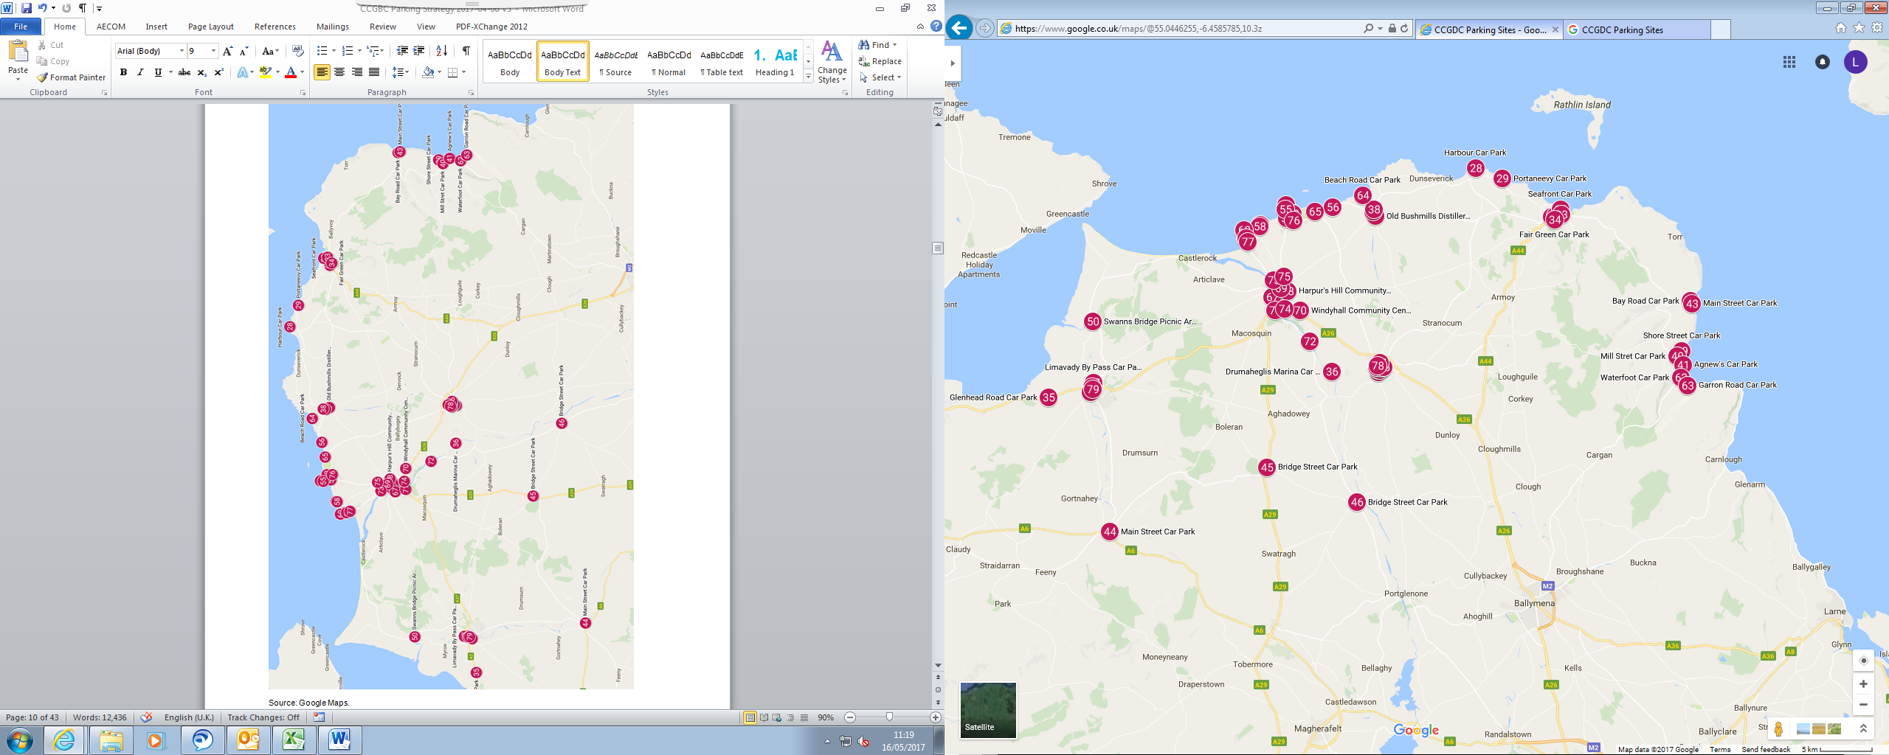

Figure 2 - Council car parks between Portstewart and Ballycastle

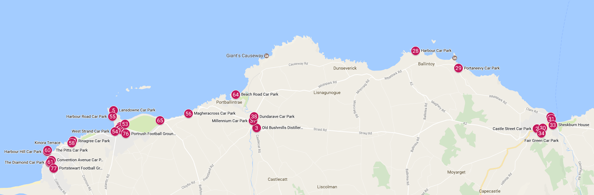

Figure 3 - Council car parks in Cushendun, Cushendall and Waterfoot Figure 4 - Council car parks in Coleraine, Ballymoney, Garvagh and Kilrea

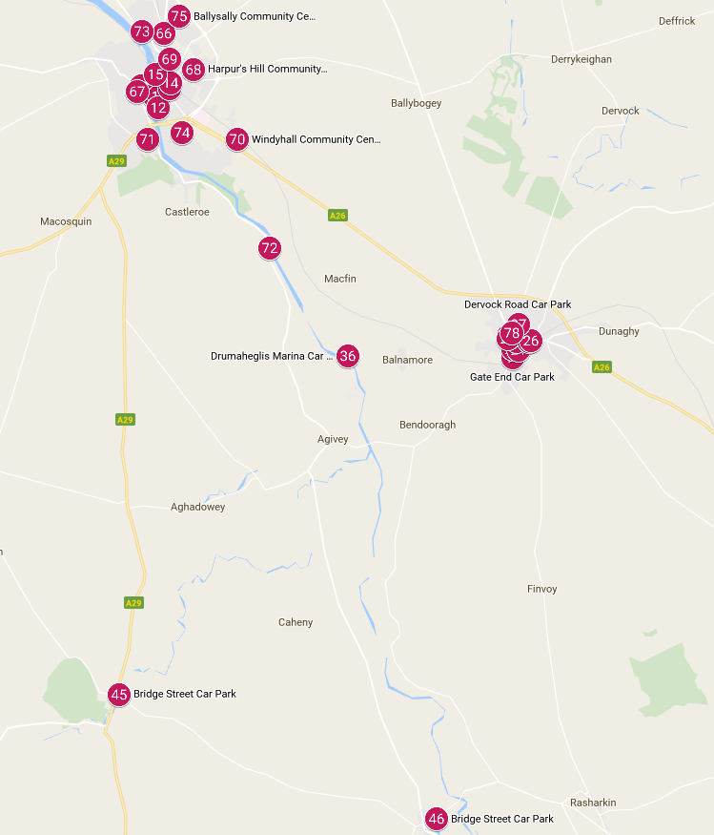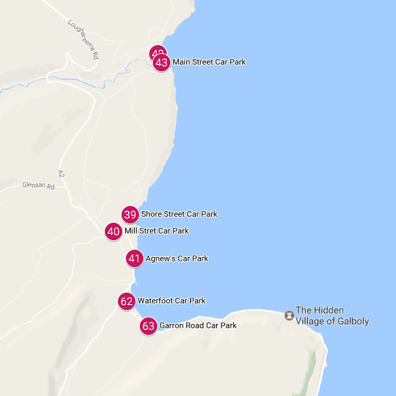

Figure 5 - Council car parks in Limavady, Ballykelly and Dungiven

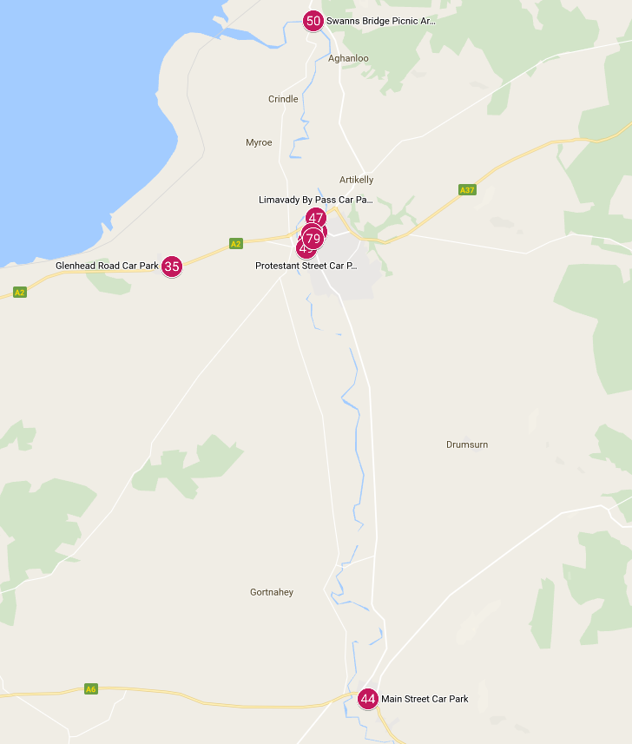

## 

Table 1 – Council Car Parks

## Wider Context

It is necessary to consider wider issues that affect parking in the Borough. The most obvious are the increasing numbers of tourists visiting key sites within the Borough.

Data[1] shows increasing volumes at Bushmills Distillery and Carrick-a-Rede Rope Bridge where volumes have increased by 46% between 2011 and 2015. At the Giant’s Causeway World Heritage Site volumes have increased by 60% over the same period.

It is reasonable to assume that increased tourist volumes would have resulted in some increased car trips and therefore parking volumes. For example, data shows that car parking usage in the East Strand and West Strand car parks in Portrush has increased by 26% from 2011 to 2015. Therefore increases may have been seen at key car parking sites along the ‘Causeway Coastal Route’ i.e. Waterfoot, Cushendall, Cushendun, Ballycastle, Ballintoy, Bushmills, Portrush, Portstewart and Limavady.

This is reflected in an increase in traffic volumes at key locations within the Borough. Data[2] collected by DfI has shown that traffic volumes at count locations along the North Coast in 2015 were between 3% to 14% higher than the yearly average for the period 2011 to 2015. Count data on roads outside of the Causeway Coastal Route but still within the Borough shows that 2015 volumes were up to 4% higher than the yearly average for the period 2011 to 2015.

This data is also reflective on an improving jobs picture across Northern Ireland. Data[3] obtained from the Department for the Economy shows that there has been an overall increase of 5.2% in the number of employee jobs in Northern Ireland from 2011 to 2015. For Causeway Coast & Glens Borough the equivalent figure is 3.1%. Improving employment prospects lead to people having higher disposable incomes and increased spending confidence, meaning they are more likely to take day trips or holidays, amongst other things.

It is important to consider wider regional policies that have an impact on parking and these include the Regional Development Strategy, the Regional Transportation Strategy, the Sub-Regional Transport Plan and the aforementioned SPPS. These policies discuss key themes of parking demand management and the importance of economic activity and growth to the success of hubs and clusters i.e. towns such as Coleraine, Ballymoney, Ballycastle and Limavady.

The existing area plans have been prepared in the context of the Regional Development Strategy and the Regional Transportation Strategy which promote the shared vision of a “modern, sustainable and safe transportation system which benefits society, the economy and the environment and which actively contributes to social inclusion and everyone’s quality of life”. Further the local development plans should consider a range of initiatives such as parking pricing policy, designating areas of parking restraint and reducing long term parking spaces, in order to better manage existing car parking provision in the Borough.

Of particular note is a feasibility study commissioned by Council in 2016. The study identified 18 candidate sites for the possible provision of ‘Park & Ride’ or ‘Park & Stride’ facilities for the British Open Golf Championship which is to be held at Royal Portrush Club in 2019. Two sites on the Ballywillan Road in Portrush were identified as the best sites for the proposed facilities, although others were also workable in principle. These facilities could also be used to assist with other large events such as the North West 200 and Portrush Airshow and they would be useful for the numerous other smaller events that happen in the area throughout the year.

# Issues and Opportunities

It is evident that there are a number of opportunities that exist to improve the approach to and quality of parking that is provided by Council. This would lead to an improved parking experience for users whilst protecting the Council’s short and long term interests and objectives.

The key areas of consideration are increasing user activity within the Borough and the need to ensure that parking provision complements rather than discourages this activity, along with ensuring the high quality and ease of use of parking for users.

The respective aspects of these issues are summarised as follows:

**Increasing Activity**

* With increasing tourist and traffic volumes, more pressure will be felt in key areas. Most of the car parks located on the Causeway Coast have very limited capacity, and some attractions have limited if any parking (e.g. Dunluce Castle, Whitepark Bay, and the Dark Hedges etc. which are provided by the National Trust or DfI Roads). Council need to consider how they can provide additional parking in these areas that would also include coach / bus parking.
* The Causeway Coast is also an area of Outstanding Natural Beauty and this should be managed sensitively. This means removing unsightly and inconsiderate kerbside parking and preventing anti-social driver behaviour in public spaces e.g. on beaches.
* There is therefore a need to manage demand within limited parking supply, and this can primarily be achieved through linking payment with parking desirability.
* There is also a need for the area to be able to accommodate short seasonal peaks in demand e.g. single day trips or weekend peaks due to events or particularly good weather. Users need to be able to find a parking spot without having to revert to parking on verges or circulating looking for parking spaces.
* There are a number of ‘hubs’ that are already the focus of activity and these will become increasingly so. These include Portrush and Portstewart but also Bushmills and Ballycastle. Bushmills is an attractive town in its own right but it has also become a hub for trips to the Giants Causeway (by both shuttle bus and the heritage railway). There is the potential for Bushmills to further connect trips to Whitepark Bay and the Dark Hedges in the east and to Portballintrae and Dunluce Castle in the west. Ballycastle performs a similar function and is also the hub for trips to Rathlin Island.
* The increasing number of overnight stays from those using campervans will add to pressure on certain sites, and it is worth considering how this can be managed more effectively. Consideration should be given to enforcement solutions bearing in mind coastal car parks accommodate a range of users including outdoor recreation enthusiasts (including commercial operators) who often have high sided vehicles carrying equipment associated with their pursuit/activity, thus height restriction barriers may not help address this issue.
* In the absence of managing parking demand, the attraction of key tourist sites could be diminished which may ultimately lead to declining volumes due to a poor user experience.
* Similarly, parking in the towns within the Borough could become affected by inappropriate all day parking acts which can inhibit town centre trade. Research[4] shows that it may be advantageous to displace the ‘all day workers’ to the periphery of towns to encourage shoppers and tourists into areas of high footfall.

**Parking as an Essential Asset**

* Parking enforcement can be approached in a number of different ways and it does not have to rely on traffic attendants which can often be viewed negatively by the general public and local businesses.
* The Borough hosts large tourism and sporting events, with the 2017 Irish Open and impending 2019 Open Golf tournaments being the notable headlines, as well as large annual events such as the North West 200, Auld Lamas Fair and Portrush Airshow etc. There is a need to ensure that these events run smoothly and parking provision and management is a critical aspect.
* Parking can help to ‘link trips’ between various attractions through shuttle bus park and ride services or linked parking tickets etc. This needs to be fully explored, see action point 7.
* An effective parking policy can also increase the length of stay of visitors through incentives rather than reduce it.
* A revenue stream arising from parking can then be used to invest in local facilities. These do not only include the car parks and their associated equipment/management systems but revenues can be used to provide improved cycling and walking links which improve connectivity within the Borough.
* Parking sites can be requisitioned for events or identified for reuse if surplus to requirements, realising significant land values in certain locations subject to review by the Capital Assets Realisation Team (C.A.R.T).
* Parking sites can be used to provide advertising opportunities for local businesses.
* Investment in parking sites can increase user confidence, safety and ease of use.
* Modern parking technology can be used to guide users to individual car parks, advise on availability and provide easy payment options.
* Parking facilities should have appropriate features such as lighting, good signage, white lining and spaces for those with limited mobility.

# Best Practice in Parking

In developing the parking strategy, it is important to identify and consider best practice. Parking technology is a particularly evolving area, however there are other principles that apply when seeking to provide the best parking offer to users and wider society.

In general terms, the parking strategy should seek to address the following areas:

* Ease of use in relation to payment options where applicable;
* Increase turnover of spaces in the most desirable locations so that more people can visit per day e.g. areas of town centres closest to shops etc.;
* Improved signage would aid in the redistribution of vehicles wishing to park, and ensure that parking takes place in the most appropriate location;
* Improving access for pedestrians and those with mobility issues will improve the attractiveness of some car parks;
* The perception of safety in car parks is vital for continued use. This could include creating defined areas with perimeter fencing, CCTV and reducing the feeling of isolation at some car park locations could increase occupancy; and
* The setting of parking tariffs can influence parking activity including the level of usage, and hence the traffic generated, the type of user and also length of stay i.e. increased space turnover.

**Tariffs and Payment**

There are a wide range of approaches to tariffs and payment. When setting parking tariffs, factors that should be taken into account include the price elasticity of parking demand, competition between areas and incentives for the use of off-street parking. When setting tariffs at public car parks, it is good practice to set them at a level so that 10-15% of the space is free at peak times ensuring that drivers will be confident that parking will be available. As surrounding factors change, a review of tariffs in response to particular events should be undertaken regularly i.e. each three year period.

The ‘pay on foot’ system issues a ticket upon entry which the driver then feeds into a payment machine to calculate the cost for the length of their stay upon returning to their vehicle. The same ticket is then used to exit the car park via the barrier system. A major benefit of pay on foot is that parking enforcement patrols are not required as users pay for the amount of parking they use before being able to leave.

Cashless parking means that users do not have find loose change to pay for their parking. Instead, users can pay online, over the phone or via an app. This also means they are less likely to overpay for their parking, which is something that can occur in a ‘pay and display’ scenario. Some cities have developed parking ‘apps’ that assist users to find car parks and spaces and then pay for them electronically. Similarly, parking bay sensors can be used to identify if a space is occupied and then drivers and parking system operators accordingly.

Season tickets can also be purchased by certain users and they then need to display the permit on their vehicle. Season tickets can provide dedicated/assured parking space for those undertaking essential activities (e.g. key workers such as nurses, firefighters etc.) Collaboration with TNI is essential to allow Council to manage off street car parks effectively and where possible facilitate additional visitor parking to assist with the alleviation of TNI’s resident parking issues.

**Parking Management**

It is important to set out the reasons why some parking acts need to be closely managed. In the first instance, it is evident that with no restrictions on parking, people can park for as long as they want. Whilst this may be acceptable in locations where there is ample parking, it is not the case in most towns or indeed most of the key locations in the Borough where space is constrained or is at a premium.

Having no restrictions effectively limits the number of people who can park in a given place per day. This means businesses see lower footfall and limited parking supply will mean visitors find it hard to park. Rather than providing more parking, the solution in constrained areas is to increase space turnover so that spaces become available more often. It is also worth noting that research[5] in other areas has shown that shopkeepers consistently overestimate the share of their customers coming by car. In some cases[6], this is by a factor of as much as 400%.

Managing parking can mean that some users have to realistically consider whether their trip can be made by other means such as public transport. In the absence of parking controls, users may not have to make this consideration. If this occurs then it frees up parking and road space for others and increases public transport patronage. Similarly, providing park and ride sites means that parking acts can be concentrated in non-central locations and then people can arrive at their destination by bus. This is a much more efficient means of transporting large numbers of people into a particular location.

There is also a balance that needs to be struck between providing sufficient space for all day parkers (typically local workers) and short stay parkers who are often the customers of the same businesses or visitors to the area. In towns, there is not one type of user and therefore the parking restrictions need to be cognisant of this by providing flexible tariffs. In other areas such as at tourist attractions, a set time period is reasonable to allow visitors to see the attraction and then depart, freeing up space for others.

There is always a cost to parking acts. If parking is provided free to the end user, the car park provider has to bear the construction, ongoing maintenance and enforcement costs of the car park (even free sites require some enforcement). Related to this, if the car parks are publicly owned, local residents who don’t need to park in the car parks are effectively subsidising visitors who do need to park. However with car park charges in place, this subsidy burden is removed from local residents. There are also ongoing issues with requests for resident’s permits to be able to park directly outside their properties. Although this remains an ‘On Street’ issue for TNI, (see previous) Council will liaise with TNI on how they can assist in areas such as Long Commons in Coleraine and Ramore Avenue in Portrush.

There are also costs to people who are unable to find a parking space. They either have to keep circulating until they find their space or they even may not make the trip again. Costs are also experienced in terms of environmental damage from the congestion associated with circulating vehicles and there are associated impacts on personal health and the visual amenity of individual towns.

It is also worth pointing out that parking price is not a big consideration for retail customers. Numerous research publications[7] have come to this conclusion, and they note that location/convenience and personal safety rank above parking price. Furthermore, recent research[8] into parking conducted by the Welsh Assembly Government noted the following:

*“Car park charging should not be viewed in isolation from other factors (availability of parking, signage and traffic flow) which affect willingness to drive in town centres”*

*“There is very little published evidence which links changes in car park charges to changes in town centre footfall.”*

*“General availability of spaces is felt by visitors to be more important than cost in their overall decision about visiting. Traffic flow and parking signage are felt by visitors to have the same, if not greater, effect on their decision to visit the town centre, how long they spend there, and how much money they spend.”*

Wales is similar in many ways to Northern Ireland, and this research reinforces the point that the introduction of parking charges/controls does not in isolation have a detrimental impact on how town centres perform. The key factor is availability and in locations where space is at premium, the best way to ensure availability is through parking pricing. In other words, if people can’t find a space or feel unsafe when parking then those are bigger reasons for not returning than the actual cost of parking.

**Examples**

To understand potential approaches to parking management within the strategy, a review of similar tourism/leisure locations elsewhere in the UK has been undertaken. These are detailed below and shown on Figure 6.

**Cornwall**

Cornwall is located on the South-West coast of England. Newquay and St Ives are two of the main towns located on the County’s North-Western coastline. Cornwall has numerous beaches which attracts tourists to the county such as Carbis Bay Beach, Fistral beach (Newquay) and Porthmeor Beach (St Ives). Attractions such as The Eden Project, Land’s End, Pendennis Castle and The Lost Gardens of Heligan attract tourists to Cornwall.

Twenty five car parks were reviewed and it was found that four of the 25 car parks provide short stay parking and the remaining 21 provided long stay car parking facilities. Tariff charges are approximately £1.40 per hour. Twenty three of the 25 car parks provide seasonal car parking facilities from March 15th to 31st October/30th November each year. Non seasonal parking tariffs are either significantly reduced or free. Ten out of the 25 car parks provide free non seasonal car parking.

**Conwy**

Conwy, Colwyn and Llandudno are situated on the North Wales coast. Betws y Coed is a village located further inland within Gwydir Forest Park. The area is popular with tourists due to the presence of numerous attractions and beaches such as Conwy Castle, Snowdonia Mountains, Penryn Castle and Llandudno North Shore Beach.

There are a total of 17 car parks within the study area, all of which are charged. Parking tariffs are approximately £1.00 per hour. Reduced parking charges and free car parking generally apply between 18.00 and 08.00.

**Northumberland**

Northumberland is located on the North-East coast of England. The towns of Bamburgh, Beadnell, Blyth and Seaton Sluice are all situated on Northumberland’s coastline with the North Sea. Tourists are attracted to Northumberland’s coast due to the presence of local attractions such as Lindisfarne National Nature Reserve (Holy Island), Bamburgh Castle and Dunstanburgh Castle. An abundance of beaches along the coastline also attract tourists to the area such as Bamburgh Castle Beach, Coves Haven and Seahouses South.

There are 10 coastal car parks on the Northumberland coast. A mixture of free and tariff charges apply at each car park. Seven out of the 10 car parks provide free car parking facilities. All day car parking tariffs in Low Newton, Holy Island and Seahouses are approximately £3.50 daily.

**Isle of Skye**

The Isle of Skye is located off the North-West of mainland Scotland and is the largest of the Inner Hebrides Islands. Portree is the largest town on the island and is situated on the Eastern coast. The abundance of natural attractions and sights on the Isle of Skye makes it a popular destination for tourists such as The Old Man of Storr, Faerie Glen, Dunvegan Castle and Quiraing. There are two car parks in Portree. Car parking tariffs apply in both car parks and are approximately £0.40 per hour.

**Isle of Wight**

The Isle of Wight is located in the English Channel off the coast of Portsmouth. It is the largest and second most populous island in England and is accessible via ferry or aeroplane. Ryde is the largest town and is a seaside resort on the island, located on the North-East coast. The large town of Newport is centrally located on the island. The Isle of Wight is popular with tourists due to the abundance of beaches in the area. The Needles, Carisbrooke Castle, Appuldurcombe House and Fort Victoria are examples of just some of the attractions which bring tourists to the Isle of Wight.

There are 61 car parks on the Isle of Wight, all of which charge tariffs. Eleven out of the 59 car parks are short stay and there are a total of approximately 4,400 car parking spaces on the island. The short stay car parks charge £1.30 per hour compared to the long stay car parks which charge £1.00 per hour.

**Conclusions**

This review of sites shows that (1) they are similar to the Causeway Coast and Glens context, (2) they all provide a degree of charged parking, (3) tariffs vary but are generally related to desirability and the proximity to key attractions, (4) they provide a revenue stream for local authorities assisting with offsetting maintenance and other service provision costs, and (5) having parking charges does not discourage use as these are well established destinations.

Figure 6 - Map denoting locations of five main study sites in relation to Northern Ireland

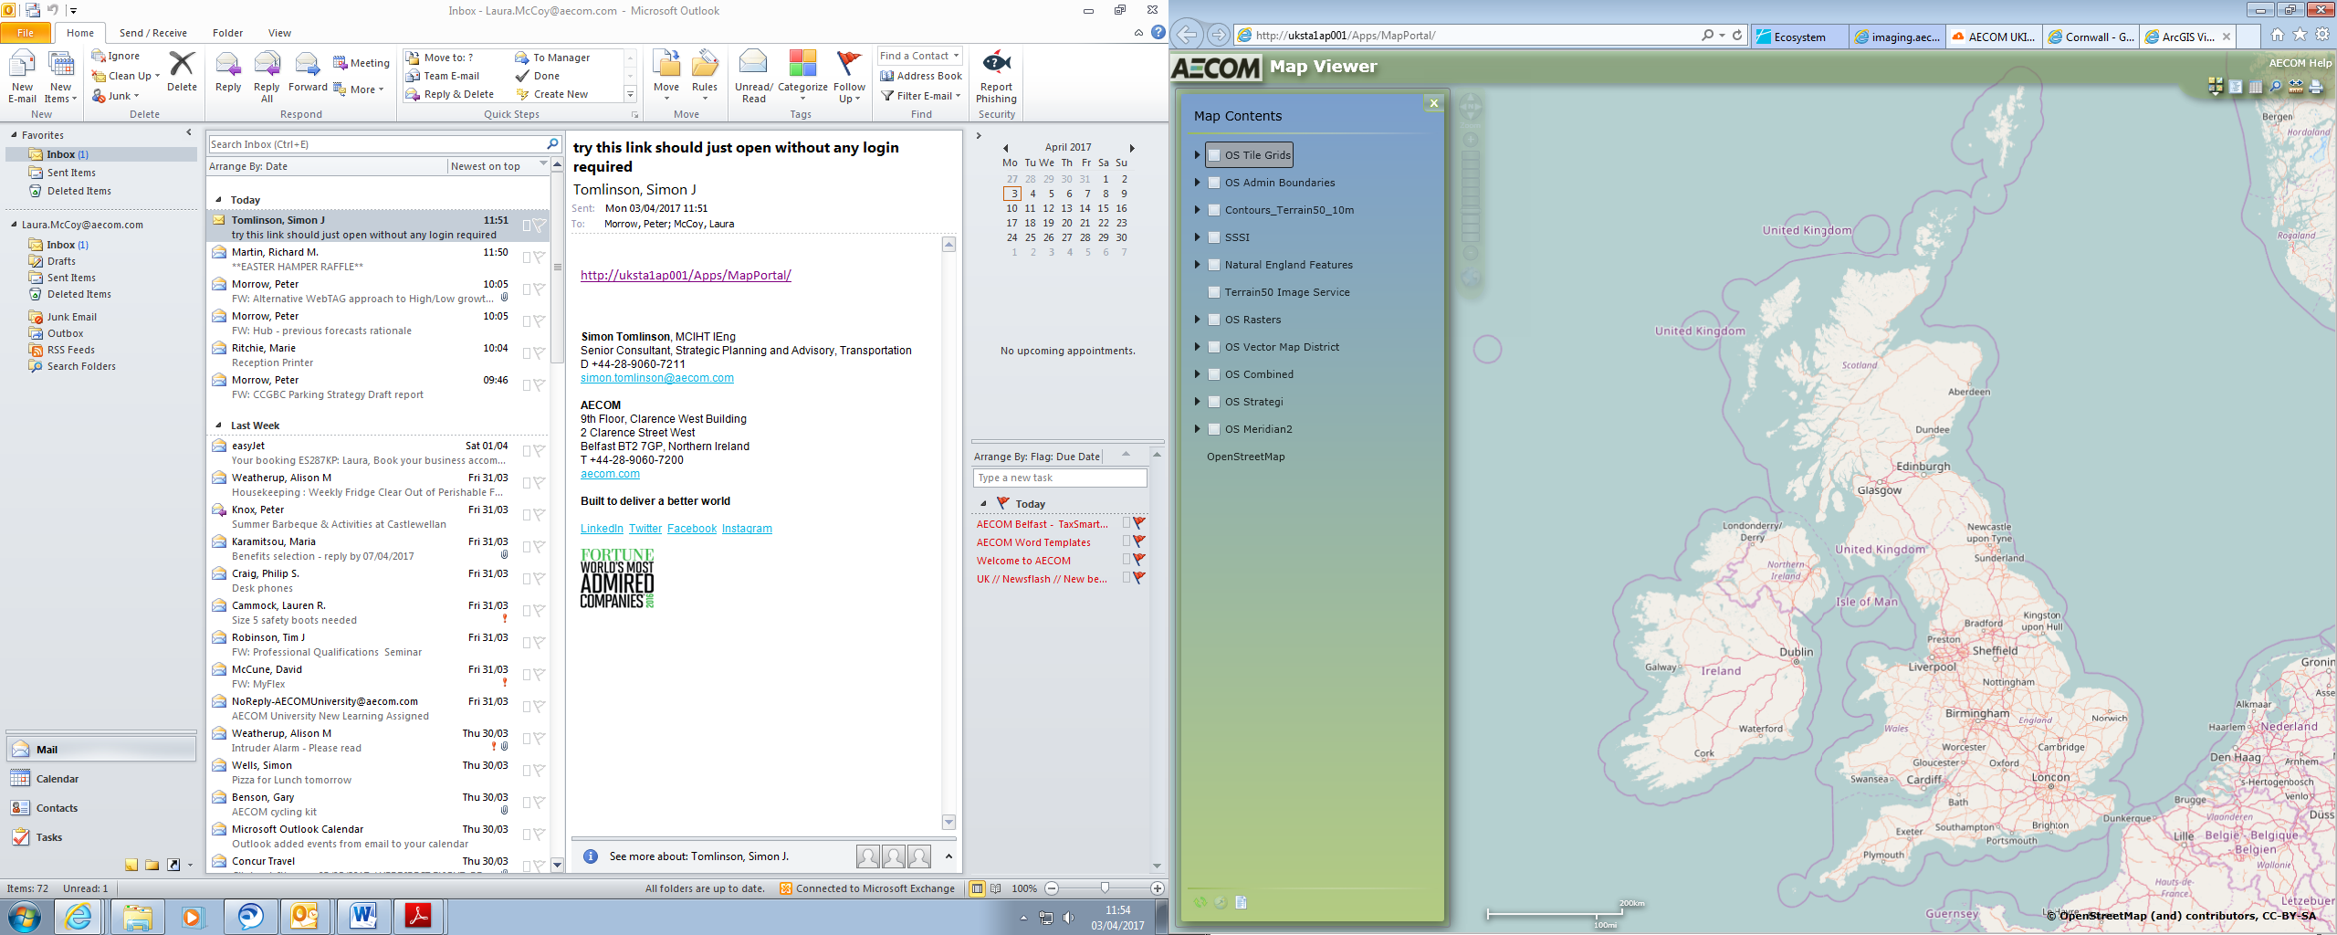

Isle of Skye

Causeway Coast and Glens Borough

Northumberland

Cornwall

Isle of Wight

Conwy

# 

# The Parking Strategy

## Objectives

A set of objectives for the parking strategy have been developed. These primarily consider the Council’s economic, social and environmental objectives and are cognisant of the issues identified to date.

The objectives for the Causeway Coast & Glens Parking Strategy are as follows:

1. Ensuring that parking supports economic vitality within the Borough
2. Ensuring that parking supports tourism and large events
3. Ensuring that parking takes place in appropriate locations and promotes connectivity
4. Providing high quality parking and information, ideally through technology
5. Providing parking for all types of users

## Actions

The individual actions of the parking strategy for the Council are detailed in the following sections. Each is explained in terms of the current and proposed arrangement and a rationale for implementation is also discussed. It should be noted that actions that could be carried out by others have not been considered in this parking strategy.

The actions have been grouped into three main strands:

1. **Parking Management** – covering parking charges, restriction periods and payment systems
2. **Parking Location and Events** – covering key parking locations, alternative usage and arrangements for large events
3. **Parking Quality** – covering the standards of and features within car parks

### Parking Management

At the existing ten charged sites in the Borough (Market Yard available November/December), the **tariffs will be reviewed** to determine their validity. This will consider whether an increase or reduction is required, based on local factors and characteristics. This will also include the hours and days of the week where charging is in force. It is considered that maintaining a mix of free and charged car parks in the main towns provides sufficient long and short stay parking opportunities for all user types.

As detailed in preceding sections, it is evident that increased parking management is required at a number of locations. There is also a need to establish a link between parking desirability and price in certain locations.

There are a number of highly popular car parks located within the Borough which are busy during the summer months. Introducing charged parking at those locations will facilitate traffic management improvements and provide a revenue stream associated with usage.

An opportunity exists to introduce **seasonal car parking charges** between March and September. Details would be brought forward to the Council for initial consideration at the following nine locations:

* Ballintoy Harbour Car Park;
* Ballycastle Marina Car Park;
* Portballintrae Beach Car Park;
* Portrush East Strand Car Park;
* Portrush West Strand Car Park;
* Portrush Landsdowne Road Car Park;
* Portrush Dunluce Avenue Car Park; and
* Portstewart Convention Avenue Car Park.

The car parks at Ballintoy, Portballintrae and Ballycastle are all located at highly desirable tourist destinations and also have limited capacity which needs to be managed to encourage turnover.

In Bushmills tour coaches let their clients exit at the Giants Causeway and then park their coaches at Dundarave Car Park in Bushmills to wait for their Clients to finish. Council will liaise with the National Trust who have a lease on the Dundarave Car Park and also Tourism and Development to potentially develop this site to provide increased Coach parking / Park and Ride to the Causeway and also other areas such as Portballintrae, Dunluce Castle, the Causeway Coast through to Whitepark Bay and east across to the Dark Hedges.

In Portrush, which is the centre of the numerous large events that happen throughout the year, there needs to be a strategic approach to car parking provision in order to ameliorate many of the traffic congestion issues associated with people circulating to look for a parking space. There are also currently no parking charges in either Portrush or Portstewart. The car parks identified in Portrush and Portstewart are highly desirable locations and this should be reflected in charged parking. The Convention Avenue car park in Portstewart is also of a suitable size for charging in comparison to the other car parks in the town. Implementing charges at these locations will also provide a revenue stream that means further investment can be made in the parking facilities themselves as well as potentially other key infrastructure such as walking and cycling routes as mentioned previously.

Any future changes to car parks will result in an additional revenue stream. If members were to consider charging in various car parks such as in Ballintoy, Bushmills, Portballintrae, Ballycastle, Portrush and Portstewart, **Officers will investigate the best payment systems available** to include multiple payment options i.e. cash, card and online etc. Any future system should give consideration to high level compliance and low level enforcement. The often negatively perceived traffic attendant patrols should be kept to an absolute minimum but undoubtedly some level of enforcement will be required.

As such, the revenue generated by these sites will be used initially to pay for any new payment systems. It would also be worth considering whether discounted ‘linked ticketing’ can be provided between these respective car parks given that some users travel to multiple attractions in one day, and incentivised car park ticketing could further encourage this.

The car parks will also be examined to **identify any associated refurbishment** **required** and new signage will be installed which states the terms of use, operating hours and tariffs applicable.

Associated with these changes, there is the opportunity to provide improved parking information for users as they approach the towns where there is a choice of car parks. At this moment in time it is suggested that **active Variable Message Signage (VMS) is investigated** to be installed on key arterial routes located in certain towns, similar to that already in place at Bushmills for the park and ride site and also in Coleraine. Whilst the long term opportunity exists for in-car / app based parking information to be used to guide users to car parks, this technology is in its infancy and does not have a wide uptake of users. Similarly, visitors to the area are unlikely to be aware of such a facility, never mind download or install the software prior to making their trip.

As such, VMS signage should be considered for installation or updated at the following locations in the first instance as these are towns where users are more likely to be unfamiliar with the parking facilities available:

Portrush:

* approach from east on A2 Bushmills Road
* approach from west on A2 Portstewart Road
* approach from south on Atlantic Road

Portstewart:

* approach from east on A2 Portrush Road
* approach from south on both Coleraine Road and Station Road

Ballycastle:

* approach from west on both A2 Straid Road and Moyarget Road
* approach from south on A2 Mary Street (i.e. west of Cushendall Road and Glenshesk Road junction)

Bushmills / Giants Causeway:

* approach from the south and east towards the Giants Causeway on Causeway Road highlighting alternative parking in Bushmills and Park n Ride facility.
* update existing VMS system to include Dundarave and Millennium car parks

The VMS equipment will be linked to any future payment systems located in the car parks so that live occupancy data can be shared and then displayed. This means that as car parks fill up, users can change their intended parking destination accordingly. This will reduce unnecessary circulating and u-turning trips.

VMS signage in Ballymoney is not required at this time as users are more likely to be those who frequent the town which would mitigate the need for such signage.

Any associated investment regarding VMS would be brought to members for consideration.

Council is also aware of instances of **overnight parking** by campervans at certain key sites located near tourist destinations e.g. Portballintrae Beach Road car park, Whiterocks car park and Magheracross car park on Dunluce Road. There is a need to clarify (1) that some car parks should not be used for this purpose altogether and (2) where overnight parking is permissible, terms and conditions should be developed and consideration given to implement a charging regime. Council will audit existing facilities and consider other areas within the Borough under Council land ownership. This will consider the associated facilities that may be required for overnight use such as aire de service machines, tank emptying equipment and electricity hook-ups. Any consideration needs to take into account our current campervan facilities at various sites including Juniper Hill, Carrick Dhu, Benone, Cushendall, Cushendun, Drumaheglis and Sandhill Drive. This will be done in conjunction with our Leisure & Development Department.

Also, Council should investigate the legalities surrounding those that are non-compliant and what enforcement methods are available for those who park overnight on Council car parks and land.

The Parking Management strategy actions are summarised in Table 1.

Table 1 - Parking Management Actions

| Action | Current Arrangement | Proposed Arrangement |
| --- | --- | --- |
| Review tariffs at existing charged sites | Ten sites are currently charged. Tariff ranges between 20p – 50p per hour. | Examine tariffs and assess need for change according to local factors. |
| Consider introducing parking charges | Free parking at:  Ballintoy Harbour Car Park;  Ballycastle Marina Car Park;  Portballintrae, Beach Car Park;  Portrush East Strand Car Park;  Portrush West Strand Car Park;  Portrush Landsdowne Road Car Park;  Portrush Dunluce Avenue Car Park; and  Portstewart Convention Avenue Car Park. | Consider introducing seasonal parking charges between March and September at these eight sites.  Investigate discounted ‘linked ticketing’ between these car parks to encourage multiple stops per day. |
| Payment System | None at above car parks.  Ten charged car parks across the Borough operated by Pay & Display machines. All other car parks free to use. | Review all car parks and consider best payment system available. Also review free car parks with high occupancy levels that could potentially become charged, i.e. Townhead Street Ballymoney. |
| Refurbish car parks | Current condition of car parks. | Refurbish the above car parks as required. Install signage, directional pointers, litter bins etc. Possibly improve aesthetics in certain coastal car parks. |
| Variable Message Signage | Limited VMS signage system in Bushmills and Coleraine. | Consider new systems across the Borough and link to any new system in car parks. Consider updating the Bushmills VMS system to include Council car parks. |
| Overnight parking | Some sites have facilities, others have none and some appear to be used by campervans to park overnight disregarding “no overnight parking” signage. | Clarify which car parks can be used for overnight parking. Implement charging and hours of use arrangements for those that can be used and explore the ability to carry out enforcement if necessary. Examine need for associated facilities. |

### Parking Location and Events

A key outcome of the consideration of existing issues is that there are a number of important **activity ‘hub’ locations within the Borough** that could improve connectivity and stimulate economic development through a strategic approach to parking.

There are considered to be six ‘hubs’ in this respect, and how these should respectively be developed is considered below:

**Bushmills** is a key hub given its central location in relation to the main tourist attractions. It already performs a partial hub function through the provision of the park and ride bus service and heritage railway through to the Causeway Head, however there is a need to increase the length of stay of users within the town itself. There are attractions such as the Bushmills Inn and Distillery and the associated retail and food offer complement these amenities.

However the ‘scope’ of Bushmills could be extended to include Portballintrae, Dunluce Castle, the Causeway Coast through to Whitepark Bay and east across to the Dark Hedges. Developing car parks that provide linkages to these sites should be considered, meaning it may be feasible to introduce walking, cycling or bus links from Bushmills car parks through to these other sites (e.g. along former railway lines to be developed as greenways). We will liaise internally with Tourism & Development and externally with the National Trust who have a lease on Dundarave Car Park.

**Portrush** is the focus of many small and large events throughout the year, most notably the North West 200 and Portrush Airshow. It is also the location of the 2019 Open Golf Championship. As such, parking provision should be considered strategically within the town, and the first steps in this regard are the introduction of parking charges and VMS as proposed in the previous section. It is recommended that further consideration is given to additional park and ride/share sites in the town that could be used to accommodate peaks in demand associated with these large events, and feasibility work[9] has already been completed to identify potential parking sites. This will consolidate Portrush as a large hub and encourage people to stay in the town for longer, providing benefits to local businesses and leisure providers. This would also reduce congestion and the negative perception that can dissuade people from returning.

**Portstewart** also plays host to the North West 200 and also hosted the Irish Open in July 2017. The town has a good tourism and leisure offer and appropriate car parking can increase the length of stay of visitors and reduce traffic congestion, improving the visual amenity. In addition to the introduction of parking charges and VMS as proposed in the previous section, there is the potential to further strengthen transport links between Portstewart and Portrush through the strategic provision of park and ride sites along the A2 Coast Road, which already benefits from a regular bus service. This could encourage further businesses to locate along this corridor. Consideration should also be given to linkage between Atlantic Circle car park and the Promenade to encourage better usage of the car park and thus alleviate congestion at peak time on the Promenade.

**Ballycastle** is a popular seaside town with a good retail offer along its main street. However the distance between the traditional town centre (at the Diamond) and the seafront is around 1km, which means that users may be discouraged from undertaking both beach/seaside activities and retail trips. Parking can encourage this by rewarding longer stays in appropriate locations and conversely increasing turnover at more popular locations, or promoting the use of other sites such as Ann Street car park which is more centrally located but not well signposted. Ballycastle also performs a hub function for Rathlin Island, and parking provision could incentivise leisure trips to the island by allocating some spaces for all-day trip parking at the Harbour car park, or where a parking discount can be obtained when a ferry ticket is purchased. Consideration should also be given to Island Residents who shop and socialise in the town by way of parking permits.

**Limavady** is located to the west and is centrally located in relation to Binevenagh, Roe Valley, Magilligan Point and Benone Strand. The town centre also has lots to offer, and parking can encourage town centre footfall by offering discounts for visitors. Linkages to the nearby attractions can also be developed from the Council’s car parks through appropriate signage and also VMS directing traffic to the free car park on Main Street.

**Cushendall** and **Waterfoot** are located on the eastern seaboard on the Causeway Coastal Route and are close to a number of other attractions such as Cushendun and its associated beach, Glenariff Forest Park and Waterfall, Torr Head and the Glens of Antrim including Trostan, Slieveanorra and Glendun. Linkages from car parks to these attractions to facilitate walkers and cyclists could be developed along with associated signage. This means that the car parks act as the start/finish point for such routes.

On occasion, enquiries have been made to the Council about **requisitioning particular car parks for** **events** by various organisations. While these are usually made on an ad hoc and seasonal basis, there is the need for the Council to develop a policy and protocol in relation to these requests. This is related to the need for the respective organisations to hold the appropriate insurance cover, to accept liability for any loss/damage whilst using the car park and for the Council to receive appropriate remuneration, particularly if a charged site is to be used in order to cover loss of revenue. As such, these considerations may rule out certain car parks for such events. We need to liaise internally with the Events Department and Land & Property reference this.

As mentioned before, **parking on the beach** is currently allowed at Benone, Downhill and Castlerock and this is not charged. It is recommended that this approach is reviewed given the popularity of beach parking and the need for sensitive management of these areas of coastline. Parking at these locations is subject to local byelaws, precautionary advice and/or terms and conditions. It is recommended that these are re-examined to determine fitness of purpose and appropriate scope. This study would be carried out in conjunction with the Tourism and Outdoor Recreation service and the Coast & Countryside team.

It is also considered necessary that all of the Council’s car parks are reviewed to identify any that are either surplus to requirements as a car park and **which could be used for alternative use,** **or which can be leased** to third parties. In such cases all assets could be reviewed via the Capital Assets Realisation Team (C.A.R.T) and a conclusion brought to members for consideration. Some car parks are located in areas of high land value, and the Council should consider whether these portions of land can be put to better use. A set criteria list should be developed which considers typical car park usage, the ability of adjacent car parks to accommodate any lost parking supply, the respective location of each car park, planning restrictions or designations and the car park’s wider importance to the local community (i.e. if it is occasionally used for events throughout the year). It should consider potential alternative uses, again in consultation with the local community. The approach to leasing should be similar and this should include safeguarding of use by the new occupier. Once a site is identified as suitable for sale/lease, the market can be notified. *note, any such considerations would initially be brought to members.

Table 2 - Parking Location and Event Action

| Action | Current Arrangement | Proposed Arrangement |
| --- | --- | --- |
| Development of activity ‘hubs’ within the Borough | Limited performance of hubs at: | Develop each location as a hub: |
| Bushmills | Bushmills – increase scope of town and develop linkages through parking. |
| Portrush | Portrush and Portstewart – consider additional park and ride sites. |
| Portstewart |
| Ballycastle | Ballycastle – encourage linking of activity from top to bottom of the town via certain incentifications. Promote trips to Rathlin Island through parking provision. Consider parking permits for Island residents who shop in the town. |
| Limavady | Limavady – offer discounts to visitors who park. Develop linkages from car parks to nearby attractions. |
| Cushendall / Waterfoot | Cushendall / Waterfoot – develop walking and cycling links and signage from car parks to nearby attractions. |
| Car Parks used for events | No formal policy or protocol in place to facilitate usage. | Develop policy and protocol to stipulate requirements for use, remuneration levels, decide which car parks can be used for this purpose. |
| Beach parking | Free parking currently allowed on Benone, Downhill and Castlerock Strands. | Review need for beach parking and potential for charging; assess existing byelaws, precautionary advice and terms and conditions in liaison with Leisure & Development, Coast & Countryside and external stakeholders. |
| Car park usage/lease | No specific policy or strategic approach. | Ensure the registry of car park land is transferred to Council from TNI a.s.a.p. Consider each of the Council’s car parks according to set criteria. Identify which sites are then candidates for other usage or lease and bring before members for consideration. |

### Parking Quality

Council is responsible for a total of 79 car parks, some of which are available for general use and some of which are associated with adjacent facilities. A mapping exercise is currently underway by GIS Officers and this total may increase. There is a need to fully understand the current features of all of the car parks so that decisions can be made on where future investment and ongoing maintenance is required. **\***Note, current contract with TNI expires October 2019, any associated procurement will be carried out prior this date.

The first action within this section is therefore a **full review of existing car park features or lack of**, ascertaining any pertinent issues such as;

* White lining condition and whether there are safety concerns. This will help to determine what level of intervention is needed to bring the car parks up to a higher standard in order to encourage use and increase user confidence. It is also understood that some car parks do not have any white lined spaces, and this means parking acts can be unregulated, reducing the overall number of people who can park.
* Continue to manage the current priority condition table for each car park to ensure any resurfacing work is carried out. A maintenance regime has already been brought before members and features within the capital programme. Work has already been completed in 2016 in The Mall and Abbey Street car parks and work is due to commence in Long Commons and Railway Road car parks this year.
* Lighting. To ensure the smooth transfer of lighting from TNI to Council and upgrade to metered supply. Review lighting in all car parks and to explore movement sensitive LED lighting which is more energy efficient in line with the energy management strategy.
* Cameras. Investigate the possibility of installing cameras that could be placed in certain car parks to offer the customer more safety, deter anti-social behaviour, monitor occupancy levels etc.
* Height restriction barriers. Review seasonal/tourist car parks for the need for height restriction barriers due to complaints about overnight parking.
* Signage. A review of all signage to ensure legislative requirements are met, adequate signage is in place and to phase in the Council logo on all signage.
* Better marketing of Council car parks via local radio advertising campaign. Promote tariffs and the ability of cashless parking, easy parking, and easy pay systems.
* Electric charging points. To investigate implementing additional electric charging points throughout car parks including council facilities such as depots and offices.

Alongside this first task, a **parking manual** should be developed which sets out the desired standard of car parks. This will consider the features mentioned above and will also identify the applicability of the various parking payment systems as well as policies and procedures in relation to issues such as vegetation maintenance, resurfacing, re-lining and gritting during cold weather. Gritting is currently carried out via an agreement with TNI whereby the car parks are gritted on a secondary route by TNI. Liaise with the Councils estates team to ensure a firm arrangement is in place reference gritting and also an inspection schedule for all car parks which will ensure repairs and maintenance will be carried out in a timely manner. The manual will also consider the legal aspects of parking provision such as dealing with illegal encampment in car parks and on other council land.

The need to **provide parking facilities for all user and vehicle** types, in line with section 75 of the Northern Ireland Act is critical. The car parks should be reviewed against guidance and user feedback to ensure they provide an appropriate level of disabled and parent and child spaces within the overall total number of spaces. Such spaces should also be located at an appropriate spot within the car parks, normally next to a key amenity or the entrance to an attraction. Associated facilities such as dropped kerbs to aid wheelchair users and tactile paving for those with visual impairments are also required. This review should also consider the need for motorcycle, bicycle, coach and lorry parking as this need will vary depending on location.

Car parks also provide **revenue** **opportunities for advertising, mobile trading and possible product placement** as they are often focal points of footfall. This can include billboard advertising which advises users of nearby amenities, product placement as well as portable food stalls such as ice-cream vans and coffee vans. This already takes place at the likes of East Strand in Portrush via licensed ice-cream vans etc. Using spaces within car parks for these purposes could provide an additional revenue source for the Council and provide valuable exposure to local businesses, although this should be sensitively provided in order to not detract from the visual amenity of many of the Borough’s car parks. Local advertisers could then be approached and offered fixed term arrangements in specific car parks, with rates varying depending on site popularity.

Table 3 - Parking Quality Actions

| Action | Current Arrangement | Proposed Arrangement |
| --- | --- | --- |
| Review of car park features or lack of | Full understanding of existing car park features is not known. | Review each site according to set criteria of features. Identify gaps and address. Consider best practice in provision. |
| Develop parking manual | No parking manual. | Develop parking manual in order to provide clarity to Council staff. Identify timelines for various interventions. |
| Parking for all user types and vehicles | Limited understanding of level of provision for different user types. | Assess level of disabled and parent/child parking spaces in each car park and compare with guidance and customer feedback. Allocate spaces according to location within car parks and identify ancillary facilities required. Assess need for parking for motorcycles, bicycles, coaches, lorries and electric vehicles. |
| Advertising opportunities and mobile food sales | No advertising in car parks, although limited mobile food provision e.g. East Strand Portrush ice-cream vans. | Identify car parks suitable for advertising, mobile trading and possible product placement and assess suitability. Develop advertising and assess rates according to location. |
| Enforcement | None outside P&D car parks. | Explore legislation to ensure Council has an adequate reactive response process in place to deal with situations as they occur. |
| Future delivery off-street car parking | Agency Agreement with TNI which will expire 31st Oct 2019. | To explore all future delivery options and deliver a comprehensive competitive tendering process to ensure the best possible service is in place for the provision of car park management/off-street enforcement and a PCN processing service. |

## Action Plan

The action plan on the next two page sets out each of the respective actions, and maps them against the objectives presented in section 4.1.

The action plan also allocates a timeframe during which the action should be completed, along with a priority level. In terms of timescales, seven of the actions should be completed within the next 12 months. A further seven should be completed within 24 months and the remaining three should be completed within five years.

In terms of priority, seven of the actions have a high priority level of one which indicates the highest urgency, with the remaining ten have a slightly lower urgency.

|  |  |  |  |  |  |  |
| --- | --- | --- | --- | --- | --- | --- |
|  | **Action** | **Current Arrangement** | **Proposed Arrangement** | **Meets Objective(s)** | **Timeframe** | **Priority** |
| 1 | Review tariffs at existing charged sites. | Ten sites are currently charged. Tariffs range between 20p – 50p per hour. | Annually examine tariffs and assess need for change according to local factors | 1,3 | 0 - 5 years | 2 |
| 2 | Consider introducing parking charges. | Free parking at: | Consider introducing seasonal parking charges between March and September at these eight sites. Investigate discounted ‘linked ticketing’ between these car parks to encourage multiple stops per day. | 1,2,3,4 | 0 – 1 year | 1 |
| Ballintoy Harbour Car Park; |
| Ballycastle Marina Car Park; |
|  |
| Portballintrae, Beach Car Park; |
| Portrush East Strand Car Park; |
| Portrush West Strand Car Park; |
| Portrush Landsdowne Road Car Park; |
| Portrush Dunluce Avenue Car Park; and |
| Portstewart Convention Avenue Car Park. |
| 3 | Payment system. | Ten charged car parks operated by Pay & Display machines. All other car parks free to use. | Review all car parks and consider best payment system available at all sites. Also to review free car parks with high occupancy levels that could potentially become Pay & Display, i.e. Townhead Street. | 1,2,4 | 0 – 1 year | 1 |
| 4 | Refurbish car parks. | Current condition of car parks. | Refurbish the above car parks as required. Install directional signage, extra litter bins etc. | 1,2,4,5 | 0 – 2 years | 2 |
| 5 | Variable Message Signage. | Limited VMS signage system in Coleraine and Bushmills. | Consider installing new systems across the Borough and link to any future pay system in car parks. Update the Bushmills VMS system to include Council car parks | 1,2,3,4,5 | 0 – 1 year | 1 |
| 6 | Overnight parking | Some sites have facilities, others have none and some appear to be used by campervans to park overnight disregarding no overnight parking signage. | Clarify which car parks can be used for overnight parking. Consider implementing charging and hours of use arrangements for those that can be used including enforcement for non-compliance. Examine need for associated facilities in conjunction with Leisure & Development. | 1,2,4,5 | 0 – 2 years | 2 |
| 7 | Development of activity ‘hubs’ within the Borough. | Limited performance of hubs at; | Consider developing each location as a hub: | 1,2,3, | 0 – 5 years | 2 |
| Bushmills | Bushmills – increase scope of town and develop linkages through parking. |
| Portrush | Portrush and Portstewart – consider additional park and ride sites. |
| Portstewart |
| Ballycastle | Ballycastle – encourage linking of activity from top to bottom of town. Promote trips to Rathlin Island through parking provision. |
| Limavady | Limavady – offer discounts to visitors who park. Develop linkages from car parks to nearby attractions |
| Cushendall / Waterfoot | Cushendall / Waterfoot – develop walking and cycling links and signage from car parks to nearby attractions. |
| 8 | Car parks used for events. | No formal policy or protocol in place to facilitate usage. | Develop policy and protocol to stipulate requirements for use, remuneration levels, decide which car parks can be used for this purpose. | 1,2 | 0 – 1 year | 1 |

|  |  |  |  |  |  |  |
| --- | --- | --- | --- | --- | --- | --- |
|  | **Action** | **Current Arrangement** | **Proposed Arrangement** | **Meets Objective(s)** | **Timeframe** | **Priority** |

|  |  |  |  |  |  |  |
| --- | --- | --- | --- | --- | --- | --- |
| 9 | Beach parking. | Free parking currently allowed on Benone, Downhill and Castlerock Strands | Review need for beach parking and potential for charging; assess existing byelaws, precautionary advice and terms and conditions in conjunction with Tourism and Outdoor Recreation service, more specifically Coast & Countryside Team. | 1,2,3,4, | 0 – 2 years | 2 |
| 10 | Car park reuse/lease. | No specific policy or strategic approach. | Consider each of the Councils car parks according to set criteria. Identify then which sites could be considered as candidates for reuse or lease and notify the market. | 1,3 | 0 - 5 years | 2 |
| 11 | Review of car park features or lack of. | Full understanding of existing car park features is unknown. | Review each site according to set criteria of features. Identify gaps and address. Consider best practice in provision. | 3,4,5, | 0 – 1 year | 1 |
| 12 | Develop parking manual. | No parking manual. | Develop parking manual in order to provide clarity to Council staff. Identify timelines for various interventions. | 2,4 | 0 – 2 years | 2 |
| 13 | Parking for all user types and vehicles. | Limited understanding of level of provision for different user types. | Assess level of disabled and parent/child parking spaces in each car park and compare with guidance and customer feedback. Allocate spaces according to location within car parks and identify ancillary facilities required. Assess need for parking for motorcycles, bicycles, coaches and lorries and electric vehicles. | 4,5 | 0 – 2 years | 2 |
| 14 | Advertising opportunities/mobile trading/product placement. | No advertising in car parks, although limited mobile food provision e.g. East & West Strand Portrush ice-cream vans. | Identify car parks suitable for advertising, mobile trading, product placement and assess suitability. Develop advertising and assess rates according to location. | 1,2,4 | 0 – 2 years | 2 |
| 15 | Enforcement. | Current enforcement in P&D car parks is carried out through NSL via the TNI/Council Agency Agreement. No enforcement is in place to deter or prevent vehicles parking on Council land causing obstruction at locations such as harbours/marinas/coastal car parks/Council offices/beach access for emergency vehicles etc. This has recently been highlighted via social media and local papers. | To explore by-laws and legislation to ensure Council has an adequate reactive response process in place to deal with situations as they occur. Appropriate signage in place informing the public of the consequences of illegal or inconsiderate parking. | 2,3,4 | 0 - 1 year | 1 |
| 16 | Future delivery off-street car parking. | Current Agency Agreement with TNI which will expire on 31st October 2019. | To explore all future delivery options and deliver a comprehensive competitive tendering process to ensure the best possible service is in place for the provision of car park management/off street enforcement and a PCN processing service. | 1,2,3,4,5 | 0 - 2 years | 2 |
| 17 | Market Yard project | Empty site since 2006? | Multi use facility which will incorporate upwards of 90 to 100 charged car parking spaces. | 1,2,3,4,5 | 0 - 1 year | 1 |

1. Northern Ireland Visitor Attraction Survey, NISRA 2011-2015
2. Traffic and Travel Information (2015) Report – DfI TransportNI
3. Business Register and Employment Survey (BRES)
4. Chartered Institute of Highways & Transportation Parking Strategies and Guidance
5. http://chrisabruns.blogspot.co.uk/2009/10/shoppers-and-how-they-travel.html
6. ‘The relevance of parking in the success of urban centres’ - A review for London Councils, October 2012
7. Key Success Factors, ‘In-Town Parking: What Works?’ Association of Town Centre Managers
8. ‘Impact of Car Parking Charges’, Welsh Government, 2015
9. Causeway Coast & Glens Enabling Infrastructure for The British Open Golf Portrush 2019