Recovery and Renewal – an economic strategy for the Causeway Coast and Glens
Causeway Coast & Glens Borough Council
July 2020

A new economic reality

  - Introduction
Welcome to the emerging themes for Causeway Coast and Glens Borough Council’s Strategy for 2020- 2035.
We are committed to help shape the Causeway Coast and Glens Borough Council as a dynamic, progressive Council and as an exemplar of best practice across all areas of service. We also seek to work for the benefit of our residents and continue to develop the reputation of our unique geographical location.
Our area prides itself on being a great place to live, work and visit. Very few areas can boast the richness and diversity of the landscape our Council has to offer - a coastline which stretches over 140 km along the Atlantic Coast from Lough Foyle to the Glens of Antrim, as well as three areas of outstanding natural beauty encompassing Binevenagh, the Causeway Coast and the Glens of Antrim.
The purpose of this work is to prepare Causeway Coast and Glens Borough Council’s economic strategy until 2035, with an initial work plan for a three year period.
The borough aspires to be a strong and fulfilling employment hub attracting creative and dynamic people and businesses, working within a low-carbon economy where individuals flourish and are notable for their enterprise, ambition, creativity and pride in the borough.
It is critical that the economic potential of the borough is maximised and that Council promotes the borough’s particular strengths and natural environment to provide a competitive environment that stimulates entrepreneurship and attracts investment, both from home and abroad.
The Strategy will assist the Council to lead the borough in achieving its full potential to deliver sustainable wealth and well-being for all its citizens.
We would love to get your thoughts in relation to the emerging themes arising from this draft economic development summary document. Please click on the link below and have your say.
https://www.surveymonkey.co.uk/r/V23QX6J

  - Background
The economic strategy and action plan for the Causeway Coast and Glens council area was envisaged in a vastly different context, one where the global and local economies were in relatively positive growth territory, albeit with a range of long standing and emerging challenges in play. These challenges included the prospect of trade wars between China and the USA and the unknown terms of trade for the UK following the European Union Exit as well as and long standing issues such as high levels of deprivation and economic activity etc. holding back the local economy. While many of our economic challenges hold, Covid-19 changed everything. While the economic challenges will always rightly pale in significance against the human tragedy of the global pandemic, it is appropriate to acknowledge the long-standing challenges our economy faces, take the economic lessons from the Covid-19 crisis and strive to meet them head on.
  - An uncertain path
The future path for the economy deeply uncertain. At the time of writing (July 2020), close to 20 years’ worth of economic growth have been lost in little over three months. HM Treasury’s collation of independent forecasts suggests the average of approximately 20 independent forecasts is for the UK economy to contract by just over 9% in 2020 before posting growth of 6.6% in 2021. There is no consensus around these rates of growth and they range from -12% to -6.6% this year and 1.5% to 10.3% next year. Locally, Danske Bank have taken a view that the economy here will contract by 11% this year and grow by 7% in 2021.
Estimating the impact of Covid-19 is obviously extremely difficult. A body of work from Ulster University’s Economic Policy Centre (UUEPC) is tracking potential impacts and offering insights into the future path for the economy. Current thinking is that the economy will take between two and four years to recover lost ground.
Unpicking the impact of Covid-19, and indeed finding opportunity within it, will be influenced by the extent to which the rapid changes and disruptions to our working and leisure practices take hold. For example. The rapid adoption of home working could benefit our borough by attracting new residents craving an exceptional quality of life. Global supply chain disruptions might also prompt businesses to seek a more localised supply chain, offering our borough an opportunity to build our industry.

Higher risks across sectors
The economic impacts of Covid-19 will affect sectors and occupations differently due to shifts in demand and reductions in capacity due to social distancing. The risk profile of sectors and occupations is below.
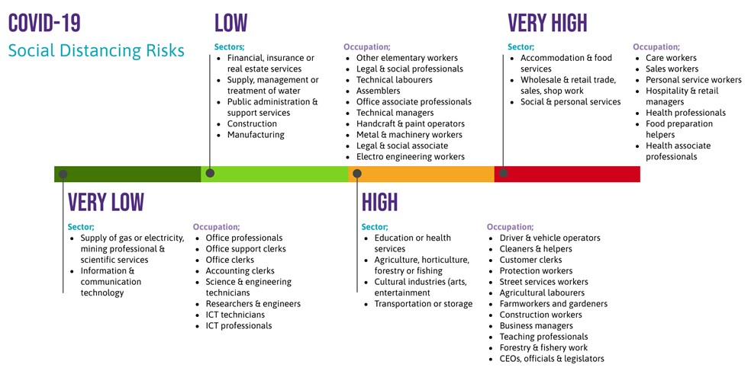
Given our employment structure, where just over two fifths (41.2%) of our employees are employed within high risk sectors (Retail – 20.4%, Manufacturing – 10.7%, Accommodation and Hospitality – 10.1%) our council area may be impacted harder than most.
  - The Growth Deal
A Growth Deal, or a City Deal as it is more commonly known, is an agreement between the Government and a city or a region. It gives the city and its surrounding area certain powers and freedom to take charge and responsibility of decisions that affect their area; do what they think is best to help businesses grow; create economic growth; and decide how public money should be spent. For Causeway Coast and Glens, a Growth Deal is very similar in purpose, but is less geographically restrictive.
The local Growth Deal represents a total package of £72m for the area. There is a further £100m for Northern Ireland for complementary projects. Our new Economic Development Strategy will act as the basis for the identification of potential projects for the Growth Deal. Possible themes could include:
Improving our local digital and communications infrastructure – as a rural area, Causeway Coast and Glens consistently suffers from digital infrastructure which is not fully fit for purpose. A significant improvement in this would help our resilience in the face of future lockdowns and allow for improved home, office and school working.
Improving our energy infrastructure – the area also suffers from having a “skinny network” of power supply which also holds back our ability to grow as a region. Growth Deal funding could help to address this and allow local business to expand.
Regeneration – town and village centres require periodic regeneration as local needs change. The Growth Deal could unlock potential opportunities to regenerate those areas which are in need of modernisation or have identified specific projects.
Tourism – tourism is obviously a mainstay of the local economy, providing many thousands of jobs and millions of income to the Causeway Coast and Glens area. Growth Deal may provide an opportunity to develop new projects which could augment the many points of interest along the Causeway Coastal Route.
As part of this consultation, you can use a specific response to feed back any ideas you might have. Your ideas should focus on capital projects or infrastructure which could tackle economic growth, grows job potential and levers-in other private or public investment.
  - A great challenge, and opportunity
It is within this new operating context that this economic strategy for the Causeway Coast and Glens area has been developed. This Strategy sets out to understand and evaluate the economic position of the Causeway Coast & Glens area and give recommendations for the council with a horizon of 2035. This strategy and action plan will be used by the Council to lead the borough in achieving its full potential in order to deliver inclusive and sustainable wealth and well-being for its citizens.
Aiding that drive towards the Borough achieving its full potential is the multi-million pounds growth deal that the NI Executive and UK Government have agreed for the borough. This growth deal capital fund will support a suite of capital projects that allow the borough to raise the level of ambition for the economy.
The Covid-19 pandemic has highlighted the importance of being able to react at pace to new context. While our new economic strategy and action plan provides a framework for action, and has been developed through rigorous data analysis and through conversations across the borough, it cannot afford to be rigid. The borough’s Economic Advisory Group, made up of a broad range of participants with a role in the economic life of the borough, will play a crucial role in maintaining the relevance of the actions taken to support the economic wellbeing of the borough.

  - Areas of Focus
Building on the series of consultations and body of supporting work undertaken in support of the development of this strategy, including comprehensive data analysis and an assessment of policy initiatives elsewhere, the following areas of focus are proposed. The six areas of focus for recovery and renewal are presented in figure 5.1 below, with a commentary on their rationale for inclusion. Each theme for action aims to deliver on an ambition to deliver a green, connected and fair economy in Causeway Coast and Glens.
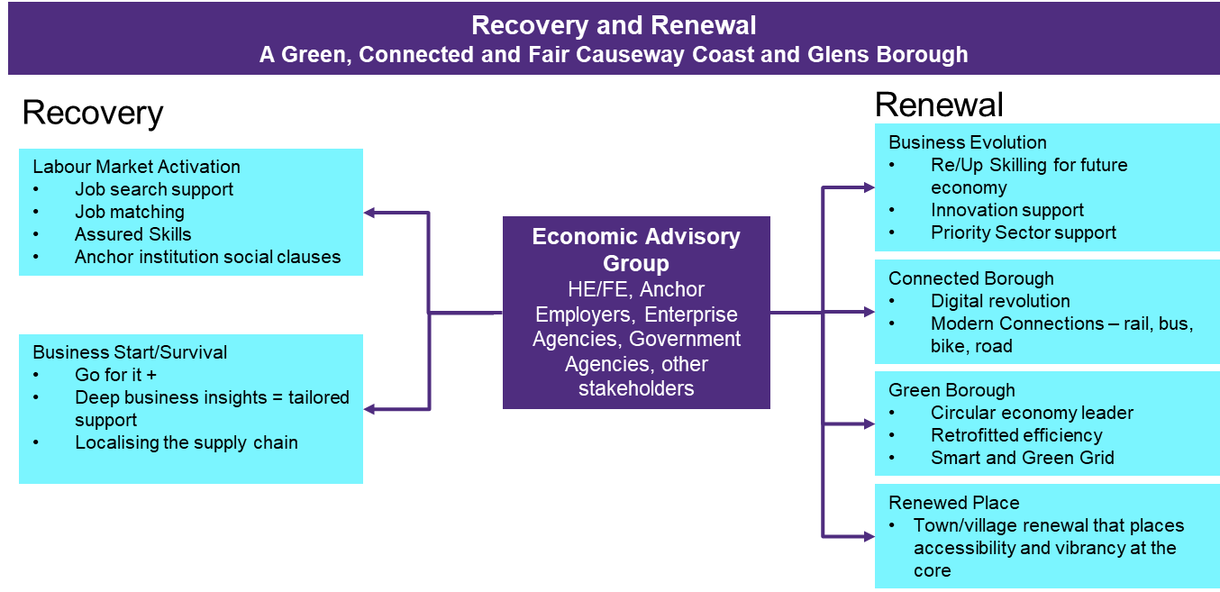
Figure 1 Emerging themes - Source: Grant Thornton

  - Recovery
Labour market activation
The Causeway Coast and Glens borough is facing challenging times ahead. The impact of the Covid-19 pandemic and the ongoing uncertainty around Brexit raises the risk of significant levels of unemployment. Supporting people through uncertain economic times and puts the borough into a period of re-invention, where recovery and growth is vital for a prosperous future. The UK government has been pro-active in implementing job retention schemes across the UK. Council has a key role to play in localising these initiatives through training support, job search assistance and job matching services.
Further, beyond a Covid-19 context, the availability of appropriately skilled people is of fundamental importance to economic growth. A large body of research notes the importance of skills to economic success and there is a noticeable increase in reports of skill shortages and gaps across the UK and Northern Ireland from employer bodies such as the CBI and Chamber of Commerce. The Northern Ireland Skills Barometer from Ulster University, which estimates the extent of future demand across a range of skills levels and a range of sectors, supports findings that the demand for skills will outstrip projected supply over the next decade. There is a marginal undersupply of skills at graduate levels and a more acute shortage at mid-tier skills levels. Considering Skills Barometer research at a local level suggests similar issues around employability and skills.
Table1 – Labour Market activation
Theme | Sub theme | Issue | Implication | Causeway Coast and Glens Call to Action
Labour Market Activation | Job search support | Approximately 14,500 of the Borough’s employees were Furloughed during the Covid-19 lockdown and there is a heightened risk of significant levels of unemployment | Sudden and significant numbers of people becoming unemployed can lead to economic depression, erode the skills base of the labour force and have significant mental health and wider health impacts if short term unemployment becomes ingrained/long term. | Council can act as a key enabler in providing labour market activation programmes (training, interview support) and community employment programmes as well as providing a rapid response ‘one front door’ for job matching across the borough.
 | Job matching | Redundancy announcements have doubled between May and June and are projected to increase further.
 | Assured skills | The Skills Barometer from Ulster University shows a mismatch between supply of skills and demand. Consultations bear skills challenges out | For companies that wish to grow, the inability to recruit staff is a key barrier, which can lead to delayed growth or companies locating elsewhere. | An assured skills programme (only inward investors/Invest NI clients are currently eligible) would alleviate skills shortages
 | Anchor institution social clauses | Anchor institutions in the borough (such as the Council, University, Colleges and Hospital) can have a significant influence on labour demand either directly or through annual procurement expenditure. | Anchor institutions can be utilised to support the creating job opportunities for residents in the Borough | Devise a procurement strategy that promotes local delivery and promotes social clauses that provide opportunity for unemployed residents.

Business Start and Survival
New business creation is a key part of the economy. Northern Ireland has traditionally struggled to keep pace with the entrepreneurial pace of other jurisdictions and our borough is below the Northern Ireland average for entrepreneurial activity. In fact, we are the fourth lowest of the 11 NI Councils for Entrepreneurial Activity. Coupled with this, there has been a sharp decline in business creation during the Covid-19 lockdown. The various supports available from HM-Treasury to protect employment during the crises omitted new business starts.
The entrepreneurship picture is now more complicated – on the one hand, people might see the lack of support from HM-Treasury as a disincentive to start a business and on the other hand people who lose their jobs as a result of the crisis might feel like self-employment is the only option. It is also apparent from recent FDI statistics and projections of future FDI opportunities that the possibility of a large inward investor coming to the borough and creating significant employment is low. As a result, the need to promote and support entrepreneurship is heightened.

Creating a culture of entrepreneurship and generating more indigenous businesses has the potential to generate local wealth and provide future employment opportunities within the borough. When considering any gaps in provision, there was a broad consensus from consultees that Council needs to engage more and provide a service that better links businesses to support.
For existing businesses, various forms of support are available. Indeed, there are many business supports available. An audit of enterprise support provision conducted by McClure Watters in 2008 (the most recent comprehensive assessment of business support). This audit estimated that 200 organisations are providing approximately 2,000 business support programmes. The needs of businesses and awareness of supports have been assessed through a recent comprehensive study undertaken by Ulster University on behalf of the Federation of Small Businesses Northern Ireland.
Across 200 businesses, the study queried the barriers and obstacles impacting on growth and what role government could play in addressing these barriers. Of particular relevance is that a lack of suitable business support was noted by 27% of respondents as being a significant barrier to their business success. During consultations undertaken over the course of developing this strategy, this issue was raised several times.
Several consultees noted that there is far too much support but that small business does not know where to look for it. Indeed, the FSB/Ulster University survey found that one in ten survey respondents did not know where to seek support. Perhaps, as one consultee noted this is due to ‘business owners are focused on the task of surviving/growing their business and do not have the time to hunt out 10 different providers of the same course to decide which one works for them.
Table2 – Business Start/Survival
Theme | Sub theme | Issue | Implication | Causeway Coast and Glens Call to Action
Business Start/Survival | Go for it + | Causeway Coast and Glens have a relatively low level of entrepreneurship compared to the NI average, ranking 4th last of 11 councils. | Fewer new business starts hinders economic growth and diversity. | Enhanced ‘exploring enterprise’ programmes from school age and up and ongoing ‘Go for it’ business start support.  Additional Exploring enterprise support for newly unemployed  Fast track/intensive support for high growth potential startups.
 |  | A considerable majority of companies are not Invest Northern Ireland clients, thus not accessing client company support levels. Our borough ranks 10th of 11 councils on Invest NI assistance per business. | A clear cohort of companies can be serviced without overlap with Invest Northern Ireland. | Understand the pool of non-serviced companies and build engagement plan to provide relevant support programmes
 | Deep business insights=Tailored Support | Business support is crowded with limited effectiveness and low awareness. | The solution is not merely ‘more’ support but value added, high quality support that business know about. | Map current provision, listen to business and create a concierge and signposting service
 |  | Interactions are transactional rather than being focused on relationship building. | Does not build ambition or promote correct behaviours. | Longer term engagement with smaller pool of companies where CC&G can show leadership, mentorship, accredited courses
 | Localising the supply chain | There is a growing movement towards local wealth building and using the anchor institutions and local assets to maintain as much economic activity within the local area as possible. Working towards local wealth building principles (as championed by Preston) can greatly enhance local growth. | Procurement contracts are awarded to large multinationals and some of the economic benefit is extracted from the local area. | Pursue a local wealth building strategy.

  - Renewal
The economic shock from the Covid-19 pandemic, and the different ways of working that emerged during lockdown, show that our economy needs to become more resilient and evolve into new opportunities. It is correct that our economic development efforts focus on recovery in the first instance. From recovery, we must move to renewal. While the £72m growth deal undoubtedly offers an exciting opportunity to introduce new capital expenditure that can make a significant positive impact on our economy, renewal is not just about new buildings and infrastructure. Our business community needs to evolve and renew to remain competitive.
Business Evolution
Aligned to Business Start/survival in the recovery phase, business evolution recognises that there are long standing challenges and new opportunities that our sectors (both established and emerging) should be supported to grasp. For example, key business challenges remain low levels of relative productivity and low levels of innovation, both of which lag behind our nearest neighbours. This productivity gap can in part be explained by the high levels of employment concentrated within lower value-added sectors as well as the heavy reliance on its public sector which accounts for 29.7% of total employment but there is also an issue with uptake of innovation and implementing automation or improved management techniques. Supporting our businesses become more productive, innovative or more resilient to shocks is a key aim.

Business evolution also encapsulates grasping new opportunities. For example, in tourism, the North Coast is globally renowned and our tourism sector drives significant employment. However, there is always more we can do. For example, cycling tourism (both leisure cycling and mountain biking) is big business in other places. In Scotland, the economic value of cycling tourism, including mountain biking in excess of £500m per annum. The borough is blessed with natural assets that could be harnessed to maximize a significant impact from evolving our tourism offer.
It was evident from consultations and from assess where our priority sectors lie that our business base can evolve to create some nice areas of specialism such as artisanal craft and food and in agri-tech/animal-health. Councils can’t create sectors but can play a key enabling role in supporting them where needed.

Table3 – Business evolution
 | Theme |  | Sub theme |  | Issue |  | Implication |  | Causeway Coast and Glens Call to Action
Business Evolution |  | Re/Upskilling for future economy |  | The economic landscape is changing – industry 4.0, trends towards home working and online retail are all influencing the skills our economy needs. |  | Without adapting to a changing economic context through management and leadership skills, adoption of new techniques and process automation, our businesses could get left behind. |  | Future economy training/business support should be available to support our business base adapt.
 |  | Innovation support |  |  |  |  |  | Product and process innovation support programmes are required.
 |  | Priority sector support |  | ‘Picking winners’ can risk missing new emerging sectors but our borough clearly has a range of sectoral strengths and the ability to gain specialisation in some areas such as artisanal food and craft and green/clean energy. |  | Developing specialisms builds profile, which helps attract more businesses to start in the area. |  | Develop a priority sector plan and tailor support according to need.

Connected Borough
The success of any modern economy is dependent on world-class road, cycling, walking, water, energy, communication and public transport infrastructure and an attractive living environment. The importance of infrastructure investment as a key driver of economic growth is documented across key policy documents such as Regional Development Strategy for Northern Ireland. A well-developed infrastructure can enhance the overall competitiveness of Causeway Coast and Glens, enhance employment opportunities and enhance the quality of life for residents.
Although the borough benefits from some excellent infrastructure (e.g. M2 and A26 connection to Belfast) there remains significant gaps in provision. As our lives and business activities become ever more digital dependent, it is imperative that the borough has exceptional broadband infrastructure.
Table4 – Connected Borough
Theme | Sub theme | Issue | Implication | Causeway Coast and Glens Call to Action
Connected Borough | Digital revolution | Business and residential demands for fast broadband is relentless. | Without exceptional business and domestic broadband provision, the borough could lose out to other locations for investment and residents. | Ensure the broadband infrastructure is with the best available for all areas of the borough.
 | Modern connections | There are key infrastructure weaknesses across the borough in roads, energy, leisure (cycle ways and river use) public transport etc. | Better infrastructure will support economic growth. | Deliver a capital expenditure programme that addresses key weaknesses.

Green Borough
We will play our part in the UK becoming net carbon neutral by 2050 (or sooner) and develop a regional energy strategy for the borough. This requires us to take bold steps to rethink our economy and provides opportunities to embrace the circular economy, support energy efficiency in business and residential settings and develop a smart and green grid. Achieving net carbon neutrality is not going to be easy. In a survey of businesses undertaken in the British Chamber ‘Net Zero’ survey in March 2020, the availability or cost of low carbon alternatives was the main barrier to businesses reducing their carbon footprint. Council can play its part in raising awareness of how to reduce carbon and can retrofit our buildings to achieve maximum efficiency and use these as demonstrators of best practice.

Table5 – Green Borough
Theme | Sub theme | Issue | Implication | Causeway Coast and Glens Call to Action
Green Borough | Circular Economy Leader | We continue to land fill 26% of our waste, significant amounts of which have to be exported at considerable cost. The proportion of our waste going to landfill places us 8th of 11 councils. | Poor waste management is inefficient and environmentally unsound. Maximising the circular economy mitigates this. | Support the growth of a circular economy across the borough.
 | Retrofitted efficiency | Our buildings are some of the most inefficient in Europe. | Addressing the environmental inefficiency of existing buildings is a significant step towards net carbon neutrality and creates employment opportunity. | Retrofit inefficient buildings across the borough.
 | Smart and green grid | The smart control of grids with capacity to handle and store renewable sources of energy is highly efficient. | Smart and green grids are a key element of a move towards better climate change management. | Develop a regional climate strategy to capture a comprehensive approach to delivering net carbon neutrality.

Renewed Place
Footfall is declining across global high streets as internet shopping changes how consumers shop. This has led to ‘death of the high street’ worries to emerge. To counter that scenario, a ‘reimaging the high street’ theme has emerged across initiatives such as Main Street America and the Institute for Place Management. These initiatives aim to reinvent, reposition, restructure and rebrand the high street.
This is particularly pertinent for Causeway Coast and Glens, where our towns and villages are crucial to our economic wellbeing, especially tourism. Further, the move to more working from home offers our borough a chance to offer employees in major employers the opportunity to live in the borough but work anywhere. Being able to provide a fantastic quality of life and ensuring that the borough is an area in which people want to work, live and visit.becomes even more important in this context.
Table6 – Renewed Place
Theme | Sub theme | Issue | Implication | Causeway Coast and Glens Call to Action
Renewed Place | Town village renewal that places vibrancy at the core | Our towns and villages have to reinvent themselves to ensure they remain vibrant, accessible and safe. | Losing the vibrancy of our towns and villages will have deeply damaging long-term economic and social costs. | Develop a town and village renewal strategy to ensure the continued viability of towns and villages across the borough.

Response Opportunity
A questionnaire is available at the following link: https://www.surveymonkey.co.uk/r/V23QX6J

This questionnaire asks about some of the themes and ideas which emerged through the first rounds of consultation about the local economy. Brexit is just around the corner, and new opportunities and challenges will emerge from it. The country is still dealing with the effects of an economic lockdown, and this equally presents its own challenges. We hope you will engage with this questionnaire to share your own thoughts.

You do not have to answer every question, and there are no right answers, but this is your chance to help shape the delivery of local economic development for the next ten years.

While restrictions still exist around the current Covid Pandemic, we cannot undertake large meetings of consultees. However, if you would like to have a direct discussion with one of our team, please submit your contact details and we will be in touch shortly. Your details will only be used for this purpose and not retained for any other means. If any small group wishes to meet with us, we will attempt to facilitate this.

The consultation will run until Friday 25 September 2020.

