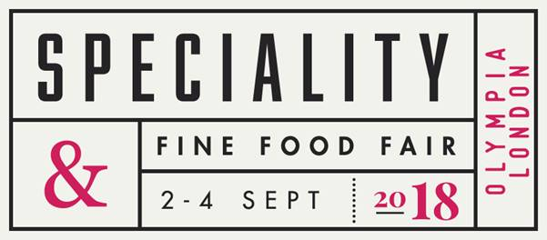

CAUSEWAY COAST AND GLENS BOROUGH COUNCIL ARE OFFERING BUSINESSES SUBSIDISED STAND FEES TO SHOWCASE THEIR BUSINESS AT THE SPECIALITY FINE FOOD FAIR LONDON 2018.

Speciality and fine food fair provides an unrivalled opportunity for independent retailers, delicatessens, chefs, hoteliers, restaurateurs, importers, distributors and wholesalers to meet over 700 producer and suppliers of artisan Food and Drink.

**FOR 18 YEARS, THE FAIR HAS BEEN THE UK'S LEADING EVENT FOR FINE FOOD AND DRINK.**

Exhibiting at Speciality & Fine Food Fair puts your products directly in front of a high quality audience of food and drink buyers looking to source the latest in speciality, artisan and fine food and drink.  Set in Central London to capture a top-end audience, the Fair creates a centre of excellence for the food and drink world by delivery **quality decision makers from retail, hospitality and distribution** who benefit from unrivalled networking and the chance to stay ahead of their competitors by sourcing the latest trends.  There's no better way to do business than face-to-face with buyers from independent retailers, food halls, delis, restaurants, hotels, coffee shops, cafes and farm shops.

<https://www.specialityandfinefoodfairs.co.uk/>

<https://secure.viewer.zmags.com/publication/55500022#/55500022/8>

As part of the Causeway Coast and Glens Food and Drink Network, applications are now open for food and drink producers in the borough to apply to attend the Speciality Fine Food Fair in September 2018 on the joint Food NI/CCAG/MEA stand.

Closing date for applications: Wednesday 18th July 2018

**Causeway Coast and Glens Producers Showcase at Speciality 2018**

**Producer Application Form**

|  |  |
| --- | --- |
| Business Name |  |
| Contact Name |  |
| Business Address |  |
| Postcode |  |
| Telephone number |  |
| Mobile number |  |
| Email address |  |

Please provide information on the products you intend to showcase at the Speciality Show, including any awards specific to these products.

|  |
| --- |
|  |

If no awards have been won, what makes your product suitable for exhibiting at the Speciality Fine Food Show?

|  |
| --- |
|  |

Have you exhibited at a Trade Show with Causeway Coast and Glens Borough Council or any other support organisations before? E.g. Invest NI, Food NI

If yes, please provide details of how your attendance at these shows have benefitted your business.

|  |
| --- |
|  |

Do you currently distribute outside NI? Yes/NO

If yes, please detail where you sell to? If no, please detail how your company has the capacity to sell into export markets in the UK?

|  |
| --- |
|  |

Please demonstrate your capacity/capability to supply the food service/hospitality sector in export market UK.

Please provide an indication of the research you have already carried out to attend the speciality show, can you provide names of the companies you intend to target and set up meetings with?

Please detail how exhibiting at the Speciality Show will benefit your business?

Please include main objective and intended outcomes.

Producers are offered the chance to exhibit on the following dates, with flexibility to move

Please state which days you would prefer to exhibit:

|  |  |
| --- | --- |
| **Date** | **Available** |
| Sunday 2nd September 2018 |  |
| Monday 3rd September 2018 |  |
| Tuesday 4nd September 2018 |  |

**IMPORTANT NOTICE**

* **Businesses selected must also complete in detail an evaluation of the outcomes of the show**
* **Businesses selected will be charged a stand fee of £350 to participate on the stand, which is payable to Food NI directly. The remainder of the stand and product transport costs are covered by Causeway Coast and Glens Borough Council and Food NI.**

**\*This fee does not include costs for your travel and accommodation!**

* **Businesses must make arrangements for their own travel and accommodation and associated costs. Please liaise with Food NI on possible budget accommodation options.**

Signature ……………………………………. Date…………………………………

***\*Please enclose a copy of***

* *Your Food Hygiene Rating Certificate*
* *Public Liability Insurance*

**Please note applications from businesses that have not previously taken part on the Council’s shared stands are particularly welcome.**

**Please return this form by EMAIL by Wednesday 18th July to**

[sharon@placesolutions.com](mailto:sharon@placesolutions.com)

Thank you for your application.

**Guidance Notes**

* Council cannot guarantee that you will be offered the date you have selected.
* Producers must be producing the product(s) in Northern Ireland using local ingredients where possible.
* Producers must source, use and promote Northern Ireland ingredients.
* Traders must comply with all Health & Safety and Environmental Health requirements at all times**.**
* Producers must **NOT** be showcasing their products at another stand at the Speciality Show.