Community Buildings Mentor Programme
SUPPORT REQUEST FORM
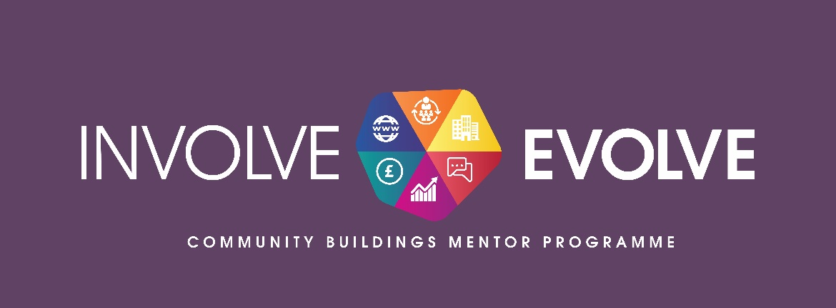
Name of Organisation
Contact name
Contact Telephone number
Contact E-mail address
Contact address
Postcode
District Electoral Area
Please provide a brief description of the main objectives of your organisation (bullet points)
Objective 1
Objective 2
Objective 3

Please indicate area of support that mentor is needed within your organization.

Strategic Growth & Development (C&V)
General Business Planning including preparation of funding applications, business case development
Community Engagement and Community Consultation
Financial Management and Administration & Governance (Accounting/Book-Keeping/GDPR/Constitution/Articles of Association) – (C & V)
Employment, Human Resources and Management & Staff Development
Health and Safety of Community Facilities, including Fire and Legionella & Risk management
Financial Management and Administration
Marketing and Social Media/Website Development for Community Development organizations
Social Enterprise Development
Tendering and Procurement

Please provide brief details of the project that support is required for (eg sustainability of a community facility, organisational sustainability, preparing business case for community facility etc)

1. | Are your activities for the benefit of all the community and is your organisation based in the Causeway Coast and Glens Borough Council area and are your activities based in the Causeway Coast and Glens Borough Council area. | TICK
2. | Does your organisation have a Constitution/Governing document in place
3. | Does your organisation have a bank/building society account and keep a proper record of your accounts.
4. | Does your organisation operate on a not-for-profit basis and cannot share out profits to members or shareholders.
5. | Is your organisation non-party political. You do not seek to promote any political activity and are open to the full range of public opinion.
6. | Is membership of your organisation open to all those residing in the area that we seek to represent in accordance with Section 75 of the Northern Ireland Act (1998) i.e. regardless of racial group, age, gender, religious belief, political opinion, marital status, sexual orientation, disability or having dependants etc.
7. | You agree to Causeway Coast and Glens Borough Council's monitoring and evaluation procedures as required.

Signature | Date | Position

Please return to the address below or by e-mail to: communitydevelopment@causewaycoastandglens.gov.uk

