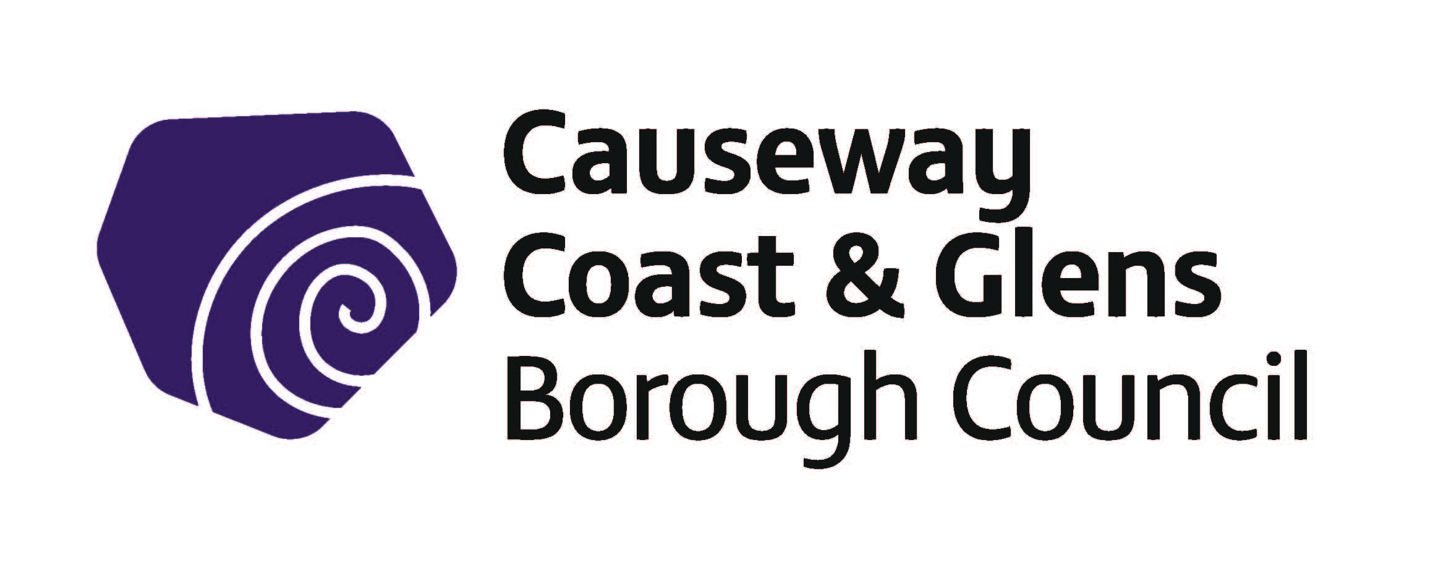

Culture, Arts and Heritage
Grant Programme 1st April 2020 – 31st March 2021

Guidance Notes

The deadline for applications for events/projects taking place between 1 April 2020 and 31 March 2021, is FRIDAY 31 January 2020 at 12noon. Please note there is only one application deadline.

Guidelines Number | CAH
Version Number | 2
Author | P O’ Brien

Date of Screening of Policy
EQIA Recommended? | YES/NO
Date Adopted by Council
Date Guidelines Revised

Contents
1.0 Introduction
1.1. Purpose of Grant Programme
1.2 Overview of fund
1.3 Levels of grant award
1.4 General Principles
1.5 Who can apply?
1.6 What can be funded?
1.7 What cannot be funded?
1.8 Exclusions

2.0 How to answer the questions

3.0 How we assess and score your application
3.1 Eligibility assessment
3.2 What if an application is not eligible?
3.3 Assessment and Scoring
3.4 How decisions are made
3.5 What happens if an application is successful?
3.6 What happens if an application is unsuccessful?
3.7 Government Funding Database
3.8 Late applications

Appendix 1
Data Protection Act
Freedom of Information Act

1. Introduction

The Culture Arts and Heritage grant scheme has been designed to best support, promote and develop cultural, arts and heritage events, projects and activities. It has been devised to support local community and voluntary groups to promote and develop projects which broaden cultural access throughout the council area.

You may find it helpful to discuss your project with one of the following officers within the Cultural, Arts and Heritage Service Unit before submitting your application:

Arts Projects
Elaine Gaston 028 2076 2225 elaine.gaston@causewaycoastandglens.gov.uk

Museum/Heritage Projects
Nic Wright 028 2764 9484 nic.wright@causewaycoastandglens.gov.uk

1.1. Purpose of Grant Programme

Causeway Coast & Glens Borough Council recognises the enormous cultural, artistic and heritage assets within its geographical area and commissioned a 5-year Culture, Arts & Heritage Strategy to cover the period 2016-2021.

The primary objective of the cultural strategy is to ensure that both local ratepayers and visitors to the area have continuous access to high quality, accessible, inclusive and affordable cultural services, including arts, museums and heritage. It has been developed following a wide-ranging and inclusive consultation process which took in the views, ideas and aspirations of stakeholders from community, cultural and related sectors.

The introduction of the Culture, Arts & Heritage Grant Scheme in 2016 was in direct response to the findings from the consultation process which highlighted the need to support local groups to promote and develop cultural, arts and heritage projects and activities in the area.

If your organisation is successful in securing a grant, your organisation will be contractually obliged to work closely with the Officers within the Cultural Services Unit of the Council, including active participation in any review processes and the provision of monitoring and evaluation information as required.

1.2 Overview of fund
Organisations applying for funding from the Culture, Arts and Heritage Grant Scheme will have to demonstrate how their organisation contributes to any one of the following Culture, Arts and Heritage Aims identified in the Causeway Coast and Glens Borough Council’s Culture, Arts and Heritage Strategy 2016-2021.

- Enhancing Our Cultural Venues and Assets – To use our landscape and our cultural assets and activities to enable opportunities for both local people and visitors to participate in Culture, Arts and Heritage in the area.

- Investing in Creative Learning and Skills Development –To support the creative development our young people and our creative practitioners through training, skills development and providing opportunities to showcase work

- History, Heritage and Cultural Tourism – To promote a sense of pride, identity and deeper understanding of our area by bringing together the many stories, histories, identities and languages which are present in the area

All organisations funded through the Culture, Arts and Heritage Grant Scheme must demonstrate how their project contributes towards the aim most appropriate to address the issues in their area. Organisations will be asked to report back on how effective their project has been in meeting these needs and working towards the appropriate aim.

1.3 Levels of grant award
Culture Arts & Heritage Grant Scheme | Maximum Grant Amount
Grants are available for a maximum of 100% of the total project costs up to a maximum of £1,000 | £1,000

This is a competitive process and all grant awards will be determined on the basis of merit. Applicants are advised that organisations that have been successful in securing Council funding in the past will not automatically be guaranteed funding in the future. Council reserves the right to reduce the amount of funding awarded if we do not consider that the amount applied for represents value for money.

Please note: Groups may not receive more than one funding award in any financial year.
Groups will have to provide all evidence requested once the project expenditure is complete. This may include receipts, bank statements, or any other documentation deemed necessary. If requested documentation is not supplied, then payment cannot be made. Please do not apply for funding if you cannot supply these items.

1.4 General Principles

In line with Council’s Grant Funding Policy the overarching principle for all Council grant funding is that of meeting local needs which have been identified and prioritised by Council or by others but acknowledged by Council. Any activity that cannot be shown to meet the following basic requirements will not be provided with funding:

- Have a clearly identified need.

- Can deliver outcomes which meet this need.

- Deliver cost effective and quality service provision, fitting with the purpose and remit of the funding.

- Be delivered by a credible organisation with the capacity to deliver the project as stated.

- Reflect the statutory remit of Causeway Coast and Glens Borough Council, aligning with Council’s Corporate Plan, the relevant Service plan and that they can meet the specific criteria of the fund, in this instance the Cultural, Arts and Heritage Fund criteria.

- Applicants must demonstrate their commitment to promoting Good Relations and Equality of Opportunity.

- In the interests of transparency, equality and accountability all applicants will have a right of appeal should their application be rejected.

1.5 Who Can Apply?
Organisations must be from within the Causeway Coast and Glens Borough Council area. To be eligible for grant-aid, you will have to show that your organisation is a bona fide organisation that is well run and that it:
- Has a properly adopted “Governing Document” such as a constitution or memorandum and articles of association which clearly show that it is non-profit making and taking. Evidence that a constitution has been formally adopted must be supplied.

For the purposes of this programme only formally constituted organisations which are not-for-profit organisations that are open, accountable and representative of the geographical area in which they service, promote and support the Culture, Arts and Heritage sector can apply. Such as:

- Cultural, Arts and Heritage groups e.g. drama groups, historical societies, photographic clubs etc.

- Community development groups

- Other organisations involved in Culture, Arts or Heritage development work

- Umbrella organisations provided that their work takes place at a local level

Groups must demonstrate that they are well run and that they reflect the needs of local communities. The initiatives in which they are seeking funding for must be inclusive, open to the whole community and adhere to democratic principles.

Only groups which meet these criteria can apply to the Culture Arts and Heritage grant scheme

If an organisation is satisfied that it is an eligible formally constituted organisation as outlined it MUST be in a position to meet the following criteria:
- Be based in the Causeway Coast and Glens Council area or have their main activities based in the Causeway Coast and Glens Council area.

- Be committed to Equal Opportunities in terms of organisational policies and the delivery of services to those being served or represented.

- Be non-party political and open to the full range of local opinion.

- Be able to demonstrate a fair and equitable ethos through established aims and objectives in accordance with Section 75 of the Northern Ireland Act (1998).

- Be able, without prejudice to the obligations of Section 75 of the Northern Ireland Act (1998), to demonstrate regard to the desirability of promoting Good Relations between persons of different religious belief, political belief, political opinion or racial group.

- Have membership open to all those residing in the area that they seek to represent, regardless of ethnic origin, gender, religious or political belief.

- Be accountable to local people through an established constitution, open membership, committee elections, accounting procedures and Annual General Meetings. The Office Bearing positions of Chairman, Secretary and Treasurer should be held as a minimum.

- Have appropriate and adequate insurance cover for all activities and all actions proceeding such as costs, claims, demands and liabilities whatsoever, arising from all or any of the group activities. To also ensure that any individuals or organisations worked with are properly insured.

- Ensure that all group activities abide by the law and that the necessary permissions are obtained for activities from the appropriate body/authority.

- Ensure that Child Protection Policy / Vulnerable Adults Policy and Procedures are in place and adhered to as and where appropriate.

- Have a bank/building society account and keep a proper record of group accounts.

- Be able to produce an annual statement of independently audited or certified accounts, or be able to present a bank statement in the case of newly established groups.

- Have arrangements in place for dispersing the group’s funds if they dissolve/end.

- Agree to Causeway Coast and Glens Council's promotion, monitoring, evaluation, and training procedures as required.

1.6 What can be funded?
Examples of the types of projects which can be funded:
- Training and skills development programmes.

- Projects and events which develop arts and heritage at a local level and make them more accessible for all.

- Learning activities which are not-for-profit and organised by groups for the community e.g. talks, courses, seminars.

- Cultural resources including publication, exhibitions, trails, digital resources.

Examples of eligible expenditure:

- Venue hire
- Hire of equipment
- Tutors (we will only fund a maximum of £25 per hour)
- Performance fees
- Materials
- Insurance
- Marketing and publicity
- Travel may be considered if the applicant can demonstrate that it is an integral part of the project

1.7 What cannot be funded?
In general, the following will not normally be eligible for funding through the Culture Arts and Heritage grant scheme:
- Proposals that do not directly benefit Causeway Coast & Glens Council residents
- Applications for funding which are considered to be the responsibility of another statutory organisation or Council fund
- Retrospective expenditure where projects have started or services/items have already been obtained and paid
- Applications received after the closing date specified in the promotional literature
- Applications where a committee member or trustee will have a personal financial benefit
- Costs that are not auditable e.g. cash payments unsupported by an approved petty cash system
- Costs towards ongoing running costs (e.g. electricity, rent, insurance, etc.)
- Building costs, capital expenditure or equipment
- Costs towards banking charges and/or repayment of debt
- Costs that can be claimed back from elsewhere e.g. VAT
- Community Festivals (there is a separate fund for this)
- Carnivals/fun days
- General Appeals
- Religious services where only one section of the community is represented
- Buying or leasing musical instruments, uniforms or sporting equipment
- Activities which are party-political in intention, use or presentation
- Salary costs.
- Alcohol costs
- Gratuities, gifts and prizes
- In some instances there may be an agreed hospitality allocation of funds, which must not exceed 10% of the total Council grant.

1.8 Exclusions
In general, it is important to note that this funding programme will not normally award grants to the following:
- Individuals
- Groups operating outside the Causeway Coast and Glens Council area unless the project/event takes place in the council area and directly benefits those who live in it (see 1.5).
- Organisations and events with charitable fundraising as their main or partial focus
- Organisations who have substantial demonstrable reserves
- Political Organisations

2.0 How to answer the questions
Applications for financial assistance from Causeway Coast and Glens for 2020-21 should be submitted online at www.causewaycoastandglens.gov.uk
Guidance on completing the application online is provided on the web-site link.
Hard copies can be made available. Please contact the Central Funding Unit on email grants@causewaycoastandglens.gov.uk

Applications will not be scored against how many aims the Organisation contributes to, but rather on how robustly the need was identified, what extent and how well the application addresses Culture, Arts and Heritage issues in their area.

All questions must be completed as fully and concisely as possible. Please see below for help in completing your application:
Q1 – Please give a clear and concise description of your project and include the following:

- Detailed programme/activities including timescales

- Who will benefit

Number of participants

- Number of visitors

- Who will facilitate the event/project (if applicable)? i.e. who are the practitioners/trainers or where will you source suitably qualified people to deliver aspects of your project?

- How will you showcase your project outputs?

Q2 - What are the objectives of your project i.e. what are you trying to achieve?

Q3 - How will your project help to achieve one or more of the aims from the council’s Culture, Arts and Heritage Strategy? Please read pages 3 & 4 of the guidance notes and carefully consider how your project links in with the Causeway Coast and Glens Borough Council Culture, Arts and Heritage strategic aims. Please note, it is not necessary to meet all of the aims. It is more important to have a good quality project that meets one of them.

Q4 – It is imperative that projects funded from the council Culture, Arts and Heritage Grant Scheme are managed and delivered by groups and facilitators who have the ability to do this effectively and professionally. Please list the name, skills and experience of your group and their role in managing and delivering the project effectively. Please also list project facilitators where known. If you feel that your group requires further support to meet this requirement, please contact officers within the Cultural Services Unit (see page 3 of these guidelines) to establish what help is available.

Q5 – Please explain why this project is needed? How do you know this? Think about previous work and / or the discussions/surveys/community feedback etc. that have led you to establish that there is a need for this Culture, Arts and Heritage project.

Q6 - It is a requirement of any group grant aided from the Cultural, Arts and Heritage Grant Scheme, that they agree to take part in any promotion or publicity of their project as deemed necessary by Causeway Coast and Glens council. It is also a requirement that, if they undertake their own publicity, reference should be made to the support they received from the fund. Please describe how you intend to publicise your project. Think about your audiences and how best to reach them.

Q7 - How will you monitor and evaluate your project so that you know that it has been successful and that you have met the objectives you have set out in Q2? How will you capture quantitative information e.g. audience figures and how will you measure the quality/success of your project. How will you know that you have met your objectives? Think about ways in which you can capture this information e.g. questionnaires, feedback etc.

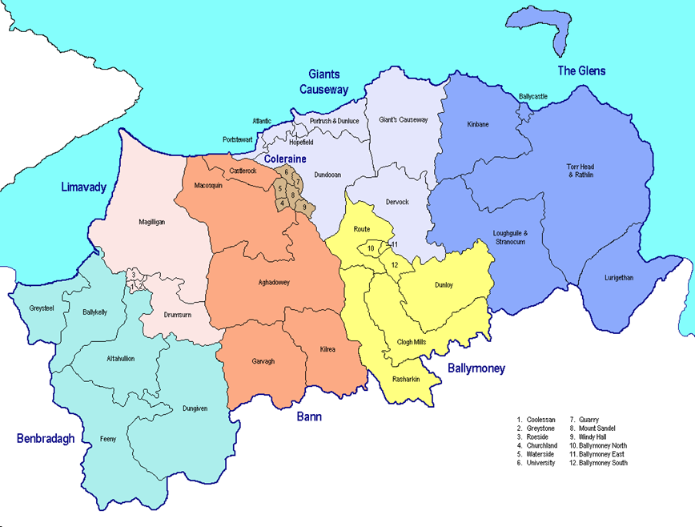
Q8 Please state the District Electoral Area in which your project will take place.

Q9 – Please provide a full breakdown of all costs for your project. This must include all expenditure and income associated with the project. Please itemise all costs e.g. publicity and marketing costs must be broken down into costs for specific items i.e. press advertising, printing of posters and fliers, distribution of publicity material etc. Please refer to sections 1.6 and 1.7 of the guidance notes to ensure that all costs are eligible.

Applicants will be expected to make efforts to maximise their income by securing other sources of funding to support their work. Causeway Coast and Glens Borough Council will pay up to a maximum of 100% of the total project costs up to a maximum of £1000.

3.0 How we assess and score your application.
Every application that we receive requesting a grant from the Culture, Arts and Heritage Grant Scheme will be assessed for the following:
- to ensure that the application is eligible, and
- for reassurance of each organisation’s capability to deliver the proposal, and
- How well the proposal contributes to Council’s Culture, Arts and Heritage Strategic Aims.

An acknowledgement receipt will be electronically issued to you once your submission has been received. The Funding Unit will assess your application for eligibility. If your application is eligible to apply for grant aid, it will be forwarded to the relevant section for a full assessment and scoring against the stated criteria.

3.1 Eligibility assessment
The assessments in respect of Part 1 of the application form are awarded a pass or fail eligibility rating.
If the organisation, based on the information supplied is able to satisfy the Council of their eligibility to draw down the grant, they will progress to the next part of the process.
If the organisation, based on the information supplied, is not able to satisfy the Council of their eligibility to draw down the grant from the fund, they will be advised of specific omissions / shortcomings and how these can be addressed to help prepare them for any future funding requests.

3.2 What if an application is not eligible?
If your application is not eligible, you will be notified immediately and the reasons will be outlined to you, it will not proceed to assessment and scoring.

If an organisation is not eligible for funding through the Culture, Arts & Heritage Fund, organisations should contact the staff member listed on page 3 who will help signpost to alternative sources of funding.
If an organisation or its activities are deemed to be the responsibility of other Council Departments, statutory agencies or voluntary bodies then you will be signposted to who you should apply to. If signposted elsewhere you will be required to complete and submit the relevant application form.

3.3 Assessment and scoring
The questions in Part 2 of the application are scored and weighted
All questions scored out of 5 as detailed below:
Criteria | Score out of a possible 5 | Weighting | Possible Score
Q1 – Clear and concise evidence of a developed project with a Culture, Arts and Heritage ethos |  | X 3 | 15
Q2 – Clear and realistic objectives set for the project |  | X 1 | 5
Q3 – A clear understanding of how the project objectives link to the Culture, Arts and Heritage aims and can help work towards these. |  | X 1 | 5
Q4 - Extent of ability, skills and experience of the group which enables them to deliver the project |  | X 1 | 5
Q5 – A clear understanding of why this project is needed and how you know this |  | X 2 | 10
Q6 – Detailed explanation of planned promotion of project |  | X 1 | 5
Q7 Monitoring and Evaluation |  | X 1 | 5
Q8 District Electoral Area | Not scored
Q9 Breakdown of costs | Not scored
 |  |  | 50

Applications must score 65% in order to be considered for funding.

3.4 How decisions are made
Council Officers will assess and score the applications after the deadline listed on the cover page of these guidelines. When the scores are finalised the officers will return the applications to the Central Funding Unit who will inform you of the decision within 7 days of your application being scored.

It will be at this point that all successful/unsuccessful applicants will be notified.

3.5 What happens if an application is successful?
If an application is successful, Council will issue a Letter of Offer which is a legal agreement with the organisation to deliver on the proposals outlined in their application form.
Signed Letters of Offer will need to be returned before any funding is released
Council funding is paid retrospectively. However, grants can be released in two instalments – 50% of the grant will be awarded upfront if the organisations do not have sufficient reserves followed by remaining 50% once evaluation/financial claim is verified satisfactorily.
Successful organisations are required to submit regular monitoring reports as well as an annual/end of funding evaluation report. Officers may discuss the monitoring information with the groups that were funded and also with some of the people who have benefited from the community activity.

3.6 What happens if an application is unsuccessful?
Officers from the relevant service area will be available to meet with the organisation to go through their application, develop a working relationship and provide practical developmental support to address areas of concern.
An Appeals Process/Review Procedure is also available if an application is unsuccessful. The purpose of this is to ensure that the decisions taken and procedures followed by Committees for individual applications are applied fairly and consistently.
The Review will provide an independent process through which an applicant will have the opportunity to demonstrate to the Review Panel that either:
- the outcome was unreasonable; or

- that the proper procedures were not followed

Appeals on any other grounds will not be considered.

3.7 Government Funding Database

Please be aware we are required to check the Government Funding Database (GFD) prior to making awards in order to avoid duplication of funding.

If registered on GFD we ask you to state your organisation’s Unique Reference Number (URN) to help with this process. Details of grants awarded will be uploaded to the GFD, it is the responsibility of the applicant group to ensure that the organisation details held on GFD are up to date.

3.8 Late applications

It is the responsibility of each applicant to ensure that their application is submitted prior to the advertised time and date of closing. Applications received after the closing time/date will not be considered for funding. No exceptions will be made and there is no recourse to appeal. It is the responsibility of the applicant to ensure submission on time.

Appendix 1

Data Protection Act

- We will use the information you give us on the application form during assessment and for the life of any grant we award you to administer and analyse grants and for our own research.

- We may give copies of this information to individuals and organisations we consult when assessing applications, when monitoring grants and evaluating the way our funding programmes work and the effect they have. These organisations may include accountants, external evaluators and other organisations or groups involved in delivering the project.

- We may also share information with other government departments, organisations providing match funding and other organisations and individuals with a legitimate interest in applications and grants, or for the prevention or detection of fraud.

- We might use the data you provide for our own research. We recognise the need to maintain the confidentiality of vulnerable groups and their details will not be made public in any way, except as required by law.

Freedom of Information Act
The Freedom of Information Act 2000 gives members of the public the right to request any information that we hold, subject to certain exemptions that may apply. This includes information received from third parties, such as, although not limited to, grant applicants, grant holders and contractors. If information is requested under the Freedom of Information Act we will release it, subject to exemptions; although we may consult with you first. If you think that information you are providing may be exempt from release if requested, you should let us know when you apply. For further information please visit the Information Commissioner’s Office at www.ico.gov.uk

