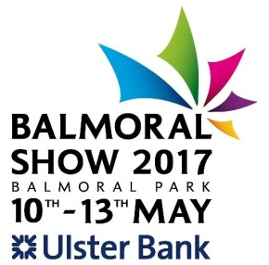
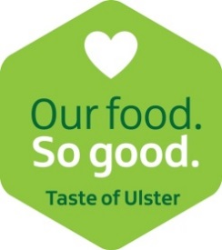
Booking Form NI Food Pavilion 2017

- Company Name

- Main contact (for Balmoral correspondence/forms etc)

- Main contact email

- Main contact direct line or mobile number

CCAG Food Network holding 68 – 71 all 2m by 2m for Artisan producers only
- Preferred stand number

- Total stand cost
£135 plus VAT per day (£65 plus VAT FREE if booked via CCAG Food Network)
Please indicate which dates you are interested in.
I would be interested in exhibiting for 1, 2, 3 or 4 days (delete as appropriate) with preference for Wed 10 Thur 11 Fri 12 Sat 13 (indicate order of preference if only wanting 1 or 2 days and delete those you are NOT interested in at all. Please note Causeway Speciality Market is Sat 13th May.

- Invoice address

- Please provide 15-20 words which will make up your company description:

N.B: This will be passed on to our designer for inclusion in the pavilion guide. Please do this ASAP

IMPORTANT – PLEASE NOTE
Stands will only be considered booked on receipt of this form and a 50% non-refundable deposit. On the occasion that a 50% deposit is not received, the stand will be released and will be made available to other exhibitors. Please make cheques payable to Food NI.
BACS details: Ulster Bank Sort Code 98-04-40 Account Number: 10222454
*Please use the reference BAL17PAYMENT1 with your company name for 50% deposit and BAL17PAYMENT2 with your company name for remaining balance. Please email remittance to jacinta@nigoodfood.com
All exhibitors in Food NI Pavilion must have their membership fee fully paid. This and the remaining 50% of the stand fee must be paid by Friday 14th April 2017. On receipt of full payment, your exhibitor wristbands, car park passes and entry passes will be posted out.
Food NI will reserve the right to release any trade stand for resale if these terms are not met. Exhibitors may not sub-let any part of their stand to another company without prior written approval from Food NI.
Signed: Date:

BY SIGNING THIS FORM YOU AGREE TO THE TERMS AND CONDITIONS OULINED IN THE EXHIBITOR MANUAL AND ABOVE

Please do not hesitate to contact us if you have any queries. Thank you.
Food NI Ltd Belfast Mills 71 - 75 Percy Street Belfast Co Antrim BT13 2HW

Please do not hesitate to contact us if you have any queries. Thank You
Food NI Ltd. Belfast Mills 71-75 Percy Street Belfast County Antrim BT13 2HW
028 90 249 449

