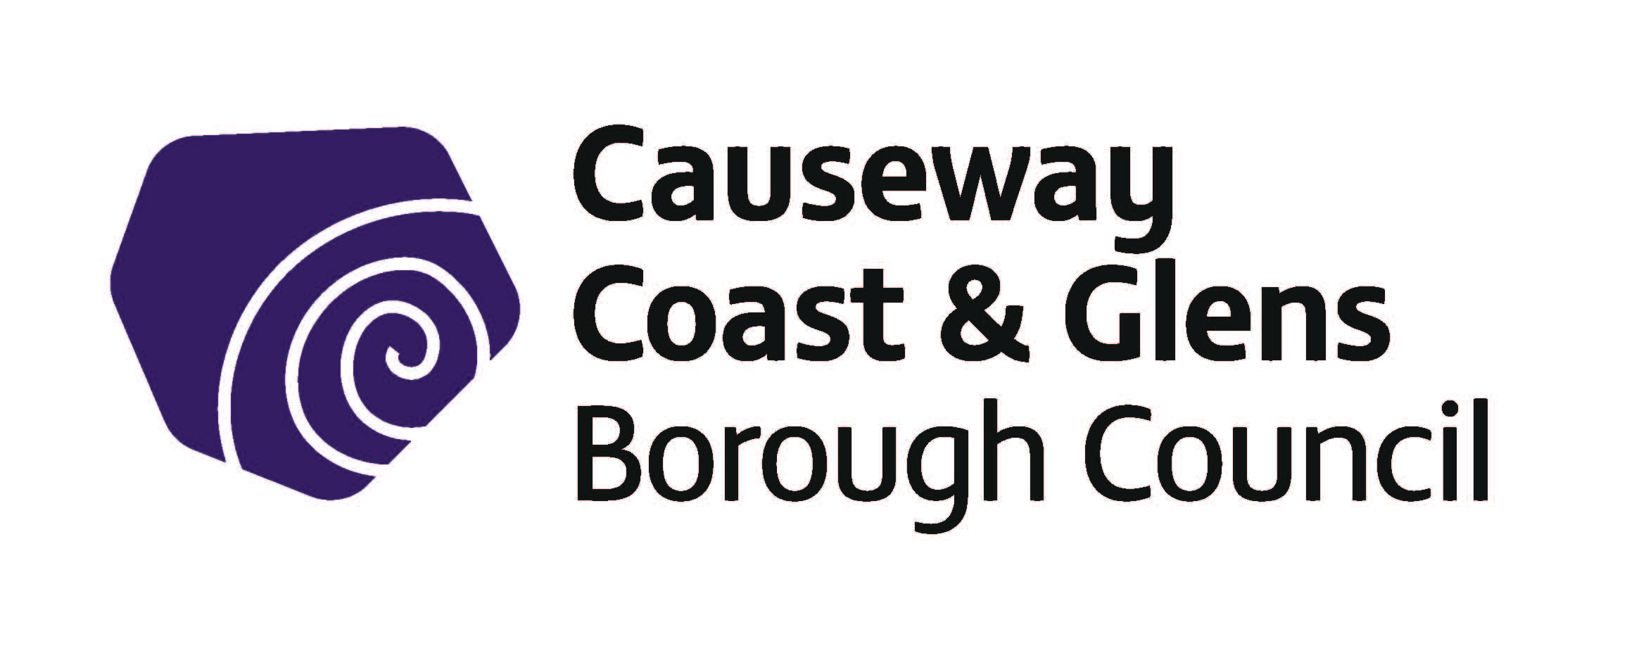

Building a United Community Fund
Grant Programme 2020/21

Guidance Notes
The Building a United Community Fund
Grants Programme will be a rolling fund and will remain open throughout the year until the budget is expended, at which point the fund will close for applications. There will be assessment points throughout the year, contact the Good Relations Team for advice on when the next assessments will take place. This will help you plan your project to ensure that grant-aid is awarded in time.

Guidelines Number | BUCF
Version Number | 4
Author | P O’ Brien

Date of Screening of Policy
EQIA Recommended? | YES/NO
Date Adopted by Council
Date Guidelines Revised

Contents
1.0 Introduction
1.1. Purpose of Grant Programme
1.2 Overview of fund
1.3 Levels of grant award
1.4 General Principles
1.5 Who can apply?
1.6 What can be funded?
1.7 What cannot be funded?
1.8 Exclusions

2.0 How to answer the questions

3.0 How we assess and score your application
3.1 Eligibility assessment
3.2 What if an application is not eligible?
3.3 Assessment and Scoring
3.4 How decisions are made
3.5 What happens if an application is successful?
3.6 What happens if an application is unsuccessful?
3.7 Government Funding Database
3.8 Late applications

Appendix 1
Data Protection Act
Freedom of Information Act

1.0 Introduction

“Building a United Community” Fund has been designed to support, promote and develop Good Relations projects throughout the Council area.

You may find it helpful to discuss your project with one of the following officers within the Good Relations Unit before submitting your application:

Good Relations Team 02877760312 goodrelations@causewaycoastandglens.gov.uk

1.1. Purpose of grant programme

“Good Relations” is about developing positive relationships between people of differing religious beliefs, political opinions and racial backgrounds.

Causeway Coast and Glens Borough Council’s Good Relations Strategy provides an opportunity for the Borough to be a model of best practice in developing respect, understanding and tolerance of the cultural, historical and traditional diversity between the residents within the Council area.

If your organisation is successful in securing a grant, your organisation will be contractually obliged to work closely with the Good Relations Officers in the Council, including active participation in any review processes and the provision of monitoring and evaluation information as required.

1.2 Overview of Building a United Community Fund

Organisations applying for funding from the Building a United Community Fund will have to demonstrate how their organisation contributes to the Good Relations aims identified in the Causeway Coast and Glens Borough Council Good Relations Strategy 2018/23.These aims are directed by a government strategy published in May 2013 entitled “Together: Building a United Community”. (T:BUC)

- Our Children and Young people – To continue to improve attitudes amongst our young people and to build a community where they can play a full and active role in building good relations

- Our Shared Community – To create a community where division does not restrict the life opportunities of individuals and where all areas are open and accessible to everyone

- Our Safe Community – To create a community where everyone feels safe in moving around and where life choices are not inhibited by fears around safety

- Our Cultural Expression – To create a community which promotes mutual respect and understanding, is strengthened by its diversity, and where cultural expression is celebrated and embraced

All organisations funded through the Building a United Community Fund must demonstrate how their project contributes towards the aim most appropriate to address the good relations issues in their area. Organisations will be asked to report back on how effective their project has been in meeting these needs and working towards the appropriate aim.

1.3 Levels of grant award

Building a United Community Fund | Maximum Grant Amount
Up to 100% of total project costs will be available for eligible projects | £1,500

This is a competitive process and all grant awards will be determined on the basis of merit. Applicants are advised that organisations that have been successful in securing Council funding in the past will not automatically be guaranteed funding in the future. Council reserves the right to reduce the amount of funding awarded if we do not consider that the amount applied for represents value for money.

Please Note: Groups will have to provide all evidence requested once the project expenditure is complete. This will include receipts, bank statements, project outcomes, Participant Evaluation Forms, end of project Evaluation/ Monitoring report and / or any other documentation deemed necessary. This list is not exhaustive. If requested documentation is not supplied then payment cannot be made. Please do not apply for funding if you cannot supply these items.

1.4 General Principles

In line with Council’s Grant Funding Policy the overarching principle for all Council grant funding is that of meeting local needs which have been identified and prioritised by Council or by others but acknowledged by Council. Any activity that cannot be shown to meet the following basic requirements will not be provided with funding:

- Have a clearly identified need.

- Can deliver outcomes which meet this need (see page 9, question 7)

- Deliver cost effective and quality service provision, fitting with the purpose and remit of the funding.

- Be delivered by a credible organisation with the capacity to deliver the project as stated

- Reflect the statutory remit of Causeway Coast and Glens Borough Council, aligning with Council’s Corporate Plan, the relevant Service plan and that they can meet the specific criteria of the fund, in this instance the Building a United Community Fund criteria.

- Applicants must demonstrate their commitment to promoting Good Relations and Equality of Opportunity.

- In the interests of transparency, equality and accountability all applicants will have a right of appeal should their application be rejected.

1.5 Who Can Apply?

• Applications can be made by not-for-profit community and voluntary organisations that are based in the Causeway Coast and Glens Borough Council area or have their main activities based in the Causeway Coast and Glens Borough Council area.
- Organisations that have a properly adopted “Governing Document” such as a constitution or memorandum and articles of association which clearly show that it is a not–for-profit organisation. Evidence that a constitution has been formally adopted must be supplied.

For the purposes of this programme only formally constituted organisations which are not-for-profit organisations that are open, accountable and representative of the geographical area in which they serve, promote and support Good Relations can apply. Such as:

- Minority ethnic groups.

- Community development groups.

- Cultural organsiations (e.g Historical socities, bands, etc)

- Women’s / men’s groups.

- Children’s or young adults’ groups.

- Playgroups; parent and toddler groups.

- Senior citizens groups.

- Faith based groups.

- Other organisations involved in community relations, reconciliation and cultural diversity.

- Umbrella organisations provided that their work takes place at a local level.

Groups must demonstrate that they are well run and that they provide a voice for local concerns. The initiatives for which they are seeking funding must be inclusive and open to the whole community, adhere to democratic principles, and be working in partnership with others. This may include Community Associations, Residents’ Groups, Town or Village Committees or similar.

Only groups which meet these criteria can apply to the Building a United Community Fund

If an organisation is satisfied that it is an eligible formally constituted organisation as outlined, it MUST be in a position to meet the following criteria:

- Be based in the Causeway Coast and Glens Borough Council area or have its main activities based in the Causeway Coast and Glens Borough Council area.

- Be committed to Equal Opportunities in terms of organisational policies and the delivery of services to those being served or represented.

- Be non-party political and open to the full range of local opinion.

- Be able to demonstrate a fair and equitable ethos through established aims and objectives in accordance with Section 75 of the Northern Ireland Act (1998).

- Be able without prejudice to the obligations of Section 75 of the Northern Ireland Act (1998), to demonstrate regard to the desirability of promoting Good Relations between persons of different religious belief, political opinion or racial group.
- Be accountable to local people through an established constitution, open membership, committee elections, accounting procedures and Annual General Meetings. The Office Bearing positions of Chairman, Secretary and Treasurer should be held as a minimum.

- Have appropriate and adequate insurance cover for all activities and all actions proceeding such as costs, claims, demands and liabilities whatsoever, arising from all or any of the group activities including the project for which they are applying for funding. To also ensure that any individuals or organisations worked with are properly insured.

- Ensure that all group activities abide by the law and that the necessary permissions are obtained for activities from the appropriate body/authority.

- Ensure that Child Protection Policy / Vulnerable Adults Policy and Procedures are in place and adhered to as and where appropriate.

- Have a bank/building society account and keep a proper record of group accounts.

- Be able to produce an annual statement of independently audited or certified accounts, or be able to present a bank statement in the case of newly established groups.

- Have arrangements in place for dispersing the group’s funds if they dissolve/ end.

- Agree to Causeway Coast and Glens Borough Council's promotion, monitoring, evaluation, and training procedures as required.

- Be prepared to take part in any peer supported workshops that the Causeway Coast and Glens Borough Council deems necessary.

1.6 What can be funded?

The types of expenditure that can be funded through this programme are:

- Facilitator’s fees

- Hospitality Maximum 15% of the total grant awarded only (includes refreshments, accommodation, subsistence and ingredients)

- Entrance fees

- Travel

- Room Hire (we will not pay for hire of your own premises)

- Accreditation fees

- Printing *

- Publicity *

- Materials *

* Please note that any printed materials (such as posters, flyers, booklets or other publications) must be forwarded to goodrelations@causewaycoastandglens.gov.uk prior to circulation. Payment will not be made in respect of printed materials which have not been shown in advance to Good Relations staff.

1.7 What cannot be funded?

In general the following will not normally be eligible for funding through the Building a United Community Fund:-

- Projects that only bring groups together and do not address a specific Good Relations need will not be eligible for funding

- Proposals that do not directly benefit Causeway Coast & Glens Council residents.

- Projects that are considered to be the responsibility of another statutory organisation or Council fund.

- Retrospective expenditure where projects have started or services/items have already been obtained and paid.

- Applications where the applicant will have a personal financial benefit.

- Costs that are not auditable e.g. cash payments unsupported by an approved petty cash system.

- Costs towards ongoing running costs (e.g electricity, rent, insurance etc)

- Building costs/capital expenditure/equipment

- Costs towards banking charges and / or repayment of debt.

- Costs that can be claimed back from elsewhere e.g. VAT.

- Festivals (there is a separate fund for this)

- Carnivals/fun days/parties

- Commemorative/anniversary events

- Religious services where only one section of the community is represented

- Buying or leasing musical instruments, uniforms, sporting equipment, or similar type items.

- Activities which are party-political in intention, use or presentation

- Salary costs.

- Alcohol costs.

- Gratuities, gifts and prizes.

In some instances there may be an agreed hospitality allocation of funds, which must not exceed 15% of the total Council grant awarded and must be seen as a reasonable amount that is reflective of participant numbers.

1.8 Exclusions

In general it is important to note that this funding programme will not normally award grants to the following:-

- Individuals

- Groups operating outside the Causeway Coast and Glens Council area

- Organisations with charitable fundraising as their main focus

- Organisations who have substantial, demonstrable reserves

- Political Organisations

2.0 How to answer the questions

Applications for financial assistance from Causeway Coast and Glens for 2020/21 should be submitted online at www.causewaycoastandglens.gov.uk
Guidance on completing the application online is provided on the web-site link.
Hard copies can be made available. Please contact the Council’s Central Funding Unit via email grants@causewaycoastandglens.gov.uk

Applications will not be scored against how many aims the Organisation contributes to, but rather on how robustly the good relations need was identified, to what extent and how well the application addresses good relations issues in their area, and how they will effectively measure the change.

All questions must be completed as fully and concisely as possible. Please see below for help in completing your application.

Please note that Questions 1, 2, 3, and 4 form part of the eligibility criteria for this fund. Question 1 will be assessed as either eligible or not eligible. Questions 2, 3 and 4 will each be scored out of a maximum 5 points. For your application to progress to full scoring and assessment it must score a minimum of 3 points in each of these three questions:

Q1 has your project been funded by Council in the last 3 years?
It is important that Grants from the Building a United Community Fund are not used to fund the same activities on an ongoing basis and that they are used to address issues affecting your area now or to build on the success of a previous project. Please give details of any other Good Relations projects you have received grant funding for so that we can establish that this is a unique project addressing needs in your area now. Please state if you are a newly formed group who has not had any previous funding or been involved in any other Good Relations themed projects.
(Assessment criteria: Eligible/Not Eligible)

Q2 – Please give a clear and concise description of your project. Making sure that the Good Relations benefits are obvious from your description. It will be helpful to read section 1.2 of these guidance notes to review the Causeway Coast and Glens Borough Councils’ Good Relations Strategy aims. Please remember to include a start and end date bearing in mind that all projects must be complete and claimed for by end of February 2021.

Q3 & Q4 - Think carefully about the objectives of your project. What will it achieve? How will it help to achieve one or more of the themes from the councils Good Relations strategy? It will be helpful to read these guidance notes and carefully consider how your project links in with the Causeway Coast and Glens Borough Council Good Relations Strategy. Please note, it is not necessary to meet all of the aims but more important to have a good quality project that meets one of them (see 1.2 above).

Please Note: If your application is deemed eligible at Q1 and scores a minimum of 3 points out of a possible 5 in questions 2, 3, & 4, it will progress to full assessment and scoring. If your application does not achieve the minimum scores for eligibility it will be deemed ineligible and will not be progressed.

Q5 – It is imperative that projects funded from the Building a United Community Fund not only fit in with the Causeway Coast and Glens Good Relations aims but that they work towards resolving good relations issues in your area. It is also important that you do not assume what those issues are but that you have a robust way of collecting information about this to ensure that the funding is being used in the most effective way possible. Desk Research and statistics will strengthen your application.

Q6 – Think about the issues identified in question 5 and how well the objectives of your project will help to tackle and improve these issues. How will what you’re doing make a difference to the Good Relations issues in your area now?

Q7 – It is a requirement that each organisation be able to adhere to Council’s monitoring and evaluation policies. Please think about how you will measure the success of your project against the objectives that you set? Are your objectives measurable? Do you have a baseline that you can measure progress against? You will need to ensure that each person involved in your project completes a Participant Evaluation Form, and these will need to be returned together with your final Monitoring/ Evaluation report. If required further guidance or training in this area can be gained by contacting the Good Relations Officer using the contact details on page3 of these guidelines.

Q8 - Please give details of any other groups or projects that you plan to work with. This will demonstrate that you are happy to engage with other groups, agencies etc in your area and are committed to partnership working. If you are a new group, please contact the Good Relations Officer for any further information you need.

Q9 - To be effective in addressing issues in their area and to be financially viable Good Relations projects must target the correct group and participants to make the project effective. Please give details, including the number of participants that will be involved in your project. Are there other people who will benefit apart from the participants? How will they benefit? For example, if there is an identified issue with flags, a project aimed at working with a local group to address this issue will not only have benefits for participants but also for the residents who live in that area.

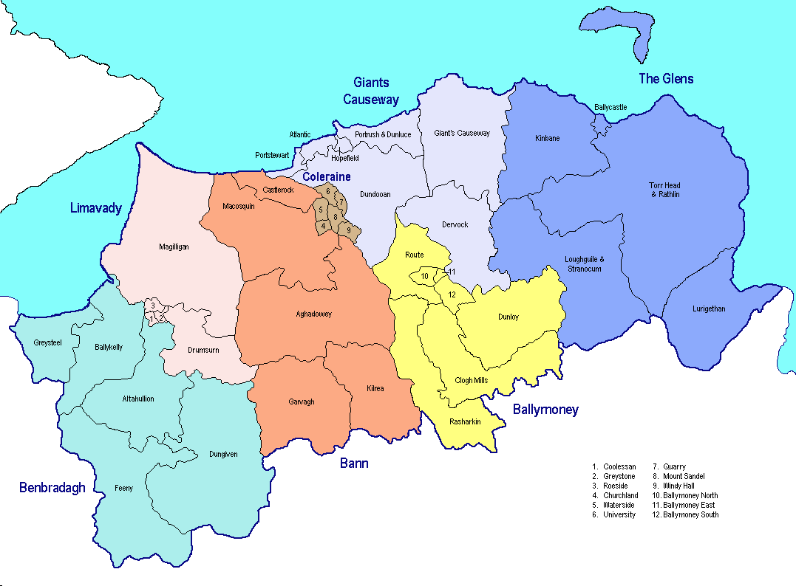
Q10 - Please state the DEA that your project will take place in.

Q11 – It is a requirement that funded projects or initiatives are open to all those residing in the area that they seek to represent, regardless of ethnic origin, religious or political belief. Please explain how you are proactively ensuring that your project will provide this accessibility and confirm that you are able to welcome anyone to participate in your events regardless of the factors listed above

Q12 – If applicable, it is a requirement of any group applying for funding from the Building a United Community fund, that, if successful in their application, they agree to take part in any promotion or publicity of their project as deemed necessary by Causeway Coast and Glens council. It is also a requirement that, if they undertake their own publicity, reference should be made to the support they received from the fund. Please describe how you intend to publicise your event.

Q13 – please provide a full breakdown of the total costs for your project. Please refer to the what can/cannot be funded in 1.6/1.7 of these guidance notes to ensure that all costs are eligible.

3.0 How we assess and score your application

Every application that is received requesting a Building a United Community Fund Grant will be assessed for the following:

- to ensure that the organisation is eligible to apply to this particular Grant Programme

- for reassurance of each organisation’s capability to deliver the proposal, and

- how well the proposal meets community needs and contributes to Council’s Strategic Priorities

An acknowledgement receipt will be electronically issued to you once your submission has been received. The Funding Unit will assess your application for eligibility. If your application is eligible to apply for grant aid, it will be forwarded to the relevant section for a full assessment and scoring against the stated criteria.

3.1 Eligibility assessment

The assessments in respect of Part 1 of the application form are awarded a pass or fail eligibility rating.

If the organisation, based on the information supplied is able to satisfy the Council of their eligibility to draw down the grant, they will progress to the next part of the process.

If the organisation, based on the information supplied, is not able to satisfy the Council of their eligibility to draw down the grant from the fund, they will be advised of specific omissions / shortcomings and how these can be addressed to help prepare them for any future funding requests.

3.2 What if an application is not eligible?

If your application is not eligible, you will be notified immediately and the reasons will be outlined to you, it will not proceed to assessment and scoring.

If an organisation is not eligible for funding through the Building a United Community Fund, organisations should contact the staff member listed on page 3 who will help signpost to alternative sources of funding.
If an organisation or its activities are deemed to be the responsibility of other Council Departments, statutory agencies or voluntary bodies then you will be signposted to who you should apply to. If signposted elsewhere you will be required to complete and submit the relevant application form.

3.3 Assessment and Scoring

PART B Eligibility

Questions 1, 2, 3 and 4 form part of the eligibility criteria for this fund. Question 1 is an eligible/not eligible question. Questions 2, 3 & 4 will be scored out of a maximum 5 points. For your application to progress to full scoring and assessment it must score a minimum of 3 points in each of these three questions. If your application does not achieve the minimum scores for eligibility it will be deemed ineligible and will not be progressed.

 | Criteria | Score out of a possible 5 (must achieve min of 3) | Pass/Fail
Q2 | Clear and concise evidence of a developed project with a Good Relations ethos
Q3 | Clear and realistic objectives set for the project
Q4 | A clear understanding of how the project objectives link to the Good Relations aims and can help work towards these.

Assessment & Scoring

If your application scores a minimum of 3 points out of a possible 5 in each of the above 3 questions it will progress to full assessment and scoring. All questions will be scored out of 5 and weighting will be applied as detailed below:

 | Criteria | Score out of a possible 5 | Weighting | Possible Score
Q5 | Extent of awareness and evidence base of specific Good Relations needs in the area |  | X2 | 10
Q6 | A clear understanding of how the project will address specific Good Relations needs in the area. |  | X2 | 10
Q7 | Robust system to measure baseline before project and change after completion of project. |  | X1 | 5
Q8 | Demonstrates willingness to work on a collaborative basis to find solutions to locally identified issues. |  | X2 | 10
Q9,11 | Proactive promotion of community cohesion, ensuring that the whole community can be involved |  | X2 | 10
Q12 | Wide reaching promotion of the project |  | X1 | 5
 |  |  |  | 50

Applications must score 65% in order to avail of funding.

3.4 How decisions are made

Each year Council agree a budget for this fund. The fund will remain open throughout the year until the budget is expended. Council Officers will assess and score the applications at various times throughout the year. Contact the Good Relations Team for advice on when the next assessments will take place. This will help you plan your project to ensure that grant-aid is awarded in time, should you be successful. When the scores are finalised the officers will return the applications to the Central Funding Unit who will inform you of the decision within 7 days of your application being scored.

It will be at this point that all successful/unsuccessful applicants will be notified.

3.5 What happens if an application is successful?

If an application is successful, Council will issue a letter of offer which is a legal agreement with the organisation to deliver on the proposals outlined in their application form.

Signed Letters of Offer will need to be returned before funding is released

Council funding is usually paid retrospectively.
Grants on occasions be released in two instalments – 50% of the grant will be awarded upfront if the organisations does not have sufficient reserves followed by remaining 50% once evaluation/financial claim is verified satisfactorily

Successful organisations are required to submit Participant Evaluation Forms as well as an annual/ end of funding evaluation report. Officers may discuss the monitoring information with the groups that were funded and also with some of the people who have benefited from the community activity.

3.6 What happens if an application is unsuccessful?

Officers from the relevant service unit will be available to meet with the organisation to go through their application, develop a working relationship and provide practical developmental support to address areas of concern.

An Appeals Process / Review Procedure is also available if an application is unsuccessful. The purpose of this is to ensure that the decisions taken and procedures followed by Committees for individual applications are applied fairly and consistently.

The Review will provide an independent process through which an applicant will have the opportunity to demonstrate to the Review Panel that either:
- the outcome was unreasonable or

- that the proper procedures were not followed

Appeals on any other grounds will not be considered.

3.7 Government Funding Database

Please be aware we are required to check the Government Funding Database (GFD) prior to making awards in order to avoid duplication of funding.

If registered on GFD we ask you to state your organisation’s Unique Reference Number (URN) to help with this process. Details of grants awarded will be uploaded to the GFD, it is the responsibility of the applicant group to ensure that the organisation details held on GFD are up to date.

3.8 Late applications

It is the responsibility of each applicant to ensure that their application is submitted prior to the advertised time and date of closing. Applications received after the closing time/date will not be considered for funding. No exceptions will be made and there is no recourse to appeal. It is the responsibility of the applicant to ensure submission on time.

Appendix 1

Data Protection Act

- We will use the information you give us on the application form during assessment and for the life of any grant we award you to administer and analyse grants and for our own research.

- We may give copies of this information to individuals and organisations we consult when assessing applications, when monitoring grants and evaluating the way our funding programmes work and the effect they have. These organisations may include accountants, external evaluators and other organisations or groups involved in delivering the project.

- We may also share information with other government departments, organisations providing match funding and other organisations and individuals with a legitimate interest in applications and grants, or for the prevention or detection of fraud.

- We might use the data you provide for our own research. We recognise the need to maintain the confidentiality of vulnerable groups and their details will not be made public in any way, except as required by law.

Funding Unit holds personal information on an eletronic management system and/or in hard copy for the purpose of administering Councils grants process in Causeway Coast and Glens Borough. As a public authority, Council takes your rights and freedoms seriously and will only release information when required under law or with your consent.

Further information about your rights, how to contact the Data Protection Officer and how long information is held or how we process any payments made can be found at:
https://www.causewaycoastandglens.gov.uk/footer-information/privacy-statement

Freedom of Information Act

The Freedom of Information Act 2000 gives members of the public the right to request any information that we hold, subject to certain exemptions that may apply. This includes information received from third parties, such as, although not limited to, grant applicants, grant holders and contractors. If information is requested under the Freedom of Information Act we will release it, subject to exemptions; although we may consult with you first. If you think that information you are providing may be exempt from release if requested, you should let us know when you apply. For further information please visit the Information Commissioner’s Office at www.ico.gov.uk

