2019

aRMOY VILLAGE PLAN

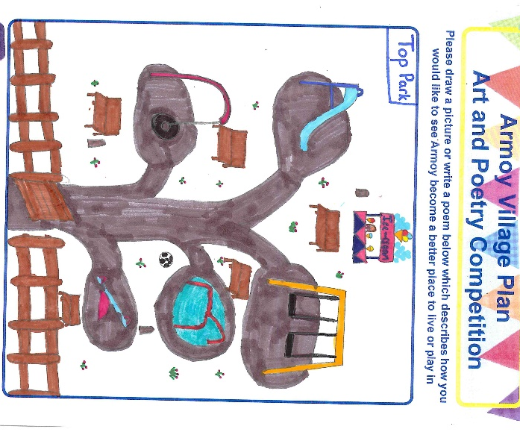 | 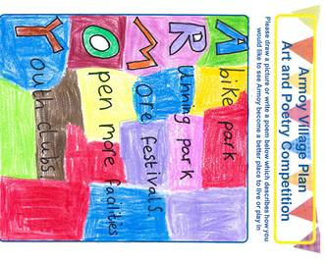
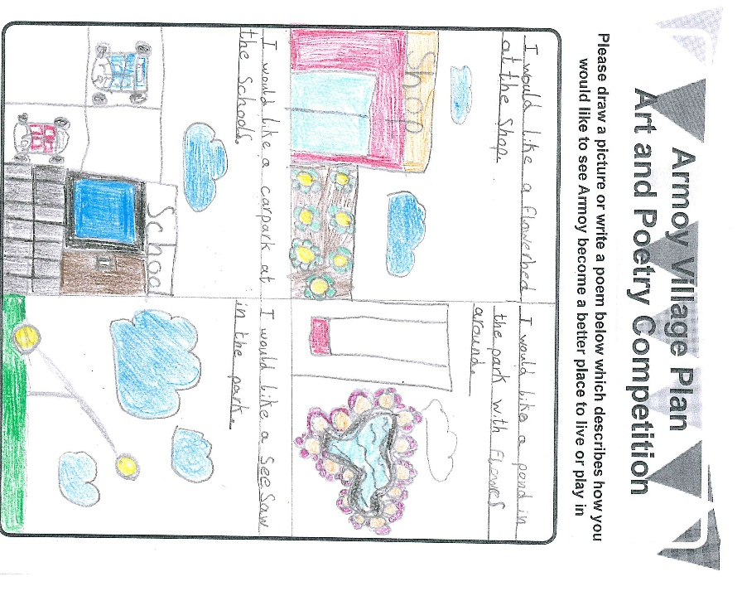 | 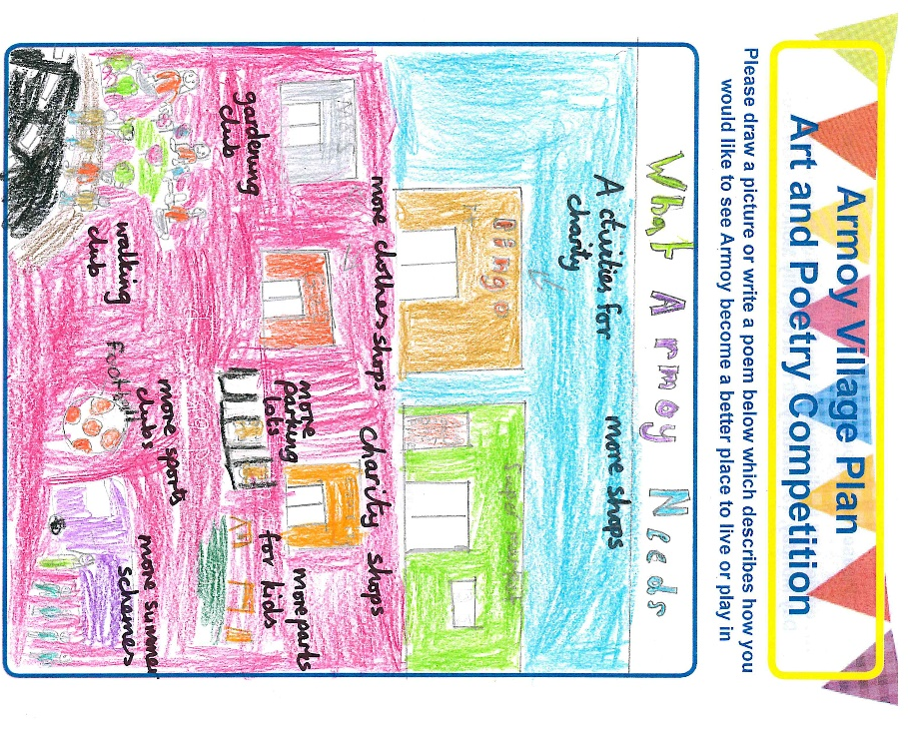

Youth Engagement, Art and Poetry Competition – A Selection of Winning Entries from local school children from Armoy Primary School and St Olcan’s Primary School

Armoy Village Plan

Contents Page
 |  | Page
1. | Introduction | 3
2. | Village Plan Process | 5
3. | A Better Future Together, A Community Plan for Causeway Coast and Glens 2017 – 2030 | 6
4. | Area Profile | 7
5. | Spatial Analysis Audit | 9
6. | SWOT Analysis | 16
7. | Engagement Events | 17
8. | Summary from Engagement Findings | 18
9. | Key Messages from Engagement Findings | 23
10. | Priority Actions | 24
11. | Next Steps – Working Together | 35
Appendices
Appendix 1 – Engagement Open Day Findings

Appendix 2 – Online Survey Findings

This Village Plan was developed by Community Places, March 2019

1. Introduction

The Village Plan process for Armoy plays an important role in supporting local people to identify priorities and to plan and shape activities, projects and programmes to promote sustainable village renewal, vibrant and cohesive communities, and to deliver long-term benefits and investment to the whole community in line with the ambitions set out in the ‘A Better Future Together’ Community Plan.

The Village Plan is a working document that will help local communities to lobby and influence the local council, statutory partners and other service providers to respond to local needs and priorities as well as evidencing need and identifying potential funding opportunities. The plan includes a number of priority actions that have emerged from engagement with the local community and other key stakeholders. Over recent years a number of consultation processes have taken place in the village and these findings have also informed the development of this Village Plan.

The Village Plan process took place between January and March 2019 and was commissioned by Causeway Coast and Glens Borough Council.

Map of Armoy Village and Hinterlands, CCGBC Interactive Maps

The Armoy Community Association (ACA) was established in 1994 to make a positive transformation to village life for all. One of the biggest achievements of the ACA is the successful development of the Tilly Molloy Community Centre. The centre acts as a civic glue creating and strengthening connections within the village and promoting a shared and welcoming environment for all in the village and wider hinterland. It is an important community hub providing a café, shared cross community play group, pharmacy facility, hairdressers, community office and hall, community initiatives, an annual summer scheme and public toilets.

The ACA provides community facilities and social events for all, and places an emphasis on improving quality of life, developing positive community relationships, celebrating the history of the area, enhancing the local environment and providing employment opportunities. The ACA are committed to ensuring that village life in Armoy offers ‘Sharing over Separation’ and the village and community development approach adopted by ACA is an example of good practice for promoting positive good relations and a shared village ethos.

ARMOY VISION STATEMENT

“A ViBRANT AND SUSTAiNABLE SHARED VILLAGE AND COMMUNITY WHERE PEOPLE SUPPORT ONE ANOTHER AND WORK TOGETHER TO ENHANCE QUALITY OF VILLAGE LIFE FOR ALL.”

2. Village Plan Process

The Village Plan process followed a number of key steps including:

- Development of a robust socio-economic profile of the village;
- Preparation of infographics to animate the area statistics;
- Analysis of existing documents, consultations and plans;
- Spatial analysis audit and mapping of physical and community assets;
- Community engagement;
- Developing priority actions;
- Agreeing the Village Plan.

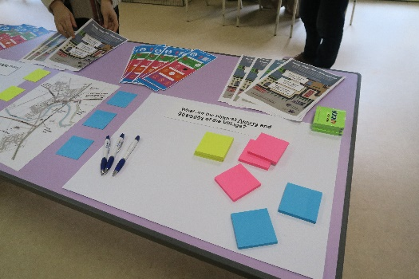
Each step informed and complemented the next drawing together the research and engagement findings to develop a village plan which sets out a long-term vision for the village to meet local needs and those of visitors. The plan itself and the process for developing and agreeing it has brought people together, strengthened relationships and has built support to implement the plan.

Posters and flyers were distributed throughout the village and shared on social media to raise awareness of the plan process and opportunities to get involved in helping to shape the future of Armoy.

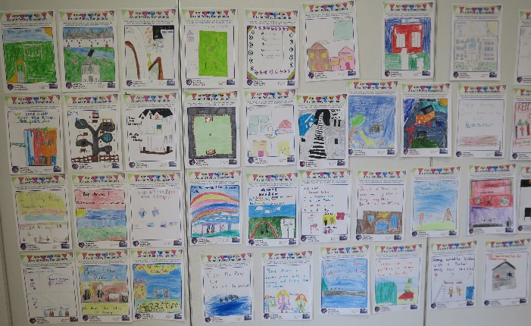
After discussions with representatives from the ACA it was agreed that three Community Engagement events would be held. These took place on Monday 18 February 2019, one in the afternoon at Tilly Molloy’s in the centre of the village and two in the evening at Park Orange Hall and at the Glen Rover’s Hurling Club.

Pupils from St Olcan’s Primary School and Armoy Primary School took part in an Art and Poetry Competition highlighting how they would like to see the village improve and become a better place. A short online survey was also prepared to accommodate those who were not able to attend one of the engagement events.

3. A Better Future Together, A Community Plan for Causeway Coast and Glens 2017 – 2030

The Community Plan sets out a long-term shared vision for the Causeway Coast and Glens area and all who live in, work in and visit the area. It concentrates on three main issues:

- A Healthy Safe Community: where people will contribute to and benefit from a healthy, connected and safe community that nurtures resilience, promotes respect and supports everyone to live well together;

- A Sustainable Accessible Environment: where people will value and benefit from a diverse, sustainable and accessible environment with an infrastructure that is fit for purpose and that enables connections; and

- A Thriving Economy: where people will contribute to and benefit from a thriving economy built on a culture of growth, entrepreneurship, innovation and learning.
A Better Future Together, p.7.
The Community Plan is the overarching framework for the area and acts as a strategic planning tool bringing key statutory and support partners together to plan and deliver better outcomes for people in relation to health, education, housing, public safety, communities, the economy and the environment at a council wide area and at local and neighbourhood levels. The Community Plan was developed in close collaboration with key partners and with extensive engagement with local communities, groups and individuals.

The Community Plan is linked to and reflects other key strategies and plans. This includes the new Local Development Plan 2030 which will provide the spatial framework for the Borough and will consider any land use planning aspects which emerge through the Community Plan such as housing, employment, open spaces and connectivity. Where relevant, linkages to and between the Community Plan and this Village Plan have been highlighted.

4. Area Profile
Armoy village is located nine kilometres south west of Ballycastle and 13 Kilometres north east of Ballymoney and lies within the Armoy Ward.
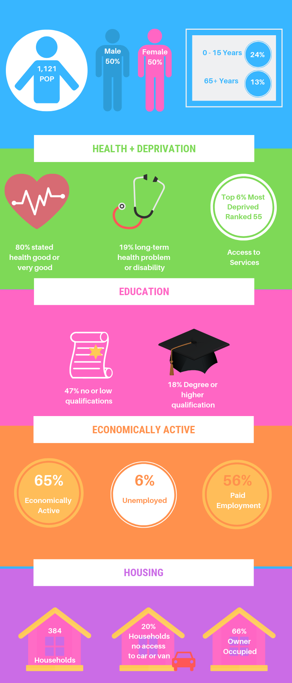

Population

The estimated population of Armoy ward at 30 June 2018 was 1,121, of which 560 (50%) were male and 561 (50%) were female. This was made up of: 265 children aged 0-15 years; 329 people aged 16-39 years; 386 people aged 40-64 years; and 142 people 65 years and older. Just under a quarter of the population (23.6%) are aged 15 years and under and 12.6% are 65 years and over.
Between 2007 and 2017 the population increased by 88 people or 8.5%.

Ethnicity, Identity, Language and Religion

Considering the resident population on Census Day, 98.72% were from the white (including the Irish Traveller) ethnic group. 43.85% belong to or were brought up in the Catholic religion and 50.23% belong to or were brought up in a ‘Protestant and Other Christian’ religion. 54.42% indicated that they had a British national identity, 18.05% had an Irish national identity and 34% had a Northern Irish identity.
Considering the population aged 3 years and over: 10.62% had some knowledge of Irish; 31.39% had some knowledge of Ulster-Scots; and 0.10% did not have English as their first language.

Health
On Census Day, 79.58% of people stated their general health was either good or very good. 18.78% of people had a long-term health problem or disability that limited their day to day activities. 11.58% of people stated that they provided unpaid care to family, friends, neighbours or others.

Housing and Accommodation

On Census Day there were 1,097 people living in 384 households, giving an average household size of 2.86. 66.15% of households were owner occupied and 30.99% were rented. 34.64% of households were owned outright. 9.11% of households were comprised of a single person aged 65+ years. 8.59% were lone parent households with dependent children. 20.05% of households did not have access to a car or van.

The Causeway Coast and Glens Housing Investment Plan Annual Update 2018
The five year (2017-2022) projected social housing need for Armoy is 6. A social housing development programme of 9 General Needs housing is programmed for 2019/20 at New Street, Armoy by Triangle Housing under the Rural Need policy theme.

Housing Executive Stock (Sold stock in bold)

Armoy | Bungalow | Cottage | Flat | House | Mais | Total | Void
 | 29 | 9 | 0 | 36 | 0 | 74 | 1
 | 31 | 37 | 0 | 34 | 0 | 102

Applicants and Allocations at March 2018
In Armoy there were 14 Applicants, 10 of which were experiencing Housing Stress (30 points or more) and there were <10 allocations.

Qualifications
Considering the population aged 16 years old and over, on Census Day 27 March 2011: 17.69% had a degree or higher qualification; while 46.70% had no or low (Level 1) qualifications. (Level 1 is 1-4 O Levels/CSE/GCSE any grades or equivalent).

Labour Market
Considering the population aged 16- 74 years old: 64.52% were economically active, 35.48% were economically inactive; 56.20% were in paid employment; and 6.45% were unemployed.

Multiple Deprivation
The NI MDM provides information on seven types of deprivation and an overall measure of deprivation for small areas. The 2017 NI Multiple Deprivation Measures are very concerning. The Armoy and Mosside and Moyarget SOA falls within the top 19% (169) of multiple deprived SOAs across NI. It also ranks high across a number of the domains. In relation to Access to Services and Income Deprivation affecting older people it falls within the top 6% (55) most deprived; in relation to Income Domain it falls within the top 8% (72) most deprived; and with reference to Income Deprivation affecting children it falls within the top 9% most deprived Super Output Areas.

5. Spatial Analysis Audit
An audit was undertaken of the physical and community infrastructure and asset base of the village, this is detailed and mapped below:
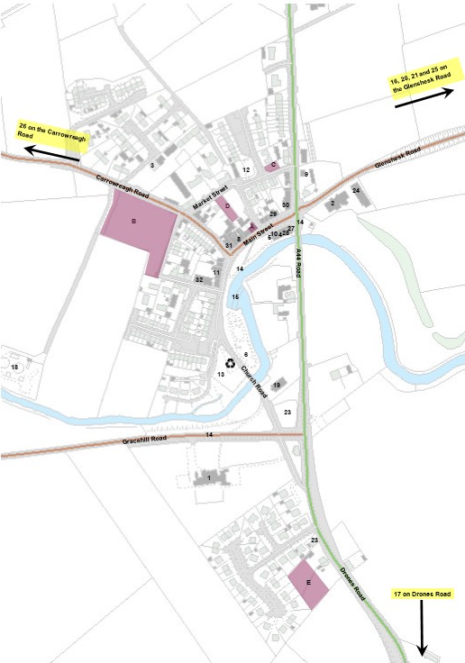

Asset | Name | Baseline Map Number
Key Services and Facilities | Armoy Primary School  St Olcan’s Primary School  Christian Family Centre NI  Armoy Community Pharmacy  Public Toilets  Riverside Gardens- Memorials to Armoy Armada and Armoy tenor Uel Deane  Riverside Gardens Walkway  McCaughan’s Mace/Post office  Kennedy’s Vivo/Armoy Filling Station  Tilly Molloy Centre  Dalriada SureStart  Armoy Cross Community Play Group and Summer Scheme  Causeway Coast and Glens Heritage Trust Office  Turnarobert Play Park  Church Road Play Park  Ulster Bus Service Bus stops  Bush River  Glen Rovers GAC/Social Centre- 2 hurling pitches and a training pitch  Naomh Pádraig Juvenile Hurling and Camogie  Limepark Playing Field  Sewage Works  Riverside Park Recycling Banks  Boys Brigade  Girls Brigade | 1  2  3  4  5  6  7  8  9  10  10  10  11  12  13  14  15  16  17  18
Churches | Armoy Presbyterian Church  St Patrick’s Church of Ireland  St Olcan’s Roman Catholic Church  House of the Lord Fellowship -Gospel Hall | 19  20  21  22
Halls | Armoy Presbyterian Church Hall  St Olcan’s Parish Hall  Lagge Hall (Parish Hall for St Patrick’s Church of Ireland)  The Park Lodge Orange Hall  Community Hall-Tilly Molloy Centre | 23  24  25  26  10
Businesses | Katrina’s Unisex Hair Salon  Tea at Tilly’s  The Tuck Inn  The Armada Inn-Public House, Restaurant and Guest House  The Rooks Nest Public House  H O’Kane Motors | 27  28  29  30  31  32
Groups in the area | Over 55s Group- Tilly Molloy Centre  Armoy Motorcycle and Road Racing Club Limited  Armoy Community Association  Women’s Institute  Armoy LOL 1065  Armoy W LOL 175  Bushside Independent LOL  Kerr Smiley LOL 956  Pride of the Park Armoy Flute Band  Armoy Auld Boys Flute Band  Bushside Accordion Band  Armoy Horse Show  Armoy Horse Shoe Throwing Competition  Armoy Pigeon Homers  North Antrim Village Forum – Armoy
Derelict / Opportunity Sites | Derelict dwellings on 11 and 13 Main Street  Opportunity site: vacant land at New Street/Carrowreagh Road zoned for housing  Land opposite 15 Market Street zoned for housing  Land opposite 25 Market Street zoned for housing  Land to the rear of 19/21 Drones Road zoned for housing | A  B  C  D  E
Tourism | Armoy Road Race  Dark Hedges  Armoy Armada

Key Services: Programme Delivery and Outreach Activities
Armoy Primary School  - After School Clubs eg Construction Kits, Cookery, Games, Crafts  - Football Club | Tilly Molloy Centre  - Play Group  - Summer Scheme  - Counselling and Advice  - Sure Start  - Slimming World  - Room Hire  - Over 55s group  - Ballycastle District Vintage Club  - Activities and Events | St Olcan’s Primary School  - Breakfast Club  - After School Club  - Extended Schools- out of school activities- sports classes, free parent classes

Northern Area Plan (2016)
The Northern Area Plan designates Armoy as a village and notes its provision of primary education, convenience shopping and a post office, and a range of community facilities as illustrated below.
The NAP 2016 recognises the role which the Tilly Molloy Project has played in enhancing the commercial and community life of the village. The community regeneration project was implemented under the International Fund for Ireland’s Community Regeneration and Improvement Special Programme (CRISP) by the Armoy Community Association. The project redeveloped a key derelict site at the entrance of the village providing four shop units, four apartments, community care facilities and public toilets. As part of the CRISP project the physical environment of the village was further enhanced by the Riverside Park and an environmental improvement scheme on Main Street. Today, the Tilly Molloy Centre continues to act as an important hub for the community.

Of the sites zoned for housing within the village three remain to be developed including: AYH 04 and 05, Carrowreagh Road; AYH 03 Market Street (See Planning History) and AYH 08, Drones Road.

The centre of Armoy is designated an Area of Village Character to protect and enhance the distinctive character of the area including the curving form of Main Street which follows the bend of the River Bush; the mixture of terraced houses and shops in the style typical of 19th Century Irish country towns and villages; and traditional shop signage. The Plan identifies major areas of existing open space, the majority of which lies along the bank of the River Bush including the River Side Park.

There is also a Local Landscape Policy Area (AYL 01) Bush River LLPA which seeks to protect the features which contribute to the environmental quality, integrity and character of the area including: the incised meander of the River Bush with its wooded banks and the tree lined eastern approach to the village.

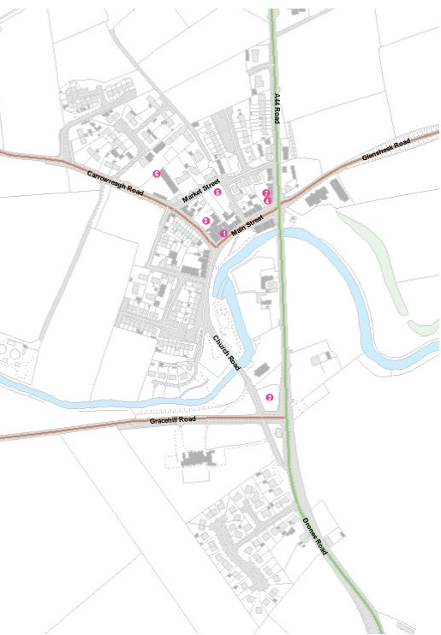
Planning History Map

Key Planning History Table, February 2019

Map Ref | Planning Reference | Site Address | Proposal | Application Received | Planning decision | Decision Date
1. | E/2010/0246/F | 15 Main Street, Armoy | Demolition of part of existing shop and alterations/additions to existing shop | 7/09/10 | Granted | 24/11/10
2. | E/2011/0053/F | 14 Church Road, Armoy | Proposed new church hall | 24/02/11 | Granted | 2/03/12
3. | E/2013/0044/F | 15 Main Street, Armoy | Demolition of part of existing shop/store and outbuildings. Alterations/Additions to existing shop, New store/Offices and Carpark | 21/03/13 | Granted | 14/06/13
4. | E/2014/0050/F | 167-169 Hillside Road, Armoy | Demolition of Existing Public House and 2no. Units of Living Accommodation and Replacement with new Public House and Restaurant with 2 No. Apartments above | 25/03/14 | Granted | 18/10/16
5. | E/2014/0250/F | Opposite 1-5 and 21-23 Market Street, Armoy | Proposed 3 No. Detached dwellings with associated parking | 22/12/14 | Granted | 7/03/17
6. | LA01/2017/0621/F | 21 Carrowreagh Road, Armoy | Retrospective application for wood pellet boiler and associated silo | 15/05/17 | Granted | 6/11/17
7. | LA01/2017/1280 | 167-169 Hillside Road, Armoy | Retrospective application variation of E/2014/0050/F to permit the retention of building as constructed, including, additional window opening, variation to windows and door fenestration, solar panels, modification to chimney, refrigeration units and retention of external canopy and toilet block. Change of use of 1no. residential apartment to provide bed and breakfast accommodation. | 23/08/17 | Granted | 17/09/18

6. SWOT Analysis

Strengths | Weaknesses
The people and sense of shared community and genuine friendships  Armoy Community Association  Tilly Molloy Centre  Two Primary Schools  - Shared Education  Parks  River Walkway  Facilities and Services  Pharmacy  AONB: Natural beauty and tranquillity  Rich History | Lack of affordable housing  Inadequate sewage infrastructure  Public transport linkages  Lack of activities for teenagers  Lack of shared sports facilities  47% no or low qualifications  20% households have no access to a car or van  Derelict properties on Main Street  Lack of car parking  Perceived lack of political representation at Council level
Opportunities | Threats
Village is a good practice example of sharing and positive community relations  Integrated Education  Extended use of school and other facilities for community use  Tourism and celebrating history of area  Redevelopment of Limepark into shared Multi Sports Community Facility | Lack of affordable housing  Inadequate sewage infrastructure  Frustrations at resources available for Single Identity areas  Top 6% most deprived in relation to Access to Services and Income Deprivation affecting older people (Ranked 55)  Top 19% (169) of multiple deprived SOAs across NI.  Top 8% most deprived in relation to Income Domain (72);  Top 9% most deprived with reference to Income Deprivation affecting children  Traffic calming and safe crossing points

7. Engagement Events

After discussion with representatives from Armoy Community Association it was agreed that three community engagement events would be held across the village and wider hinterland to maximise participation. The events were held at the Tilly Molloy Centre; Park Lodge Orange Hall and the Glen Rovers GAC Social Club.
At each event participants were invited to comment on the existing strengths of the village; the greatest challenges facing the community and to share their ideas and ambitions on how the village could be enhanced and improved in relation to a range of thematic issues. Infographics were displayed to illustrate area statistics in an engaging and accessible style. At the Tilly Molloy Centre entries from the Art and Poetry Competition were displayed for all to see the priorities of the younger people in the village.
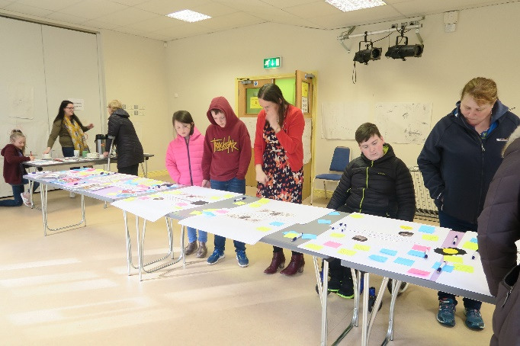 | 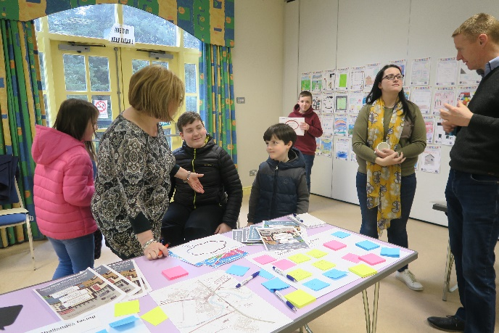
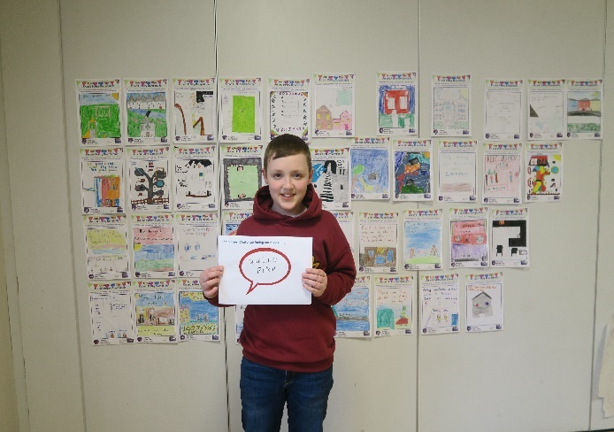 | 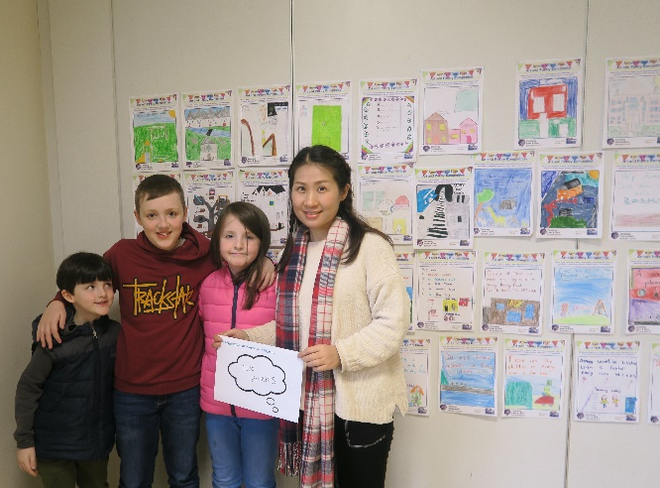
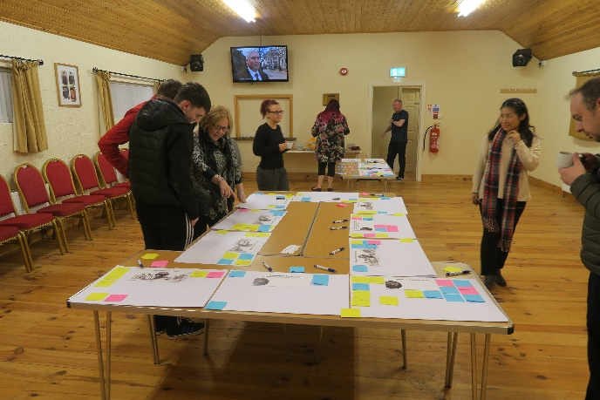 | 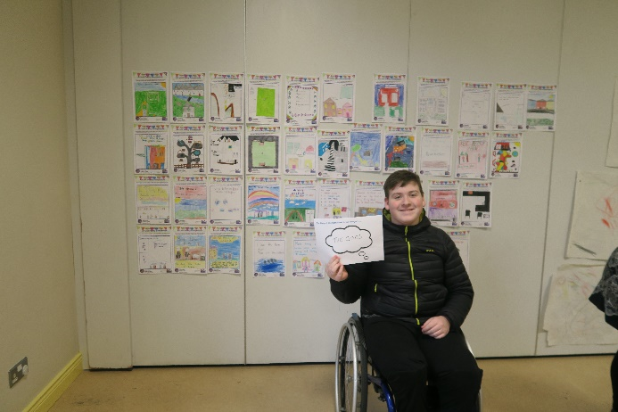

8. Summary of Engagement Findings

Participants were invited to share their ideas and comments under a number of thematic issues and to consider the biggest assets of and challenges facing the village.

Assets and Strengths of the Village
Respondents noted that the local people, sense of community spirit, close friendships and shared nature of the village were key assets and strengths to be celebrated. The role which the Armoy Community Association has played in developing and improving the village was also consistently highlighted. Others emphasised the important role which the cross community Play Group performs in providing a strong foundation for positive community relationships in the village and wider rural hinterland. The natural beauty (AONB), calmness and history of the area were also highlighted as important assets. Key services and facilities such as the two Primary Schools; the cross-community Summer Scheme; the pharmacy; two parks; the Riverside Park and Walkway, and the Armada Bar which is welcoming to all were all identified as positive aspects of village life. The Armoy Road Race and week of community events associated with it were also highlighted.

Biggest Challenges facing the Village
A consistent message coming from local people was the lack of affordable housing within Armoy and the need for new housing development. People stressed their concerns that without additional housing key services such as local primary schools and sporting clubs could come under threat of closure (Rugby Club has already closed) and that more housing provision in the village was central to keeping life in the village.

“Young families keep a community vibrant. All communities need a mix of young and elderly.”
Others noted that the lack of sewage infrastructure is compounding this issue and has restricted a planned social housing scheme by Triangle Housing. Some members of the Over 55 Club also noted that there is a lack of attention given to social housing tenants with kitchens in need of refurbishment and poor heating. Others suggested that provision of Fold or sheltered accommodation for elderly or single people could make more houses available for young families.

A lack of car parking and accessible parking spaces was also highlighted with people noting that it prevents them from availing of local services including the Tilly Molloy Centre. Others noted that cars obstruct footpaths on the Main Street which makes is extremely difficult for wheel chair users or parents with push chairs. Traffic congestion, speeding, traffic calming measures on main road (A44) for children crossing from the school into the village; road safety and parking issues associated with drop-off and pick-up times at the local schools were also stressed. Poor transport connections and the lack of a bus shelter in the village for younger people going to school in Ballycastle were also noted.

Environmental Improvements
Comments in relation to environmental improvements centred on better lighting near the Church of Ireland, Mill Lane, St Olcan’s Church and along Drones Road. Others noted that Christmas lighting would be a welcome addition to the village. Speed restrictions, gritting, and footpaths near to the Churches on Glenshesk Road and the GAA pitch to improve access and safety to the wider area were identified. The issue of road safety, safe crossing points at the Primary Schools and the need for footpaths from the village to key community facilities such as halls was also noted. Other comments included additional signage to direct passing tourists to local services; shop front renovations, an additional bus shelter for school children traveling to Ballycastle; a shared space community garden or vegetable plots; and additional planting and litter picks by community volunteers.

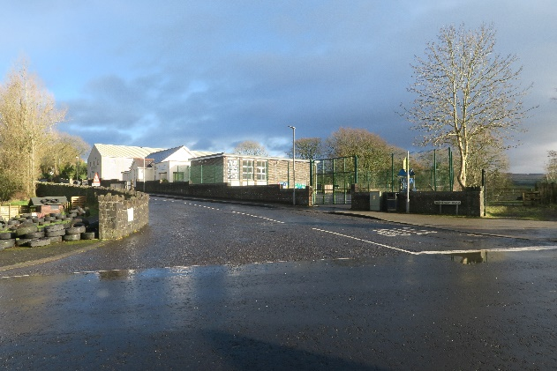 | 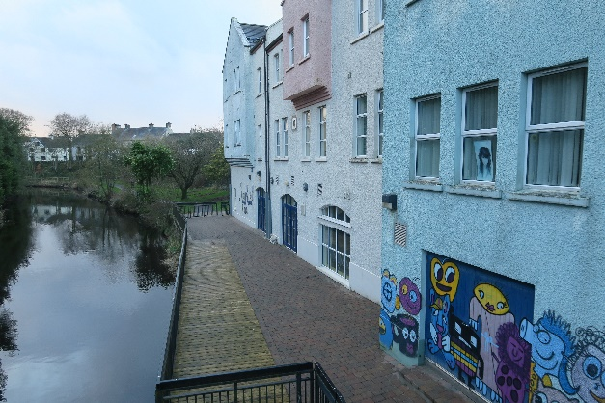

Celebrating Village Life
Many of the participants stressed how fantastic taking part in and being a runner up in the Village of the Year process was. They felt that this should be celebrated and built on going forward. Other comments suggested that the history of the area could be celebrated more and that a network of village volunteers could be developed to undertake environmental improvements such as community litter picks, community flower beds throughout the village and maintaining the river walks; and to support groups and establish a youth club. An annual Village Festival or Street Fair was suggested to bring the community together and to celebrate the success of the year. It was also noted that there is an opportunity for greater school involvement in community events e.g. Christmas Lights Switch On.

Education and Life-long Learning
The majority of comments relating to this theme highlighted opportunities to explore more shared education in the village. Some suggested that the two primary schools could join together in a modern facility, opening up space in the village for housing or additional community facilities to complement the Tilly Molloy Centre. Other suggestions for classes and up-skilling events referred to: Braille and Sign Language, art and photography, and e-learning. Others noted that the schools could be used for extended hours to benefit the community and that the training room in the Tilly Molloy Centre could be made available to the Recovery College for talks and courses. Another suggestion highlighted the benefits of a Men’s Shed noting that they can be used to exchange skills, bring people together to socialise and to exchange stories of the village in years gone by.

Youth Facilities or Activities
Participants emphasised the success of the annual Cross Community Summer Scheme and suggested that regular Youth Clubs (Primary School Age and Post Primary) located from the Tilly Molloy Centre would be a welcome addition to the village. It was noted that efforts should be made to encourage more young people to get involved with village events and activities to give them a sense of pride and ownership in the village. Other suggestions for youth activities included: Disco for under 18s, Kids’ Club, baking classes, cross community activities, activities for teenagers, bird watching.

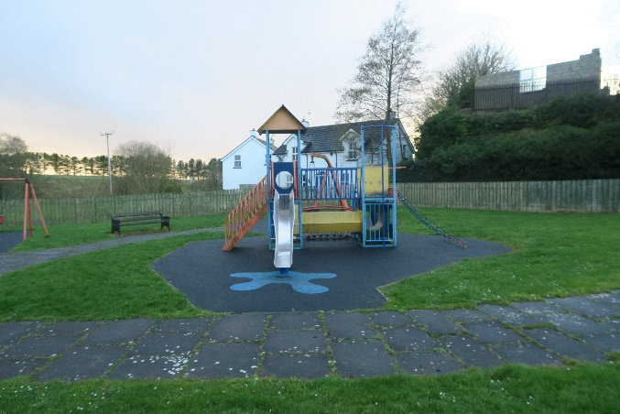 | 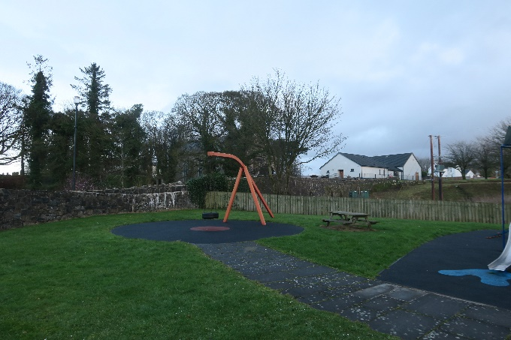

Sports and Active Living
Ideas and suggestions under this theme included improving or developing new sporting facilities or activities e.g. football pitch, 4G facilities, hurling and camogie, hockey, tennis, netball, volleyball and keep fit classes. Several people noted that the closure of the Rugby Club and pitches was a huge loss and that Limepark should be upgraded to a shared multi sports leisure facility for the village and wider hinterland. A more creative idea suggested a roller coaster park. Several comments highlighted the need for safe walking routes, a Park Run, an outdoor gym or trim trail along the River Walk, and coaching support. Others noted that a walking path around the Armoy Races Track would be a great idea.

Older People Facilities or Activities
Suggestions included a luncheon club, knitting club, bingo club for younger and older people and baking classes. A number of people noted that the Over 55s Club which meets every Wednesday at Tilly Molloy’s helps to reduce the isolation of older people in the village. It was suggested that the Over 55s Club could also include more social activities such as exercise classes and dances. Others noted that information on Community Transport services would be useful especially for older people accessing hospital or other health services.

Health and Well-being
Participants highlighted that a Walking Group could be established with off-road walking routes. One person raised the possibility of the nearby disused railway track between Ballymoney and Ballycastle being redeveloped as a Greenway for cycling and walking. Community allotments and an outdoor gym were also suggested. Members of the Over 55s Club highlighted their concerns with availability of appointments at local GPs and waiting times for appointments with medical consultants.

Tourism, Heritage, Culture
There was recognition of the rich heritage, cultural and tourism assets within the village including the Round Tower, early Irish history, Ulster Scots links, Armoy Armada, the Dark Hedges, Tilly’s Ice-cream, and the Armoy Races. It was suggested that a tourism trail, improved signage or even a local information and heritage centre could be located in the village to celebrate and promote these assets.

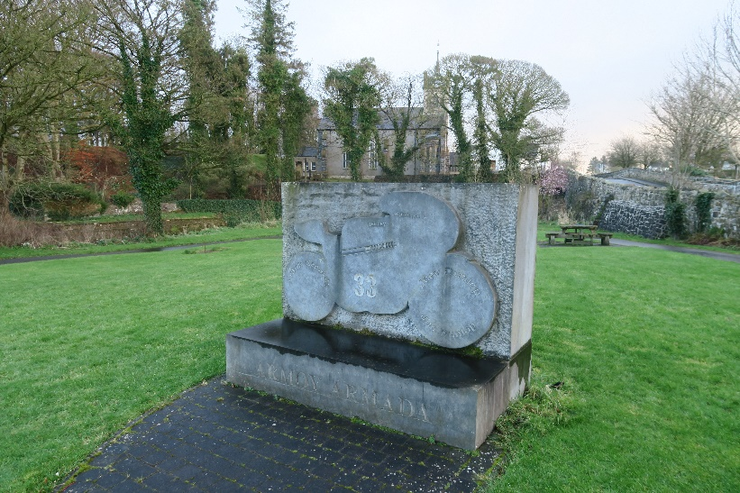

Community Facilities
A number of people suggested that a Community Notice Board would be a useful addition to the village enabling different groups to advertise their activities and events. The establishment of a weekly Farmers or Artisan Market was also suggested. Others noted that existing facilities could be used more widely across the community and that this would help to continue to build strong cross community relationships. Another comment suggested that funding could be sought for a Community Bus to access activities, services and events outside of the village.

Other Ideas or Comments
Other ideas included a Community Fridge, a Bio-diversity Park, Men’s Shed, a wheelchair swing in the park near the Armoy Primary School, support and access to information for families in relation to childcare, universal credit and back to work programmes, ATM, a year-round programme of activities and events for all ages and a Parents and Tots group.

Youth Engagement – Art and Poetry Competition
Pupils from Armoy Primary School and St Olcan’s Primary School took part in an Art and Poetry competition exploring how they would like to the see the village improve. The pupils came up with some interesting and creative ideas from cleaning the river, stopping litter, planting flowers, improvements to the parks, clubs and facilities for those with disabilities, Library or book shop, fun days, a youth club, a Virtual Reality gaming room, Community Fridge, Fittest Family Competition, Graffiti Wall and Walking Trails.

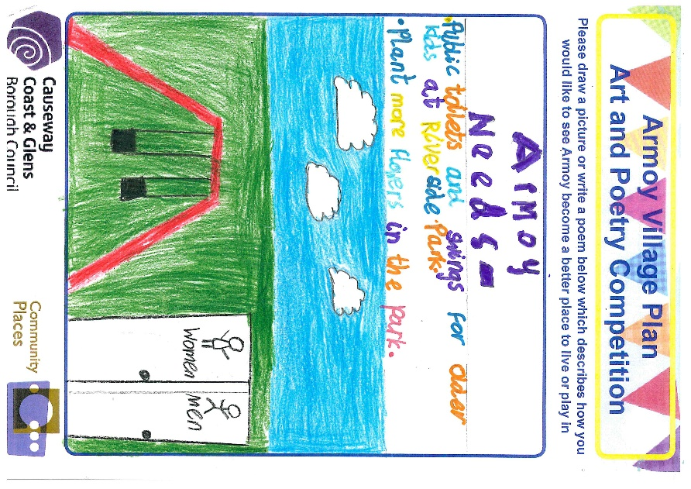 | 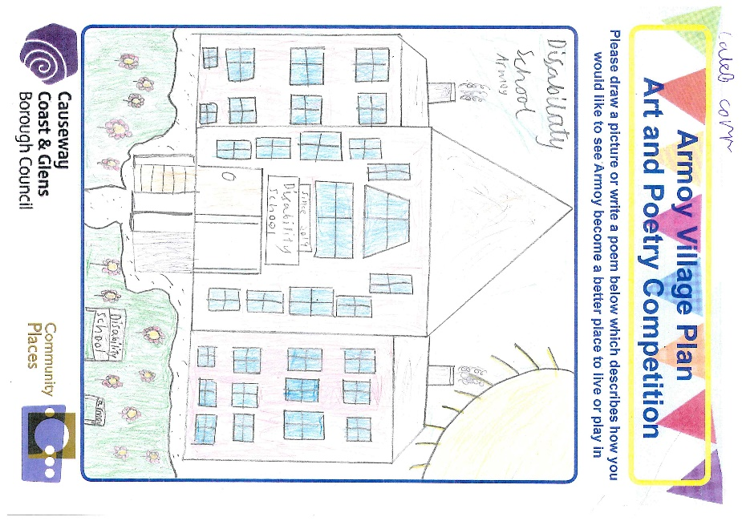
Youth Engagement, Art and Poetry Competition – A Selection of Winning Entries from local school children from Armoy Primary School and St Olcan’s Primary School

9. Key Messages from Engagement Findings

- The people and community spirit are Armoy’s biggest assets
- Armoy Community Association and the Cross-Community Play Group have an important role in building positive community relationships in the village
- The Village represents a lived experience of peace building which should be celebrated as an example of good practice for promoting shared space
- Lack of affordable housing in the area and threat to survival of key services such as schools if not addressed “Keep Life in the Village”
- Lack of sewage infrastructure restricting housing development
- Opportunities for shared or integrated education
- Car parking facilities
- Improving road safety, traffic calming and safe crossing points
- Additional Lighting, foot paths and a Bus Shelter
- Develop a Network of Volunteers and encourage younger people to get involved
- Celebrate and build on the success of the Cross-Community Summer Scheme and establish a Youth Club
- Improving or developing shared Multi Sport facilities in the village
- Green Gym or Trim Trail
- Additional community events and activities to bring people together, celebrate village life and improve health and well-being e.g. Annual Street Fair or Festival, Artisan or Farmers Market, Walking Group
- Local information or heritage centre to celebrate the heritage and culture of the Village
- Community Noticeboard
- ATM (external)

10. Priority Actions

Keeping Life in the Village: Lobbying for Strategic Infrastructure Improvements

Some of the principal challenges facing the village are out of the control of the ACA and sit at a strategic departmental level. It is essential that the ACA continue to relentlessly lobby for improvements to the sewage infrastructure to enable land which is zoned for housing to be realised. Existing zoned housing land could be extended, and larger land parcels created to make alternative sewage treatment options such as reed beds more feasible. Without additional housing the life and vibrancy of the village will be seriously jeopardised and existing services and facilities may struggle to survive. The population statistics illustrate that younger people (under the age of 15 years) make up nearly a quarter of the area population. If housing provision is not addressed, it will impede the next generation from having the option to remain in the village.

The ACA are critically aware of the need for affordable housing and are tirelessly lobbying and campaigning to find a solution to this issue.

Key Action | S | M | L | Lead Partners
Lobby Department for Infrastructure, Water NI, MLAs and Local Councillors for upgrades to the sewage infrastructure |  |  |  | ACA, North Antrim Village Forum
Make representations to the Causeway Coast and Glens Borough Council Local Development Plan 2030 process for extended and additional land zonings within the settlement limit for Housing |  |  |  | ACA, Causeway Coast and Glens Borough Council, North Antrim Community Network, North Antrim Village Forum
Liaison with NIHE and Triangle Housing re provision of social and affordable housing |  |  |  | ACA, Causeway Coast and Glens Borough Council
Liaison with NIHE re: Regular Estate Inspection Toolkit review; Housing Transfer System- scope interest from those who may want to downsize and ongoing Maintenance and Modernisation e.g. Kitchen Upgrades |  |  |  | ACA, NIHE Local Councillors
Lobby together with other villages on these strategic infrastructure issues |  |  |  | ACA, North Antrim Village Forum, North Antrim Community Network, Rural Community Network

Links to ‘A Better Future Together’ Community Plan

- A Sustainable Accessible Environment
- A Healthy Safe Community

Potential Funding Opportunities or other Useful Links

- National Lottery Community Fund www.tnlcommunityfund.org.uk/northern-ireland#section-1 Awards for All £300- £10,000; People and Communities £10,000 – 500,000
- North Antrim Community Network
- Rural Community Network
- Supporting Communities

Environmental Improvements, Road Safety and Parking

A scheme of environmental improvements should be developed to address the concerns of villagers in relation to accessibility for people with disabilities, general up-keep of the village, lighting (Church of Ireland, Mill Lane, St Olcan’s Church, along Drones Road), parking provision, an additional bus shelter for those accessing services in Ballycastle, introduction of footpaths (various locations were identified including routes into the village and the road way between St Olcan’s Church and the Gaelic Club); traffic calming measures including ‘go slow’ signage and road safety awareness.

A key theme running through the Children’s Art and Poetry Competition entries from the local Primary Schools was the issue of the environment – and the concerns and sense of custodianship from the children for the need to keep Armoy tidy and free from litter to enhance the beauty of the area, make it colourful with flowers and to enhance the river and walkways. A ‘Keep Armoy Tidy’ campaign should be developed in partnership with local primary schools and other community volunteers. The campaign could include a ‘Big Spring Clean’ Day. A number of initiatives organised by Keep NI Beautiful could be introduced along the River side walkway and gardens including ‘Adopt a Spot’ and ‘Live Here Love Here’ enhancing the environmental and aesthetic appeal of the village. This would offer opportunities for intergenerational activities e.g. community flower planting and gardening; foster a sense of community ownership at specific areas throughout the village which could be ‘adopted’ by the pupils from the primary schools and adjacent residents; and increase the participation of local people and the primary schools in the village. Another clear message from the young people through the art competition was the need to provide additional activities for people with disabilities in the village. This included, the introduction of wheelchair swings to make both play parks more inclusive.

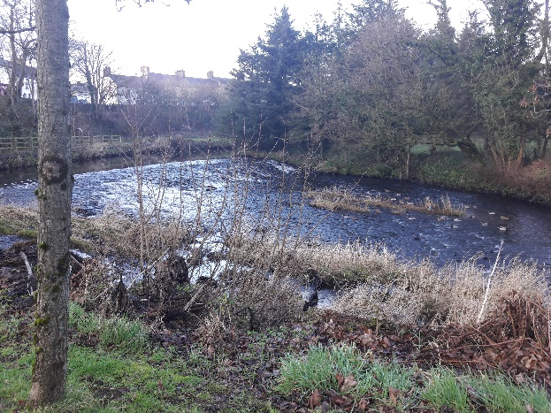 | 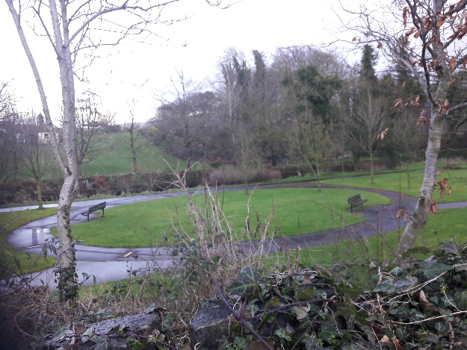

The local primary schools should explore the Sustrans Active School Travel in NI Programme. A walkability assessment and the potential of developing a walking bus from a safe location within the village could be explored. This may not be suitable for all children given the rural nature of the area but there may be opportunities for some children to walk or scoot to school. Road Wise sessions could be held in the primary schools to promote road safety more broadly.

Information on how to access the North Coast Community Transport scheme should be promoted within the village. This could help to address unmet transport needs and improve access to hospitals, GP surgeries, youth facilities and cultural and social facilities.

Key Action | S | M | L | Lead Partners
Lobby Department for Infrastructure - Roads for introduction of traffic calming measures including slow signage adjacent to both schools and safe crossing points and walking routes |  |  |  | ACA, St Olcan’s Primary School, Armoy Primary School, Local Councillors, PSNI
Undertake a Feasibility Study to Identify options for additional car-parking in the village including accessibility parking |  |  |  | ACA, Local Businesses, Local Councillors, Causeway Coast and Glens Borough Council
Develop a programme of environmental improvements and lobby Department for Infrastructure - Roads for additional Footpaths and Gritting Services |  |  |  | ACA, Local Councillors, Local Churches, GAA Club, North Antrim Village Forum
Develop a Keep Armoy Tidy Campaign including an annual ‘Big Spring Clean’ Day, Adopt a Spot and Community gardening |  |  |  | ACA, Primary Schools, Community Volunteers, Causeway Coast and Glens Heritage Trust
Local Primary Schools to explore The Sustrans Active School Programme: undertake walkability assessment and raise road safety awareness for pupils and parents |  |  |  | Armoy Primary School, St Olcan’s Primary School
Primary Schools to communicate to all parents that school traffic should not impede or cause road safety concerns |  |  |  | Armoy Primary School, St Olcan’s Primary School
Lobby Department for Infrastructure and Local Councillors for an additional Bus Shelter on the A44 Road in the village for school children going to Ballycastle |  |  |  | ACA, Local Councillors, Local Secondary Schools – Cross and Passion School and Ballycastle High School
Link to and promote existing Community Transport Services to address unmet travel needs |  |  |  | ACA, North Coast Community Transport,
Lobby local Councillors and the Causeway Coast and Glens Borough Council for the provision of wheelchair swings and general upgrade of both play parks |  |  |  | ACA, Armoy Primary School, St Olcan’s Primary School, Local Councillors

Links to ‘A Better Future Together’ Community Plan

- A Healthy Safe Community
- A Sustainable Accessible Environment

Potential Funding Opportunities or other Useful Links

- Sustrans www.sustrans.org.uk/northern-ireland/our-work-northern-ireland
- North Coast Community Transport https://www.northcoastcommunitytransport.com/
- Keep NI Beautiful Initiative www.keepnorthernirelandbeautiful.org
- Groundwork NI www.groundwork.org.uk
- National Lottery Community Fund www.tnlcommunityfund.org.uk/northern-ireland#section-1 Awards for All £300- £10,000; People and Communities £10,000 – 500,000 Empowering Young People £10,000 – 500,000
- Asda Foundation https://www.asdafoundation.org/
- Tesco Community Grants https://www.groundwork.org.uk/tesco-local-community-scheme-uk-programmes

Celebrating Village Life and Promoting Armoy as a good practice example of local peacebuilding and shared service provision

One of the key strengths which local people consistently acknowledged was the sense of community and genuine friendships which existed within the village. The work and community development approach adopted by Armoy Community Association and the role played by important shared and cross community services such as the Play Group; the annual summer scheme; café, pharmacy and activities delivered from the Tilly Molloy Centre have been critical to the embedding and development and promotion of the village as a shared space. The Cross Community Play Group has helped to forge a strong foundation and positive relationships across the village. This could be developed further, and opportunities explored to foster greater shared and integrated primary education options ensuring the sustainability of education facilities in the village.

There is a clear opportunity to celebrate and share the lived experience of the village as an example of good practice in local peacebuilding. Exploring opportunities to celebrate and promote the shared nature of the village may also address the real frustrations which are felt within the community that ‘Single Identity Communities’ are able to avail of numerous funding routes and initiatives, while villages and communities who have taken genuine risks and difficult paths to develop sharing and good relations are not afforded the same resourcing opportunities. Linkages could also be developed with the nearby Corrymeela Community which could showcase Armoy Village and the approach adopted by Armoy Community Association as international good practice within their programmes related to ‘Legacies of Conflict’.

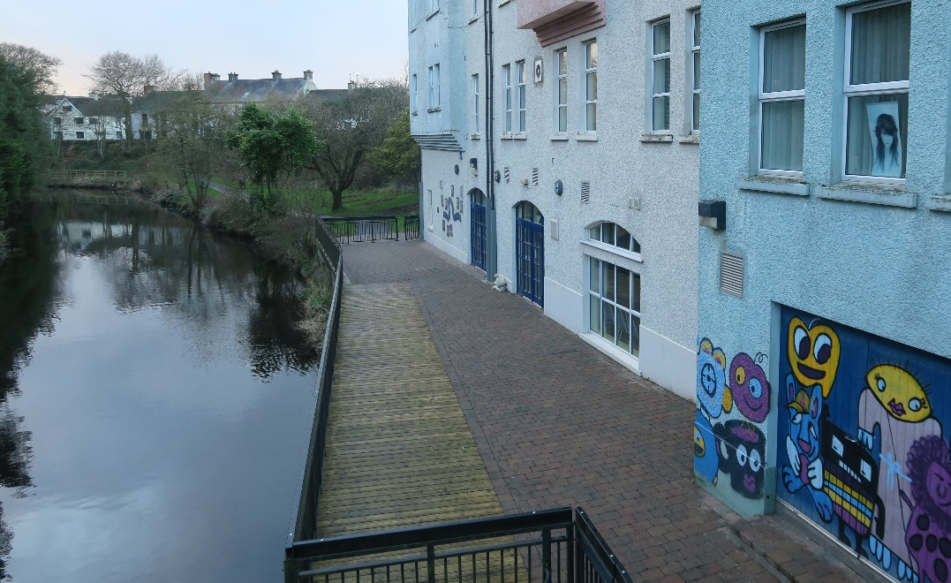

Building on the success of the Cross-Community Summer Scheme a Shared Youth Club (Junior and Senior) could be established and based at the Tilly Molloy Centre. A network of Community Volunteers could be identified to support the running and animation of the Youth Club. This could lead to the development of a Youth Led Project and encourage greater interaction and involvement of young people, the primary schools and sporting clubs.

A programme of community events and activities, including an annual Community Fair scheduled after the Armoy Race Week, and the introduction of a Farmers and Local Artisan Market in the village (perhaps 4 times a year) should be developed to build on and deepen community interaction, encourage enterprise and sharing within the village and wider hinterland.

There may also be opportunities to: promote existing activities and events to all in the village through the introduction of a Community Noticeboard; encourage and promote volunteering; and make better use of existing facilities for community use such as the local schools through extended hours; the Park Lodge Orange Hall; GAA facilities; and Church Halls. This would enable additional services and facilities to be delivered for the benefit of the wider community including a Men’s Shed and a Community Fridge.

Key Action | S | M | L | Lead Partners
Explore options to foster greater shared and integrated primary education provision to ensure the sustainability of school services in the village |  |  |  | ACA, Cross Community Play Group, Armoy Primary School, St Olcan’s Primary School
Capture the Lived Experience of Village Life and explore opportunities to develop Armoy as a good practice example of peacebuilding, good relations and shared services |  |  |  | ACA, Corrymeela Community, Community Relations Council, Causeway Coast and Glens Borough Council
Develop a programme of community events including a Community Fair and seasonal Farmers Market to promote and build on community interaction and sharing |  |  |  | ACA, local businesses and artisans
Establish a Network of Community Volunteers to run and animate the Youth Club; Men’s Shed; Community Fridge |  |  |  | ACA, local primary schools,  Community Volunteers
Assessment exercise to explore making better use of existing facilities within the village and immediate hinterland. Introduction of a Community Noticeboard to promote events and activities |  |  |  | ACA, all building and facility holders, Causeway Coast and Glens Borough Council

Links to ‘A Better Future Together’ Community Plan
- A Healthy Safe Community
- A Sustainable Accessible Environment
- A Thriving Economy
Potential Funding Opportunities or other Useful Links
- National Lottery Community Fund www.tnlcommunityfund.org.uk/northern-ireland#section-1 Awards for All £300- £10,000; People and Communities £10,000 – 500,000 Empowering Young People £10,000 – 500,000
- www.corrymeela.org
- International Fund for Ireland www.internationalfundforireland.com/
- Causeway Coast and Glens Borough Council Building a United Community Fund
https://www.causewaycoastandglens.gov.uk/grantsandfunding/building-a-united-community-fund
- Community Relations Council www.community-relations.org.uk/
- Volunteer Now www.volunteernow.co.uk/

Sports, Active Living, Health and Wellbeing

The importance of creating shared opportunities for sport and health and well-being activities were consistently emphasised throughout the village plan process. The Limepark facility could provide an important shared community asset. A Feasibility Study should be undertaken on the potential of redeveloping the Limepark Facility as a multi sports facility and community hub with a range of potential integrated services e.g. health and support services, sports, education and training.

A Walking Group could be established, and a trail map developed promoting existing walking routes and introducing new routes in and around the village e.g. linking the village to the Limepark Facility via an off-road trail along the Bush River. The introduction of a trim trail or green gym could also be explored along the River walkway and park offering ‘off-road’ exercise and walking spaces. This would promote healthy active choices and improve mental health and well-being. Linkages could be developed to the planned “Greenway of Thrones” a 30 km stretch of the old Ballycastle to Ballymoney Railway which originally opened in 1880 and is to be developed into a community greenway. The initiative has been allocated £25,000 from Department for Infrastructure and the Public Health Association for the production of detailed design proposals.

As a result of lobbying by the Armoy Community Association a ‘Healthy Places’ place-based approach to improving Health and Wellbeing programme is being piloted in Ballycastle and Hinterlands to include Armoy. This will be an important opportunity to tackle the high levels of multiple deprivation experienced in the area.

Key Action | S | M | L | Lead Partners
Feasibility Study for Redevelopment of Limepark as a Multi Sports Facility and Community Hub |  |  |  | Causeway Coast and Glens Borough Council; ACA; Local Sporting Clubs; Local Schools
Establish a Walking Group; Development of a Walking Trail Map and Trim Trail; Consider connectivity to Limepark and the proposed Community Greenway between Ballycastle and Ballymoney |  |  |  | ACA; Local Volunteers; Causeway Coast and Glens Borough Council; Causeway Coast and Glens Heritage Trust
Connect with the ‘Healthy Places Place-based approach to improving Health and Wellbeing Outcomes in NI’ demonstration programme which will be taken forward in Ballycastle and Hinterlands |  |  |  | ACA; Causeway Coast and Glens Borough Council; All Departments Official Group (ADOG); Making Life Better, PHA.

Links to ‘A Better Future Together’ Community Plan
- A Sustainable Active Environment
- A Healthy Safe Community
- A Thriving Economy
Potential Funding Opportunities or other Useful Links
- https://nigreenways.com/antrim/ballymoney-ballycastle-greenway-of-thrones/
- https://nigreenways.com/northern-ireland-government-greenway-strategy/
- National Lottery Community Fund www.tnlcommunityfund.org.uk/northern-ireland#section-1 Awards for All £300- £10,000; People and Communities £10,000 – 500,000
- Tesco Community Grants https://www.groundwork.org.uk/tesco-local-community-scheme-uk-programmes
- Healthy Places – Placebased approach to improving Health and Wellbeing Outcomes in NI Demonstration Programme- Ballycastle and Hinterlands

Celebrate the history of the area and build on the tourism assets

There are opportunities to celebrate and maximise the tourism potential of the village. A History Guide to Armoy has already been produced by the Causeway Coast and Glens Heritage Trust which details the rich history, people and architecture of the village e.g. the Armoy Armada, Uel Deane the Armoy Tenor, Tilly Molloy and St Patricks Church of Ireland. These and other tourism assets such as Tilly’s Ice-Cream, Armoy Races; Armoy as a Peace-building exemplar and the Dark Hedges should be promoted widely. Traditional signage, interpretative panels and even audio recording via QR codes enabling an oral history to be celebrated could be introduced to navigate visitors and locals around a tourism trail of points of interest. This could be designed to align with and complement the proposed walking routes.

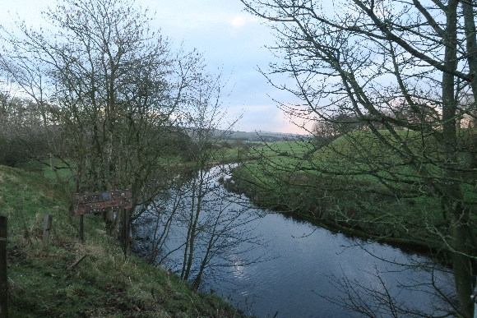 | 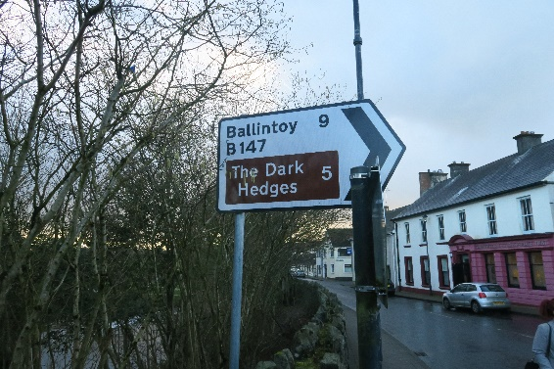

Key Action | S | M | L | Lead Partners
Develop a Tourism Trail with signage, interpretative panels and audio history. Local school children and community volunteers could be involved in developing the Story of the Village |  |  |  | ACA, Local Primary Schools, Causeway Coast and Glens Heritage Trust,  Causeway Coast and Glens

Links to ‘A Better Future Together’ Community Plan
- A Thriving Economy
- A Sustainable Accessible Environment
- A Healthy Safe Community
Potential Funding Opportunities or other Useful Links
- National Lottery Community Fund www.tnlcommunityfund.org.uk/northern-ireland#section-1 Awards for All £300- £10,000; People and Communities £10,000 – 500,000; Empowering Young People £10,000 – 500,000
- Tesco Community Grants https://www.groundwork.org.uk/tesco-local-community-scheme-uk-programmes

11. Next Steps – Working Together

Central to the successful implementation of the plan will be the continued commitment from the Armoy Community Association, key stakeholders within the village and volunteers to work together and lobby statutory and support partners to drive forward the implementation of this Plan. A Village Plan Working Group will be established with the support of the Causeway Coast and Glens Borough Council and North Antrim Community Network to bring key stakeholders and local representatives together to deliver the priority projects and actions as detailed in the Plan.

It is important to note that during the Plan period other actions or development opportunities may arise to improve and enhance Armoy. It is clear that Armoy Community Association, supported by the wider community, are committed to continuing to enhance and improve village life for all.

Appendix 1: Engagement Open Day Findings

What are the biggest Assets and Strengths of the village

The people

Community Spirit

The Armoy Community Association

The Play Group provides a strong foundation for community relationships

Mixed village, plus a large outlaying area of rural dwellers who use the village for school/ shops etc.

The Riverside Park

Armoy Races – Races began on 12 September 2007

The Armoy Road Races and all the events and activities during that week

Chemist

The Summer Scheme – cross community summer scheme

The two Primary Schools

The Park Orange Hall – has lots of events for people to come together, perfect hub for all events

Armada Bar – everyone is welcome

Rugby Pitch – 3 pitches but closed down

Two Parks

“The Road races and the race week when it gives a chance for people to come down and catch up with each other and for people to watch classic cars and bikes.”

What are the biggest challenges facing the village

Social Housing

No housing would be good to have a new development

No housing

Lack of Housing – Getting land zoned for housing through the Northern Area Plan. Schools and Clubs need a minimum number of people to survive – additional housing is the key to supporting this

Lack of sewage infrastructure is preventing housing – Triangle Housing have a planned scheme which they have not been able to build because of this issue

Sewage issue restricting housing

Smelly drains

Keep life in the village – Housing, Recreation and Sports.

Car parking facilities

Accessible Parking for wheelchair users – people park on footpaths obstructing wheel chair users

Really need a car-park so local people can use facilities

Better parking is needed at Armoy Primary School

Speed of traffic that goes through the village – very dangerous

Drop off and Pick up times at schools – traffic congestion and very unsafe. Need more Lollypop wardens.

Traffic very busy on Market Day – Monday evening

Lack of sports clubs

Sports teams e.g. football team/ rugby team declined over the years be good to get these going again

Lack of continued Youth Club for young boys / kids

Poor transport links and connections

Transport – bus to bring elderly people on shopping trips- but limited to 3 times a year and doesn’t always cater for all needs e.g. access/ ramp / capacity.

Have to go to Armoy to get the bus

Bus Shelter for young people going to Secondary School in Ballycastle

Environmental Improvements e.g. lighting, walkways, derelict sites, allotments, flower planting/maintenance

Better lighting near the Church of Ireland and St Olcan’s Catholic Church

Better lighting and a crossing on the Drones Road- would help if get Rugby pitches up and running as a sports facility again.

Seasonal / Christmas Lighting

LED lighting

More signage to direct people to the café e.g. tourists passing in bus

Gritting on Glenshesk Road

Bus Shelter for children going to Ballycastle

Shared space community garden or vegetable plots

Speed restrictions near Churches on Glenshesk Road and pathing to improve access to the area

Armoy Primary School – no safe crossing points for children

St Olcan’s Primary School need a Zebra crossing it is very dangerous- high speeds of drivers. Lollipop person a St Olcan’s but just in the morning time.

No footpath on leaving the village out to the hall -people have to walk on the grass

Volunteers could do some planting and litter pick etc.

Celebrating Village Life E.g. Volunteering, Good Relations

History of the area

Recruit volunteers for youth clubs, Mum and tots to help support groups

Volunteer and Network training (river walks, litter picks)

Village of the Year runner-up – fantastic, celebrate and build on this

Education / Lifelong Learning

Opportunities for more shared education

Shared or Integrated Education

Integrated education good thing going forward – bring the two existing primary schools together

Integrated school with modern facilities for Sports, Special Needs education. The school could become a community hub to complement the Tilly Molloy Centre

Integrated school and more mixed community events

Braille and Sign Language Classes

Photography Club and classes

Art Shop and Art Classes

Internet Connections for e-learning

Skills/ Upskilling Workshops and training events

Youth Facilities or Activities

Kids Camp / Kids Club

Get youth more involved in village events/activities to give them a sense of pride in the village

Discos for under 18s

Mums and tots re-established would be good

Youth Club for young ones

Youth Club in Tilly Molloy Centre – regular during term time

Long standing youth club would be beneficial rather than one-offs

Summer scheme is fantastic, but a weekly or monthly youth club would be great

Summer scheme is highly successful should build on this

Bird watching

“I thought the summer scheme was very good”

Baking classes

Sports and Active Living

Football Pitch

4G Pitch

Park Run

A walkway / path to go walking

Outdoor Gym

Football and rugby activities- Ballymoney is the closest

Use the space at the Rugby Club for outdoor bowling

Rugby team

Drainage at the Rugby pitches was never completed – could be used as a football pitch

Astro turf for hockey / tennis

Leisure centre

Keep fit classes

Mini golf

Hurling and camogie team

Need football facilities for young people and mixed sport

Fishing school / lessons

Out-door gym at park

Walking path around race track

Safer walking routes

Swimming Pool

Roller Coaster Park

Recreation and community facilities

Room Hire

Irish Dancing

Netball / Volleyball

Older People Facilities or Activities

Community Transport – Information and availability – going to hospital etc.

Baking classes

Knitting Club

Luncheon Club

Bingo Club

Over 55 Club meet every Wednesday 1-3 pm at Tilly Molloy’s – helps reduce isolation

Meetings on a Wednesday or Friday for solutions to help and improve the village

Health and Well-being

Community allotments

Out-door gym

Green gym

Better park and recreational area

Walking Group

Walkway – off-road walking

Greenway

Cycle path on disused railway track

Tourism / Heritage / Culture

Round Tower, Church History – Early Irish

Signage in Park with information on area, wildlife and history

Better signage about the village history

Armoy Armada - AMRRC – should grow opportunities for mini museum

Tilly’s Ice-cream

Ulster Scots links

Events – the motorbike racing but perhaps road cycling to draw people in and get local people involved

Armoy has Dark Hedges and Armoy Armada connections – have a centre in the village which celebrates this.

Community Facilities

Community Notice Board to advertise events

Weekly Market – local artisan produce / farmers market e.g. Jam on the door

Footpath between the GAA pitch and the church

Funding for a Community bus to take children away on outings - older people could use it too

Presbyterian Church Hall – indoor bowling, Girls Brigade. Armoy Primary use it as a facility. Building relationships local GAA centre to use space

More facilities at the main Play Park – it badly needs an upgrade

Rugby Club site redeveloped to multisport facility- football /rugby

A multipurpose sports centre

Other comments or ideas to improve the Village

Vegetable and Fruit Store

Sweet Shop

Supermarket

Community Fridge

Biodiversity Park

Tourist / Visitor Information Centre

Security cameras to prevent graffiti

Men’s Shed

A better park

A wheelchair swing in the big park near Armoy Primary School

Annual Community Event or Street Fair
- ATM

St Olcan’s Art and Poetry Competition – Key Issues

A ball wall at Hurling pitch

A community fridge

A mini Ireland’s Fittest Family

Bingo

Bins

Birdhouses could be hung on trees to encourage birds to come to Armoy

Bridge across the river and path on the other side of the river

Charity Shop

Chinese Take Away

Cinema

Clean up River

Community Garden

Doctor’s Surgery

Dog Park

Flowerbed at the shop

Flowers planted along the river

Golf Club

Graffiti wall

Gym

Health Shop

Hotel

Kids Club

Litter pick

More shops

Mountain bike trails

New Bus Stop

Pizza shop in village

Plants and trees

Ramps

Saturday Morning Kids’ club

Seesaw in Park

Skate park

St Patrick’s Day Parade

Stop littering

Stop vandalism

Sweet Shop

Treasure/egg hunts

Turn Rugby Club into running area

Tyre Swing

Walking Trails

Youth Clubs

Zipline

Armoy Primary School Art and Poetry Competition – Key Issues

Sweet Shop

Art Supplies and classes / club

A bigger kitchen for summer scheme

A dance class

Remove graffiti

Armoy museum and tourist point

Disability school

Funfair

Cut the grass and plant flowers at the play ground

Demolish St Olcan’s make one big school at Armoy Primary School and turn St Olcan’s into McDonalds

Fun day

Football club

A new Park

Stop throwing Litter

Plant flowers

Parades and celebrations for everyone to enjoy

VR Room / Gaming room

More litter picks

Clubs for people with disabilities

New bottom Park

Improved top Park

Starbucks

Armoy Hospital

A new hall for everyone – child friendly

Bring back the rugby club

Football Pitch

Youth Club

Clean the River

Sewing and Knitting Club for everyone

Keep Armoy Clean

Library and Book Shop

Tourism Centre – Markets, crafts, visitors, enterprise

Shops

Cheer everyone up bring more animals to Armoy

Armoy Train Station

Ice-cream Shop

Old Folks Home

Clean and improve the toilets

Playing field for summer scheme

Don’t throw rubbish in the River

Over 55s Group Meeting - Findings

What are the main assets of Armoy?
- A very friendly community and with some direction and leadership could do more
- River Walks
- Parks
- Over 50s Club
- People are very helpful and friendly
- Delightful village

What are the main challenges in the Village?
- Parking
- Better Street Lighting
- Lack of attention given to tenants – social housing e.g. ancient kitchens and poor heating
- Lighting in parks
- When people come into the town nowhere to park

Health and Wellbeing
- More appointments needed at the GPs surgeries
- Transport is a problem
- Waiting times to see consultants
- 55 Club is excellent and helps a lot of the older people

Sports and Active Living
- A sports complex for all types of sports

Environmental Improvements
- Car Parking
- Lighting
- Footpath between Chapel and Hurling Field
- Cars speeding through village
- Delivery drivers
- Footpath up the Glen – lighting poor which makes walking dangerous

Community Facilities
- Increase use of Rugby Grounds (Council owned)
- Development of gym
- Nearest pool is Ballymoney
- Bit warmer in the Winter

Youth Facilities/ Activities
- More activities and facilities for young people
- Sports like football
- More coming together of the community

Older People’s Facilities/Activities
- Exercise classes at the Over 50s Club
- Music and dance at over 50s Club

Celebrating Village life e.g. Volunteering, Good Relations
- Motor Bike Week – all motor centric
- Car boot last year
- Lost social aspect of club
- Quiet place for a drink / dance

Other Comments or Ideas
- More events throughout the year to bring people to town

Appendix 2: Online Survey Findings

Question 1 – What do you like about living or working in Armoy?

Small village so get to know everyone well. Good relationships with people in the community"

Supportive and close community

Beautiful. Calm. Outstanding area of natural beauty and history.

Friendly. Good relations.

Community spirit - improvement in services available over the years "

Friendly community feel

The people

The community aspect of friendly welcoming people

Quiet Village

Community Feel

I love Armoy as a small village but hate seeing it turning into a red white and blue colour fest.

Question 2 – What services or facilities are needed or could be improved in Armoy?

Improved sewage system. Gritting of road outside St Olcan's as it can be extremely treacherous on icy days. Traffic calming measures on main road for children crossing from school into village. Designated area that can be used by all members of the community for children to go to ride bikes, play football etc. More affordable housing in the village. More organised activities for teenagers. Increased community use of school facilities.

Youth Club. Sports facilities. Coaching support. Support for working families e.g. child care. Support for families on benefit - back to work programmes. Church networks.

Car parking. Street lights especially on mill lane beside the children's park, accident waiting to happen ...

More parking. Updated sewage facilities. More houses. Fold/sheltered accommodation for elderly couples and single people thus leaving houses available for young families. Young families keep a community vibrant. All communities need a mix of young and elderly.

Car parking in village for those using community centre. Rugby club started up again. More community activities and use of all the community venues in area. Year-round programme of activities/events for all ages.

Parking facilities, mums and tots’ group, more activities for the younger kids

Children's activities

All the services are in need of a major upgrade. There needs to be a shared space venue for sport and community functions

Local sports area, shop front renovation, housing and green area

Nursery

Think for a small village it has a lot of facilities"

Question 3 – What new activities or events would you be interested in attending?

Greater school involvement in community events e.g. at switch on of Christmas lights. Any community events that would be of interest to children in the schools."

Medium and long -term planning of village facilities. Making the education provision available in the village more effective and improving outcomes for all pupils.

Community litter picking etc

The training room at Tilly’s should be made available to The Recovery College for talks and courses. These talks are very popular elsewhere as you have to pre-book for a place. A men’s shed would be a benefit for exchanging skills and socialising even for a few singing sessions and exchanging about days of yore. Look at the reaction and feedback to old photographs on the Community Association Facebook site.

Physical activity classes. More activities for younger children.

Mums and tots. Youth club for primary age. Youth club for secondary age.

Fitness classes, cooking demonstrates, flower arranging, sewing classes

Village Festival post the Armoy Road Races to celebrate the success of the year

Sports, football or rugby related.

Cross community activities for kids

For the teenagers

Question 4 – Have you any other comments or ideas about how the village could be improved?

There is already a history of shared education between the 2 schools and we need to build on this and increase community participation.

Immediate need for a 4g sports facility centrally placed in the village to meet immediate needs. Group to address long and medium-term planning for housing, employment, medical and education needs.

Street lights on mill lane beside the children's play park. Also play park could do with some TLC.

Could residents in different areas in the village be encouraged to tidy up and look after communal flower/shrub beds in their area.

Tidy up of play park

No

No

The infrastructure, and accessibility of the village needs to be sorted. There needs to be leisure and sporting facilities that are open access for everyone. The transport links need to meet the needs of the community. The rural regeneration of Armoy is needed now not in 5- or 10-years’ time.

Pull down derelict buildings, more shop fronts instead of housing on main street, revamp the river park, tidy appearance of Station Road to Dean Park

Parking

More inclusive

