Causeway Coast and Glens Borough Council

## Citizen's Newsletter

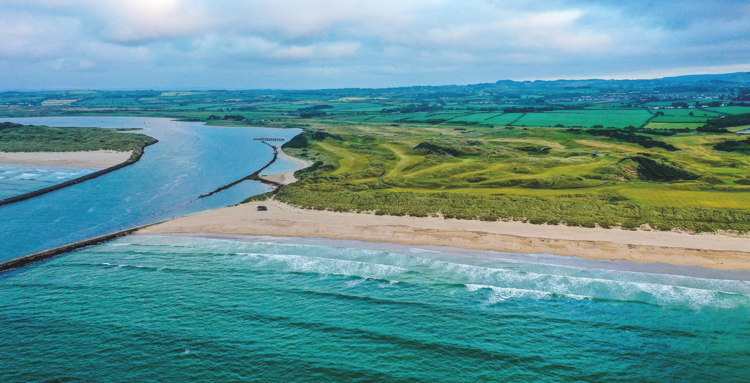

The Barmouth at Castlerock. Image courtesy of Tourism Northern Ireland

# Inside this issue

## Where to turn

Support services guide

Pages 9-18



# Contact us

Sheskburn House, Ballycastle: 028 2076 2225

Riada House, Ballymoney: 028 2766 0200

Cloonavin, Coleraine: 028 7034 7034

Connell Street, Limavady: 028 7772 2226

Planning (located in Cloonavin): 028 7034 7100

# Useful Numbers

Housing Executive Main number

(including grass cutting and graffiti): 03448 920 900

Repairs line: 03448 920 901

Housing benefit: 03448 920 902

Land Registry: 0300 200 7803

Rates (Property Rating and Valuation): 0300 200 7801

DfI Roads Northern Division: 0300 200 7891

Flooding incident line: 0300 2000 100

Flooding emergency: 999

Street lighting faults (emergency): 0300 200 7899

Telephone / Utility Boxes (BT fault): 0800 023 2023

Burst water mains and blocked sewers: 03457 440088 (24 hours)

Water pollution hotline: 0800 80 70 60

## If an emergency affects your supply of electricity, gas or water, use the contact details below:

Northern Ireland Electricity: 0345 7643 643

Northern Ireland Water: 0345 7440 088

Phoenix Natural Gas: 0800 002 001

Firmus Energy: 0800 002 001

# Get in touch

**The Citizens’ Newsletter can be obtained in alternative formats including large print, braille and on audio cassette.**

Please email all requests and feedback to [Email Causeway Coast and Glens Citizen Newsletter](mailto:citizensnewsletter@causewaycoastandglens.gov.uk)

# The Mayor of Causeway Coast and Glens Borough Council, Councillor Ivor Wallace.

The Mayor of Causeway Coast and Glens Borough Council, Councillor Ivor Wallace.

# A message from the Mayor

I am now over halfway through my term, and from the outset I said that one of my priorities would be to celebrate the many organisations in our Borough who are committed to helping those in need.

Their presence has always been important, but the ongoing cost of living crisis has served to emphasise this.

I have met with the Salvation Army, local foodbanks, St Vincent de Paul, Christians Against Poverty, the Samaritans and Causeway Citizens’ Advice, and our Borough is a better place for the services they provide.

As a Council we recognise the difficulties our householders are facing, and I want to remind those who find themselves in need to please ask for help.

Our ‘Where to Turn’ campaign aims to bring wraparound organisations together to make it easier for people to access the support they require. You’ll find information about this in the newsletter, including a guide with lots of useful telephone numbers. Whoever you turn to, you’ll get a non-judgemental welcome along with practical assistance and advice, which will make a big difference to you.

As a Council, improving the quality of life enjoyed by our residents and visitors remains our key commitment and our newsletter aims to give you a flavour of our work, initiatives and achievements across the Borough.

I want to take this opportunity to thank all of those in our local communities who share this aim with us.

Being the Mayor of this outstanding area is a huge source of pride for me, and I will continue to do all I can to champion and advocate on your behalf.

***The Mayor of Causeway Coast and Glens Borough Council,***

***Councillor Ivor Wallace***

***Councillor Ivor Wallace's signature***

Council’s Energy Efficiency Service is here to help  
   
Are you or someone you know affected by the cost-of-living crisis?  
   
Council’s Energy Efficiency Service, funded in partnership with the Public Health Agency, is here to help everyone in the Borough.

Fuel poverty has been an issue for a significant number of people for many years, but now the cost of heating our homes or cooking warm, healthy meals is a concern for more of us than ever before.

A household is said to be in fuel poverty if it needs to spend more than 10% of its income on energy costs. While Department for Communities estimates that this affects 160,000 households across Northern Ireland, the figure is now even higher.  
   
The Energy Efficiency Service aims to combat this type of poverty which can have major implications on our overall wellbeing.  
   
Alongside tips for energy saving, grants are available for people who own their own home or for those renting privately (depending on personal circumstances) to address energy issues.  
   
Some are funded by the Department of Communities, as part of its Fuel Poverty Prevention Strategy, while others come from the Utility Regulator under its Energy Efficient Carbon Reduction Strategy.   
    
A new oil condensing boiler could save a household an average of £500-£600 per year while proper insulation could save on average £200 per year.  
   
You may be eligible for a grant if any of the following applies to your home:

* Home Owner
* Private renting
* Heating Boiler over 15 years old
* Boiler is broken beyond repair
* Solid Fuel heating only
* Liquid Petroleum Gas heating only
* Electric Heating only (For example Economy 7)
* Single Glazed, poorly fitting, or rotten windows
* Less that 270mm (approximately 11 inches) depth of insulation in your attic
* No cavity wall insulation

Grants can also be used to change from oil to gas when available subject to applicants meeting the relevant criteria.  
   
**Contact Council’s Energy Efficiency Officers if you would like to find out more.**

**Pat McGettigan** 07759536625

[Email Patrick McGettigan](mailto:patrick.mcgettigan@causewaycoastandglens.gov.uk)

**Rachael Wauchope** 07841970330

[Email Rachael Wauchope](mailto:rachael.wauchope@causewaycoastandglens.gov.uk)

# Make sure you know ‘Where To Turn’

We want to ensure you know **‘Where To Turn’** if you are experiencing financial difficulties.

As part of our Where To Turn campaign, Council is working closely with a network of advice centres, foodbanks and other organisations which exist across Causeway Coast and Glens to ensure that people can receive wraparound support based on their individual needs.

W have collated a directory of useful telephone numbers for advice centres, foodbanks, charities, and social supermarkets.

We recognise that it can feel overwhelming and isolating, especially for those who find themselves in this situation for the first time. We want to ensure those who need assistance are aware of the organisations that can help.

If you have a friend, family member or neighbour who is in need, please tell them about Where To Turn and together we can ensure that no-one is left to struggle alone.

Advert for advice from Council. Copy from advert says "Are you or someone you know struggling with the cost of basic living expenses?
Reduced income? In crisis? Need help?"

Where to turn

## A quick guide to support services in Causeway Coast and GlensAdvice IconAdvice Centres

Council-supported Advice Services provide free, independent and confidential advice and support on a range of concerns.

## Community Advice Causeway

Community Advice Causeway provide free, independent advice to all areas of Causeway Coast and Glens about:

* Benefits and appeals
* Money and debt
* Employment
* Housing
* Consumer issues
* Education
* Family issues

You can send your contact details at any time to [Email Advice Causeway](mailto:advice@advicecauseway.com) to receive a call back or advice via email.

Or you can call their telephone helpline 028 7034 4817 to get advice or arrange an appointment.

**Opening Times:**

Monday, Tuesday, Wednesday, Friday: 09:30-13:00 and 14:00-16:00

Thursday: 09:30-13:00 and 14:00-19:00

Face to face appointments can be arranged in Ballycastle, Ballymoney, Coleraine and Limavady. Evening and weekend appointments are available.

## Glenshane House

Glenshane Community Development provide a free, independent advice service for the Dungiven area at Glenshane House.

Ring 028 7774 2494. Appointments are available from 09:00 to 17:00 Monday to Friday.

# Foodbank IconFoodbanks

Foodbanks work with frontline care professionals such as health visitors, district nurses, social workers and advice centres, churches and local charities. These organisations can provide you with a voucher which can be exchanged at your local foodbank where you may receive other emergency essentials like toiletries and hygiene products, nappies, and other baby items, if these are required and in stock. You will also be signposted to wraparound services to help you move to a position of financial stability.

## Ballycastle Foodbank

Telephone Number: 07536986448 / 028 20054006

Email: ballycastlefoodbank@gmail.com

Address: Unit 6, Causeway Enterprise Centre, Leyland Road, Ballycastle BT54 6EZ

**Opening hours**

Wednesdays: 14.00-15.30 and 16.30-18.00.

Appointments are also available outside of these times.

Outreach access is available through Armoy Community Larder at the Tilly Molloy Centre and Glens Youth Centre in Cushendall.

## Ballymoney Foodbank

Telephone number 07565840571

Email info@ballymoney.foodbank.org.uk

Address Unit 10 41 Ballymena Road Ballymoney BT53 7EX

**Opening hours**

Tuesday: 10:00-12:30

Friday: 14:00 – 16:30

## Causeway Foodbank (Coleraine)

Telephone number 028 70 220 005

Email [Email Causeway Foodbank (Coleraine)](mailto:info@vineyardcompassion.co.uk)

**Addresses and opening hours:**

**The Hope Centre**, 10 Hillmans Way, Coleraine, BT52 2ED

Tuesday, Wednesday & Friday: 11:30 - 13:00

Thursday: 19:00 - 20:00

**Terrace Row Presbyterian Church**,

Terrace Row, Coleraine BT52 1HF

Friday: 17:00-18:00

**Coleraine Elim Church**, 13 Pates Lane, Coleraine (Coleraine Elim & Hazelbank Presbyterian Church partnership)

Thursday: 11:00-12:00

**Portstewart Baptist Church**,

172-174 Coleraine Rd, Portstewart BT55 7PL

Thursday: 11:00-12:00

**Mobile Open Door**

Portrush - Bath Street (parking spaces overlooking the sea)

Tuesday: 14:00-15:00

Garvagh- Bridge Street Car Park (behind D&G Fashions)

Wednesday: 11:00-12:00

Bushmills - Dundarave Car Park

Thursday: 11:00-12:00

## Roe Valley Foodbank

Telephone number: 028 777 65438

Email: [Email Roe Valley Foodbank](mailto:manager@lcdi.co.uk)

Address: LCDI, 'Old Roe Valley Hospital' 24 Benevenagh Drive, Limavady BT49 0AQ

**Opening hours**

Monday – Friday: 10:00 to 14:00

## Local community food support

Some local community organisations provide food support for people living in the area or for their service users. They are reliant on donations and are happy to also receive items during their drop-in times.

Further contact details and drop-in times are listed on our website.

[Website link to Causeway Coast and Glens Community Fridges](http://www.causewaycoastandglens.gov.uk/live/advice-services/community-food-cupboards-community-fridges)

# Charities IconCharities

## St Vincent DePaul

SVP can offer a wide range of support, from practical help and advice, to a friendly ear, all in the strictest of confidence and based on the need of the individual or family. They may be able to offer some practical or financial assistance towards day- to-day essentials, or they may offer information about other relevant services.

**There are local conferences in:**

Ballymoney, Ballycastle, Portrush, Castlerock, Cushendall, Glenariffe, Portstewart, Coleraine, Kilrea, Errigal, Limavady, Dungiven & Feeney.

You can contact the Regional Office and they will put you in touch with the local conference in your area.

Telephone: 028 90351561

Email: [Email St Vincent DePaul](mailto:info@svpni.co.uk)

You can also request assistance online by filling out the online form at the following link [St Vincent DePaul Request Help Online Website Link](http://www.svp.ie/get-help/request-help-online.aspx)

## Salvation Army

The Salvation Army offers friendship, practical help and support through its church and community centre (and may be able to offer emergency help with fuel).

Address: Meetinghouse Street, Ballymoney BT53 6JN

Phone: 028 2766 5520

Email: [Email Ballymoney Salvation Army](mailto:ballymoney@salvationarmy.org.uk)

## Christians Against Poverty

Debt help is available at Vineyard Compassion and St Patrick’s Church of Ireland, Ballymoney

Phone: 0800 328 0006

Website: [Christians Against Poverty Website](http://www.capuk.org/)

# Social Supermarkets

Social Supermarkets provide members with the opportunity to shop at a reduced cost for a period of months alongside engaging in a range of other wraparound supports.

**RESET Social Supermarket**

Located at Vineyard Compassion

Phone: 02870220005

Email: reset@vineyardcompassion.co.uk

Facebook: Vineyard Compassion

Website: [RESET Social Supermarket Website](http://www.vineyardcompassion.co.uk/reset)

**Opening Times:**

Tuesday, Wednesday & Friday: 11:30am - 1:00pm

Thursday: 7pm - 8pm

**LCDI Social Supermarket**

Located at Roe Valley Community Foodbank in LCDI

Phone: 028 7776 5438

Email: manager@lcdi.co.uk

Website: [Roe Valley Community Foodbank Website](http://www.roevalleyfoodbank.com/)

## NI Direct Cost of Living Information

Information and advice about support with the cost of living is available at [NI Direct Cost of Living Website](https://www.nidirect.gov.uk/campaigns/cost-living)

* Help with energy costs
* Help with your income
* Help for families and children
* Help for older people
* Help with housing
* Help with other costs

## Resources and practical support for families

The Children & Young Peoples Strategic Partnership has produced a Cost of Living Crisis resource which provides details of targeted resources and support for families & children struggling with the current cost of living crisis.  This document is live and is updated regularly. The guide can be accessed by going to [The Children & Young Peoples Strategic Partnership Cost of Living Guide](http://cypsp.hscni.net/cost-of-living-resource)

## Make the Call Service

Make the Call is a government provided service that makes sure you're getting all the benefits, services and supports you're entitled to.

Freephone (network charges may apply): 0800 232 1271

Email: [Email Make the Call Service](mailto:makethecall@dfcni.gov.uk)

# Useful telephone numbers

Community Advice Causeway 028 7034 4817

Glenshane House 028 7774 2494

Ballycastle Foodbank 07536986448

Ballymoney Foodbank 07565840571

Causeway Foodbank 028 7022 0005

Roe Valley Foodbank 028 7776 5438

RESET Social Supermarket 028 7022 0005

Ballymoney Salvation Army 028 2766 5520

St Vincent DePaul 028 9035 1561

Make the Call Service 0800 232 1271

Community Navigator for Older People 028 276 65068/ 075 93130700

BCRC Ethnic Minority Support 07716 401059/ 07922 020044

Christians Against Poverty 0800 328 0006

Samaritans 116 123

Lifeline 0808 808 8000

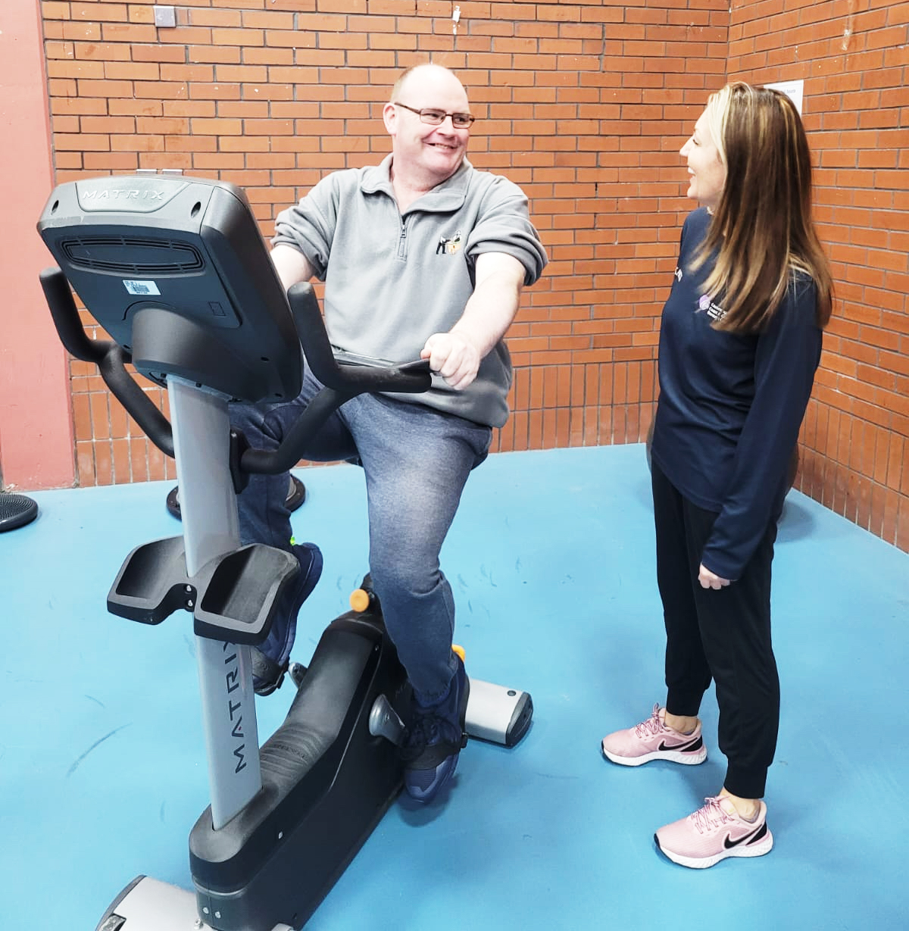Paddy McNally pictured with his mentor and PARS Exercise Professional Karen Deery.

# How PARS helped me

## Thanks to Portrush resident Paddy McNally for sharing his experience of the Physical Activity Referral Scheme

When I started PARS, I had no level of fitness and everything was a chore.

My local shop is 800m away. It was too much bother to walk. I always drove.

The first day I walked into the programme I was petrified.

Karen, my mentor and Exercise Professional, met with me early to prepare me.

Karen introduced me to the 11 others in the group. I thought I wouldn’t be able to do it for two reasons - crippling anxiety and because I thought I was too unfit.

Karen understood the enormity of my challenge. Before the session was over, we were exchanging phone numbers to meet up and exercise together. We quickly realised we were all in the same boat with a different paddle.

The programme manages your expectations. Goals can be achieved, we were guided to understand that there is a process.

I loved that there were a lot of people older than me there, I could sense their apprehension. I saw these clients go from shy and introverted to, comfortable, confident and interactive. That was really nice and extremely motivational.

One or two of the group approached me for help. Being able to support them built my confidence so much and improved my self-esteem. I was able to motivate and support my colleagues on their journey and not only did it support and develop my physical health, it did wonders for my mental health.

When I started, the last thing I wanted was to be in a group of strangers. With hindsight, Karen knew the group would work. Now that it is over, I miss it so very much.

PARS is an amazing programme.

We all had the same needs, to get healthy, fit and mentally stronger. We all arrived for different reasons and every single one of us achieved so much - improved self-confidence, improved body image, physical strength, and mental wellness.

Everyone had their own personal needs and with professional help and kindness we found our own way.

I really enjoyed sharing the experience and our achievements. There was no pressure. You worked to your own ability.

Physically I am not ashamed of myself anymore. I don’t mind looking in the mirror. I would never, ever have gone for a swim. Now I take my kids to the pool and swim with them.

Not having access to the programme has made me want it more.

It is easy to get stuck in a rut. PARS brought me out of that rut and showed me there is a big world out there.

A few weeks in, a couple of my colleagues mentioned my Autism NI lanyard. They asked me what Autism meant and how it made me feel. I was open with them. At the end of that session, they thanked me for sharing. They had a better understanding of me, and they had a better understanding of Autism.

Going to the gym gave me freedom and I left every session buzzing.

I hope this encourages others to be open about their world.

Now I enjoy walking to the shop and my kids walk with me.

Exercise is part of my daily life and I continue to exercise independently.

I have gym equipment in the house and my wife has taken part in the programme as well.

The more we share, the more we understand.

# Do you know about the Council’s Physical Activity Referral Scheme?

**Do you know about Council’s Physical Activity Referral Scheme?**

The Physical Activity Referral Scheme (PARS) is delivered with our partner the Public Health Agency.

It provides ***eligible*** clients with a 12-week activity programme under the guidance of a qualified exercise professional.

The scheme enables GPs and other registered health professionals to make referrals directly to Council’s Leisure Centres.

**It is aimed at clients with a BMI of between 25 – 40 - this is essential entry criteria and referral is by Health Care Professional only.**

**Eligibility criteria**

* be aged 19 years or over
* be inactive*
* be motivated to change
* have a BMI ≥ 25kg and < 40kg

With one or more of the following conditions:

* Hypertension / raised blood pressure
* Hyperlipidaemia / raised cholesterol
* Impaired glucose levels or diabetes
* Family history of heart disease (no previous heart attack/damage)
* Asthma, bronchitis or COPD
* Musculoskeletal conditions / conditions affecting the bones, joints and muscles can be a common cause of long-term pain
* Mild or moderate mental health conditions

*\* Not currently meeting the guidelines of 150 minutes of moderate intensity activity a week or 75 minutes of vigorous intensity activity weekly*

# Causeway Actively Aging

## Weekly older adult racquet sports and keep fit sessions

## 2023 Timetable - Starts 9th January

## Tuesdays

**Roe Valley Leisure Centre**

Racquet sports: 9.30am to 10.30am

Keep fit: 10.30am to 11.30am

## Thursdays

**Joey Dunlop Leisure Centre**

Racquet sports: 9am to 10am

Keep fit: 10am to 11am

**Coleraine Leisure Centre**

Racquet sports: 10am to 11.30am

Keep fit: 11.30am to 12.30pm

## Fridays

**Dungiven Sports Centre**

Racquet sports: 11am to 12pm

Keep fit: 12pm to 1pm

**£2.50 per session includes both activities**

*No need to register pay as you go sessions*

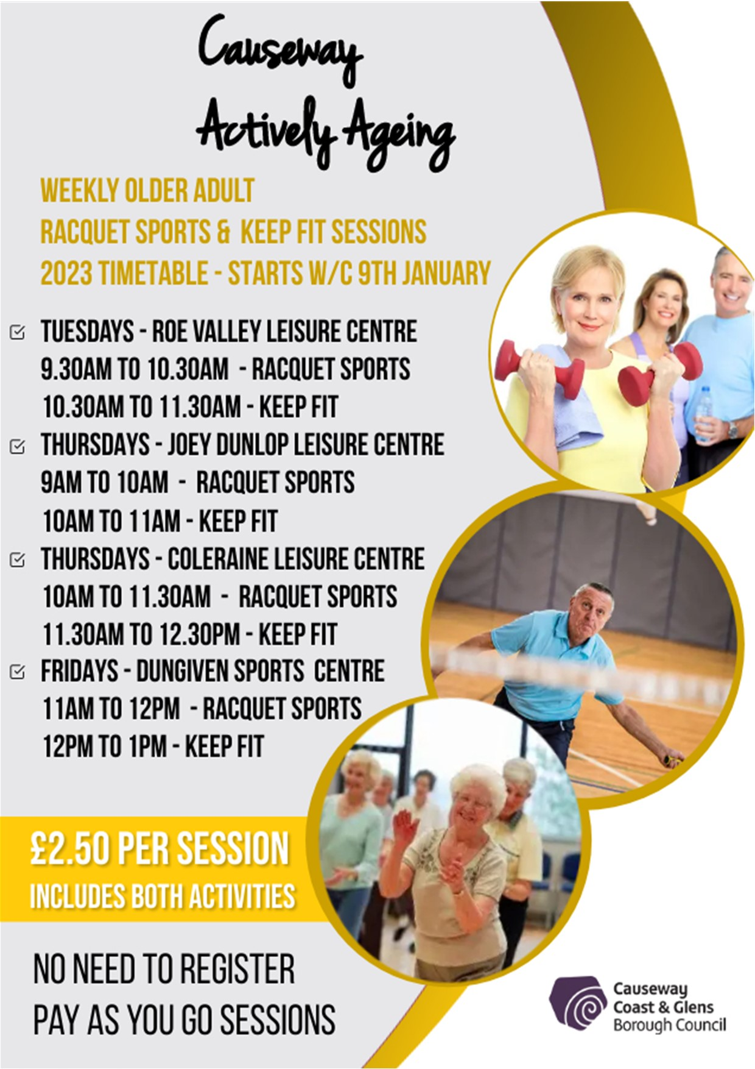

# Food Smart Logo

# Community Fridges

## Not just feeding people

Our Borough is home to five community fridges in Ballycastle, Bushmills, Cloughmills, Dungiven and Magilligan.

Community Fridges are fantastic examples of mutual aid with local people voluntarily helping each other by sharing resources.

The concept is simple - the fridges redistribute food which might otherwise end up in landfill.

The network is managed by a committed group of volunteers seeking to make a difference to people and planet.

The five fridges divert approximately three tonnes of food from landfill each month. This is the equivalent of three family cars!

They also prevent approximately 1.5 tonnes of gases such as carbon dioxide and methane from entering the atmosphere every month as well.

Community fridges often accept surplus food from gardens or farms – please check with your local fridge in advance.

In many instances they have evolved into community hubs to include:

* information points
* uniform and clothing exchanges
* cookery lessons
* loan of equipment
* recipe exchanges

**For more information contact** **the Environmental Resource team** at [Email Causeway Coast and Glen's Environmental Resource team](mailto:recycle@causewaycoastandglens.gov.uk) or 028 2766 0248.

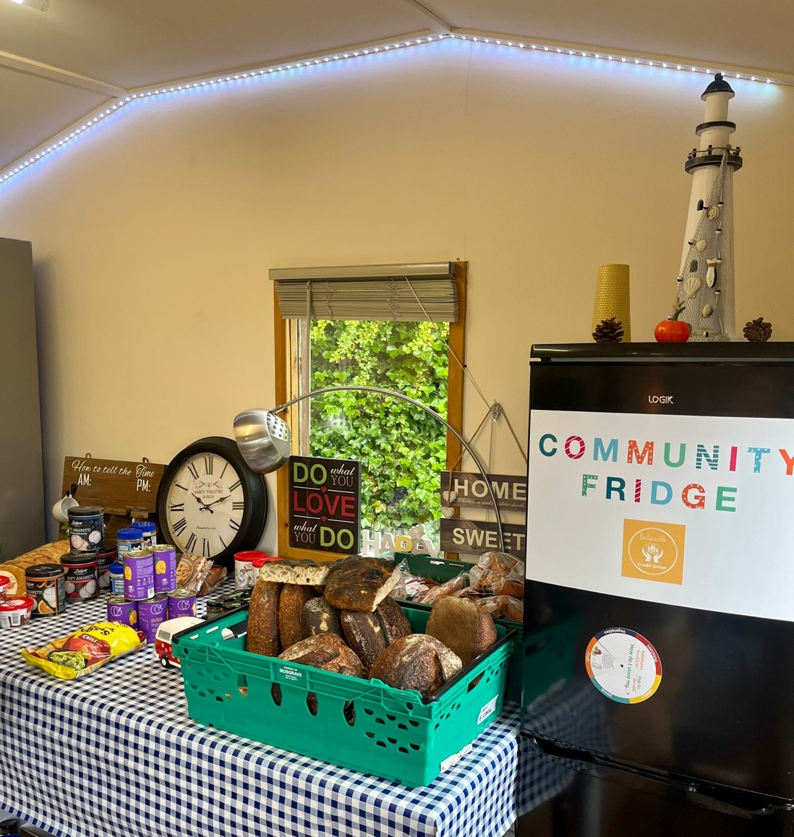

A selection of foods from the Community Fridges project

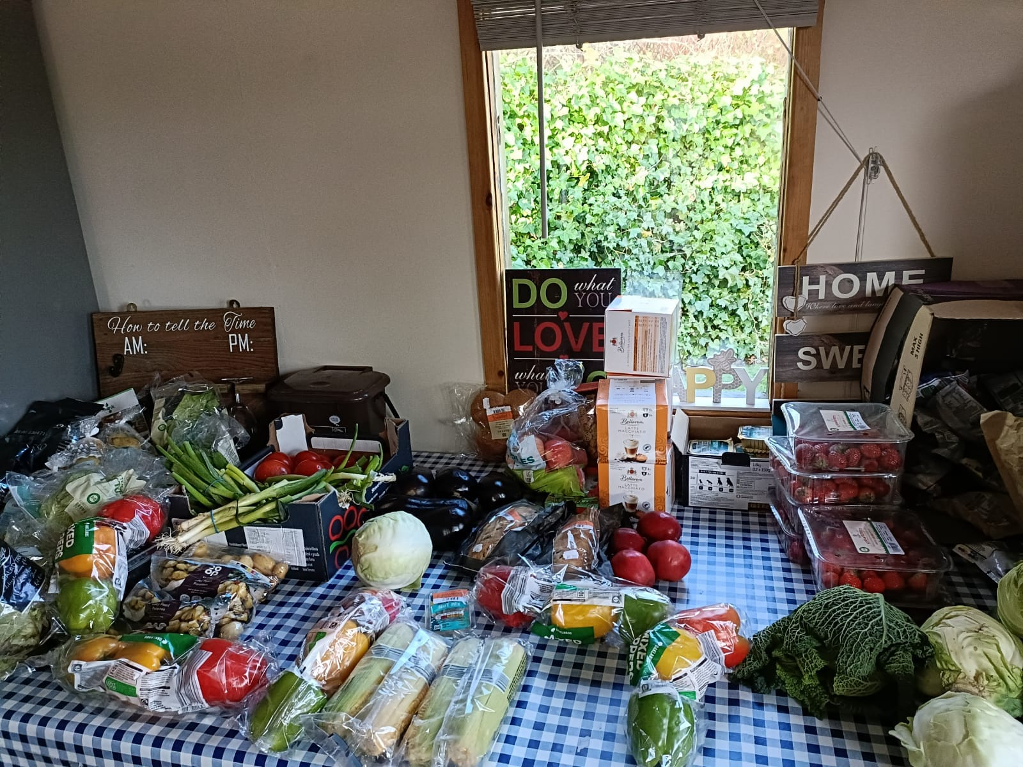

A selection of foods from the Community Fridges project

# Household Recycling Centres

## What to do when visiting

To make your trip to the Household Recycling Centre (HRC) as quick and easy as possible please follow the simple steps below:

* **Sort** recyclable and non-recyclable materials at home. Disposal of recyclable items in waste skips is no longer permitted.
* **Organise** your recyclables and waste in your vehicle so that when you visit the HRC you can place items in the correct containers. This will make your visit much quicker.
* **Re-use** items when and where you can - look out for relevant containers. Your local charity shop may also want your reusable items.
* **Talk** to our staff – if you are unsure about what can and cannot be recycled, please ask, our staff will provide advice on which container to use.

A wide range of materials can be recycled at your local HRC:

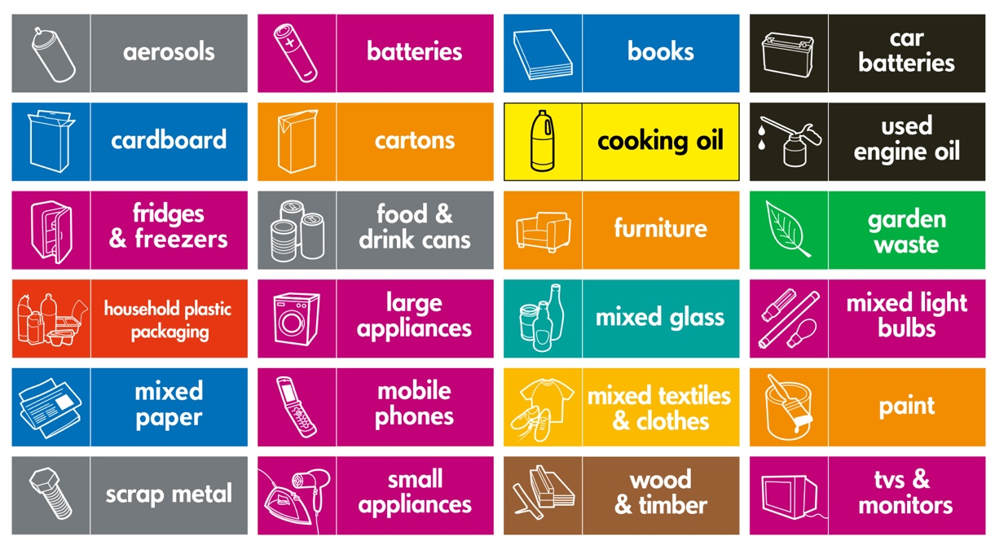

**Note:** Gas bottles can be recycled at Ballymoney and Carneatly. Rubble can only be recycled at Coleraine, Crosstagherty (Ballymoney), Dungiven, Kilrea and Limavady household recycling centres. Hard plastics can be recycled at Limavady only. Soil can be recycled at Crosstagherty only.



# Your household recycling centres

There are 11 Household Recycling Centres at locations across Causeway Coast and Glens Borough Council area.

More information on your nearest site can be found at [**Causeway Coast and Glens Recycle Website**](http://www.causewaycoastandglens.gov.uk/recycle)

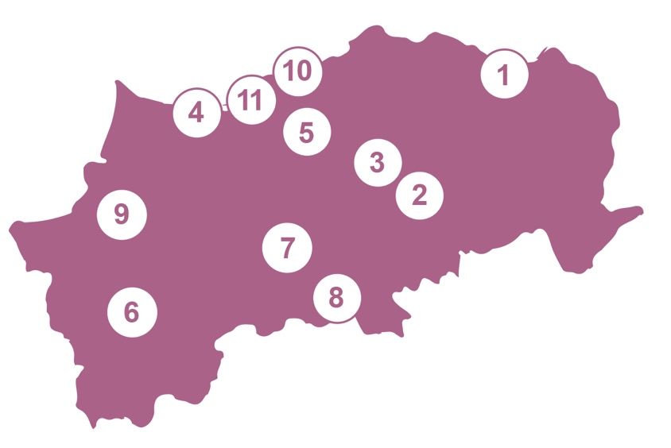

**1:** Moyarget Road, Ballycastle

BT54 6HL

**2:** Burnquarter Road,

Ballymoney T53 7EN

**3:** Knock Road, Ballymoney

BT53 6LX

**4:** Freehall Road, Castlerock

BT51 4TR

**5:** Gateside Road, Coleraine

BT52 2NR

**6:** Chapel Road, Dungiven

BT47 4RS

**7:** Limavady Road, Garvagh

BT51 5ED

**8:** Lisnagrot Road, Kilrea

BT51 5SF

**9:** Ballyquin Road, Limavady

BT49 9ET

**10:** Causeway Street, Portrush

BT56 8JE

**11:** Roselick Road, Portstewart

BT55 7PP

# Your Town Centre Forum needs you!

## Supporting our towns and villages as great places to live, work and visit

*A Town Centre Forum is an advisory group to Council, that will consist of members of the local community, business owners, elected representatives, statutory bodies and council officials.*

**What will the Town Centre Forums do?**

Discuss new ideas for the way forward for your town centre development and sustainability.

Work together to find solutions to recurring issues and emerging challenges. Provide feedback to council officials and elected local representatives.

**Who can apply to become a member?**

Any group, business or stakeholders with an active presence in Ballycastle, Ballymoney, Coleraine, Limavady, Portrush and Portstewart.

**We welcome applications from:** Community or voluntary groups, residents’ groups, independent businesses, commerce sector and professional services.

**How to apply?**

To obtain an application form, please send an email to:

town.management@causewaycoastandglens.gov.uk

Please include your name and a contact phone number.

Please note that places are limited and receipt of completed application does not guarantee membership of the forum.

For more information, please contact:

Geraldine Wills - Town & Village Management Officer.

**Telephone - 07864 605684.**

***“We strive for diversity within each of our forums and welcome and encourage applications from all”***

# Business Support in Causeway Coast and Glens

*Council’s Place and Prosperity team is here to help create the conditions to grow your business or even start a new one!*

Alchemy offers **FREE** bespoke support.

Go to [**Causeway Alchemy Website**](http://www.causewayalchemy.com/)to register.

Keep in touch: Email our team at [Email Causeway Coast and Glens Business Team](mailto:business@causewaycoastandglens.gov.uk)

Subscribe to our monthly e-zine at [Causeway Coast and Glens Business Website](http://www.causewaycoastandglens.gov.uk/business)

Find us on Facebook: Business Support in the Causeway Coast and Glens

Follow us on Twitter: @CCAGBusiness

Follow us on Instagram: @ccagbusiness

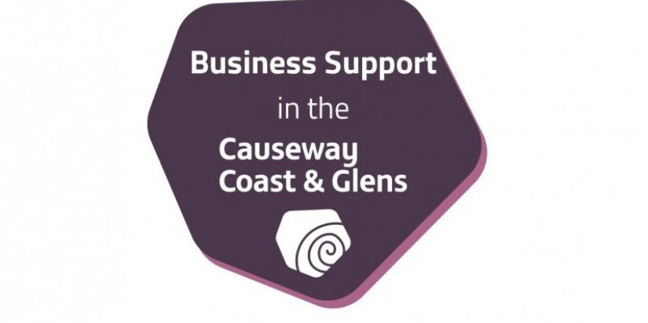

# Causeway Coast and Glens Local Development Plan 2035

*In previous newsletters we outlined the purpose of the Council’s Local Development Plan (LDP) 2035 for the Borough. We informed you of the various stages in the preparation of the LDP as well as our progress to date and indicative timeframes involved going forward. This included the publication of the LDP Preferred Options Paper (June 2018). The first in a series of LDP publications, this public consultation document set out the main planning issues identified in the Borough, a range of options for addressing the issues, including the Council’s “preferred option”.*

*In this edition we provide a further update on the Council’s Plan-making process.*

## What we have done

Since our previous update we have published the following documents:

**Statement of Community Involvement in Planning (SCI) (Revised March 2021) -** this document sets out how Council intends to engage with you, stakeholders and government departments in exercising its planning functions, including the preparation of its LDP; deciding planning applications in the Borough; planning enforcement; and other planning matters.

**Retail & Leisure Capacity Study and Perception Studies Update (2020 & 2021) -** consultants undertook a borough-wide Retail & Leisure Capacity Study as well as Perception Surveys in the key towns (in 2017) to inform the POP. The Retail & Leisure Capacity Study (retail element only) was updated in 2020, and the Perception Studies updated in March 2021.

**Local Development Plan Timetable (Revised May 2021) -** this document sets out indicative timeframes for the key stages in the Council’s Plan-making process.

All of these documents* are available to view online at: [Causeway Coast and Glens Development Plan](https://www.causewaycoastandglens.gov.uk/live/planning/development-plan)

*\* Please note that the SCI and LDP Timetable may be subject to review at any time.*

## Where we are now

We have carried out extensive research, covering a wide range of issues and topic areas, to properly consider all relevant factors and to enable us to move to this, the next stage in our Plan-making process – the LDP draft Plan Strategy (dPS).

The dPS is prepared in the context of the Council’s Corporate Strategy and Community Plan. It takes account of representations received at the Preferred Options Paper (POP) stage, as well as expert input from our key consultees and stakeholders. We have also continued to engage with our adjoining councils and regional working groups throughout the preparation of the dPS.

## Where we are going

We are working towards the publication of the dPS, a document that sets out the Council’s LDP Vision, Overarching Principles and Strategic Objectives for the sustainable development of the Borough up to 2035.

The dPS contains the Council’s Growth and Spatial Strategy for the Borough. It sets out the Strategic Subject Planning Policies that will be used when taking decisions on development proposals in the Council area. The dPS public consultation document will be accompanied by a range of background evidence papers, assessments and appraisals.

The indicative timeframe for publication of the dPS is 2023, when we will commence an 8-week public consultation exercise. We will hold a number of public engagement events in and around this time. Following this we will undertake another 8-week public consultation exercise, seeking comments, known as ‘counter-representations’, on (only) those representations received during the previous 8-week consultation period.

## Have your say!

We are very keen to engage with you throughout this process. You are therefore encouraged to participate in the public consultation exercise. Come along and participate in the public engagement events and comment on the published documents, as only those comments received during the consultation period can be considered by the Council going forward.

## Register your interest

The Council has developed a Register of Interest for any group or individual who may wish to be kept informed on its Local Development Plan 2035 progress as we continue through our Plan-making process.

**You can register your details in any of the following ways:**

Online at: [Causeway Coast and Glens Website](http://www.causewaycoastandglens.gov.uk/)

By e-mail to: [Email Development Plan at Causeway Coast and Glens](mailto:development.plan@causewaycoastandglens.gov.uk)

By post to: Local Development Plan Team, Cloonavin, 66 Portstewart Road, Coleraine, BT52 1EY

By telephone on: 028 7034 7100

**Regular updates on the progress of the LDP will also be posted on our website at:** [**Causeway Coast and Glens Development Plan**](https://www.causewaycoastandglens.gov.uk/live/planning/development-plan)

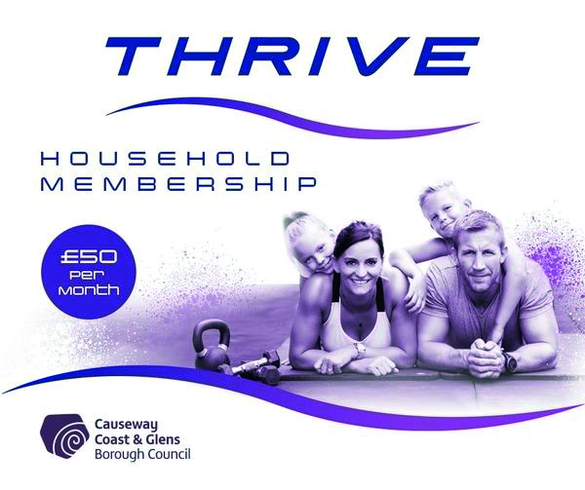

# Thrive Household Membership is now available for £50 per month

## Did you know a new Household Membership option is now available which offers accessto our six main leisure facilities?

For **£50 per month**, our Thrive package allows members to use swimming pools, gyms, classes and health suites in Coleraine Leisure Centre, Roe Valley Leisure Centre, Joey Dunlop Leisure Centre, Dungiven Sports Centre, Sheskburn Recreation Centre in Ballycastle. and the Jim Watt Sports Centre in Garvagh.

A household can include up to two adults and any children under the age of 18 living at the same address.

**For more details email** [**Email Leisure Membership at Causeway Coast and Glens**](mailto:leisure.membership@causewaycoastandglens.gov.uk) **or visit our website.**

# Causeway Coast and Glens Youth Voice Logo

# Causeway Coast and Glens Youth Voice

## Young people aged 15–21 who live in the Borough can now apply to the Youth Voice programme.

**Youth Voice will provide an opportunity to:**

• Engage with key decision makers

• Have their say on local issues

• Meet new friends

• Be a representative voice for young people in their area

• Be involved and proactively engaged with local

decision-making processes.

The Youth Voice group will meet on a regular basis and there will be opportunities for residential and study visits.

Everyone is invited to apply regardless of background, abilities, or interests.

**Find out how to apply by going to** [**Causeway Coast and Glens Community Planning News Website**](http://www.causewaycoastandglens.gov.uk/council/community-planning/news)

*Youth Voice is managed by the Council in partnership with our Community Planning partner, the Education Authority, through its Youth Service provision.*

# Councillor Cara McShane, Diversity Champion.

Councillor Cara McShane, Diversity Champion.

# An update from Council’s Diversity Champion on our commitment to diversity and inclusion

*The Council continues to promote diversity and inclusion through its initiatives. Some of these are listed below against specified priorities.*

**Design, commission and deliver accessible, inclusive and responsive services**

• Council has worked with community organisations and other external bodies across the area including support for the Community Fridges project, Affordable Warmth Scheme, Fiver Fest to promote local businesses and a pre-loved toys Christmas collection.

• We continue to raise awareness about SignVideo which provides our deaf or hard of hearing customers who use British Sign Language (BSL) instant access to a SignVideo online BSL interpreter, in real time, on a video relay system.

• Inclusive leisure provision was extended by opening an accessible play park in Limavady along with continued inclusive cycling and swimming sessions. In addition, 3195 individuals enjoyed both virtual and in-person summer recreation programmes. Council intends to build more accessible play parks across the Borough.

• Extensive in-house and partnership grant programmes promoted social inclusion and helped connect individuals and communities, as we emerged from the pandemic.

• Funding was obtained to purchase two mobile accessible changing facilities, which can be used at events across the Council area.

**Raise awareness of equalities issues and tackle prejudices, internally and externally**

• Good Relations and peace building initiatives were supported through engagement across the area.

• The PCSP provided Makaton and Learning Disability Awareness training for staff, elected members, partner agencies and the community. Makaton is a visual way of communicating.

• An Easy Read package has been purchased to make written information easier to understand.

**To find out more, make a suggestion about promoting diversity or if you would like to get more involved as a consultee, we would love to hear from you.**

Email: [Email Equality at Causeway Coast and Glens](mailto:equality@causewaycoastandglens.gov.uk)

# Causeway Coast and Glens Borough Map

# Causeway Coast and Glens Borough elected members

Party Abbreviations: ALL – Alliance Party, DUP – Democratic Unionist Party, IND – Independent, SDLP – Social Democratic & Labour Party, SF – Sinn Féin, PUP – Progressive Unionist Party, UUP – Ulster Unionist Party, DEA – District Electoral Area

*Every effort is made to ensure the information contained within this newsletter is correct at time of print*

## Ballymoney

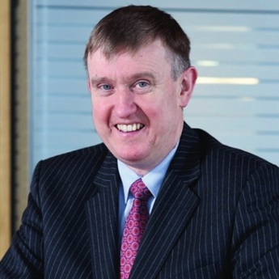

**Mervyn Storey (DUP)**

Ballymoney

M: 07967 795 684

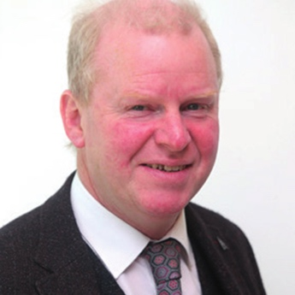

**Tom McKeown (UUP)**

Ballymoney

M: 02827 662 758

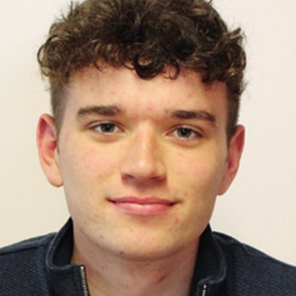

**Ciarán McQuillan (SF)**

Ballymoney

M: 07512 014 473

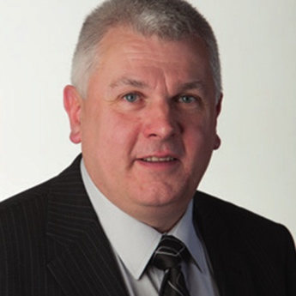

**Alan McLean (DUP)**

Ballymoney

M: 07885 109 104



**Leanne Peacock (SF)**

Ballymoney

M: 07511 132 057

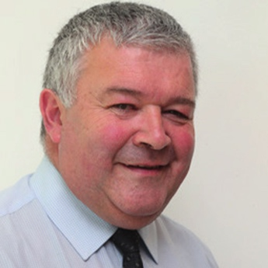

**Ivor Wallace (DUP)**

Ballymoney

M: 07979 666 343



**Darryl Wilson (UUP)**

Ballymoney

M: 07412 630 814

## Benbradagh

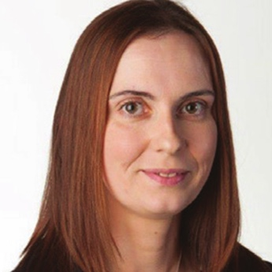

**Orla Beattie (SDLP)**

Benbradagh

M: 07834 636038

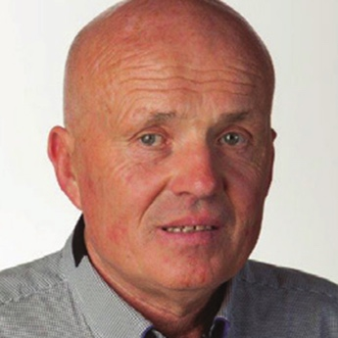

**Sean McGlinchey (SF)**

Benbradagh

M: 07889 352489

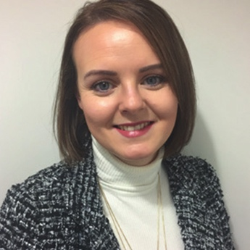

**Kathleen McGurk (SF)**

Benbradagh

M: 07851098477

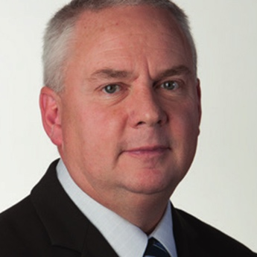

**Dermot Nicholl (SF)**

Benbradagh

M: 07713 357 592

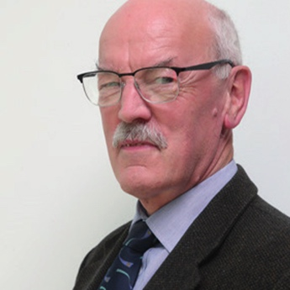

**Edgar Scott (DUP)**

Benbradagh

M: 07841 355 040

## Causeway

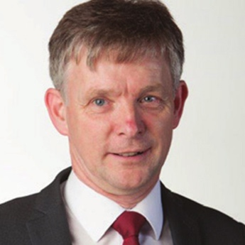

**Mark Fielding (DUP)**

Causeway

M: 07971 059829

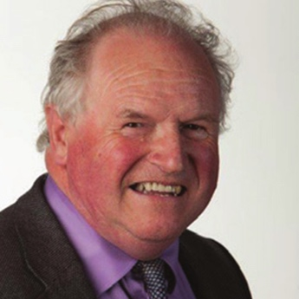

**Norman Hillis (UUP)**

Causeway

M: 02870 822692

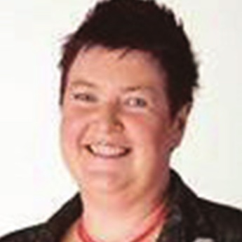

**Sandra Hunter (UUP)**

Causeway

M: 07850 884017

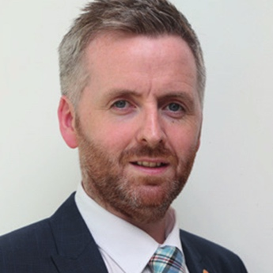

**John McAuley (DUP)**

Causeway

M: 07736 474 848



**Chris McCaw (ALL)**

Causeway

M: 07769 831250

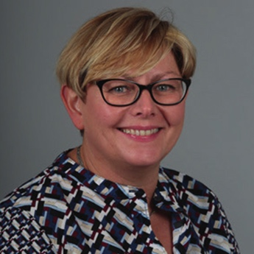

**Sharon McKillop (DUP)**

Causeway

M: 07793 678991

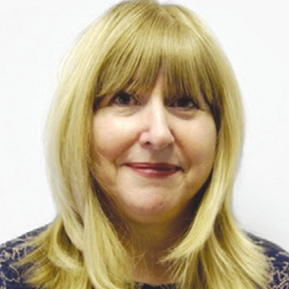

**Angela Mulholland (SDLP)**

Causeway

M: 07706 395856 / 07914048787

## Coleraine

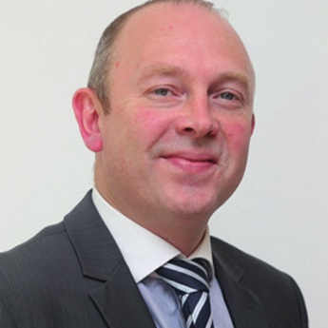

**Philip Anderson (DUP)**

Coleraine

M: 07772 272 479

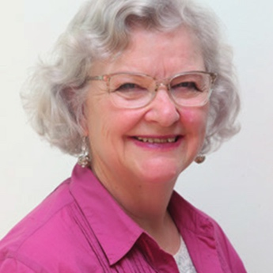

**Yvonne Boyle (ALL)**

Coleraine

M: 07761 979 251

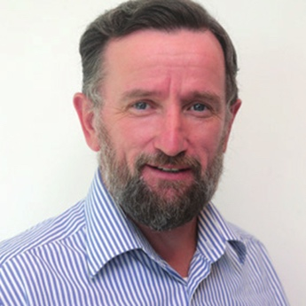

**George Duddy (DUP)**

Coleraine

M: 07734 347 878

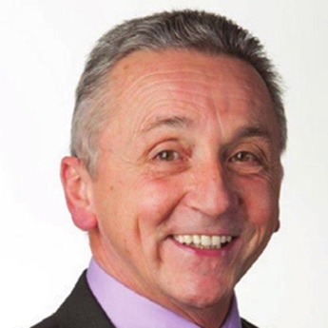

**William McCandless (UUP)**

Coleraine

M: 07719 097874



**Stephanie Quigley (SDLP)**

Coleraine

M: 07746 208084

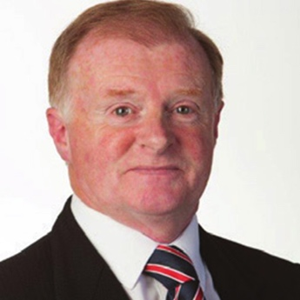

**Russell Watton (PUP)**

Coleraine

M: 07981 545952

## Limavady



**Aaron Callan (DUP)**

Limavady

M: 07843 879 358

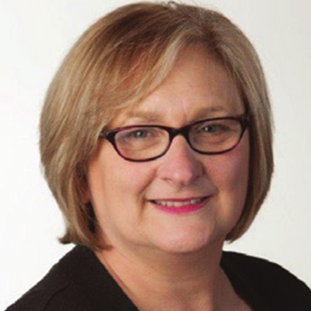

**Brenda Chivers (SF)**

Limavady

M: 07730 495 794

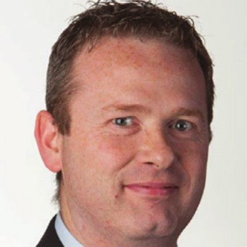

**James McCorkell (IND)**

Limavady

M: 07545 309970

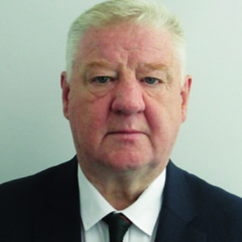

**Steven Callaghan (DUP)**

Limavady

M: 07824 365 219

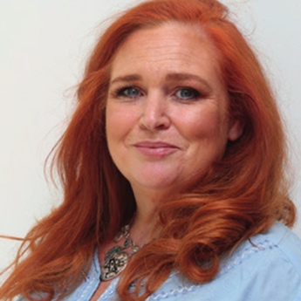

**Ashleen Schenning (SDLP)**

Limavady

M: 07720 046 169

## The Glens

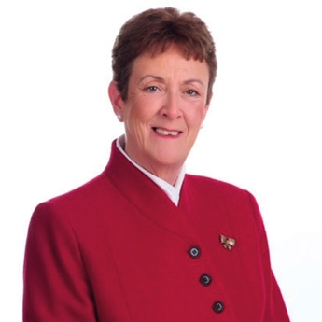

**Joan Baird (UUP)**

The Glens

M: 07732 855807

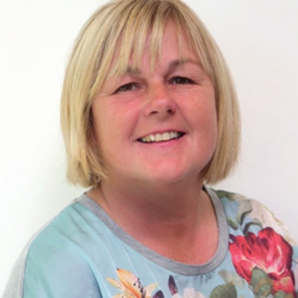

**Margaret Anne McKillop (SDLP)**

The Glens

M: 07850 883716



**Cara McShane (SF)**

The Glens

M: 07752 417316



**Padraig McShane (IND)**

The Glens

M: 07828 112129

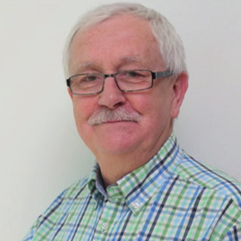

**Oliver McMullan (SF)**

The Glens

M: 07803 505 081

## Bann



**Sean Bateson (SF)**

Bann

M: 07417 688 160



**Richard Holmes (UUP)**

Bann

M: 07884 303 639



**Helena Dallat O’Driscoll (SDLP)**

Bann

M: 07890 562 573

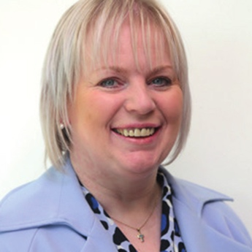

**Michelle Knight-McQuillan (DUP)**

Bann

M: 07793 544 264



**Adrian McQuillan (DUP)**

Bann

M: 07792 804 925

# Visit us online:

Website:

[Casueway Coast and Glens Website](http://www.causewaycoastandglens.gov.uk/)

Facebook:

Causeway Coast and Glens Facebook

Twitter:

[Causeway Coast and Glens Twitter](http://www.twitter.com/CausewayCouncil)

