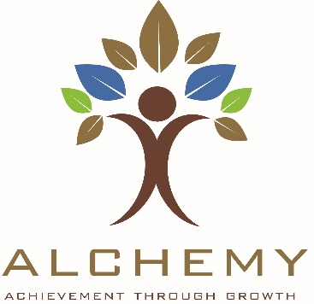

INITIAL BASELINE ASSESSMENT – please return your completed form to Louise.pollock@causewaycoastandglens.gov.uk

Business Name:
Contact Person:
Address:
Tel:
Email:
Website:
Facebook:
Twitter:

The Alchemy programme offers (up to) 5 days of one-to-one bespoke mentoring giving you the opportunity to grow your business with professional support.

There are a number of partner organisations with Council who can also provide support and the process is that the Alchemy officer will complete an initial assessment of your business.

The officer will identify the need for support in your business and signpost you to relevant agency that can help or make a recommendation to the panel for the provision of one-to-one support, if required for your business (that cannot be provided by any other business support organisation).

In order to prepare a case, the Alchemy officer requires answers to the following questions overleaf in advance of the assessment visit.

Please email your completed form to Louise.Pollock@causewaycoastandglens.gov.uk

Thank you.

Company commenced (month/year)

‘Go For It’ business start programme completed (or other new business start support received)
Company status
(sole trader, partnership, limited company)
Employee number:
(full-time / part-time)
Turnover
(most recent audited – please advise date)
Profit
(most recent audited – please advise date)
Brief description of products/services you provide
Do you export outside NI?
Or have potential to export outside NI?
Customers (sectors, areas, countries)

How do you plan to grow the business (with funding opportunities or not?)
Have you identified specific area of need for support in your business to allow growth?
If yes, in what area?

Do you plan to introduce new products/services? Target new markets?
What would be your anticipated growth?

Have you ever received funding?
Would you like to enquire about funding opportunities?
Is funding necessary for business growth?

